SEED: The Untold Story Premieres on Independent Lens
FOR IMMEDIATE RELEASE

CONTACT
Lisa Tawil, ITVS 415-356-8383 lisa_tawil@itvs.org
Mary Lugo 770-623-8190 lugo@negia.net
Cara White 843-881-1480 cara.white@mac.com
For downloadable images, visit pbs.org/pressroom/
Monday, April 17, 2017 on PBS

Online Streaming Begins April 18

As many irreplaceable seeds near extinction, SEED reveals the story of passionate seed keepers as they wage a David and Goliath battle against chemical seed companies, defending a 12,000-year food legacy

(San Francisco, CA) — Worshipped and treasured since the dawn of humankind, few things on Earth are as miraculous and vital as seeds. SEED: The Untold Story follows passionate seed keepers intent on protecting our 12,000 year-old food legacy. Produced and directed by Taggart Siegel and Jon Betz (The Real Dirt on Farmer John, Queen of the Sun: What are the Bees Telling Us?), the film premieres on Independent Lens Monday, April 17, 2017, 10:00-11:00 PM ET (check local listings) on PBS.
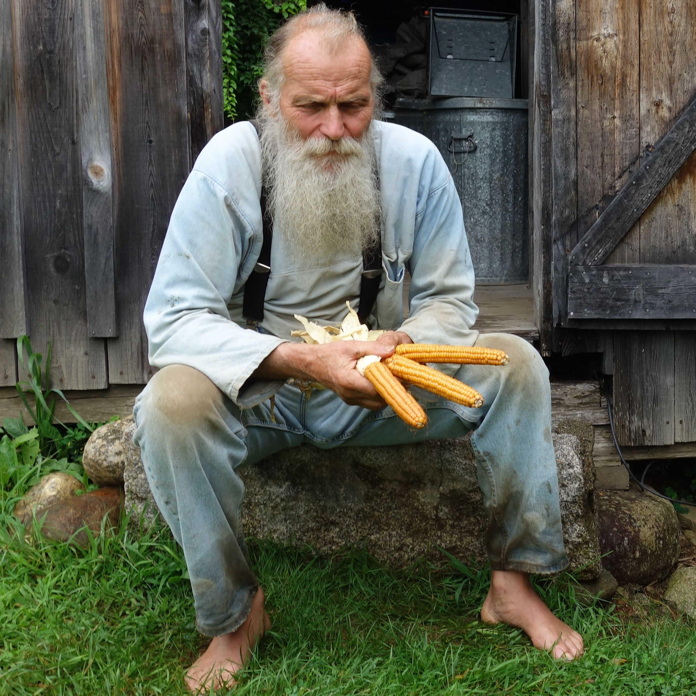
Will Bonsall, seed saver and organic farmer from Maine.
Credit: Collective Eye Films

In the last century, 94% of our seed varieties have disappeared. This once abundant seed diversity — painstakingly created by ancient farmers and gardeners over countless millennia — has been drastically winnowed down to a handful of mass-produced varieties. Under the spell of industrial “progress” and corporate profits, family farmsteads have given way to mechanized agribusinesses sowing genetically identical crops on a massive scale. But without seed diversity, crop diseases rise and empires fall. More than a cautionary tale of “man against nature,” SEED reveals the work of the farmers, scientists, lawyers, and indigenous seed keepers who are fighting a David and Goliath battle to defend the future of our food. In this story both harrowing and heartening, we meet a wide variety of reluctant heroes working to rekindle a lost connection to our most treasured resource, from the pueblos of New Mexico to a seed bunker in Norway, from India to America’s heartland, from Peru to Hawaii. Among the dozens of people featured are Will Bonsall of the Scatterseed Project, Dr. Jane Goodall, environmental lawyer Claire Hope Cummings, ethnobotanist Gary Paul Nabhan, botanical explorer Joseph Simcox, Andrew Kimbrell of the Center for Food Safety, and physicist/activist Dr. Vandana Shiva.

“SEED began with an article in National Geographic that reported that up to 96% of the vegetable seeds available in 1903 have disappeared. The speed and scope of this loss is staggering, and its implications for our future are stark,” said filmmakers Siegel and Betz. “In an era of climate uncertainty, this dearth of diversity is a recipe for catastrophic crop failure and human suffering – not unlike The Great Famine of Ireland that saw the starvation of nearly a million people when their sole crop variety, a potato, was wiped out by blight. SEED explores the hidden fabric of our food and the people that painstakingly and meticulously curate its diversity, fighting the immense corporate power of chemical companies that now control the majority of our food.”

Visit the SEED: The Untold Story page on Independent Lens, which features more information about the film. SEED will be available for online viewing on the site beginning April 18.

About the Filmmakers

Taggart Siegel (Producer/Director) has produced and directed Emmy-nominated, award-winning documentaries including Queen of the Sun: What are the Bees Telling Us? and The Real Dirt on Farmer John (Independent Lens). Both received critical acclaim during their theatrical release and garnered over 40 international awards. Siegel is a Fledgling Outreach and Engagement Lab Fellow and was selected to pitch at Britdoc’s GoodPitch for SEED: The Untold Story. His previous PBS films include Split Horn (Independent Lens), Between Two Worlds, Blue Collar and Buddha and Heart Broken in Half. Collectively, they capture the struggle of refugees and immigrants in America. He produced the National Geographic film Disenchanted Forest about orangutans in Borneo. Taggart is the founder and Executive Director of Collective Eye Films, a nonprofit media production and distribution organization based in Portland, Oregon.

Jon Betz (Producer/Director) is an award-winning independent documentary filmmaker. He was the producer and editor for Queen of the Sun: What Are the Bees Telling Us? (2010). His previous film, Memorize You Saw It (2008), journals his experience as an aid worker living with former child soldiers in Eastern Uganda. Betz is a Fledgling Outreach and Engagement Lab Fellow, a Britdoc’s GoodPitch alumni and a graduate of the Rhode Island School of Design. He is the director of Collective Eye Films.

Marc Turtletaub (Executive Producer) has served as a producer on numerous independent films including the Academy Award-winning Little Miss Sunshine. Recent releases include Sam Mendes’ Away We Go, starring Maya Rudolph and John Krasinski, Christine Jeffs’ Sunshine Cleaning, starring Amy Adams and Emily Blunt, and John Crowley’s Is Anybody There?, starring Michael Caine. Turtletaub also produced Liev Schrieber’s Everything Is Illuminated. Other producing credits include Jack Goes Boating, Laws of Attraction, The Honeymooners, and the documentary Lucky by Jeffrey Blitz.

Phil Fairclough (Executive Producer) was intimately involved as executive producer and producer on several of Werner Herzog’s documentaries, including the acclaimed Grizzly Man, the Oscar-nominated Encounters at the End of the World, and Cave of Forgotten Dreams. He was a network executive at Discovery Channel and EVP of Development and Production for NHNZ. Before working at Discovery, Phil held senior positions at the BBC and ITV and had extensive production experience in the UK, including the acclaimed BBC Natural History Unit where he was an executive producer and head of the commercial production unit.

CREDITS

Directed, Produced and Edited by Taggart Siegel & Jon Betz
Executive Producers Marc Turtletaub
Phil Fairclough
Original Music by Garth Stevenson
Additional Original Music by Benjy Wertheimer
Martin Watkinson
Cinematography by Taggart Siegel
Associate Producers Darby Crouss
Jenny Siegel

A Collective Eye Films presentation in association with Seneca Falls Picture Company.

About Independent Lens
Independent Lens is an Emmy® Award-winning weekly series airing on PBS Monday nights at 10:00 PM. The acclaimed series, with Lois Vossen as executive producer, features documentaries united by the creative freedom, artistic achievement, and unflinching visions of independent filmmakers. Presented by ITVS, the series is funded by the Corporation for Public Broadcasting, a private corporation funded by the American people, with additional funding from PBS, the John D. and Catherine T. MacArthur Foundation, Wyncote Foundation, and the National Endowment for the Arts. For more visit pbs.org/independentlens. Join the conversation: facebook.com/independentlens and on Twitter @IndependentLens.

###

