FOR IMMEDIATE RELEASE

CONTACT
Donna Hardwick, ITVS 415-356-8383 donna.hardwick@itvs.org
Mary Lugo 770-623-8190 lugo@negia.net
Cara White 843-881-1480 cara.white@mac.com
For downloadable images, visit pbs.org/pressroom/
The Untold Tales of Armistead Maupin
Premieres on Independent Lens
Monday, January 1, 2018 on PBS

Online Streaming Begins January 2

A Frank and Funny Portrait of the Creator of
the Iconic “Tales of the City”

(San Francisco, CA) —Jennifer M. Kroot’s The Untold Tales of Armistead Maupin, winner of an Audience Award at the 2017 SXSW Film Festival, premieres on Independent Lens, Monday, January 1, 2018, 10:30 PM to Midnight ET (check local listings) on PBS.
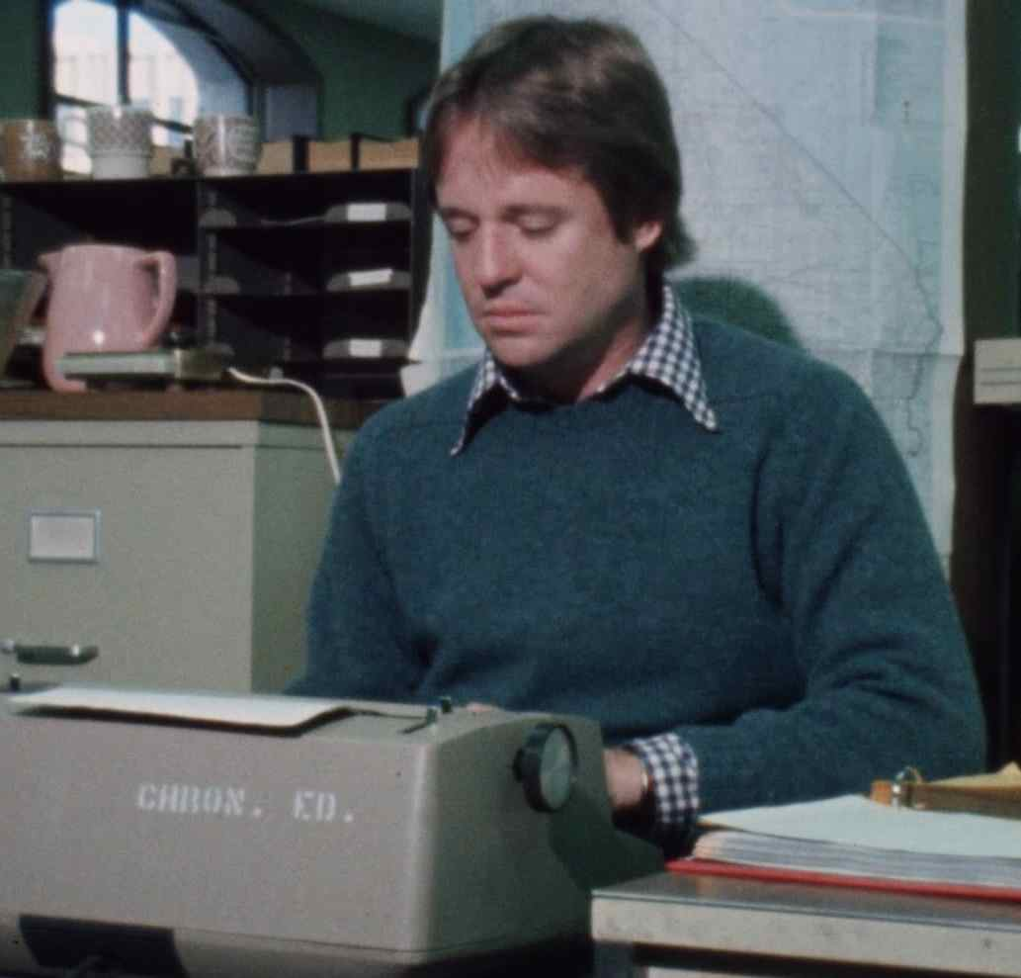
Credit: KQED

The Untold Tales of Armistead Maupin examines the life and work of one of the world's most beloved storytellers, following his evolution from a conservative son of the Old South into a gay rights pioneer whose novels have inspired millions to claim their own truth. Kroot's documentary about the creator of Tales of the City moves nimbly from playful to poignant to wildly funny. With help from his friends — including Neil Gaiman, Laura Linney, Olympia Dukakis, Sir Ian McKellen and Amy Tan — Maupin offers a disarmingly frank look at the journey that took him from the jungles of Vietnam to the bathhouses of 70s San Francisco to the frontlines of America’s ongoing culture war.

“Jennifer Kroot’s documentary — alternately warm, heartbreaking, and uproarious — reveals how Maupin became one of the first gay writers to attain crossover status,” said Lois Vossen, Independent Lens Executive Producer. “For those who know Tales of the City – the books or television series – the documentary offers a frank look at Maupin's unlikely personal trajectory. For those who don't, it’s a fascinating introduction to an extraordinary man and a crash course in the evolution of the left-right culture clash that continues to this day."

Visit the Untold Tales page on Independent Lens, which features more information about the film. The film will be available for online viewing on the site beginning January 2.

About Armistead Maupin

Armistead Maupin was born in Washington, D.C., in 1944 but grew up in Raleigh, North Carolina. A graduate of the University of North Carolina, he served as a naval officer in the Mediterranean and with the River Patrol Force in Vietnam. Maupin worked as a reporter for a newspaper in Charleston, South Carolina, before being assigned to the San Francisco bureau of the Associated Press in 1971. In 1976, he launched his groundbreaking Tales of the City serial in the San Francisco Chronicle.

Maupin is the author of nine novels, including the six-volume Tales of the City series, Maybe the Moon, The Night Listener and, most recently, Michael Tolliver Lives. His latest book, Logical Family: A Memoir, will be published in October 2017. Three miniseries starring Olympia Dukakis and Laura Linney were made from the first three Tales of the City novels; the first aired on PBS in 1994 and the subsequent series aired on Showtime in 1998 and 2001. The Night Listener became a feature film starring Robin Williams and Toni Collette. Netflix recently announced that it is developing a new installment of Armistead Maupin’s Tales of the City with Working Title Television U.S. Laura Linney and Olympia Dukakis are on board to revive the characters they played in the Showtime and PBS adaptations. Maupin lives in San Francisco with his husband, Christopher Turner.

About the Filmmakers

Jennifer M. Kroot (Director) is a seasoned documentary filmmaker. Her most recent feature length documentary, To Be Takei, a portrait of actor/activist George Takei, premiered at the 2014 Sundance Film Festival and was released theatrically by Starz Digital in August 2014 to critical acclaim. Her feature documentary It Came From Kuchar, following cult filmmaking duo George and Mike Kuchar, premiered at the 2009 South by Southwest Film Festival.

Kroot brings a background in underground filmmaking to her documentaries, and uses that sensibility to create surprises within her stories. Her tales incorporate shifts in pace and tone that allow a fluid and engaging structure. Kroot focuses on the humanity of her subjects, keeping their stories accessible and unpretentious. She has received grants from the Andy Warhol Foundation, Creative Work Fund, Frameline, the Pacific Pioneer Fund, California Civil Liberties Public Education Program, and the Fleishhacker Foundation. Kroot is a Bay Area native and studied film at The San Francisco Art Institute (SFAI), where she taught film. She has been a guest lecturer at Stanford and Denver University.

Bill Weber (Co-Director/Editor) is a San Francisco-based documentary editor. He directed and edited the documentary feature The Cockettes which premiered at the 2002 Sundance Film Festival and 2002 Berlinale. Weber co-directed and edited the documentary feature We Were Here, which played at the 2011 Sundance and Berlinale festivals, and To Be Takei, which premiered at Sundance in 2014.

As an editor, Bill’s work includes A Revolution in Four Seasons (2016 HotDocs), Feelings Are Facts: The Life of Yvonne Rainer (2015 Berlinale), The Galapagos Affair (2013 Telluride Film Festival and 2014 Berlinale), and the Oscar-nominated documentary short film, The Final Inch. He also edited the award-winning documentaries Last Letters Home and The Alzheimer's Project.

CREDITS

Written and Directed by Jennifer M. Kroot
Edited and Co-Directed by Bill Weber
Produced by Gerry Kim
Jennifer M. Kroot
Mayuran Tiruchelvam
Director of Photography Shane King
Composer Michael Hearst
Sound Edit & Mix Lora Hirschberg
Animation and Design Grant Nellessen
Producers Tina S. Kroot
Lewis Gillian
Consulting Producer Jeffrey Schwarz
Associate Producers Mission Pictures
Lotti Knowles

About Independent Lens
Independent Lens is an Emmy® Award-winning weekly series airing on PBS Monday nights at 10:00 PM. The acclaimed series, with Lois Vossen as executive producer, features documentaries united by the creative freedom, artistic achievement, and unflinching visions of independent filmmakers. Presented by ITVS, the series is funded by the Corporation for Public Broadcasting, a private corporation funded by the American people, with additional funding from PBS, the John D. and Catherine T. MacArthur Foundation, Wyncote Foundation, and the National Endowment for the Arts. For more visit pbs.org/independentlens. Join the conversation: facebook.com/independentlens and on Twitter @IndependentLens.

###

