I Am Another You Premieres on Independent Lens
FOR IMMEDIATE RELEASE

CONTACT
Donna Hardwick, ITVS 415-356-8383 donna.hardwick@itvs.org
Mary Lugo 770-623-8190 lugo@negia.net
Cara White 843-881-1480 cara.white@mac.com
For downloadable images, visit pbs.org/pressroom/

Monday, January 29, 2018 on PBS

Online Streaming Begins January 30

Filmmaker Nanfu Wang Explores the Meaning of Personal Freedom Through the Eyes of a Young American Drifter
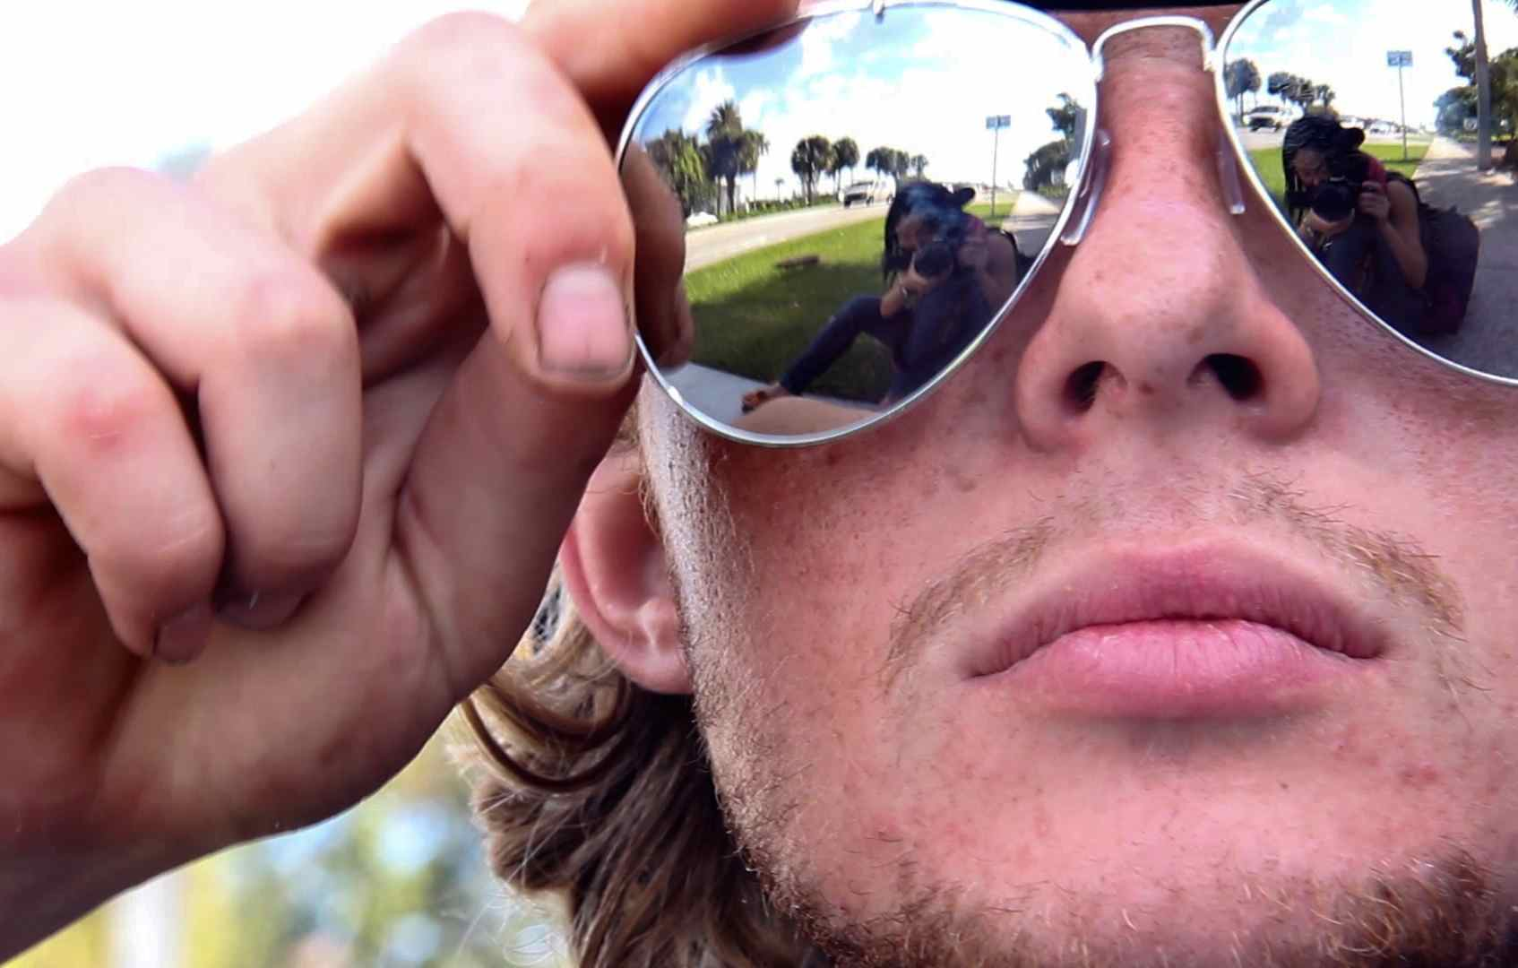
Credit: Nanfu Wang
(San Francisco, CA) — When 20-something Chinese filmmaker Nanfu Wang first came to America in 2011, Florida seemed like an exotic frontier full of theme parks, prehistoric swamp creatures, and sunburned denizens. Staying at a hostel on a break from her studies at New York University, she encounters Dylan, a blonde, charismatic, 22-year-old drifter who has left a comfortable home and loving family in Utah for a life of intentional homelessness and unfettered adventure. Fascinated by his choice and rejection of society's rules, Nanfu follows Dylan with her camera, living with him on the streets. But what begins as a portrait of a uniquely American quest for freedom is soon upended, unfolding instead as a haunting and unforgettable story of family, illness, and love. I Am Another You premieres on Independent Lens Monday, January 29, 2018, 10:00-11:30 PM ET (check local listings) on PBS.

“When I first met Dylan he seemed like a symbol for free America,” said Wang. “But the longer I spent observing how he used his freedom, my feelings changed.” Told in three chapters, I Am Another You begins with Wang’s unorthodox decision to accompany Dylan as he goes about his daily life – even if that means sleeping on the streets and eating out of garbage cans. Sympathetic strangers offer them beds, food, and cash, but Wang is soon unsettled by Dylan’s cavalier way with this charity; when he throws away a bag of bagels presented to them by a kind shopkeeper, she packs up and heads home.

The story continues a few years later when Wang is in Utah working on another film. Deciding to pick up Dylan’s trail, she finds his father and siblings — each in their own way as extraordinary as Dylan. As their story unfolds, Wang’s initial tale of a carefree drifter becomes something much more unexpected.

“Nanfu Wang is a storyteller we need to keep an eye on,” said Lois Vossen, Independent Lens Executive Producer. “She follows her curiosity wherever it takes her and in this film it took her from living on the streets of Florida to playing detective with a real-life Utah detective. I Am Another You seamlessly shows us how delicate are the ties that bind us to our family, and puts a new face on the millions of people living on the streets across America.”

Visit the I Am Another You page on Independent Lens, which features more information about the film. The film will be available for online viewing on the site beginning January 30.

About the Filmmaker

Nanfu Wang (Director/Producer/DP) is an award-winning filmmaker based in New York City. Her feature debut Hooligan Sparrow was shortlisted for the 2017 Academy Award for Best Documentary Feature. Since its premiere at the Sundance Film Festival, the film has screened at festivals in over 25 countries, including Hot Docs, Sheffield, Full Frame, and Human Rights Watch Film Fest. It opened theatrically across North America and was later released on POV on PBS, Netflix, Amazon, and iTunes. It won over twenty awards internationally including a Peabody Award, a George Polk Award, two Emmy nominations, the Best Debut Film at the Cinema Eye Honors and the Truer than Fiction Award at the Independent Spirit Awards. Wang was honored by the International Documentary Association with the 2016 Emerging Filmmaker Award. For I Am Another You, Wang won the SXSW LUNA Chicken & Egg Award for Best Documentary Feature directed by a woman and the SXSW Special Jury Award for Excellence in Documentary Storytelling. She was recently named one of Variety’s 2017’s Ten Documakers to Watch.

Originally from a remote village in China, Wang overcame poverty and lack of access to formal secondary education and went on to earn graduate degrees in communications and documentary film from universities in China and the United States. Wang holds master’s degrees from Shanghai University, Ohio University, and New York University.

CREDITS
Director/Producer/DP/Co-Editor Nanfu Wang
Producer Lori Cheatle
Co-Producer/Camera/Co-Editor Michael Shade
Creative Consultant Peter Lucas

About Independent Lens
Independent Lens is an Emmy® Award-winning weekly series airing on PBS Monday nights at 10:00 PM. The acclaimed series, with Lois Vossen as executive producer, features documentaries united by the creative freedom, artistic achievement, and unflinching visions of independent filmmakers. Presented by ITVS, the series is funded by the Corporation for Public Broadcasting, a private corporation funded by the American people, with additional funding from PBS, the John D. and Catherine T. MacArthur Foundation, Wyncote Foundation, and the National Endowment for the Arts. For more visit pbs.org/independentlens. Join the conversation: facebook.com/independentlens and on Twitter @IndependentLens.

###

