FOR IMMEDIATE RELEASE

CONTACT
Donna Hardwick, ITVS 415-356-8383 donna.hardwick@itvs.org
Mary Lugo 770-623-8190 lugo@negia.net
Cara White 843-881-1480 cara.white@mac.com
For downloadable images, visit pbs.org/pressroom/
Rat Film Premieres on Independent Lens
Monday, February 26, 2018 on PBS

Online Streaming Begins February 27

“Equal parts disturbing and humorous, informative and bizarre, Rat Film is a brilliantly imaginative and formally experimental essay on how Baltimore has dealt with its rat problem and
manipulated its black population.” — The New York Times

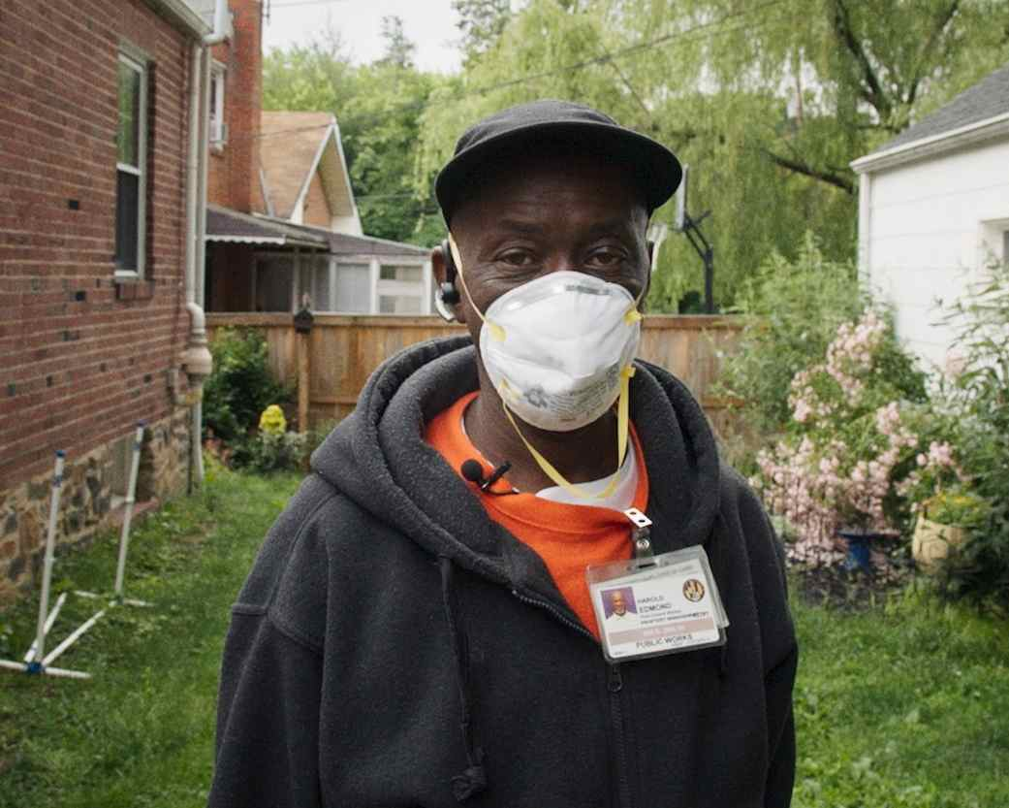
Credit: MEMORY
(San Francisco, CA) — In his critically-acclaimed directorial debut, Theo Anthony uses the rat to burrow into the dark, complicated history of Baltimore. A unique blend of history, science and sci-fi, poetry and portraiture, Rat Film explores how racial segregation, discriminatory lending practices known as “redlining,” and environmental racism built the Baltimore that exists today. Rat Film premieres on Independent Lens Monday, February 26, 2018, 10:00-11:00 PM ET (check local listings) on PBS.

In Baltimore, just as in many other urban areas, rats are part of the daily lives of residents. Some have learned to live with them, domesticating rats as pets. Others hunt them for sport, using blowguns and fishing rods. At the center of the documentary is Harold Edmond, who works for the city as a rat exterminator. As someone who spends most of his time driving from house to house in Baltimore’s rat-plagued neighborhoods, Edmond knows his job is only providing a temporary solution to a problem that is innately human.
What begins as an examination of our interactions with rats – portraits of rat-afflicted citizens, as test subjects in labs, the development of rat poison – becomes a deeper exploration of Baltimore. Anthony investigates the history of the city, and the systemic racism that established the low-income and predominantly black neighborhoods that are still plagued by rats today. In one of the film’s most shocking sequences, 2015 Baltimore city statistics are superimposed over old redlining maps, exposing a haunting correlation to present-day urban issues and the neighborhoods formed decades ago.
Combining 3D animation and computer-generated imagery with a score using rat-generated theremin and player piano sounds by Baltimore-based composer and electronic musician Dan Deacon, Rat Film thrusts viewers into a kaleidoscopic look at Baltimore, allowing them to create their own connections between scenes. Despite the title, the core of Rat Film is deeply human — an unflinching anthropological look at the racial injustices entrenched in the city’s past.

“I hate rats and yet I can’t get enough of Rat Film,” said Lois Vossen, Independent Lens Executive Producer. “Unexpected and hypnotic, Theo’s documentary is a pinhole view that opens up, layer after layer, to encompass the story of poverty and race in America. As one of the characters so aptly explains, ‘Ain’t never been a rat problem in Baltimore. Always been a people problem.’”

Visit the Rat Film page on Independent Lens, which features more information about the film. The film will be available for online viewing on the site beginning February 27, 2018.

About the Filmmaker

Theo Anthony (Writer/Director) is a writer, photographer, and filmmaker currently based in Baltimore, Maryland. His work been featured by The Atlantic, Vice, BBC World News, and other international media outlets. His films have premiered at the Toronto International Film Festival, Locarno International Film Festival, Rotterdam International Film Festival, SXSW, and Anthology Film Archives. In 2015, he was named one of Filmmaker Magazine’s “25 New Faces of Independent Film.” Rat Film, his first feature, debuted at the 2016 Locarno International Film Festival to critical acclaim.
CREDITS

Writer and Director Theo Anthony
Producers Riel Roch-Decter
Sebastian Pardo
Director of Photography Theo Anthony
Editor Theo Anthony
Composer Dan Deacon
Narration Maureen Jones

About MEMORY
MEMORY is a full service independent production company specializing in developing and producing high-quality feature film, television and digital content. Focused on discovering and mentoring new talent as well as collaborating with established filmmakers, MEMORY creates innovative, thought-provoking entertainment distributed on a variety of new digital platforms. Based in Hollywood, MEMORY is dedicated to telling stories on a global scale for a discerning and savvy international audience.

MEMORY was founded in 2014 by Riel Roch-Decter and Sebastian Pardo. Since then the duo have produced and released the feature-length documentary Life After Death From Above 1979, about the rise, breakup and reunion of Canadian dance punk band Death From Above 1979, as well as executive produced Celia Rowlson-Hall’s debut feature film MA, which premiered at the 2015 Venice Film Festival and won an Audience Award at the 2015 AFI Film Festival. This year MEMORY premiered Carson Mell’s debut feature Another Evil at the 2016 SXSW Film Festival and Dean Fleischer-Camp’s controversial documentary Fraud at Hot Docs 2016. The founders of MEMORY were recently listed as one of 2016’s 25 Filmmakers to Watch in Filmmaker Magazine’s prestigious annual list.

About Independent Lens
Independent Lens is an Emmy® Award-winning weekly series airing on PBS Monday nights at 10:00 PM. The acclaimed series, with Lois Vossen as executive producer, features documentaries united by the creative freedom, artistic achievement, and unflinching visions of independent filmmakers. Presented by ITVS, the series is funded by the Corporation for Public Broadcasting, a private corporation funded by the American people, with additional funding from PBS, the John D. and Catherine T. MacArthur Foundation, Wyncote Foundation, and the National Endowment for the Arts. For more visit pbs.org/independentlens. Join the conversation: facebook.com/independentlens and on Twitter @IndependentLens.

###

