No Man’s Land on Independent Lens
FOR IMMEDIATE RELEASE

CONTACT
Donna Hardwick, ITVS 415-356-8383 donna.hardwick@itvs.org
Mary Lugo 770-623-8190 lugo@negia.net
Cara White 843-881-1480 cara.white@mac.com
For downloadable images, visit pbs.org/pressroom/
Monday, May 7, 2018 on PBS

Online Streaming Begins May 8

Inside the 2016 Standoff Between Protesters Occupying Oregon’s Malheur National Wildlife Refuge and Federal Authorities

(San Francisco, CA) – With unfettered access, filmmaker David Byars gives a detailed, on-the-ground account of the 2016 standoff between protesters occupying Oregon’s Malheur National Wildlife Refuge and federal authorities. No Man’s Land documents the occupation from inception to demise and tells the story of those on the inside of this movement, attempting to uncover what draws Americans — the ideologues, the disenfranchised, and the dangerously quixotic — to the edge of revolution. No Man’s Land premieres on Independent Lens Monday, May 7, 2018, 10:00-11:30 PM ET (check local listings) on PBS.
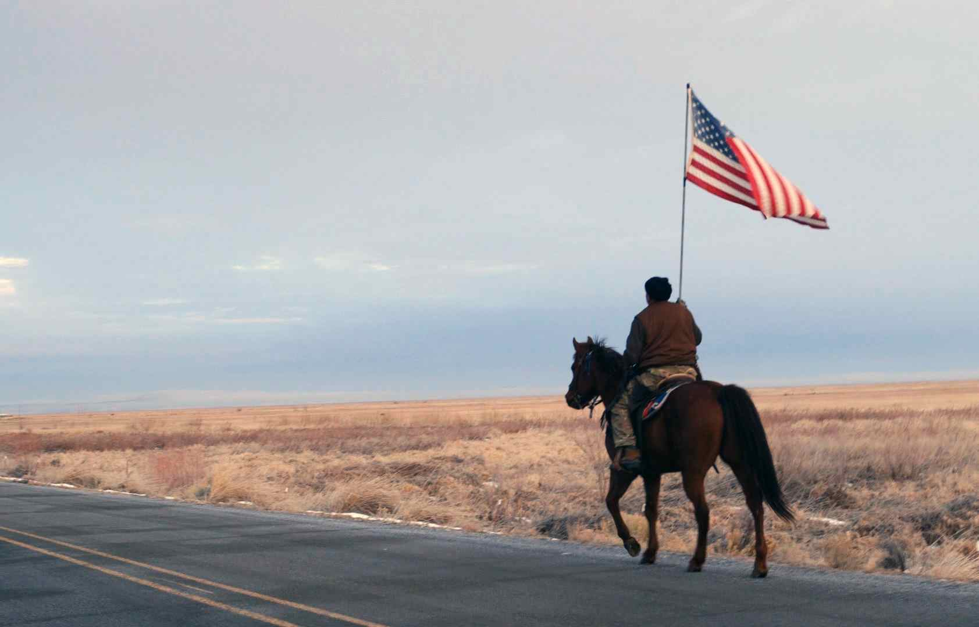
Credit: David Byars

In January of 2016, protesters gathered in Burns, Oregon to denounce the federal sentencing of two ranchers. During the protest, a group led by Ammon Bundy broke off and took over nearby Malheur Wildlife Refuge. The occupation quickly attracted a mix of right-wing militia and protesters. What began as a protest to condemn the sentencing morphed into a catchall for those eager to register their militant antipathy toward the federal government. The Malheur occupation drew the national spotlight, attracting media fascinated by the spectacle of cowboys and militia rebelling against the federal government. The siege also attracted the attention of the FBI, who set up a command center nearby to counter the occupiers.

During the 41-day siege, director and cinematographer Byars was granted remarkable access to the inner workings of the insurrection as the militants went about the daily business of running an armed occupation.

Events at Malheur took a bloody turn when federal agents waylaid occupation leaders en route to a community meeting. A car chase ensued that resulted in the arrests of the entire insurgency leadership and the dramatic on-camera shooting death of LaVoy Finicum, the semi-official spokesman for the group.

“No Man’s Land lays bare what happens when a group of self-defined ‘pissed-off people’ turn their patriot movement into an armed militia,” said Lois Vossen, Independent Lens executive producer. “In the months since this impasse between disgruntled citizens and government officials reached its climax the stories behind the standoff have become even more germane. David’s extraordinary film holds a mirror up to this microcosm of the deep divide in our country today and yet he doesn’t assign blame or point fingers. Instead he demands we see the human beings on all sides of the clash and comprehend their humanity no matter how much we disagree with them.”

Visit the No Man's Land page on Independent Lens, which features more information about the film. No Man’s Land will be available for online viewing on the site beginning May 8, 2018.

About the Filmmaker

David Garrett Byars (Director, Director of Photography, Producer) made his directorial debut at the 2017 Tribeca Film Festival with No Man’s Land. Byars is also currently working with Reel Thing’s Suzan Beraza as a producer and director of photography on her upcoming film Massacre River. He joined Reel Thing Productions in 2009, working as an editor, cameraman, and sound technician on Uranium Drive-In. His additional work includes directing two short films, Self Storage, a narrative short about existential dread and redemption, and Recapture, a short documentary chronicling the attempt of right-wing activists to reclaim the federally-managed Recapture Canyon in southern Utah.

CREDITS

Produced, Filmed and Directed by David Garrett Byars
Editor David Osit
Producers Jeremy Chilnick
Morgan Spurlock
David Holbrooke
Stash Wislocki
David Osit
Rachel Traub
Executive Producers Thom Beers
Michael Bloom
Dan Cogan
Adam Pincus
Co-Executive Producers Jenny Raskin
Co-Producer Jeff Seelbach
Jim Hurst
Music by Low
Composer David Osit

About Independent Lens

Independent Lens is an Emmy® Award-winning weekly series airing on PBS Monday nights at 10:00 PM. The acclaimed series, with Lois Vossen as executive producer, features documentaries united by the creative freedom, artistic achievement, and unflinching visions of independent filmmakers. Presented by ITVS, the series is funded by the Corporation for Public Broadcasting, a private corporation funded by the American people, with additional funding from PBS, the John D. and Catherine T. MacArthur Foundation, Wyncote Foundation, and the National Endowment for the Arts. For more visit pbs.org/independentlens. Join the conversation: facebook.com/independentlens and on Twitter @IndependentLens.

###

