True Conviction Premieres on Independent Lens
Monday, April 30, 2018 on PBS

Online Streaming Begins May 1

Discover a detective agency in Dallas, run by three exonerated men who all spent decades in prison. Their mission: to free other innocent people still behind bars.
FOR IMMEDIATE RELEASE

CONTACT
Donna Hardwick, ITVS 415-356-8383 donna.hardwick@itvs.org
Mary Lugo 770-623-8190 lugo@negia.net
Cara White 843-881-1480 cara.white@mac.com
For downloadable images, visit pbs.org/pressroom/

(San Francisco, CA) — After serving a combined 60 years in prison for crimes they did not commit, three recently exonerated Texans — Christopher Scott, Johnnie Lindsey and Steven Phillips — join forces to form the unlikeliest of investigative teams, on a mission to help wrongfully convicted prisoners obtain freedom like they did. In Jamie Meltzer's hardboiled yet rousing documentary, brotherly bonds are formed out of shared hardships — lengthy prison sentences in a state that executes more inmates than any other. Through the steadfast fieldwork of this grassroots "dream team," these Dallas detectives are transforming decades of hard time into a new career helping others just like them. True Conviction premieres on Independent Lens Monday, April 30, 2018, 10:00-11:30 PM ET (check local listings) on PBS.
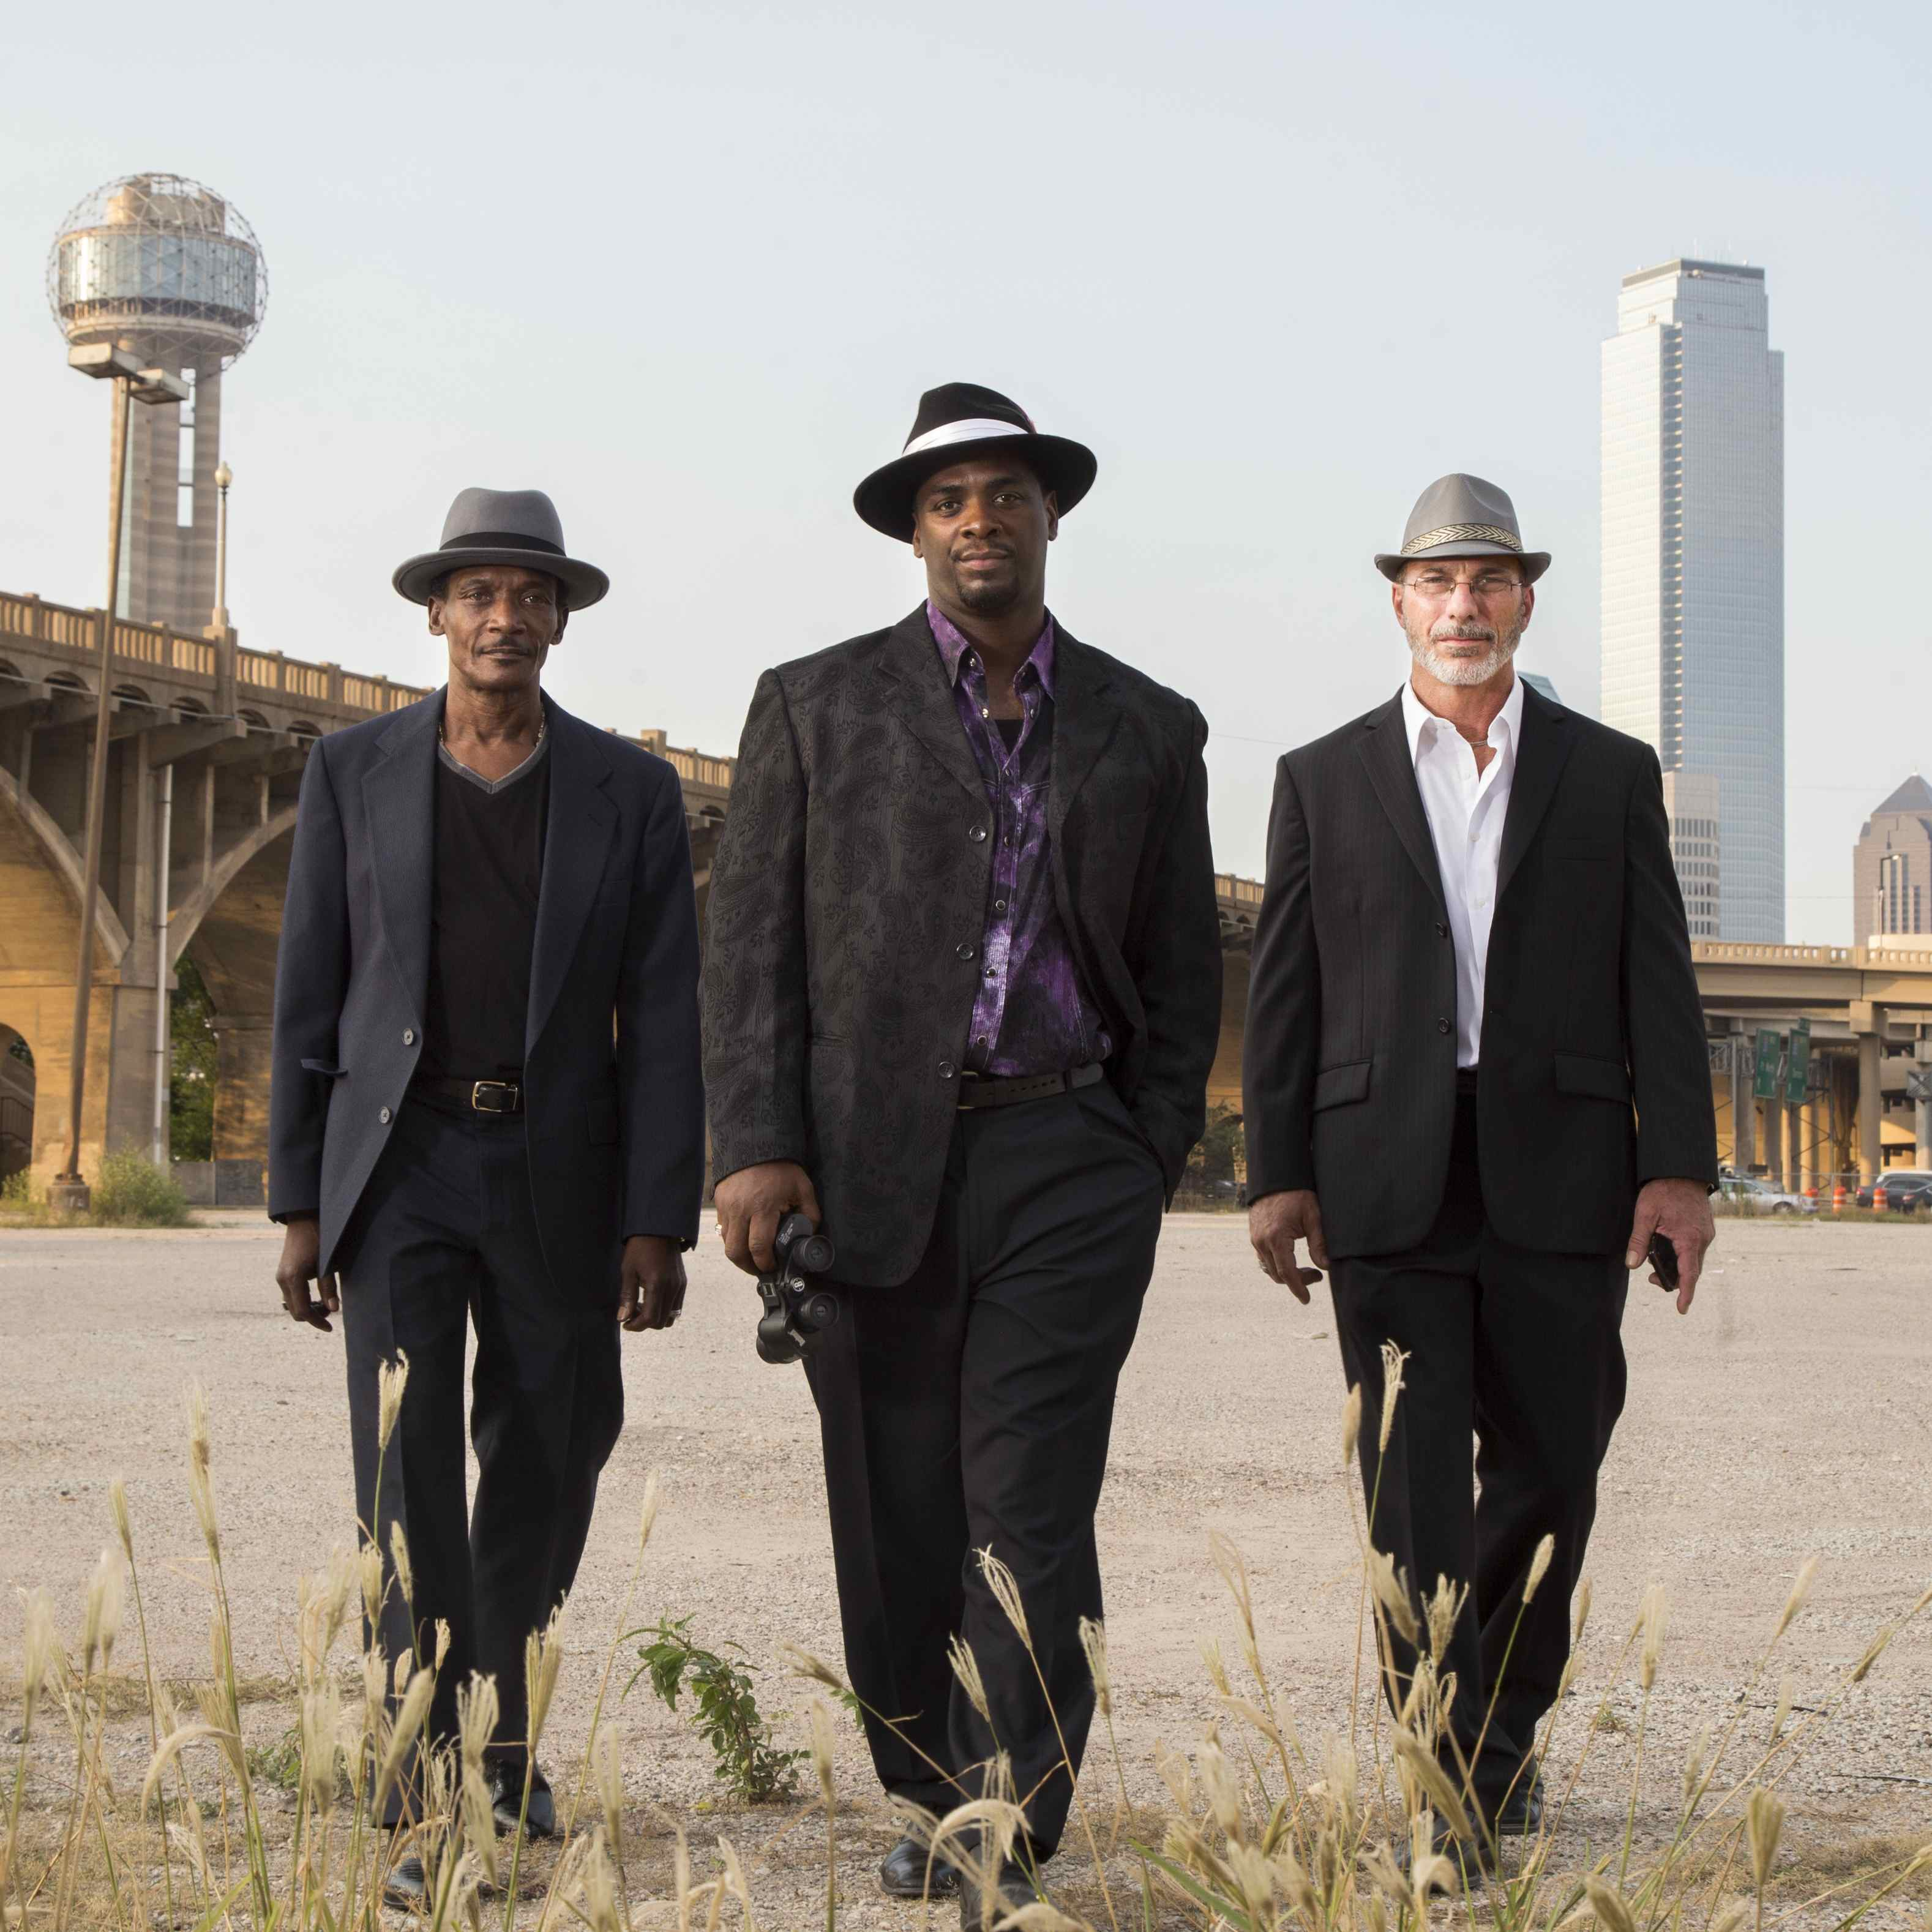
Credit: Sarah Lim Photo

Focusing on the cases of Max Soffar, a death row inmate of 35 years who was forced into a triple murder confession as a young man, and Isaiah Hill, sentenced to life in prison on aggravated assault charges after refusing a plea bargain, the trio logs in hundreds of miles digging up fresh evidence on behalf of their incarcerated clients. Through tenacity, hope and determination these freedom fighters work together to rebuild broken lives and families as they campaign to fix the criminal justice system while still fighting demons of their own.

“There’s never been a detective agency quite like the one Chris, Johnnie and Steven formed to free other wrongfully-convicted men,” said Lois Vossen, Independent Lens executive producer. “Who better than three innocent and freshly exonerated men to smell out flawed cases, false evidence or corrupt cops and DA’s? Their search for justice is part ‘true crime’ story, part struggle for redemption, and part fight for social change in a truer-than-fiction account that plays like an Easy Rawlins novel meets Hollywood movie.”

Visit the True Conviction page on Independent Lens, which features more information about the film, which will be available for online viewing on the site beginning May 1.

About the Subjects

In 1997, Christopher Scott was wrongfully convicted of capital murder as a result of faulty eyewitness identification. Scott was exonerated in 2009, based on another man’s detailed confession — the first non-DNA exoneration case. After his release, Scott founded the House of Renewed Hope, a non-profit organization whose goal is to investigate individuals claiming innocence. In 2012, Christopher was named Dallas Morning News “Texan of the Year” for his work.

After serving more than 25 years in Texas prisons for a crime he did not commit, Johnnie Lindsey was proven innocent through DNA testing and freed in September 2008. He was 30 years old when he was arrested and 56 when he was freed. Lindsey passed away in February 2018 from liver cancer.

More than 25 years after he was sent to prison for a string of Texas sex crimes he did not commit, Steven Phillips was released on parole in 2007. One year later, DNA testing proved his innocence and he was freed. The DNA testing that exonerated Phillips also implicated another man – who allegedly committed at least 16 other sexual assaults and related offenses while Phillips was incarcerated.

About the Filmmaker

Jamie Meltzer’s (Director) feature documentary films have been broadcast on PBS and have screened at numerous film festivals worldwide. True Conviction premiered at the 2017 Tribeca Film Festival and was awarded a Special Jury Mention in the Best Documentary Category; the film is a co-production of ITVS and the recipient of both Sundance Institute and MacArthur grants. Meltzer’s previous films include Informant (2012), about a revolutionary activist turned FBI informant; Off the Charts: The Song-Poem Story (Independent Lens, 2003), about the shadowy world of song-poems; Welcome to Nollywood (PBS broadcast, 2007), an investigation into the wildly successful Nigerian movie industry; and La Caminata (2009), a short film about a small town in Mexico that ran a simulated border crossing as a tourist attraction. He is the Program Director of the M.F.A. Program in Documentary Film at Stanford University.

CREDITS
Directed by Jamie Meltzer
Produced by David Alvarado
Kate McLean
Michael May
Executive Producers Adam Spielberg
Dan Cogan
Seth Gordon
Jenny Raskin
Lois Vossen
Sally Jo Fifer
Cinematographer David Alvarado
Editor Jeff Gilbert
Music by Joshua Abrams

About Independent Lens
Independent Lens is an Emmy® Award-winning weekly series airing on PBS Monday nights at 10:00 PM. The acclaimed series, with Lois Vossen as executive producer, features documentaries united by the creative freedom, artistic achievement, and unflinching visions of independent filmmakers. Presented by ITVS, the series is funded by the Corporation for Public Broadcasting, a private corporation funded by the American people, with additional funding from PBS, the John D. and Catherine T. MacArthur Foundation, Wyncote Foundation, and the National Endowment for the Arts. For more visit pbs.org/independentlens. Join the conversation: facebook.com/independentlens and on Twitter @IndependentLens.

###

