Independent Lens
1971
TCA Panelists

Keith Forsyth (Participant) took on the role of master lock picker for the Citizens’ Commission to Investigate the FBI during the burglary. Born in Marion, Ohio, Forsyth attended the College of Wooster from 1968 to 1970. Shortly after the invasion of Cambodia and the killings at Kent State and Jackson State, he hitchhiked to Philadelphia, hoping to become more involved in fighting against the war in Vietnam. For the next several years, he actively participated in both the legal peace movement and in illegal nonviolent resistance, while earning a living as a cabdriver, stamping press operator and electrician. In 1972, his main focus shifted from the anti-war movement to community and then union organizing. In 1980, he withdrew from active political work and began going to night school to study engineering, earning a bachelors degree in 1986 and a masters in 1992.
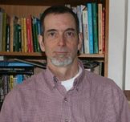

Johanna Hamilton (Director, Producer) co-produced Pray the Devil Back to Hell, the gripping account of a group of brave, visionary women who demanded peace for Liberia, a nation torn to shreds by a decades-long civil war. The film won the Grand Jury Prize for Best Documentary at the 2008 Tribeca Film Festival, was shortlisted for an Academy Award and premiered on PBS as part of the Women, War & Peace miniseries. Hamilton has produced non-fiction programs for PBS, History Channel, A&E, Discovery, The Washington Post/Newsweek Productions and New York Times Television, among others. Her career began in South Africa, where she worked for that nation’s premiere investigative magazine program, Carte Blanche. Hamilton graduated from the University of London and has an MA in Broadcast Journalism from New York University.1971 is her feature-length documentary directorial debut.
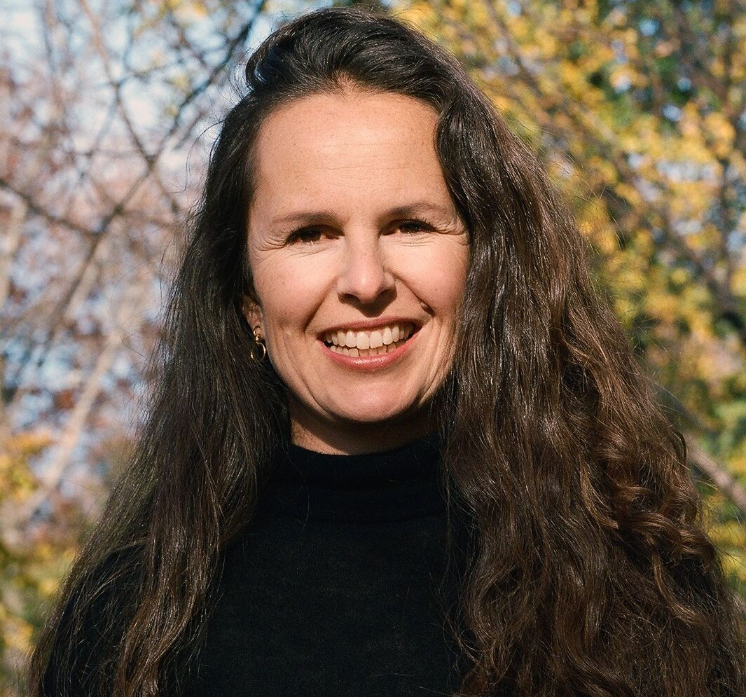

Betty Medsger (Participant) was born in 1942 in Johnstown, Pennsylvania. After graduating from college in 1964, she began her journalism career as a reporter at The Tribune-Democrat in Johnstown. Later she worked at The Evening Bulletin in Philadelphia and then at The Washington Post. In March 1971, two weeks after the burglary in Media, Pennsylvania, she was one of five people who received the first copies of Media FBI files distributed anonymously by the Citizens’ Commission to
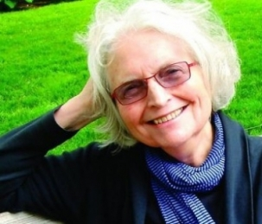

Investigate the FBI. The first reporter to write about the content of the Media files, Medsger was the only recipient who did not return the files to the FBI. It was the first time a journalist received stolen secret government files from people outside the government — as opposed to inside whistleblowers. Many years later she accidentally located two of the burglars, John and Bonnie Raines. With their help, she traced seven of the eight burglars and they agreed to tell the story they had planned to take to their graves. Medsger is the author of The Burglary: The Discovery of J. Edgar Hoover’s Secret FBI, published in 2014 by Alfred A. Knopf; it’s the full story of the burglary and its major impact. She is the former head of the Department of Journalism at San Francisco State University and founder of its Center for the Integration and Improvement of Journalism. Her photographs have been exhibited throughout the world and were used in the Academy Award-winning documentary Breathing Lessons: The Life and Work of Mark O’Brien by filmmaker Jessica Yu.
Lois Vossen, founding and deputy executive producer of Independent Lens, is responsible for commissioning new work, curating the series and working with filmmakers on content, editorial and broadcast issues. She works with the communications team on series marketing and scripts top of show introductions. Independent Lens films have received eight News & Documentary Emmy Awards, two Primetime Emmys, 14 George Foster Peabody Awards, five Alfred I. duPont-Columbia Journalism Awards, seven Academy Award nominations and the 2014 IDA Best Curated Series Award. Previously, Vossen was associate managing director of the Sundance Film Festival and Sundance Labs. She has served on the jury at SXSW, DOC New Zealand, Toronto International Film Festival and New Orleans Film Festival, among others.




