FOR IMMEDIATE RELEASE

CONTACT
Lisa Tawil, ITVS 415-356-8383 lisa_tawil@itvs.org
Mary Lugo 770-623-8190 lugo@negia.net
Cara White 843-881-1480 cara.white@mac.com
For downloadable images, visit pbs.org/pressroom/

1971 Premieres on Independent Lens
Monday, May 18, 2015, on PBS

Before Watergate, WikiLeaks and Edward Snowden,
there was the Citizens’ Commission to Investigate the FBI
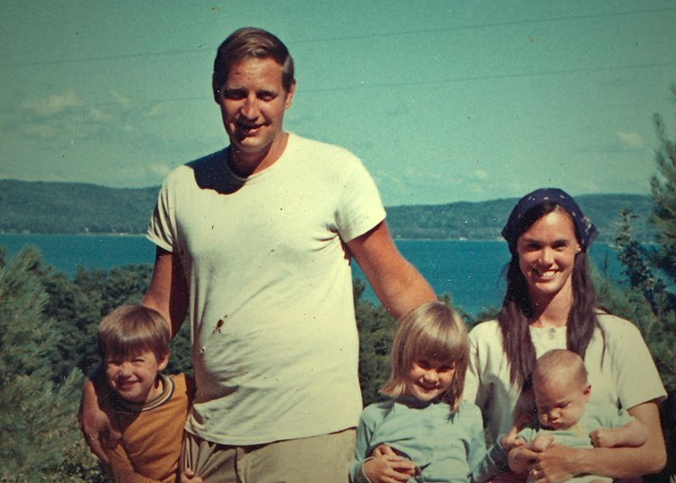
John and Bonnie Raines with their children.
Courtesy: The Raines Family

(San Francisco, CA) — On March 8, 1971, a band of suburban parents, university professors and community leaders broke into a small FBI field office in Media, Pennsylvania, just outside Philadelphia. Calling themselves the Citizens’ Commission to Investigate the FBI, the eight activists took hundreds of secret files and shared them anonymously with select members of Congress and the news media. By doing so, they uncovered evidence of the FBI’s vast and illegal regime of spying on and intimidating American citizens. Despite one of the largest investigations ever conducted, the FBI never solved the mystery of the break-in, and the identities of those responsible remained a secret — until now. For the first time, the members of the Citizens’ Commission have spoken out. 1971 is their story. Directed and produced by Johanna Hamilton, the film premieres on Independent Lens Monday, May 18, 2015, 10:00-11:30 p.m. ET (check local listings) on PBS.

On the night of the “Fight of the Century” boxing match between Muhammad Ali and Joe Frazier, the Citizens’ Commission picked the lock on the door of the Media field office, loaded every file they could find into suitcases and walked out the front door. The heist yielded a trove of evidence proving that the FBI was deliberately working to intimidate civil rights activists and nonviolent Vietnam War protesters, among others. The most significant revelation was that of a massive illegal domestic surveillance program, overseen by FBI director J. Edgar Hoover, known as COINTELPRO.

Weaving exclusive interviews with national news coverage of the burglary and dramatized scenes of the events, 1971 unfolds with the tension of a suspense thriller, with haunting echoes of today’s questions of privacy in a new era of government surveillance.

Visit the 1971 companion website (http://www.pbs.org/independentlens/1971/), which features information about the film, including an interview with the filmmaker, preview clips and more.

Participants (in alphabetical order)

Bill Davidon was the mastermind and de facto leader of the Citizens’ Commission to Investigate the FBI. He died in 2013.

Keith Forsyth took on the role of master lock picker for the Citizens’ Commission during the planning of the burglary.

David Kairys, a professor of constitutional law at Temple Law School, is a leading constitutional scholar and civil rights lawyer. He has represented the Citizens’ Commission to Investigate the FBI in secret for more than 40 years.

Betty Medsger was a reporter at The Washington Post and one of five people who received the first copies of FBI files distributed anonymously by the Citizens’ Commission. She is the author of The Burglary: The Discovery of J. Edgar Hoover’s Secret FBI, published in 2014.

Bonnie Raines cased the inside of the FBI office, providing invaluable intelligence as the Citizens’ Commission planned the break-in.

John Raines was a member of the Citizens’ Commission and drove one of the getaway cars. He also planned the distribution of documents to Congress and the press following the break-in.

Bob Williamson was a member of the Citizens’ Commission and offered comic relief during the 1971 burglary.

About the Filmmaker

Johanna Hamilton (Director, Producer) co-produced Pray the Devil Back to Hell, the gripping account of a group of brave, visionary women who demanded peace for Liberia, a nation torn to shreds by a decades-long civil war. The film won the Grand Jury Prize for Best Documentary at the 2008 Tribeca Film Festival, was shortlisted for an Academy Award and premiered on PBS as part of the Women, War & Peace miniseries. Hamilton has produced non-fiction programs for PBS, History Channel, A&E, Discovery, The Washington Post/Newsweek Productions and New York Times Television, among others. Her career began in South Africa, where she worked for that nation’s premiere investigative magazine program, Carte Blanche. Hamilton graduated from the University of London and has an MA in Broadcast Journalism from New York University. 1971 is her feature-length documentary directorial debut.

CREDITS

Directed & Produced by  Edited by  Produced by |  | Johanna Hamilton  Gabriel Rhodes  Marilyn Ness
 |  | Katy Chevigny
Executive Producers  Co-Executive Producers  Cinematographer (Interviews)  Cinematographer (Re-creations)  Original Music  Written by |  | Julie Goldman  Abigail E. Disney  Gini Reticker  Laura Poitras  Lilly Hartley  G. Perezutti Hearst  Kirsten Johnson  Andreas Burgess  Philip Sheppard  Johanna Hamilton  Gabriel Rhodes

About Independent Lens

Independent Lens is an Emmy® Award-winning weekly series airing on PBS Monday nights at 10:00 PM. The acclaimed series features documentaries united by the creative freedom, artistic achievement and unflinching visions of independent filmmakers. Presented by Independent Television Service, the series is funded by the Corporation for Public Broadcasting, a private corporation funded by the American people, with additional funding from PBS and the John D. and Catherine T. MacArthur Foundation. For more information, visit pbs.org/independentlens. Join the conversation: facebook.com/independentlens and on Twitter @IndependentLens.

###

