Wildland Launches New Season of Independent Lens
FOR IMMEDIATE RELEASE

CONTACT
Tanya Leverault, ITVS 415-356-8383 tanya.leverault@itvs.org
Mary Lugo 770-623-8190 lugo@negia.net
Cara White 843-881-1480 cara.white@mac.com
For downloadable images, visit pbs.org/pressroom/

Monday, October 29, 2018 on PBS

Filmmaker/Firefighters Tell the Epic Yet Intimate Story of
One Crew Battling Wildfires in the West

Online Streaming Begins October 30

(San Francisco, CA) — Filmed during two recent wildfire seasons, Wildland is a sweeping yet deeply personal account of a single wildland firefighting crew as they struggle with fear, loyalty, dreams, and demons. What emerges is a rich story of working-class men — their exterior world, their interior lives and the fire that lies between. Directed and produced by Alex Jablonski and Kahlil Hudson, Wildland kicks off the new season of Independent Lens Monday, October 29, 2018, 10:00-11:00 PM ET (check local listings) on PBS.

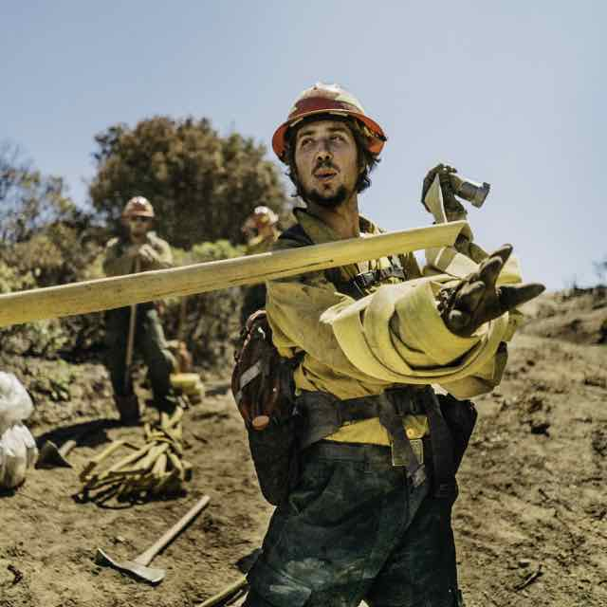
Credit: Kahlil Hudson.

Every summer, the American West burns. As climate change has increased, average temperatures have risen, resulting in a sudden increase in both the frequency and intensity of wildfires. Inside each of these fires are small crews who work to contain them by hand, using shovels, pickaxes, and methods that haven’t changed in sixty years.

With a lifelong admiration for those who do this dangerous work, filmmakers and native Westerners Jablonski and Hudson went through firefighting training with the men in the film, in Grants Pass, Oregon, a sleepy mountain town. Here they toiled alongside and chronicled the lives of the men on their fire crew. Each of them has come to this work for personal reasons — for some, it’s a need to test themselves, or a desire for adventure and purpose; for others, it may be the job of last resort after time in prison or a lifetime of addiction.

For 46-year-old John, it’s a final chance to let go of a troubled past and be a better father; for Charlie and Aidan, both 23-year-old Bible college dropouts, the summer holds the promise of challenges that will transform them from boys to men. For their crew boss Tim, a sixth-grade dropout and former meth addict, the tough work of firefighting is salvation. Together these men are tasked with facing nature’s most elemental force and finding their way through boredom, fear, and a job aptly described as “long hours of hard labor punctuated by moments of sheer terror.” For each, it’s a chance to discover a piece of themselves that they’ll be able to carry forward forever.

“Wildland firefighters put their lives on the line to save people they will never know. What does it take to do that?” asks Lois Vossen, executive producer of Independent Lens. “Alex and Kahlil have captured fire and lightning in a bottle in this riveting story about people who commit to public service, even when it means risking their own lives.”

Visit the Wildland page on Independent Lens, featuring more information about the film, which will be available for online viewing on the site beginning October 30.

About the Filmmakers

Alex Jablonski (Co-Director/Co-Producer) produced and edited Low & Clear, which premiered at SXSW where it won the Audience Award. Previously, he created the documentary project Sparrow Songs, in which he made one short documentary every month for one year. The project developed a worldwide following, and he was named to Filmmaker Magazine’s list of 25 New Faces of Independent Film. The series was spotlighted at Sundance and screened at SXSW and IDFA. In 2018, Jablonski was named a Sundance Institute/Discovery Impact Fellow.

Kahlil Hudson (Co-Director/Co-Producer) is a Native Tlingit Alaskan and currently a professor of film at Santa Fe’s Institute of American Indian Arts. His first feature documentary, Low & Clear, premiered at SXSW and went on to screen at numerous festivals including True/False, HotDocs, and IDFA. Together, Jablonski and Hudson run Finback, a branded content company with a client list that includes Patagonia, Filson, RAM Trucks, Chevy Trucks, Yeti Coolers, and the US Army.

CREDITS
Directed by Alex Jablonski and Kahlil Hudson
Produced by Alex Jablonski
Kahlil Hudson
Executive Producers Sally Jo Fifer
Lois Vossen
Consulting Producer Noland Walker
Associate Producers Ryan Heffernan
Grayson Schaffer

Cinematography by Kahlil Hudson
Alex Jablonski
Ryan Heffernan
Grayson Schaffer
Edited by Katrina Taylor
David Nordstrom
Alex Jablonski
Original Music by Tyler Strickland

About Independent Lens
Independent Lens is an Emmy® Award-winning weekly series airing on PBS Monday nights at 10:00 PM. The acclaimed series, with Lois Vossen as executive producer, features documentaries united by the creative freedom, artistic achievement, and unflinching visions of independent filmmakers. Presented by ITVS, the series is funded by the Corporation for Public Broadcasting, a private corporation funded by the American people, with additional funding from PBS, the John D. and Catherine T. MacArthur Foundation, Wyncote Foundation, and the National Endowment for the Arts. For more visit pbs.org/independentlens. Join the conversation: facebook.com/independentlens and on Twitter @IndependentLens.

###

