The Judge Premieres on Independent Lens
FOR IMMEDIATE RELEASE

CONTACT
Donna Hardwick, ITVS 415-356-8383 donna.hardwick@itvs.org
Mary Lugo 770-623-8190 lugo@negia.net
Cara White 843-881-1480 cara.white@mac.com
For downloadable images, visit pbs.org/pressroom/

Monday, November 19, 2018 on PBS

Meet the Middle East’s First Female Shari’a Judge

Online Streaming Begins November 20

“In its engaging fashion, it strikes one inspirational note after another as its follows an ambitious, tough-minded and cheerful social revolutionary.” — The Hollywood Reporter

(San Francisco, CA) — Religious courts in the Middle East, including the Shari’a courts of Islam which adjudicate domestic and family matters, have traditionally banned women from serving as judges – until Kholoud Al-Faqih dared to challenge that history. In 2009, with the support of a progressive Sheikh, Kholoud became the first woman Shari’a judge in the Middle East with her appointment to a Palestinian Shari’a court in the West Bank. A portrait of a remarkable woman and an eye-opening look at an often-misunderstood culture, Erika Cohn’s The Judge premieres on Independent Lens, Monday, November 19, 2018, 10:30 PM-12:00 AM ET (check local listings) on PBS.
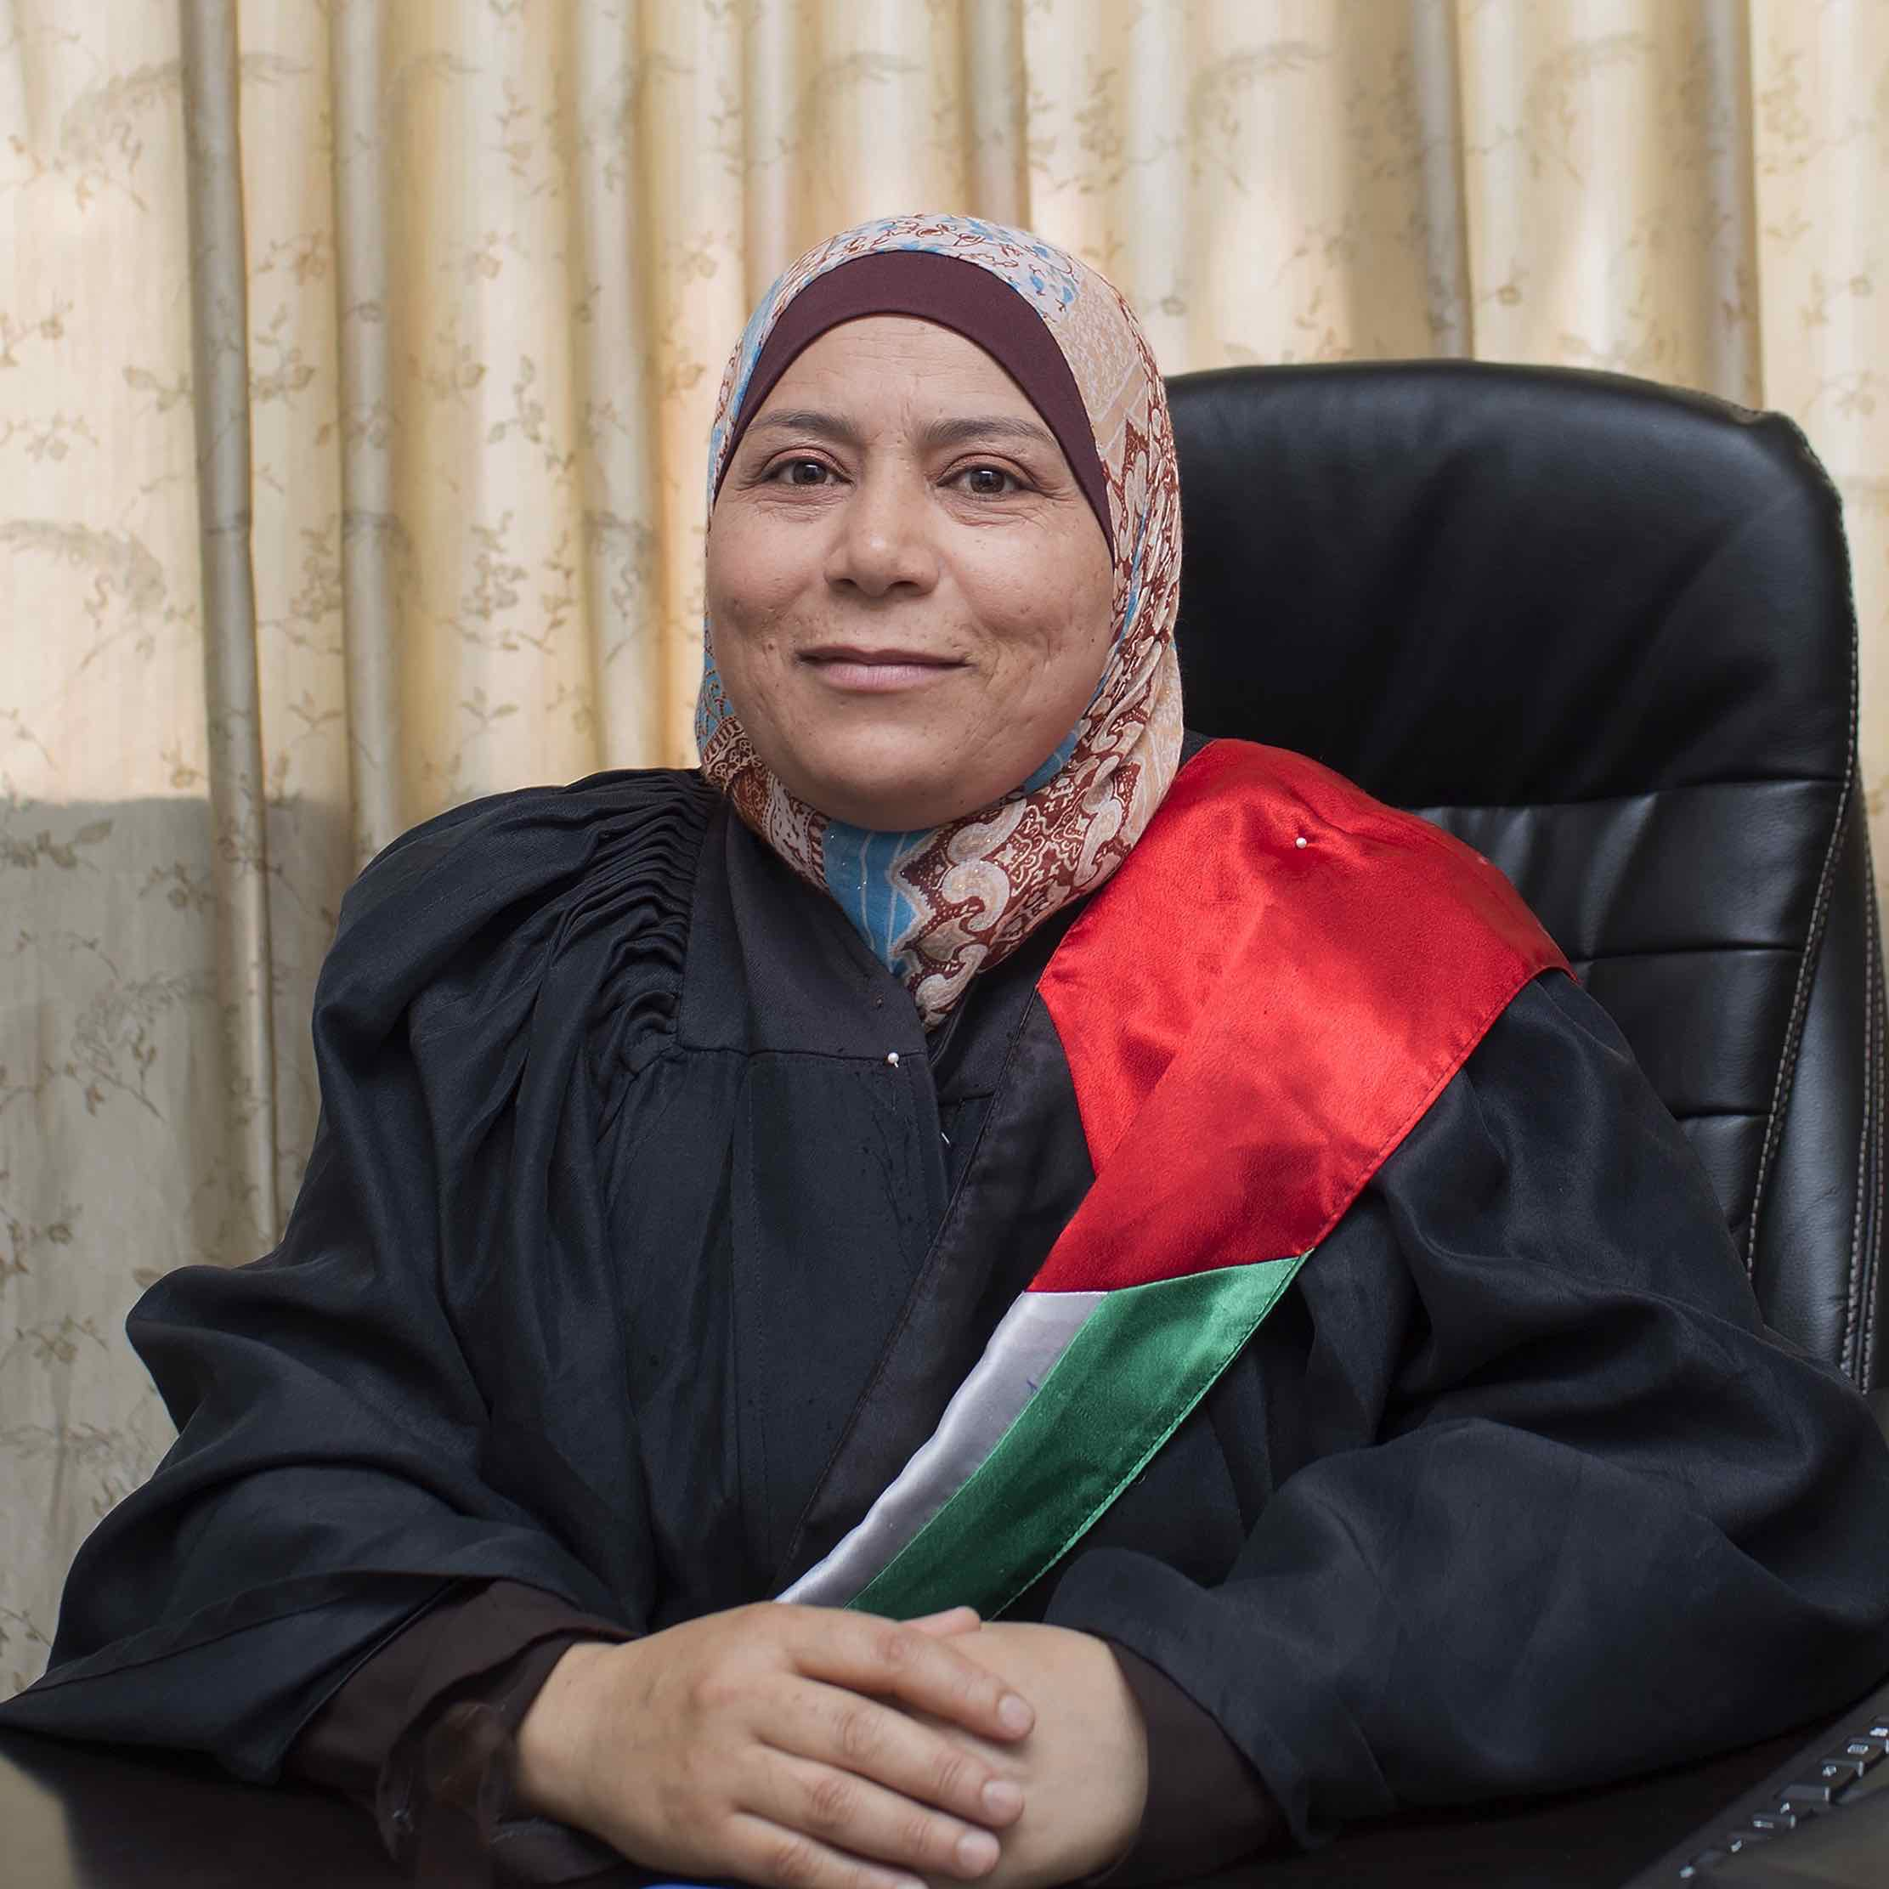
Credit: Amber Fares

When she was a young lawyer, Kholoud Al-Faqih walked into the office of Palestine’s Chief Justice and announced that she wanted to join the bench. He laughed at her. But just a few years later, Kholoud defied the odds and made history. The Judge offers a unique portrait of Kholoud — her brave journey as a lawyer, her tireless fight for justice for women, and her drop-in visits with clients, friends, and family. With unparalleled access to the courts, The Judge presents an unfolding vérité legal drama, with rare insight into both Islamic law and gendered justice. In the process, the film illuminates some of the universal conflicts in the domestic life of Palestine — custody of children, divorce, abuse — while offering an unvarnished look at life for women under Shari’a law and an inspiring look at an unforgettable woman.

“Before we named the #MeToo and #TimesUp movements, the first female judge of Shari’a law revealed what it takes to fight dominant chauvinism in Palestine’s justice system,” said Lois Vossen, Independent Lens executive producer. “A trailblazer who resembles a ‘Notorious RBG’ of her country, Judge Kholoud never suggests that Islam is anti-feminist — only the people who are resistant to equality and change.”

Visit The Judge page on Independent Lens, which features more information about the film. The film will be available for online viewing on the site beginning November 20.

About the Filmmakers

Erika Cohn (Producer/Director) is an Emmy Award-winning director/producer who Variety recognized as one of 2017’s top ten documentary filmmakers. Cohn co-directed/produced In Football We Trust, an Emmy Award-winning feature documentary about the unique faith and culture that drives young Pacific Islander men into the NFL; the film premiered at the 2015 Sundance Film Festival and was broadcast on Independent Lens in 2016. The Judge premiered at the Toronto International Film Festival and also screened at DOC NYC, the Full Frame Documentary Film Festival and more. Her work has been supported by IFP, the Sundance Institute, Tribeca Institute, Hot Docs, Sheffield, ITVS, Women in Film, BAVC and the CPB Producers Academy, among others. In 2013, Erika founded Idle Wild Films, Inc., which has released three feature documentaries and produced numerous branded content and commercial spots, including Gatorade’s Win from Within series, for which she received a 2016 Webby award nomination. Cohn is also an avid photographer and served as a U.S. Ambassadorial Film Scholar to Israel/Palestine.

Geralyn Dreyfous (Executive Producer) is a philanthropist, entrepreneur and Academy Award-winning filmmaker with a wide, distinguished background in the arts. Her passion for implementing social change through film inspired her to found the Utah Film Center and co-found IMPACT Partners with Dan Cogan. In 2013, Dreyfous co-founded Gamechanger Films, a film fund dedicated to women directors. She has produced and executive produced nearly 100 feature-length films including the Academy Award-winning Born into Brothels; the Emmy nominated The Day My God Died; the Academy Award-nominated The Square and The Invisible War, and multiple film festival winners. Dreyfous was honored with the IDA’s Amicus Award for her significant contribution to documentary filmmaking and Variety recognized her in their 2014 Women’s Impact Report, highlighting her work in the entertainment industry. From her courageous tackling of the horrific sex slave trade of Bombay to her championing the victims of rape in the military, Dreyfous has helped make films that give the silenced a voice and the underserved a platform of power.

CREDITS

Directed and Produced by Erika Cohn
Executive Produced by Geralyn Dreyfous
Diana Lady Dougan
Barbara Dobkin
Patty Quillin
Sally Jo Fifer
Lois Vossen
Co-Produced by Jennifer Jordan
Sara Maamouri
Amber Fares
Mark Lipson
Edited by Sara Maamouri
Ken Schneider
Cinematography by Amber Fares
Music by Omar Fadel

About Independent Lens
Independent Lens is an Emmy® Award-winning weekly series airing on PBS Monday nights at 10:00 PM. The acclaimed series, with Lois Vossen as executive producer, features documentaries united by the creative freedom, artistic achievement, and unflinching visions of independent filmmakers. Presented by ITVS, the series is funded by the Corporation for Public Broadcasting, a private corporation funded by the American people, with additional funding from PBS, the John D. and Catherine T. MacArthur Foundation, Wyncote Foundation, and the National Endowment for the Arts. For more visit pbs.org/independentlens. Join the conversation: facebook.com/independentlens and on Twitter @IndependentLens.

###

