The King Premieres on Independent Lens
FOR IMMEDIATE RELEASE

CONTACT
Tanya Leverault, ITVS 415-356-8383 tanya.leverault@itvs.org
Mary Lugo 770-623-8190 lugo@negia.net
Cara White 843-881-1480 cara.white@mac.com
For downloadable images, visit pbs.org/pressroom/

Monday, January 28 on PBS

Climb into Elvis’s 1963 Rolls-Royce for a Musical Road Trip and Timely Meditation on Modern America

Online Streaming Begins January 29

(San Francisco, CA) — Forty years after the death of Elvis Presley, two-time Sundance Grand Jury winner Eugene Jarecki takes the King’s 1963 Rolls-Royce on a musical road trip across America. From Tupelo to Memphis to New York, Las Vegas, and countless points between, the journey explores the rise and fall of Elvis as a metaphor for the country he left behind. What emerges is a visionary portrait of the state of the American dream and a penetrating look at how the hell we got here. The King premieres on Independent Lens Monday, January 28, 2019, 9:00-10:30PM ET (check local listings) on PBS.
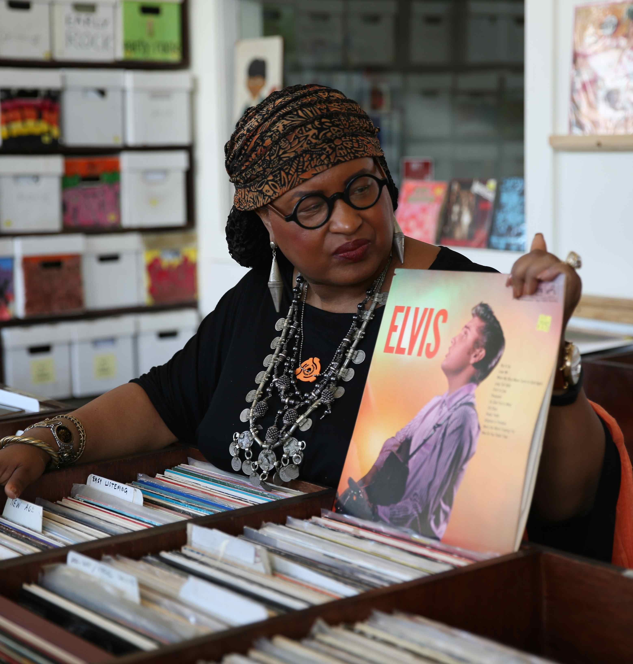
Credit: David Kuhn

Far more than a musical biopic, The King is a snapshot of America at a critical time in the nation’s history. Tracing Elvis’ life and career from his birth and meteoric rise in the deep south to his tragic and untimely end in Hollywood and Las Vegas, The King covers a vast distance across contemporary America, painting a parallel portrait of the nation’s own heights and depths, from its inspired origins to its perennial struggles with race, class, power, and money.

Over thousands of miles, a diverse group of passengers join the journey, including Alec Baldwin, Rosanne Cash, Chuck D, Emmylou Harris, Ethan Hawke, James Carville, Ashton Kutcher, David Simon, Van Jones, Mike Myers, and Dan Rather, among others. “We wanted the film’s cast of characters to reflect the rich tapestry of the American family, expressing themselves in words and, at times, in song inside Elvis’ Rolls,” said Jarecki. “The King is both an Elvis film and a film about the American experience, so we chose people who could speak to either of these in a deep and authentic way.”
“At a time when our national discourse veers increasingly toward the dogmatic, Jarecki follows the rise and fall of this quintessentially American figure to look deeper into the acute challenges of today," said Lois Vossen, Independent Lens Executive Producer. "What I appreciate most about this film is that it refrains from offering easy answers, and instead uses our cultural fascination with Elvis as an entree to dig beneath the noise and explore the evolution of American culture, capitalism, and democracy through a multitude of perspectives — from celebrities and public figures to everyday citizens across the nation.”

Weaving the sights and sounds of Elvis’ own music and films with soaring live performances
from artists as varied as teen Nashville phenomenon EmiSunshine, Mississippi bluesman Leo Bud Welch, New York City rapper Immortal Technique, the cool West Coast sounds of M. Ward, and the gospel stylings of Memphis’s Stax Music Academy, The King opens the door to a deeper, more complex discourse on America’s identity and path forward.

Visit The King page on Independent Lens, which features more information. The film will be available for online viewing on the site beginning January 29.

About the Filmmaker

Eugene Jarecki (Director/Writer/Producer) is an award-winning documentary director and producer. After directing The Trials of Henry Kissinger in 2002, Jarecki won the Sundance Grand Jury Prize and a Peabody Award for his 2005 film Why We Fight. In 2010, he created Move Your Money, a viral short encouraging Americans to shift their money from “too big to fail” banks to community banks and credit unions. His Emmy-Award winning 2011 film, Reagan, premiered at Sundance before broadcasting on HBO. The House I Live In, his 2013 film about America’s War on Drugs, once again won him the Grand Jury Prize at the Sundance Film Festival as well as a second Peabody Award; its broadcast premiere was on PBS’s Independent Lens. He executive produced the Sundance Award-winning documentary (T)ERROR, as well as Denial, which aired on PBS in 2017. In 2016, Jarecki directed The Cyclist as part of Amazon's “The New Yorker Presents” series.

CREDITS

Director/Writer/Producer Eugene Jarecki
Producers Christopher St. John
David Kuhn
Chris Frierson
Georgina Hill
Executive Producers Steven Soderbergh
Errol Morris
Rosanne Cash
Barbara Biemann
Sally Jo Fifer
Lois Vossen
Supervising Producer Melinda Shopsin
Editor Simon Barker
Èlia Gasull Balada
Alex Bingham
Laura Israel
Director of Photography Etienne Sauret
Tom Bergmann
Composer Robert Miller
Composers Antony Genn and Martin Slattery

About Independent Lens
Independent Lens is an Emmy® Award-winning weekly series airing on PBS Monday nights at 10:00 PM. The acclaimed series, with Lois Vossen as executive producer, features documentaries united by the creative freedom, artistic achievement, and unflinching visions of independent filmmakers. Presented by ITVS, the series is funded by the Corporation for Public Broadcasting, a private corporation funded by the American people, with additional funding from PBS, the John D. and Catherine T. MacArthur Foundation, Wyncote Foundation, and the National Endowment for the Arts. For more visit pbs.org/independentlens. Join the conversation: facebook.com/independentlens and on Twitter @IndependentLens.

###

