Rodents of Unusual Size Premieres on Independent Lens
FOR IMMEDIATE RELEASE

CONTACT
Tanya Leverault, ITVS 415-356-8383 tanya.leverault@itvs.org
Mary Lugo 770-623-8190 lugo@negia.net
Cara White 843-881-1480 cara.white@mac.com
For downloadable images, visit pbs.org/pressroom/
Monday, January 14, 2019 on PBS

Award-Winning Film Tells the Strange Tale of Louisiana’s War
Against Giant Swamp Rats

Online Streaming Begins January 15

"A bizarre and fascinating documentary that'll make your jaw drop."
—San Jose Mercury News

(San Francisco, CA) — The residents of Louisiana south of New Orleans have faced many an environmental threat, from oil spills to devastating hurricanes. But a growing menace now lurks in the bayous and backwaters: hordes of monstrous 20-pound swamp rats known as nutria. The voracious appetite of this unexpected invasive species from South America is accelerating erosion of the state’s coastal wetlands, already one of the largest disappearing landmasses in the world. But the people who have lived there for generations are not the type of folks who will give up without a fight. A stalwart few remain and are hellbent on saving their land before it dissolves beneath their feet. It is human vs. rodent — may the best mammal win.
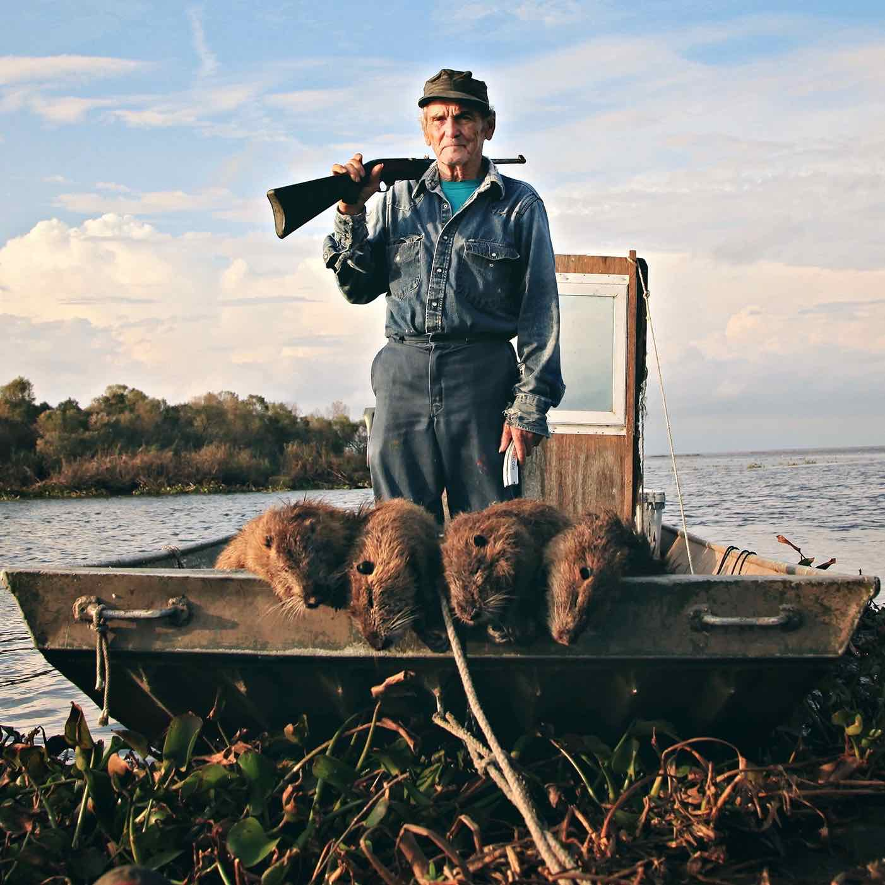
Credit: Tilapia Film

Directed by Quinn Costello, Chris Metzler and Jeff Springer, Rodents of Unusual Size is narrated by Wendell Pierce with music by the Grammy Award-winning Lost Bayou Ramblers. A film festival favorite and winner of over 15 awards, the film premieres on Independent Lens Monday, January 14, 2019, 10:00-11:00 PM ET (check local listings) on PBS.

The history of nutria in Louisiana begins in the 1930s during the Great Depression, when various entrepreneurial businessmen, including a son of Tabasco founder E.A. McIlhenny, decided to raise these giant ravenous rodents from Argentina and harvest them for their fur.

After some initial missteps the nutria industry eventually boomed, and the pelts were exported worldwide. But in the early 1980s the fur market crashed following animal rights protests; with no more demand for their pelts and no natural predators, the nutria population exploded.

One diehard resident who is fighting back is Delacroix Island fisherman Thomas Gonzales, who tries to pick off as many as he can. The state is also helping out by paying a $5 bounty for every nutria tail collected, but the fast-breeding rodents outpace the roving squads of hunters who try to control them. Others have dreamed up business ventures to capitalize on their large numbers. Kermit Ruffins, a local celebrity and jazz musician, barbecues nutria outside his concerts to create interest in eating the rodents. Members of the Atakapa-Ishak tribe want to revitalize their trapping past by not only harvesting the nutria for the tail bounty but to encourage the use of the whole animal. And fashion collective Righteous Fur designs clothes made out of nutria pelts, promoting their “sustainable fur” garments in an attempt to renew the demand for fur and save the wetlands.

Despite the havoc that nutria have wreaked on Southern Louisiana, some have embraced them. The Audubon Zoo in New Orleans has opened a nutria exhibit, the local Triple-A baseball team has a nutria mascot, and some Cajuns even keep them as pets.

Through the offbeat and unexpected stories of the people confronting the nutria problem, Rodents of Unusual Size examines issues surrounding coastal erosion, the devastation surrounding hurricanes, loss of culture and homeland, and the resilience of the human spirit.

“While the Louisiana coastline has seen more than its fair share of disasters, Rodents of Unusual Size explores an environmental threat that is no less dire though not making headlines,” said Lois Vossen, Independent Lens executive producer. "This charming and funny film invites us into the lives of a community that doesn’t just survive but fights back with heart and humor to protect the land they love."

Visit the Rodents of Unusual Size page on Independent Lens, featuring more information about the film, which will be available for online viewing on the site beginning January 15, 2019.

About the Filmmakers

Chris Metzler (Co-Director/Producer). After graduating from USC with a degree in business and cinema, Metzler’s film career has taken him from the depths of agency work to coordinating post-production for awful American movies seen late at night in Belgium. His film directing and producing work has resulted in frequent partnerships with Jeff Springer, where together they've crisscrossed the country with the aid of caffeinated beverages and made their way in the Nashville country and Christian music video industries, before finally forsaking their souls to commercial LA rock n’ roll. These misadventures culminated in their winning a Billboard Magazine Music Video Award.

Metzler eventually joined the independent documentary film scene with his feature-length directorial debut with Jeff Springer, the offbeat environmental documentary, Plagues & Pleasures on the Salton Sea, which was narrated by legendary counterculture filmmaker and “King of Trash” John Waters. The film went on to win over 37 awards for Best Documentary and was named by Booklist as one of its Top 10 Environmental Films. A cult favorite, the film was released theatrically in the United States and broadcast nationally on the Sundance Channel. Metzler’s most recent feature is the Emmy-nominated documentary, Everyday Sunshine: The Story of Fishbone, which premiered at the Los Angeles Film Festival, screened at SXSW and aired nationally on public television’s AfroPoP! series.

Jeff Springer (Co-Director/Producer/Cinematographer) was born in an abandoned town in the California desert, raised in Hawaii, and educated at USC Film School. After working at a dilapidated film studio in Russia, he returned to Los Angeles and began editing promos for NBC, Paramount, Warner Bros. and Capitol Records. After moving to San Francisco, he found himself on Lucasfilm's Skywalker Ranch, editing behind-the-scenes documentaries for a not very well received science fiction prequel.

Craving the unexpected, he directed his first feature documentary Plagues & Pleasures on the Salton Sea with Chris Metzler, about the offbeat residents, environmental disasters and flooded towns surrounding California's Salton Sea. Narrated by indie film icon John Waters, the film went on to screen at 200 film festivals worldwide, won 37 awards for Best Documentary and was broadcast on the Sundance Channel.

After working in London and Berlin, Springer has gone on to make numerous documentaries, including photographing and editing the award-winning Everyday Sunshine: The Story of Fishbone for PBS, which was narrated by actor Laurence Fishburne. He then lived in Afghanistan to edit the documentary In-Justice, about women imprisoned for supposed “moral crimes.” Recently he directed and photographed several short docs and an Emmy-nominated hour-long special for the show Artbound for KCET in Los Angeles.

Quinn Costello (Co-Director/Producer/Editor) is remarkably unequipped to live off the land for having grown up in rural Idaho. After exhibiting no ability to hunt, he fled to study film at a hippie college in Olympia, Washington, only to find himself years later making a film about hunters.

After relocating to the Bay Area, Costello began editing documentaries on subjects ranging from environmental justice, sacred islands and dancing spiders. His portfolio of work has been seen on PBS, The Learning Channel, Sundance Channel and innumerable film festivals including Tribeca and Mountainfilm in Telluride. For the past ten years, he has been editing the Emmy Award-winning public television series The New Environmentalists narrated by Robert Redford. Rodents of Unusual Size is his feature directorial debut.

CREDITS

Directors: Quinn Costello, Chris Metzler & Jeff Springer
Narrator: Wendell Pierce
Music: Lost Bayou Ramblers
Executive Producer: Sally Jo Fifer
Producers: Chris Metzler, Quinn Costello & Jeff Springer
Director of Photography: Jeff Springer
Editor: Quinn Costello
Composer: Louis Michot
Original Musical Score: Lost Bayou Ramblers
Animation: Pipsqueak Films
Sound Design and Mix: E.J. Holowicki & Zach Martin

About Independent Lens

Independent Lens is an Emmy® Award-winning weekly series airing on PBS Monday nights at 10:00 PM. The acclaimed series, with Lois Vossen as executive producer, features documentaries united by the creative freedom, artistic achievement, and unflinching visions of independent filmmakers. Presented by ITVS, the series is funded by the Corporation for Public Broadcasting, a private corporation funded by the American people, with additional funding from PBS, the John D. and Catherine T. MacArthur Foundation, Wyncote Foundation, and the National Endowment for the Arts. For more visit pbs.org/independentlens. Join the conversation: facebook.com/independentlens and on Twitter @IndependentLens.

###

