My Country No More Premieres on Independent Lens
FOR IMMEDIATE RELEASE

CONTACT
Tanya Leverault, ITVS 415-356-8383 tanya.leverault@itvs.org
Mary Lugo 770-623-8190 lugo@negia.net
Cara White 843-881-1480 cara.white@mac.com
For downloadable images, visit pbs.org/pressroom/

Monday, January 7 on PBS

The Impacts of the Rise and Fall of North Dakota’s Oil Boom
on One Small Town

Online Streaming Begins January 8

(San Francisco, CA) — Between 2011 and 2016, oil drilling in rural North Dakota reached its peak, setting off a modern-day gold rush in Trenton, North Dakota, population less than 1000. With billions of dollars to be gained in an industry-friendly state with a “reasonable regulation” climate, small towns like Trenton became overwhelmed by an influx of workers, and countless acres of farmland were repurposed for industrial development. My Country No More, a new documentary produced and directed by Rita Baghdadi and Jeremiah Hammerling, follows the rise and fall of the oil boom in North Dakota and paints a portrait of a rural American community in crisis. Through the voices of Trenton’s residents, the film challenges the notion of “progress” and questions the long-term human consequences of short-term approaches to land use, decisions that ultimate affect all Americans, rural and urban alike. My Country No More premieres on Independent Lens Monday, January 7, 2019, 10:00-11:00 PM ET (check local listings) on PBS.
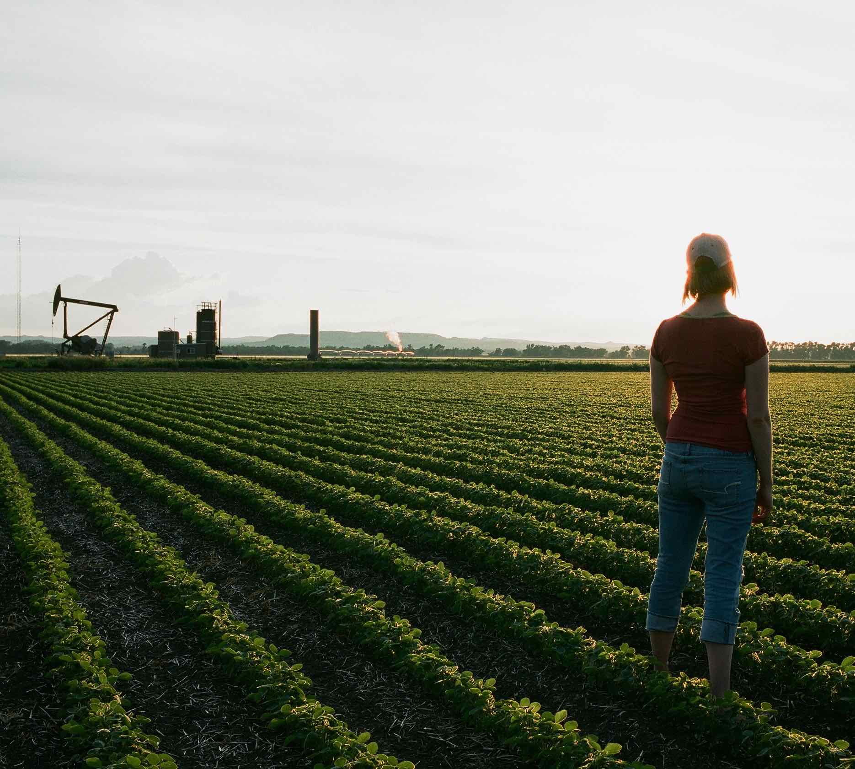
Credit: Joshua Hammerling

Kalie Rider and her older brother Jed are striving to return to a life of farming after having suffered the loss of their parents’ farm during the 1980s farm crisis. Their uncle’s decision to sell a piece of land for a planned ethanol plant sets off a chain of consequences from which there is no turning back. With the Trenton church being eyed for a diesel refinery, the community becomes divided, with some favoring development and jobs, and others bemoaning the loss of their rural way of life.

“Although the media frenzy surrounding the Dakota Access Pipeline has faded, My Country No More reveals how small communities like Trenton, North Dakota are forever changed by the rise and fall of the oil boom," said Lois Vossen, executive producer of Independent Lens. “Rita and Jeremiah have created a contemplative, beautifully shot film about a town caught between economic opportunity and personal regret. As the foundation of life and identity shifts beneath their feet, the people of Trenton are left asking what is the value of community history and what sacrifices are they willing to make to preserve a vanishing way of life."

Visit the My Country No More page on Independent Lens, which features more information. The film will be available for online viewing on the site beginning January 8.

About the Filmmakers

Born and raised in North Dakota, Jeremiah Hammerling (Producer/Director) is an Emmy Award-winning filmmaker. His documentaries have covered a wide range of topics from the Egyptian Arab Spring to gang intervention in Los Angeles. My Country No More, his most recent film, won Best Feature at the 2018 Big Sky Documentary Film Festival. Jeremiah is co-founder of the Los Angeles based production company Endless Eye. His work has been featured on CNN, ESPN, PBS, AJ+, NPR and in top festivals worldwide.

Rita Baghdadi (Producer/Director) is an award-winning Moroccan-American filmmaker whose work has been supported by ITVS, Tribeca, the International Documentary Association, Film Independent, Netflix, CNN Films, A&E, Points North Institute, Technicolor and IFP, and has screened in festivals worldwide. Recently, Rita’s documentary City Rising was awarded three LA Area Emmy Awards including best Social Issue Film. Rita is also an accomplished Director of Photography, having shot several documentary features including Served Like a Girl (SXSW 2017), which premiered on Independent Lens. Rita earned a B.A. in Film from Columbia College Chicago. She is co-founder of the production company Endless Eye, and when not filming is an active mentor, dedicated to empowering girls through documentary film training.

CREDITS
Produced and Directed by Rita Baghdadi & Jeremiah Hammerling
Edited by Jeff Consiglio
Rita Baghdadi
Original Score by BC Campbell
Cinematography by Jeremiah Hammerling & Rita Baghdadi
Associate Produced by Joshua Hammerling
Executive Produced by Alexandra Johnes
Sally Jo Fifer
Supervising Producer Shana Swanson

About Independent Lens
Independent Lens is an Emmy® Award-winning weekly series airing on PBS Monday nights at 10:00 PM. The acclaimed series, with Lois Vossen as executive producer, features documentaries united by the creative freedom, artistic achievement, and unflinching visions of independent filmmakers. Presented by ITVS, the series is funded by the Corporation for Public Broadcasting, a private corporation funded by the American people, with additional funding from PBS, the John D. and Catherine T. MacArthur Foundation, Wyncote Foundation, and the National Endowment for the Arts. For more visit pbs.org/independentlens. Join the conversation: facebook.com/independentlens and on Twitter @IndependentLens.

###

