The Providers Premieres on Independent Lens
FOR IMMEDIATE RELEASE

CONTACT
Tanya Leverault, ITVS 415-356-8383 tanya.leverault@itvs.org
Mary Lugo 770-623-8190 lugo@negia.net
Cara White 843-881-1480 cara.white@mac.com
For downloadable images, visit pbs.org/pressroom

Monday, April 8 on PBS and PBS.org

Against Overwhelming Odds, Three Medical Practitioners in Rural New Mexico Are Making a Difference in the Lives of Their Patients

(San Francisco, CA) — Set against the backdrop of the physician shortage, and opioid epidemic in rural America, The Providers follows three healthcare professionals in northern New Mexico at El Centro, a group of safety-net clinics that offer care to anyone who walks through the doors. Amidst personal struggles that reflect those of their patients, the journeys of the providers unfold as they work to reach those who would otherwise be left out of the healthcare system. With intimate access, the film shows the transformative power of providers’ relationships with marginalized patients. Directed by Laura Green and Anna Moot-Levin, both the children of doctors, The Providers will premiere on Independent Lens Monday, April 8, 2019, 10:00-11:30 PM ET (check local listings) on PBS and will also be available simultaneously for online streaming at pbs.org.
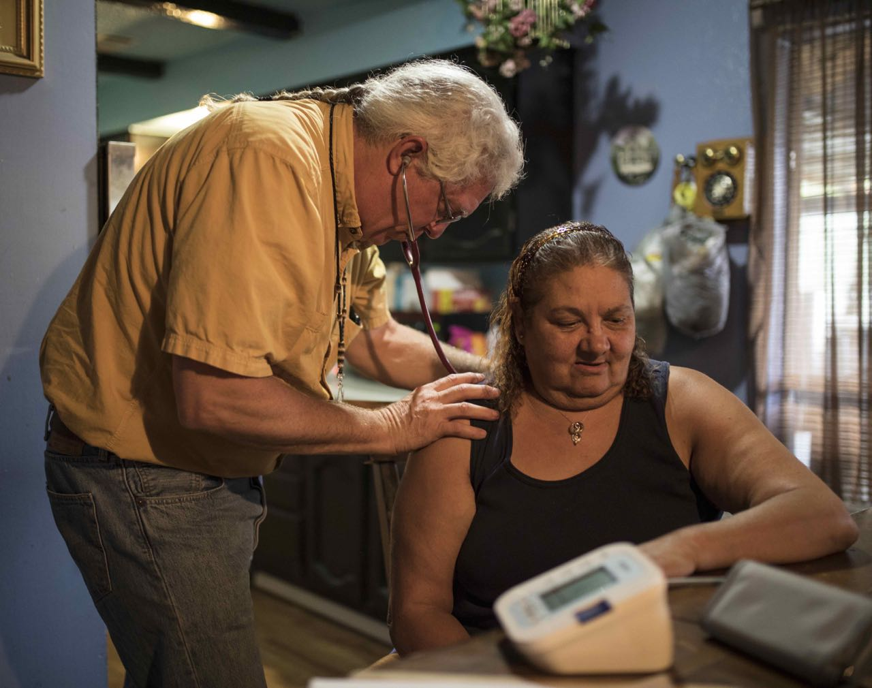
Nurse practitioner Chris Ruge listens to a patient’s heart during a home visit.
Credit: Adria Malcolm

Over the course of the film, the three providers — family physician Leslie Hayes, nurse practitioner Chris Ruge, and El Centro Medical Director Matt Probst — remain unfailingly compassionate despite a range of challenges from the system to their patients, and sometimes even their own families. Leslie believes it is critical for primary care doctors to treat patients who use opioids as part of their regular practice. When other physicians don’t want “those people” in their medical center, she says, “they’re already in your waiting room — you’re just not identifying and treating them.”

Medical director and physician assistant Matt is coping with a physician shortage and has begun training P.A.’s to be the new front line of medical care. His own background includes two family members who have struggled with addiction, his father and sister. Nurse practitioner Chris is part of a special program that allows him to visit the homes of the most marginalized patients, and believes his relationship with them is making a difference. “The job offers me the opportunity to actually be walking alongside patients and helping them find the door,” he says. “Some people you need to open the door just once. Other people it’s months and years. If you open enough doors they will walk through that door with you.”

In addition to the broadcast, Independent Lens and the Corporation for Public Broadcasting will present The Providers as part of Indie Lens Pop-Up, a neighborhood series that brings people together for free film screenings and community-driven conversations. Featuring documentaries seen on PBS's Independent Lens, Indie Lens Pop-Up draws local residents, leaders, and organizations together to discuss what matters most, from newsworthy topics to family and relationships.

Visit The Providers page on Independent Lens, which features more information.

About the Filmmakers

Laura Green (Director/Producer) is an award-winning documentary director and editor based in San Francisco. She has directed, produced and edited five short documentaries which played at festivals worldwide. Her editing work includes the Gotham-nominated documentary-comedy web series The F Word (2017) about fostering to adopt, and the feature documentary True Son (2014), which premiered at Tribeca Film Festival. She is an assistant professor at San Francisco State University. The Providers is her debut feature film.

Anna Moot-Levin (Director/Producer) is an award-winning documentary filmmaker, producer and editor based in Brooklyn. She has directed, produced, shot and edited five short documentaries, including the award-winning film Track by Track (2013), which premiered at Slamdance and is now in distribution with Sproutflix. Her work has been screened at festivals around the world including The American Pavilion at Cannes and the AFI/Discovery Channel Silverdocs Film Festival. She is also an associate producer of the Academy Award-winning documentary Inside Job (2010) and editor of The Making of Gabrieli (2017) now streaming on KQED Arts. The Providers is her debut feature film.

Jamie Meltzer (Executive Producer and Creative Advisor) is a documentary filmmaker whose films have been broadcast nationally on PBS and screened at numerous film festivals worldwide. They include Off the Charts: The Song-Poem Story (Independent Lens, 2003), Welcome to Nollywood (PBS broadcast, 2008), La Caminata (2009), Informant (2012) and True Conviction, which premiered at the 2017 Tribeca Film Festival and received a Special Jury Mention and aired on Independent Lens.

CREDITS
Directed, Produced and Cinematography by Laura Green & Anna Moot-Levin
Executive Producer and Creative Advisor Jamie Meltzer
Executive Producers Sally Jo Fifer
Lois Vossen
Original Music by Paul Brill
Edited by Chris Brown
Laura Green
Anna Moot-Levin
Consulting Editor Ben Sozanski
Story Consultant Lisa Fruchtman

About Independent Lens
Independent Lens is an Emmy® Award-winning weekly series airing on PBS Monday nights at 10:00 PM. The acclaimed series, with Lois Vossen as executive producer, features documentaries united by the creative freedom, artistic achievement, and unflinching visions of independent filmmakers. Presented by ITVS, the series is funded by the Corporation for Public Broadcasting, a private corporation funded by the American people, with additional funding from PBS, the John D. and Catherine T. MacArthur Foundation, Wyncote Foundation, and the National Endowment for the Arts. For more visit pbs.org/independentlens. Join the conversation: facebook.com/independentlens and on Twitter @IndependentLens.

About the Corporation for Public Broadcasting
The Corporation for Public Broadcasting (CPB), a private, nonprofit corporation created by Congress in 1967, is the steward of the federal government’s investment in public broadcasting. It helps support the operations of more than 1,500 locally owned and operated public television and radio stations nationwide. CPB is also the largest single source of funding for research, technology and program development for public radio, television and related online services. For more information, visit cpb.org, follow us on Twitter @CPBmedia, Facebook and LinkedIn and subscribe for other updates.

###

