Out of State Premieres on Independent Lens
FOR IMMEDIATE RELEASE

CONTACT
Tanya Leverault, ITVS 415-356-8383 tanya.leverault@itvs.org
Mary Lugo 770-623-8190 lugo@negia.net
Cara White 843-881-1480 cara.white@mac.com
For downloadable images, visit pbs.org/pressroom/

Monday, May 6 on PBS and PBS.org

Intimate, Honest and Raw Documentary Follows the Journeys of Two Native Hawaiians in a Prison Thousands of Miles from Home

“Ciara Lacy’s powerful Out of State examines the unique phenomenon of Native Hawaiian inmates who paradoxically discover their indigenous roots while incarcerated in mainland prisons. Following two of the men back to Hawai’i. . . the film uses their particular journeys as Native Hawaiians rediscovering their identity for a much more universal story on the
difficulty of re-entering society.” — Filmmaker Magazine

(San Francisco, CA) — Filmed over four years at Arizona’s Saguaro Correctional Center, Out of State is an inside look at the lives of two native Hawaiians shipped thousands of miles away from the tropical islands to a private prison in the desert. In this unlikely setting, David and Hale find a community of other native Hawaiians and discover their indigenous traditions from a fellow inmate serving a life sentence. Hoping for a fresh start and eager to prove that the experience has changed them forever, the two men finish their terms and return to Hawai’i. But once on the outside, they struggle with life’s hurdles and wonder if it’s possible to ever go home again. Directed by native Hawaiian Ciara Lacy, Out of State premieres on Independent Lens Monday, May 6, 2019, 10:00-11:00 PM ET (check local listings) on PBS and will also be available simultaneously for online streaming at pbs.org.
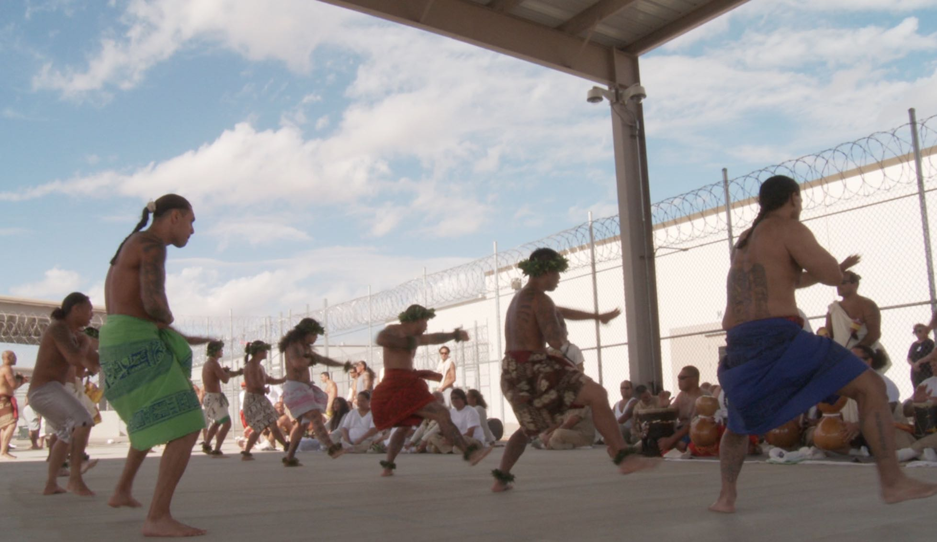
Credit: Chapin Hall

Since 1995 the state of Hawai’i has shipped male prisoners to for-profit prisons in the continental U.S. to alleviate overcrowding. Saguaro Correctional Center in Eloy, Arizona, was built specifically to house men convicted of crimes in Hawai’i. Removed far from their homes and families, most prisoners have few — if any — visitors, leading to isolation and estranged relationships, which makes the brotherhood they form with other Hawaiians inside the facility all the more important. “What captured me in this prison space was the humanity and connection between men,” said Lacy. “If, in this most unlikely location, thousands upon thousands of miles away from home, they could discover their native culture from each other and create a bond, so much more was possible.”

Out of State focuses on David, a charismatic, complex and powerful man who discovers a deep connection to his identity through cultural practices, and Hale, so accustomed to being locked up that he’s nervous about getting out. By revealing their vulnerabilities, personal transformations, hopes and dreams, Out of State challenges stereotypes about those who are in prison and casts a human light on a criminal justice system that seems almost impossible to escape.

As David and Hale transition from prison to home in Hawai’i, each finds life more challenging than they expected. David, prone to outbursts, has trouble communicating with others, including his teenage daughter, and struggles with mounting debt. Hale, a dark horse at first, finds a job driving a bus for tourists and creates a home with his fiancé Laura. But the struggle continues. Having come to terms with who they are as Hawaiians, the question is whether they will be able to fit in, to adjust to society. “I’ve been waiting all this time — I want to come home,” says Hale. “But right now, prison is home.”

“A for-profit prison in Arizona thousands of miles from home is an unexpected place to discover your Hawaiian heritage, and yet that’s what happens for many native Hawaiian inmates,” said Lois Vossen, Executive Producer of Independent Lens. “Native Hawaiian filmmaker Ciara Lacy looks at these men’s ability to change after they study the traditional language and culture of their ancestors, and the documentary fulfills our decades long tradition to fund and support emerging, diverse women filmmakers.”

Visit the Out of State web page on Independent Lens, which features more information.

About the Filmmakers

Ciara Lacy (Director and Producer) is a native Hawaiian filmmaker whose interest lies in crafting films that use strong characters and investigative journalism to challenge the creative and political status quo. She has produced documentary content for film and television, managed independent features, as well as coordinated product placement and clearances for various platforms. Her work has shown in theaters and has aired on PBS, ABC, TLC, Discovery, Bravo and A&E. Lacy is honored to be the inaugural Sundance Institute Merata Mita Fellow and a current Princess Grace Awards Special Project grantee. She has also benefited from fellowships with Firelight Media's Documentary Lab, the Sundance Institute, NATIVe at Berlinale, the Princess Grace Foundation, and IFP. Ciara holds a BA from Yale University, and graduated from Hawai`i's Kamehameha Schools.

Beau Bassett (Producer) uniquely represents the intersection of Hawai`i’s justice system, filmmaking, and native Hawaiian culture. After graduating from law school in 2005, Bassett started working in film. In 2006, he created his first short film, Tewetewe, for PBS broadcast. Tewetewe quickly gained the interest of the Sundance Institute, leading to Bassett’s acceptance as a 2008 Sundance Institute NativeLab Producing Fellow. He practiced law as a Deputy Public Defender, representing a wide array of clients in Honolulu's criminal courts. An active member of the native Hawaiian community, Bassett is a graduate of the Kamakakuokalani Center for Hawaiian Studies, is fluent in the Hawaiian language, and is an experienced Hawaiian language translator. He is also certified in ho`oponopono, a native Hawaiian form of dispute resolution, by the Queen Lili`uokalani Children’s Center.

CREDITS

Directed by Ciara Lacy
Produced by Beau Bassett and Ciara Lacy
Executive Producers Terry Leonard, Anderson Hinsch, Jessie Creel, Sally Jo Fifer, Leanne K. Ferrer
Co-Producers Jeff Consiglio, Justin Williams
Supervising Producer for ITVS Michael Ehrenzweig
Cinematographer Chapin Hall
Edited by Jeff Consiglio, Sara Booth, Jason Zeldes
Music by Tyler Strickland

About Independent Lens
Independent Lens is an Emmy® Award-winning weekly series airing on PBS Monday nights at 10:00 PM. The acclaimed series, with Lois Vossen as executive producer, features documentaries united by the creative freedom, artistic achievement, and unflinching visions of independent filmmakers. Presented by ITVS, the series is funded by the Corporation for Public Broadcasting, a private corporation funded by the American people, with additional funding from PBS, the John D. and Catherine T. MacArthur Foundation, Wyncote Foundation, and the National Endowment for the Arts. For more visit pbs.org/independentlens. Join the conversation: facebook.com/independentlens and on Twitter @IndependentLens.

###

