Bernardo Ruiz’s Harvest Season Premieres Monday, May 13 on
FOR IMMEDIATE RELEASE

CONTACT
Tanya Leverault, ITVS 415-356-8383 tanya.leverault@itvs.org
Mary Lugo 770-623-8190 lugo@negia.net
Cara White 843-881-1480 cara.white@mac.com
For downloadable images, visit pbs.org/pressroom/
Independent Lens on PBS and PBS.org

Documentary Spotlights California’s Mexican American Winemakers and the Migrant Workers Behind Every Bottle

(San Francisco, CA) — Harvest Season probes the lives of the temporary laborers, permanent residents, and multigenerational Latinos intimately connected to the production of premium wines in the Napa and Sonoma regions of Northern California — in the midst of one of the most dramatic grape harvests in recent memory. Directed by Bernardo Ruiz (Reportero), Harvest Season premieres on Monday, May 13, 2019, 10:00-11:30 PM ET (check local listings) on PBS and will also be available simultaneously for online streaming at pbs.org.
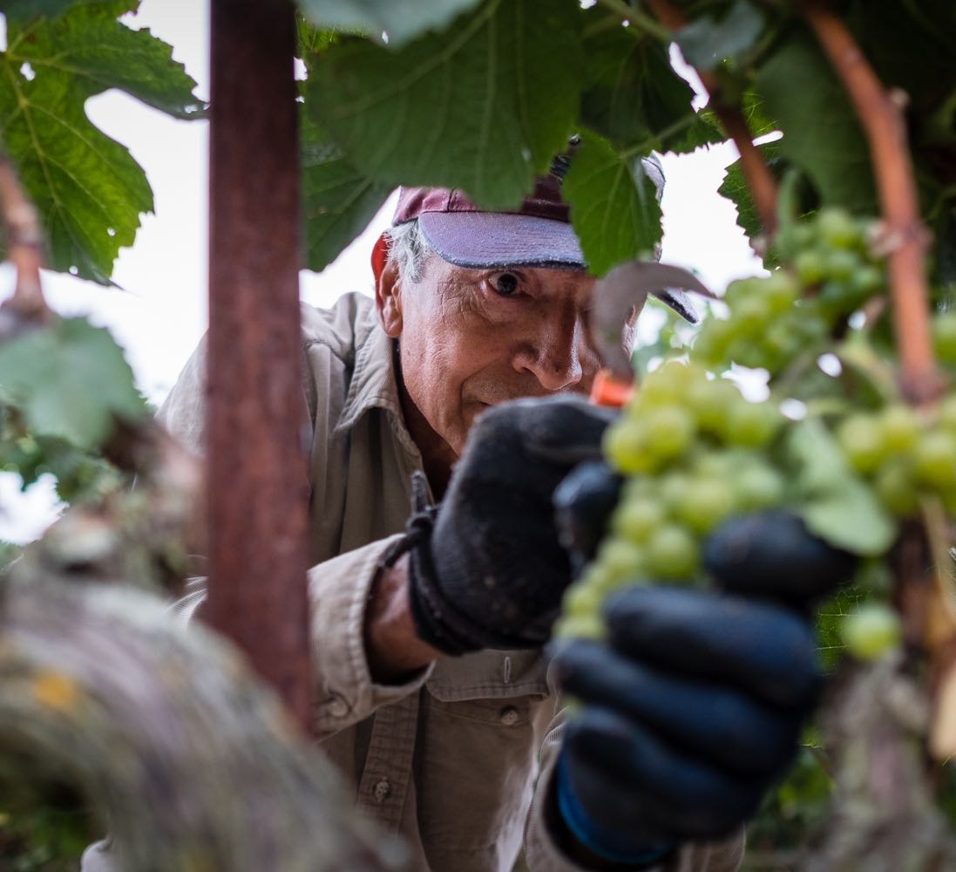
Credit: Roberto Guerra

The film follows the stories of three subjects essential to the wine industry, yet rarely recognized for their contributions: veteran winemaker Gustavo Brambila, Mexican migrant worker René Reyes, and wine entrepreneur Vanessa Robledo. Their stories unfold against the complex backdrop of reality in California’s Wine Country — a region of immense wealth that was accountable for $1.53 billion in export revenue last year. From this notion, Ruiz exposes Napa and Sonoma counties as spaces that inherently symbolize the contradictions foundational to the American story: on the one hand, romanticized global destinations replete with luxury hotels and precious real estate, and on the other, working-class agricultural communities with high rates of poverty and crises in affordable housing.

With immigration raids across the state and increasingly strict enforcement at the border, Napa’s growers and labor contractors are facing a severe labor shortage. Some have turned to the H-2A visa program, which allows them to bring in foreign nationals, like René Reyes, to fill temporary agricultural jobs. Although the work is hard, René intends to make the trip every year. The separation from his family is hard, but in Wine Country, he can make more in one hour what he used to make in a day as a truck driver back in Mexico.

Vanessa Robledo’s ancestors came to work in the vineyards in the 1940s. Her grandfather and uncles were brought to California through the Bracero program, settled in Napa, had nine children and built a successful vineyard and winemaking business. Growing up, Vanessa developed a profound respect for farming and the land, but also a desire to break away from the constraints of her role as a daughter in a traditional Mexican family. Now running her own business, she takes great pride in managing the same vines that her grandfather taught her to tend as a child.
Not far from the Robledo vineyards, we meet veteran winemaker Gustavo Brambila. For Gustavo, tradition, craft, and quality are paramount. The son of a vineyard worker, he came to the U.S. from Mexico when he was three years old. He has been making wines since 1976, and still spends countless hours perfecting each vintage.
The stories of Gustavo, Vanessa, and René culminate in a dramatic grape harvest — the most critical time of year for California winemakers. During harvest, the number of workers doubles. Tourism is at its peak. Prices rise, tempers flare, and for workers, growers and the small wine producer, the pressures could not be higher.
Before the end of the 2017 season, wildfires ignited in both Napa and Sonoma counties, resulting in a history-making disaster that caused widespread damage and claimed at least 44 lives. For growers like Vanessa and Gustavo, winemaking is full of constant challenges, but their work is also a labor of love and a cherished part of their heritage. “Wine is not just in a bottle magically,” Vanessa reminds us. “If you go out and spend a season in the vineyards to be able to appreciate the man or the woman who is farming those grapes, at that point, you will have true wine appreciation.”
“We’re very pleased to work again with Bernardo Ruiz whose documentary explores the myriad ways in which the Latinx community has contributed to the history and evolution of the wine industry in Napa,” said Lois Vossen, Independent Lens Executive Producer. “In digging beneath the romance of Napa Valley, Harvest Season brings to light the schism between the love that Americans have for the labor that immigrants bring, and America’s immigration and climate policies that threaten the sustainability of the entire industry.”
Visit the Harvest Season page on Independent Lens, which features more information about the film.

About the Filmmakers

Bernardo Ruiz (Director) is a two-time Emmy®-nominated documentary filmmaker and member of the Academy. He was born in Guanajuato, Mexico and grew up in Brooklyn, New York. His directorial feature debut, Reportero (POV, 2013), about attacks on the press in Mexico, premiered at Full Frame (U.S.), IDFA (Europe) and Ambulante (Mexico). New York Magazine called it "a powerful reminder of how journalism often requires immense amounts of physical and psychological bravery." His second feature documentary Kingdom of Shadows (POV, 2016) premiered at SXSW in the U.S. and IDFA in Europe. "Many documentaries have chronicled the drug war in the U.S. and Mexico," writes Slackerwood of the film, "but few have humanized it as poignantly as Kingdom of Shadows. [It] is more observant than crusading...rooted in first-rate journalism." The New York Times called it "unforgettable." In the fall of 2015, Ruiz was a filmmaker in residence at the Investigative Reporting Program (IRP) at the U.C. Berkeley Graduate School of Journalism. Previously he created and executive produced the two-part bilingual PBS series, The Graduates/Los Graduados (Independent Lens, 2013). Ruiz also wrote, directed and produced Roberto Clemente (American Experience, 2008) which was awarded the NCLR “Alma” Award for “Outstanding Made for Television Documentary."

CREDITS

Director Bernardo Ruiz
Co-Producer Lauren Capps
Editor Fiona Otway
Director of Photography Victor Tadashi Suarez
Additional Editing Lucas Smith
Associate Producer Andrea Cordoba
Composer Alaskan Tapes

About Independent Lens
Independent Lens is an Emmy® Award-winning weekly series airing on PBS Monday nights at 10:00 PM. The acclaimed series, with Lois Vossen as executive producer, features documentaries united by the creative freedom, artistic achievement, and unflinching visions of independent filmmakers. Presented by ITVS, the series is funded by the Corporation for Public Broadcasting, a private corporation funded by the American people, with additional funding from PBS, the John D. and Catherine T. MacArthur Foundation, Wyncote Foundation, and the National Endowment for the Arts. For more visit pbs.org/independentlens. Join the conversation: facebook.com/independentlens and on Twitter @IndependentLens.

###

