FOR IMMEDIATE RELEASE

CONTACT
Tanya Leverault, ITVS 415-356-8383 tanya.leverault@itvs.org
Mary Lugo 770-623-8190 lugo@negia.net
Cara White 843-881-1480 cara.white@mac.com
For downloadable images, visit pbs.org/pressroom

Conscience Point Premieres on Independent Lens
Monday, November 18, 2019, on PBS and PBS.org

Native Americans, Farmers and Fishing Communities Fight for
the Soul of the Hamptons

(San Francisco, CA) — In Long Island’s Hamptons, one of the wealthiest areas in the nation and an epicenter of the luxury property boom, a clash of values is taking place. Members of the Shinnecock Indian Nation — the original inhabitants of the beautiful peninsula — find themselves squeezed onto a tiny, impoverished reservation. Over hundreds of years, the Shinnecock have seen their ancient burial grounds plowed up for the widening of roads, golf courses, and new mega-mansions. Long-simmering tensions come to a head in the summer of 2018, when the U.S. Open golf tournament unfolds at the ultra-exclusive Shinnecock Hills Golf Club. As thousands descend, Rebecca Hill-Genia, a Shinnecock activist, wants the throngs of visitors to understand one thing: the world-renowned golf course’s celebrated slopes and sand traps were literally carved out of a sacred Shinnecock burial ground. Directed by Treva Wurmfeld, Conscience Point premieres on Independent Lens Monday, November 18, 2019, 10:30 PM-12:00 AM ET (check local listings) on PBS, PBS.org and the PBS Video app as part of Native American Heritage Month programming.
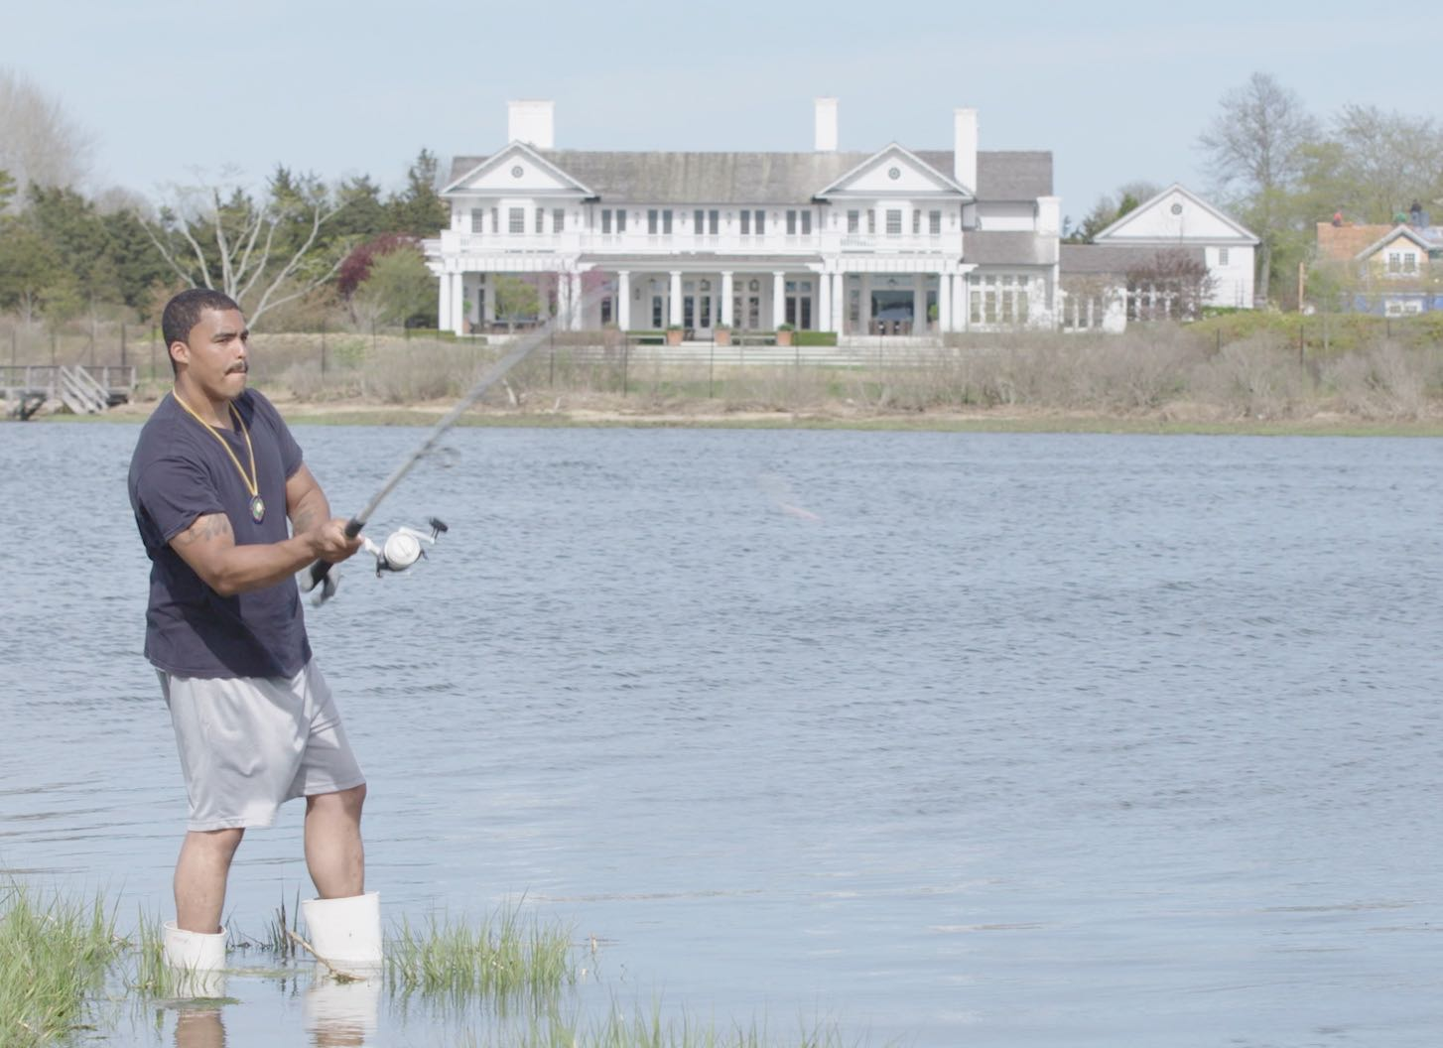
Shinnecock member Shane Weeks fishes on the reservation in Southampton.
Credit: Nadia Hallgren

With a population that quadruples in the summer months as the elite flock to its pristine beaches, Southampton is actually home to a surprisingly diverse group of residents, with some of the highest income disparities in the U.S. “Here we sit in the middle of Lifestyles of the Rich and Famous, yet sixty percent of people in our community are below the poverty level,” said Shinnecock Tribal Trustee Lance Gumbs. These economic divisions continue to grow as property values rise, pricing out long-time farming and working-class families. Fishing communities, meanwhile, are having to move to other areas as pesticides and runoff from irrigated lawns have decimated fish populations.

Featuring interviews with a cross-section of Hamptons residents, including Shinnecock Nation leaders, Town of Southampton officials, developers, farmers, and baymen, the film follows Rebecca as she tirelessly speaks out at town meetings and fights against overdevelopment. For decades, she and other leaders have continued to bring issues to the attention of officials, including improper disposal of ancestral remains and disturbances of graves sites.

Others in the film share the Shinnecock’s concerns about the negative impacts of the building boom. Bayman Chip Moran, whose family has been in the area since the early 1700s, laments the environmental destruction of the bay and says that development has destroyed his livelihood. Eleventh generation farmers Bill and Joanna Halsey discuss the changing landscape, where rising property values have made it easier to sell an acre for half a million dollars than to continue to farm it, escalating the displacement of working and middle-class families.

When long-time property owners sell to cash in on rising property values, new owners build luxury second homes. But the labor needed to service those homes can no longer afford to live in Southampton, creating tremendous traffic problems as workers are forced to commute from farther and farther away.

“When we think of the Hamptons we probably don’t realize it is being built on Native American burial grounds,” said Lois Vossen, Executive Producer of Independent Lens. “Farmers, artists, and housing for the working class are being displaced by mega-mansions, as the runoff from pristine lawns and golf courses poisons the livelihoods of fisherman who have harvested there for centuries. Conscience Point, the spot where the Shinnecock first met European settlers, feels aptly named as we consider how the choices made by the one percent of the one percent impact all the people who once called this natural paradise their home.”

Visit the Conscience Point page on Independent Lens, which features more information.

About the Filmmakers

Treva Wurmfeld (Producer, Writer, Director) made her feature directorial debut with Shepard & Dark, about playwright Sam Shepard. The film had its world premiere at the Toronto International Film Festival in 2012 and won top awards at the Woodstock International Film Festival, the Cleveland International Film Festival and the Florida Film Festival. That year, Wurmfeld was included in Filmmaker Magazine’s 25 New Faces of Independent Film. Shepard & Dark, released by Music Box films in the Fall of 2013, was an official selection at the Cannes Film Festival and Wurmfeld was nominated for the Camera d'Or prize. Previously Wurmfeld shot and produced for the Emmy Award-winning A&E series Intervention and wrote and directed the short film, Oyster in 2007. More recently, she produced and directed a short documentary The Hama Hama Way. She received her MFA from Hunter College in 2006.

Julianna Brannum (Comanche, Producer) is a documentary filmmaker based in Austin, Texas. Her first film, The Creek Runs Red, premiered on Independent Lens. She later co-produced a feature-length documentary with Emmy Award-winning producer Stanley Nelson for PBS’s We Shall Remain, a five-part series on Native American history. The episode, “Wounded Knee,” chronicled the 1973 siege of Wounded Knee, South Dakota, led by the American Indian Movement. The film had its premiere at the Sundance Film Festival and later won the ABC News VideoSource Award for Outstanding Use of Archival Footage in a Film. Brannum was selected as a Sundance Institute/Ford Foundation Fellow and has been awarded grants from the Sundance Institute’s Native Initiative, National Geographic, Women in Film, ITVS, the Oklahoma Humanities Council, Vision Maker Media, and the Sundance Documentary Fund for her public television documentary LaDonna Harris: Indian 101. She was also awarded a fellowship from the Rockefeller Foundation and the Tribeca Film Institute in support of the film. The film aired nationally on PBS in November 2015 and was executive produced by Johnny Depp. Brannum most recently served as Series Producer on the PBS series Native America, produced by Providence Pictures, a four-part series focused on the civilizations of the Americas that premiered on PBS in November 2018. Brannum has also produced programs for Discovery Channel, HGTV, DIY, A&E, and Bravo and is a graduate of the University of Oklahoma where she was awarded the 2008 Distinguished Alumni Award for the College of Arts and Sciences. She is a member of the Quahada band of the Comanche Nation of Oklahoma.

Alli Hunter Joseph (Shinnecock, Producer) is a seasoned journalist, producer and Shinnecock Indian Nation member who developed her producing, writing and editing skills working for large media companies like Scripps (Food Network), NBC Universal, Grey Advertising Worldwide, Newscorp, Salon, Cablevision, Viacom (VH1 and CBS News), AOL, Time Inc., USA Networks and Hachette Filipacchi. Alli has worked across TV, documentary film, digital and print media producing human interest and social justice stories, as well as in entertainment/news. Alli also records and edits oral histories for private clients to save stories of elders across cultures for future generations through her family history production company, Seventh Generation Stories. She was a McCormick Tribune Foundation Fellow in Executive Media Management and a Poynter Institute Sense-making Fellow, and sat on the board of the Radio and Television Digital News Association (RTDNA) representing Native American Journalists as ex-officio for the Native American Journalists Association (NAJA). Alli remains active in advocating for minority journalists’ entrepreneurship and career development, and co-directed a Ford Foundation-sponsored start-up business program called “NewU” for five years. Alli began working within the Shinnecock community as a filmmaker in 2003, chronicling land repatriation and sacred burial grounds issues. Currently she is a host/producer for Salon, and a faculty member in entrepreneurial journalism for the Maynard Institute for Journalism Education’s Maynard200 program.

CREDITS
Produced & Directed by Treva Wurmfeld
Produced by Julianna Brannum
Alli Joseph
Supervising Producer David Eisenberg
Executive Producers Sally Jo Fifer
Lois Vossen
Cinematography by Nausheen Dadabhoy
Nadia Hallgren
Treva Wurmfeld
Written & Edited by Brian Johnson
Treva Wurmfeld
Music by Garth Stevenson

About Independent Lens
Independent Lens is an Emmy® Award-winning weekly series airing on PBS Monday nights at 10:00 PM. The acclaimed series, with Lois Vossen as executive producer, features documentaries united by the creative freedom, artistic achievement, and unflinching visions of independent filmmakers. Presented by ITVS, the series is funded by the Corporation for Public Broadcasting, a private corporation funded by the American people, with additional funding from PBS, the John D. and Catherine T. MacArthur Foundation, Wyncote Foundation, and the National Endowment for the Arts. For more visit pbs.org/independentlens. Join the conversation: facebook.com/independentlens and on Twitter @IndependentLens.

###

