ACCEPT THE CALL PREMIERES ON INDEPENDENT LENS MONDAY, JANUARY 20, 2020 ON PBS AND PBS.ORG
FOR IMMEDIATE RELEASE

CONTACT
Tanya Leverault, ITVS 415-356-8383 tanya.leverault@itvs.org
Adrianna Paidas 646-762-8704 adrianna.paidas@beckmedia.com
For downloadable images, visit pbs.org/pressroom

The Documentary Follows An Anguished Somali Father in Minnesota As He Seeks To Understand What Led His American Son To Attempt To Join The Islamic State

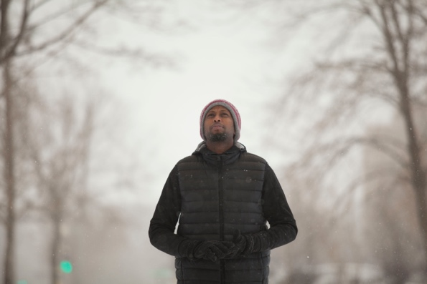
(San Francisco, CA) — Twenty-five years after Yusuf Abdurahman left Somalia as a refugee to begin his life anew in Minneapolis, Minnesota his worst fear is realized when his 19-year-old-son Zacharia is arrested in an FBI counterterrorism sting. In Accept the Call, filmmaker Eunice Lau chronicles Yusuf’s journey over three years as he tries to understand why his son would leave his American life behind to attempt to join the Islamic State (ISIS) in Syria.

Credit: The Youth Film LLC

Lauded as “hard-hitting” by Variety, Accept the Call premieres on Monday, January 20, 2020, 10:00-11:00 PM ET (check local listings) on PBS, PBS.org, the PBS Video App, and a special presentation on the Independent Lens YouTube channel.

In April 2015, Zacharia Abdurahman was arrested for planning to leave the U.S. to join ISIS. After a trial in Minneapolis he was sentenced to ten years in jail, leaving his family searching for answers as to how and why he became radicalized. Through interviews with Zacharia’s family, mainly his father Yusuf, his sister Ikraan, and others, including the FBI informant who was involved in the sting, Lau gradually reveals Zacharia’s family and how they come to terms with his arrest. As the Abdurahmans learn more about each other and settle into their own lives in Minneapolis–the city with the largest population of Somalis in the country, many of whom practice Islam–the film explores racism and prejudice against immigrants on a wider scale, detailing the rise of targeted recruitment by radicalized groups, and the struggles of Muslim youth growing up in the U.S. today.

In the most personal moments of the film between Yusuf and Zacharia as they try to mend their relationship, Lau captures their phone conversations while Zacharia is confined to federal prison. Through these conversations, Yusuf attempts to find the reasons - the societal and personal factors - behind his son’s decision.

YouTube Social Impact is a distribution partner of Accept the Call on PBS. Accept the Call received co-production support from ITVS through its Diversity Development Fund, which contributes to research and development for films by producers of color.

Visit the Accept the Call page on Independent Lens for more information.

About the Filmmaker

Eunice Lau (Director/Producer)
Eunice Lau has directed and produced several award-winning shorts and documentaries, including Through the Fire, which was nominated for Best Short Documentary at AMPAS Student Academy in 2013. A former international journalist at Al Jazeera Network, she has a penchant for telling stories concerning social justice, from dowry-killing in Bangladesh to uncovering corruption in Sarawak that decimated forests in Borneo. Originally from Singapore, Eunice has a master’s in film directing from New York University’s Tisch School of the Arts and a bachelor’s in politics, philosophy, and economics from the University of York. Her works are supported by Chicken & Egg Pictures, ITVS Diversity Development Fund, Tribeca Film Institute, YouTube Impact Lab, and the Spike Lee Production Grant.

CREDITS

Director & Produced by Eunice Lau
Edited & Co-Produced by Yasu Inoue
Executive Producers Sally Jo Fifer
Lois Vossen

Supervising Producer Ben Selkow
Consulting Producer Noland Walker

About Independent Lens
Independent Lens is an Emmy® Award-winning weekly series airing on PBS Monday nights at 10:00 PM. The acclaimed series, with Lois Vossen as executive producer, features documentaries united by the creative freedom, artistic achievement, and unflinching visions of independent filmmakers. Presented by ITVS, the series is funded by the Corporation for Public Broadcasting, a private corporation funded by the American people, with additional funding from PBS, the John D. and Catherine T. MacArthur Foundation, Wyncote Foundation, and the National Endowment for the Arts. For more visit pbs.org/independentlens. Join the conversation: facebook.com/independentlens and on Twitter @IndependentLens.

###

