THE FIRST RAINBOW COALITION PREMIERES ON INDEPENDENT LENS MONDAY, JANUARY 27, 2020 ON PBS AND PBS.ORG
FOR IMMEDIATE RELEASE

CONTACT
Tanya Leverault, ITVS 415-356-8383 tanya.leverault@itvs.org
Adrianna Paidas 646-762-8704 adrianna.paidas@beckmedia.com
For downloadable images, visit pbs.org/pressroom

Documentary Tracks the History and Legacy of a Groundbreaking Multiethnic Alliance of Community Groups that Changed the Face of 1960s Chicago Politics

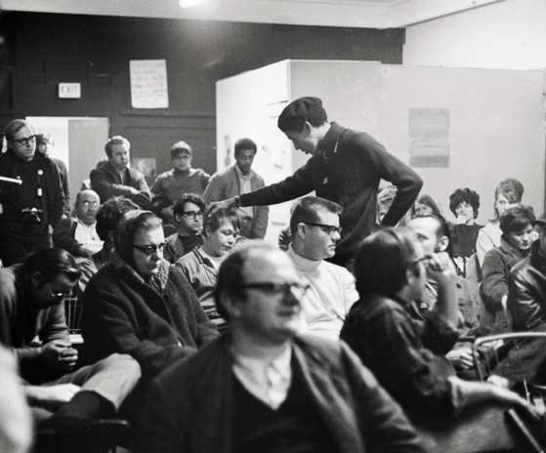
(San Francisco, CA) — A little-known 1960s movement in Chicago brought together a trailblazing alliance of community groups, including the Black Panthers, to confront social issues. Told through rare archival footage and interviews with former Coalition members, filmmaker Ray Santisteban’s The First Rainbow Coalition took more than a decade to complete and depicts the story of a powerful movement and the enduring legacy it left behind.

Credit: Paul Sequiera

Santisteban, a veteran filmmaker known for his explorations of social justice and political transformation, continues his work with the documentary premiering on Independent Lens Monday, January 27, 2020, 10:00-11:00 PM ET (check local listings) on PBS, PBS.org and the PBS Video App.

In 1969, the Chicago Black Panther Party began to form alliances across lines of race and ethnicity with other community-based movements in the city, including the Latino Young Lords Organization and the southern whites of the Young Patriots organization. Banding together in one of the most segregated cities in postwar America to collectively confront issues such as police brutality and substandard housing, they called themselves the Rainbow Coalition. But by 1973, the Coalition had collapsed under the weight of relentless harassment by local and federal law enforcement. Although short-lived, it had an outsized impact: breaking down barriers between communities, the movement created a permanent shift in Chicago politics and an organizing model for future activists and politicians across the nation.

The film presents interviews with former Rainbow Coalition members and leaders, including founding Coalition member Robert E. “Bob” Lee III, founding member of the Young Lords Jose “Cha Cha” Jimenez, and Young Patriots member Hy Thurman. All three remained friends long after the Coalition, until Lee’s death in 2017. At the time of the Rainbow Coalition’s inception in the late 1960s, Chicago was dominated by the politics of Mayor Richard J. Daley, a formidable political figure who aggressively tried to rebuild Chicago and preserve its segregated neighborhoods and schools. Amid racism and classism prevalent under his administration and all over the U.S., impoverished communities began to organize against oppression. Notable among these groups were the Young Patriots -- working-class whites from Chicago’s Uptown neighborhood — and the Young Lords — Latinx youth living in Chicago’s Lincoln Park neighborhood. Both organizations worked alongside the Illinois chapter of the Black Panther Party.

Against this backdrop of segregation, integral Black Panther Party members Fred Hampton and Bob Lee reached out across racial lines to the Young Lords and the Young Patriots to band together and protect their communities. They formed the Rainbow Coalition to empower their neighbors, demand respect, and push for social change. “All Power to the People” became their slogan, and solidarity a core value, keeping in tune with the original vision of the Black Panthers.

The Rainbow Coalition ultimately collapsed after just a few short years of formal activity. However, the Coalition’s vision lives on. Today, the legacy of the Rainbow Coalition serves as a powerful reminder of the change that can prevail when communities put aside their differences, organize together, and fight back.

The First Rainbow Coalition received co-production support from ITVS through its Open Call funding initiative, which supports projects through completion for broadcast on public television.

Visit The First Rainbow Coalition page on Independent Lens for more information about the film.

About the Filmmaker

Ray Santisteban (Director/Producer)
Ray Santisteban has worked for the past twenty-six years as a documentary filmmaker, teacher, and film curator. His work consistently gravitates toward political subjects and artist profiles, addressing the themes of justice, memory, and political transformation. A graduate of NYU’s film and TV production program, he has explored a variety of subjects including New York Black Panther leader Dhoruba Bin Wahad - Passin’ It On (Co-Producer), the roots of Puerto Rican poetry, Nuyorican Poets Cafe (1994, Director, Producer, Editor), Chicano poetry, Voices From Texas(Directed, Producer) and was Senior Producer of Visiones: Latino Art and Culture in the U.S. a three hour PBS series nationally broadcast in Oct. 2004. Awards garnered include: a 1992 Student Academy Award (information division), a 1996 “Ideas In Action” Award from the National Tele-Media Alliance, a 1996 “Faculty of the Year” Award from the Chicano Studies Program, UW Madison, a 2016 San Antonio Artists Foundation Filmmaker Award, and a 2016 Tobin Award for Artistic Excellence. Since 1998, he has been based in San Antonio, Texas.

CREDITS

Director & Produced by Ray Santisteban
Executive Producers Sally Jo Fifer
Lois Vossen
Advisors Stanley Nelson
Richard Ray Perez
Carla Gutierrez
Jim Mendiola

About Independent Lens
Independent Lens is an Emmy® Award-winning weekly series airing on PBS Monday nights at 10:00 PM. The acclaimed series, with Lois Vossen as executive producer, features documentaries united by the creative freedom, artistic achievement, and unflinching visions of independent filmmakers. Presented by ITVS, the series is funded by the Corporation for Public Broadcasting, a private corporation funded by the American people, with additional funding from PBS, the John D. and Catherine T. MacArthur Foundation, Wyncote Foundation, and the National Endowment for the Arts. For more visit pbs.org/independentlens. Join the conversation: facebook.com/independentlens and on Twitter @IndependentLens.

###

