FOR IMMEDIATE RELEASE

CONTACT
Tanya Leverault, ITVS 415-356-8383 tanya.leverault@itvs.org
Adrianna Paidas 646-762-8704 adrianna.paidas@beckmedia.com
For downloadable images, visit pbs.org/pressroom

BRETT STORY’S CRITICALLY ACCLAIMED DOCUMENTARY THE HOTTEST AUGUST PREMIERES ON INDEPENDENT LENS MONDAY, APRIL 20, 2020 ON PBS AND PBS.ORG

Interviews with a Variety of New Yorkers in One of the Hottest Months on Record Paints a Portrait of Collective Anxiety on a Warming Planet

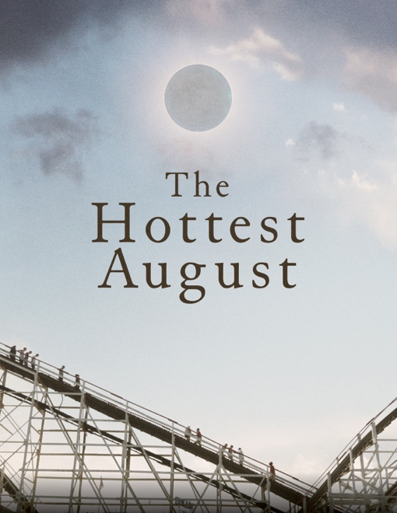
(San Francisco, CA) Tuesday, March 24, 2020 — A film about climate change disguised as a portrait of collective anxiety, The Hottest August presents an up-close and personal look at New Yorkers’ growing concerns over a variety of societal changes, from rising rents to marching white nationalists, during one sweltering month in 2017. Raising the specter of our changing climate without ever mentioning it directly, the film is a different kind of climate change documentary — one that focuses on the very human experience of yearning for security in an increasingly uncertain world.

Weaving together interviews with individuals all over New York filmed over the course of the month of August 2017, award-winning filmmaker Brett Story
holds up a mirror to a society contemplating its future survival. Named one of the best films of 2019 by Rolling Stone, Variety, Slate, IndieWire, Paste Vulture, Vox and Vanity Fair among many others, The Hottest August premieres on Independent Lens Monday, April 20, 2020, 10:00 —11:00 PM ET (check local listings) on PBS, PBS.org and the PBS Video App.

In the summer of 2017, national tensions ran high. Headlines toggled between wildfires on one coast and hurricanes on the other, white supremacists carried out public marches, and mass shootings continued across the country. Amid this instability, with the month of August shaping up to be one of the hottest on record, filmmaker and human geographer Brett Story set out to survey New Yorkers across the five boroughs on their thoughts about the future and how we will survive in it.

As the film quietly unfolds, a cross-section of citizens open up about their daily worries and distractions, touching on issues ranging from the natural disasters ravaging the country to rising rents and the high rates of homelessness, to mass shootings and white

nationalists, to political corruption, economic crisis, crumbling infrastructure, and the then-recent election of President Trump.

In the vein of Story’s previous documentaries, like the award-winning The Prison in Twelve Landscapes, The Hottest August takes a hard look at its central issue by looking away from it. Never mentioning the issue of climate change explicitly, the film creates a subtle negative space around the topic and challenges its viewers to connect overarching themes from conversations that at first glance may not appear related.

Hailed as “stunning” by Vanity Fair, “a cinematic gift, an intellectual challenge, an emotional adventure” by the New York Times, and “monumental” by Paste, the film was also a Critic’s Pick by both the New York Times and Variety.

The Hottest August received co-production support from ITVS through its Open Call Initiative, which supports projects through completion for broadcast on public television.

Visit The Hottest August page on Independent Lens for more information about the film.

About the Filmmaker

Brett Story (Director/Producer)
Brett Story is an award-winning nonfiction filmmaker based in Toronto whose films have screened at festivals internationally, including the Viennale, True/False, Oberhausen, It’s All True, and Dok Leipzig. Her 2016 feature documentary, The Prison in Twelve Landscapes was awarded the Special Jury Prize at the Hot Docs Canadian International Documentary Festival and was a nominee for Best Feature Documentary at the Canadian Screen Awards. The film was broadcast on PBS’s Independent Lens in April of 2017. Brett holds a PhD in geography from the University of Toronto and is currently an assistant professor in the School of Image Arts at Ryerson University. She is the author of the book, Prison Land: Mapping Carceral Power across Neoliberal America, and co-editor of the forthcoming volume, Infrastructures of Citizenship. Brett was a 2016 Sundance Institute Art of Nonfiction Fellow and a 2018 Guggenheim Fellow in film and video.

CREDITS

Director & Produced by Brett Story
Produced by Danielle Varga
Editor Nels Bangerter
Director of Photography Derek Howard
Executive Producers Maida Lynn
Sally Jo Fifer
Lois Vossen
Sound Designer Ernst Karel
Composer Troy Herion

About Independent Lens

Independent Lens is an Emmy® Award-winning weekly series airing on PBS Monday nights at 10:00 PM. The acclaimed series, with Lois Vossen as executive producer, features documentaries united by the creative freedom, artistic achievement, and unflinching visions of independent filmmakers. Presented by ITVS, the series is funded by the Corporation for Public Broadcasting, a private corporation funded by the American people, with additional funding from PBS, the John D. and Catherine T. MacArthur Foundation, Wyncote Foundation, and the National Endowment for the Arts. For more visit pbs.org/independentlens. Join the conversation: facebook.com/independentlens and on Twitter @IndependentLens.

# # #

