FOR IMMEDIATE RELEASE

CONTACT
Tanya Leverault, ITVS 415-356-8383 tanya.leverault@itvs.org
Adrianna Paidas 646-762-8704 adrianna.paidas@beckmedia.com
For downloadable images, visit pbs.org/pressroom

INDEPENDENT LENS PREMIERES HUMAN RIGHTS WATCH FILM FESTIVAL FAVORITE BELLY OF THE BEAST NOVEMBER 23, 2020 ON PBS AND PBS VIDEO APP

Investigative Documentary Uncovers Reproductive and Human Right Violations Happening In the World’s Largest Women’s Prison

Featuring An Original Song by Nine-Time Grammy Winner Mary J. Blige

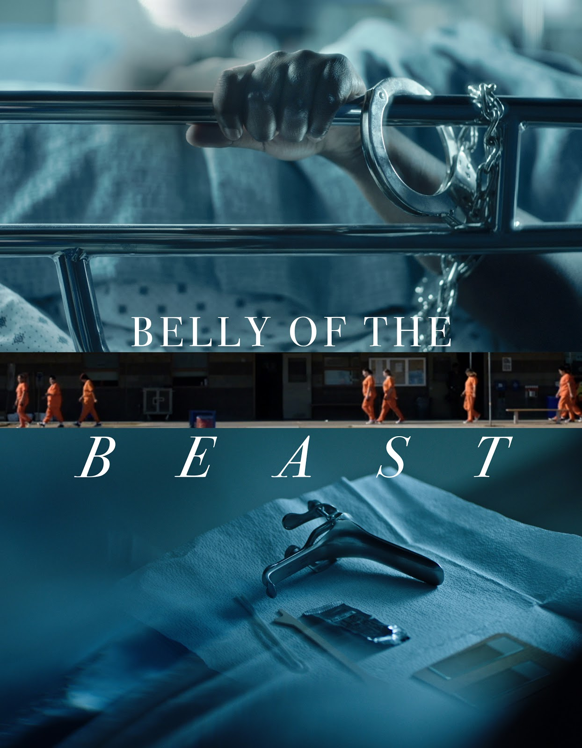(San Francisco, CA), Wednesday, September 30, 2020 – Nearly forty years after being banned, a pattern of illegal sterilizations in America’s women’s prisons has continued undetected, shielded by prison officials and doctors inside the correctional system. From Emmy and Peabody Award-winning director and producer Erika Cohn, Belly of the Beast exposes modern-day eugenics and reproductive injustice in California prisons, through intimate accounts from currently and formerly incarcerated people filmed over the course of seven years.

An opening night selection of this year’s Human Rights Watch Film Festival, Belly of the Beast will make its broadcast premiere on Independent Lens on Monday, November 23, 2020 at 10:00 p.m. ET (check local listings) on PBS and the PBS Video App.

At the Central California Women’s Facility, the world’s largest women’s prison, a young woman named Kelli Dillon, who was involuntarily sterilized at the age of 24 while incarcerated, teams up with Cynthia Chandler, a human rights lawyer, to fight for reproductive justice. As they prepare to take Kelli’s case to court with the help of Chandler’s activist organization Justice Now, they uncover a wide range of crimes occurring within the facility—from inadequate access to healthcare to sexual assault to illegal sterilization—the latter largely perpetrated against the facility’s Black and Latinx populations.

While prison doctors and officials contend that these sterilizations were in each person’s best interest and an overall social benefit, Chandler and Dillon call into question how these procedures continued for so long after being banned in California since 1979. Their joint efforts in exposing

the atrocities carried out behind closed doors ultimately shed new, timely light on the systemic racism and violence impacting people of color in women’s prisons, as activists and allies take to the courtroom to fight for reparations and some semblance of justice.

“I hope Belly of the Beast serves as a catalyst for exposing modern-day eugenics and call attention to other abuses within our criminal justice system. I believe if we hold our institutions and state actors who have committed these harms accountable, we can prevent future abuses from happening,” said Cohn. “With our public broadcast on PBS via Independent Lens, I am grateful the film will be accessible to those inside prisons today — these are their stories first and foremost, and we want to honor them and do everything we can to ensure this film reaches incarcerated audiences too.”

The film also features a new original song from the nine-time Grammy winning and two-time Oscar nominated singer-songwriter Mary J. Blige, titled “See What You’ve Done.”

“I was moved by Erika Cohn’s important documentary Belly of the Beast. I immediately knew I wanted to be involved and was inspired to write a song that would amplify the voices of women in prison,” said Blige. “‘See What You’ve Done’ is a testimony, a call to be strong, and an anthem for a movement.”

Visit the Belly of the Beast page on Independent Lens for more information about the film.

About the Filmmakers

Erika Cohn (Director)
Erika Cohn is a Peabody and Emmy Award-winning director and producer who Variety recognized as one of 2017’s top documentary filmmakers and was featured in DOC NYC’s 2019 “40 Under 40.” Most recently, Erika completed The Judge, a Peabody Award-winning and Emmy-nominated film about the first woman judge to be appointed to the Middle East’s Shari’a courts, which premiered at the 2017 Toronto International Film Festival and will be broadcast on PBS’s 2018 Independent Lens series. Erika co-directed and produced, In Football We Trust, an Emmy award-winning, feature documentary about the unique faith and culture that ultimately drives young Pacific Islander men into the NFL, which premiered at the 2015 Sundance Film Festival and was broadcast on PBS’s 2016 Independent Lens series. Her work has been supported by IFP, the Sundance Institute, Tribeca Institute, Hot Docs, Sheffield, ITVS, Women in Film, BAVC and the CPB Producers Academy among others. In 2013, Erika founded Idle Wild Films, Inc., which has released three feature documentaries and produced numerous branded content and commercial spots, including Gatorade’s Win from Within series, for which she received a 2016 Webby award nomination.

Angela Tucker (Producer)
Angela Tucker is a writer, director and Emmy nominated producer who works in narrative and documentary formats. Her directorial work includes All Skinfolk, Ain’t Kinfolk a documentary short which aired on PBS’s Reel South about a mayoral election in New Orleans and (A)sexual, a

feature length documentary about people who experience no sexual attraction that streamed on Netflix and Hulu. She was the co-executive producer of PBS's AfroPoP. Tucker also produced Pushing the Elephant and co-produced The New Black, both of which aired on PBS's Independent Lens. Her production company, TuckerGurl, is passionate about stories that highlight underrepresented communities in unconventional ways. A Visiting Professor at Tulane University, Tucker was a Sundance Institute Women Filmmakers Initiative Fellow and is an inaugural recipient of a grant from Firelight Media's The William Greaves Fund. She received her MFA in Film from Columbia University and her BA from Wesleyan University.

Christen Hepuakoa Marquez (Producer)
Christen Hepuakoa Marquez is a filmmaker who strives to create projects that spark empathy and empowerment for underrepresented communities. With her films she does not aim to create a window for her viewers to gaze through, but wants her viewers to be moved to action. She produced the fourth season of the CNN series United Shades of America, which won the 2019 Emmy for Unstructured Reality Program, and was a part of the producing team for Belly of the Beast. Her directorial debut documentary film, E Haku Inoa: To Weave A Name was completed in partnership with PBS Hawai`i, ITVS, and Pacific Islanders in Communications (PIC). She has worked more than 10 years as a director and producer for broadcasters including Discovery, Nat Geo, PBS, Oxygen, CNN, NBC Universal, and Netflix. She has been awarded the “Through the Soul of an Artist” grant for Artistic Innovation by the Native Arts and Cultures Foundation, and participated in CPB/PBS Producer's Academy. In 2018 she was awarded a Big Sky Native Film Fellowship and included in the 4th World Media Lab to workshop and develop her current documentary project The Ninth Island.

Nicole Docta (Producer)
Nicole Docta is a documentary producer who has focused her career on socially impactful projects and BIPOC stories. She co-produced the Emmy-nominated As Goes Janesville which aired on Independent Lens in 2013. Nicole was the Outreach and engagement coordinator for
the Emmy award-winning In Football We Trust (Sundance, 2015). She associate produced the Peabody Award-winning and Emmy-nominated The Judge (TIFF, DOC NYC, IDFA 2017), which
aired on Independent Lens in 2019. She is currently a producer on Belly of the Beast (HRWFF 2020) and co-producing Through The Night (Tribeca, 2020). Nicole is also a Special Initiatives producer at Firelight Media.

CREDITS
Director Erika Cohn
Producers Angela Tucker
Christen Hepuakoa Marquez
Nicole Docta
Executive Producers Geralyn Dreyfous
Blye Faust
Mark Lipson
Patty Quillin
Doree Friedman

Diane Philips
Lois Vossen
Sally Jo Fifer

About Independent Lens
Independent Lens is an Emmy® Award-winning weekly series airing on PBS Monday nights at 10:00 PM. The acclaimed series, with Lois Vossen as executive producer, features documentaries united by the creative freedom, artistic achievement, and unflinching visions of independent filmmakers. Presented by ITVS, the series is funded by the Corporation for Public Broadcasting, a private corporation funded by the American people, with additional funding from PBS, the John D. and Catherine T. MacArthur Foundation, Wyncote Foundation, and the National Endowment for the Arts. For more visit pbs.org/independentlens. Join the conversation: facebook.com/independentlens and on Twitter @IndependentLens.

###

