FOR IMMEDIATE RELEASE

CONTACT
Lisa Tawil, ITVS 415-356-8383 lisa_tawil@itvs.org
Mary Lugo 770-623-8190 lugo@negia.net
Cara White 843-881-1480 cara.white@mac.com
For downloadable images, visit pbs.org/pressroom/
The Armor of Light Premieres on Independent Lens
Tuesday, May 10, 2016 on PBS

Evangelical Minister and Mother of Teenage Shooting Victim Follow Their Faith to Fight Against Gun Violence in America

“A vital colloquy on whether we shape our lives through fear or with love…The unlikely allies shine a burning light on questions that go to the essence of who we are and what it means to value life.” – Los Angeles Times

(San Francisco, CA) — The Armor of Light follows the journey of Evangelical minister Rob Schenck, who is trying to find the courage to preach about the growing toll of gun violence in America. The film tracks Reverend Schenck, a well-known anti-abortion activist and fixture on the political far right, as he breaks with orthodoxy by questioning whether being pro-gun is consistent with being pro-life. Rev. Schenck is shocked and perplexed by the reactions of his long-time friends and colleagues who warn him away from this complex, politically-explosive issue. Along the way, he meets Lucy McBath, the mother of Jordan Davis, an unarmed teenager who was murdered in Florida and whose story casts a spotlight on the state’s “Stand Your Ground” laws. McBath, also a devout Christian, decides to work with Schenck. Lucy is on a difficult journey of her own, trying to make sense of her devastating loss while using her grief to effect some kind of viable and effective political action where so many before her have failed. The directorial debut of award-winning producer Abigail Disney (Pray the Devil Back to Hell; Women, War & Peace), and produced and co-directed by Kathleen Hughes, The Armor of Light premieres on Independent Lens Tuesday, May 10, 2016, 8:00-9:30 p.m. ET (check local listings) on PBS.
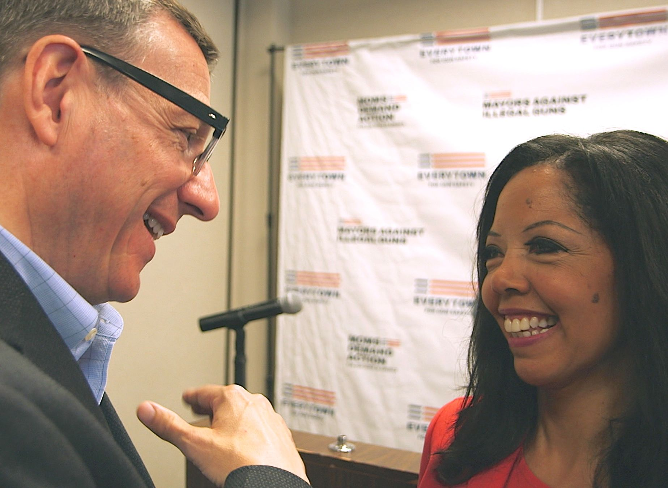
Rob Schenck and Lucy McBath.
Credit: Jeff Hutchens

The Armor of Light follows these allies through their trials of conscience, heartbreak and rejection, as they bravely attempt to make others consider America’s gun culture through a moral lens. The film is also a courageous look at our fractured political culture and an assertion that it is, indeed, possible for people to come together across deep party lines to find common ground.

Visit The Armor of Light page on Independent Lens, which features more information about the film.

About the Participants

Lucy McBath is the mother of Jordan Davis, an unarmed teenager who was shot and killed in Jacksonville, Florida, in November 2012. Since his death, McBath has advocated for solutions to the problem of gun violence as a national spokesperson for Moms Demand Action for Gun Sense in America and is currently the Faith Outreach Leader for Everytown for Gun Safety. In her
work as a gun safety advocate, she has been invited to the White House, testified before the U.S. Senate Judiciary Committee, and appeared on CNN and MSNBC. She recently founded the Walk With Jordan Scholarship Foundation.

The Reverend Dr. Rob Schenck is an ordained Evangelical minister and president of Faith and Action in the Nation’s Capital, located in Washington, DC. A leader among American Evangelicals, Dr. Schenck is serving his second two-year term as chairman of the Evangelical Church Alliance, America’s oldest association of independent Evangelical clergy. Dr. Schenck
has recently challenged the prevailing attitudes of American Evangelicals on gun ownership, opening a vigorous debate in his community on the ethical dimensions of gun use and related public policy questions.

Dr. Schenck holds a B.A. in religion, M.A. in Christian ministry, D.Min in church and state, and is a senior fellow at the Oxford Centre for the Study of Law and Public Policy at Harris Manchester College, University of Oxford. He serves on numerous boards and committees, including the National Advisory Board on Community Engagement in the State Courts. His professional
memberships include the National Association of Evangelicals, the American Academy of Religion, the Capitol Hill Executive Service Club, and The University Club of Washington. Dr. Schenck lives in Washington, DC, with his wife, Cheryl, a psychotherapist in private practice.

About the Filmmakers

Abigail E. Disney (Director) is a filmmaker, philanthropist, and the CEO and president of Fork Films. Disney's longtime passion for women’s issues and peace building culminated in producing her first film, Pray the Devil Back to Hell (winner, Best Documentary Feature, Tribeca Film Festival 2008). She then executive produced the five-part PBS series Women, War & Peace. Her executive producing and producing credits include Fork Films supported films 1971, Citizen Koch, Family Affair, Hot Girls Wanted, The Invisible War (2012 Academy Award nominee, Best Documentary Feature), Return and Sun Come Up (2011 Academy Award nominee, Best Documentary Short). Her most recent projects include Fork Films original productions The Trials of Spring, which she executive produced, and The Armor of Light, her directorial debut.

Disney is also the founder and president of Peace is Loud, a nonprofit organization that uses media and live events to highlight the stories of women who are stepping up for peace and resisting violence in their communities.

Kathleen Hughes (Producer and Co-Director) is a producer, director and writer, as well as co-founder of the documentary film company Okapi Productions. Among Hughes’s many films is Two American Families, a 21-year-long look at downward mobility, which recently premiered on PBS’s Frontline. Her 90-minute Bill Moyers special, Buying the War, detailing the media’s failure to examine the Bush Administration’s case for invading Iraq, was called “one of the most gripping and important pieces of broadcast journalism this year” by the Washington Post. From 2008-11, Hughes was Executive Producer of public television’s multi-platform series Blueprint America, which told stories about America’s crumbling infrastructure. Her other work has appeared on PBS’s NOW and Wide Angle, NBC’s TV Nation and ABC News’ Turning Point, as well as many Bill Moyers specials. Her work has received numerous awards including two national Emmys, a New York Emmy, the duPont- Columbia Gold Baton, the Gracie Award, the Sidney Hillman Prize, the Dateline Club’s Society of Professional Journalists’ First Amendment Award, the Harry Chapin Media Award, the Christopher Award, and honorable mention for the Robert F. Kennedy Journalism Award.

CREDITS

Director Abigail E. Disney
Producer and Co-Director Kathleen Hughes
Executive Producers Gini Reticker
Abigail E. Disney
Editor Andrew Fredericks
Producer Eva Anisko
Director of Photography Jeff Hutchens
Original Music Paul Brill

The Armor of Light is a production of Purple Mickey Productions in association with Fork Films.

About Independent Lens

Independent Lens is an Emmy® Award-winning weekly series airing on PBS Monday nights at 10:00 p.m. ET. The acclaimed series features documentaries united by the creative freedom, artistic achievement, and unflinching visions of independent filmmakers. Presented by Independent Television Service, the series is funded by the Corporation for Public Broadcasting, a private corporation funded by the American people, with additional funding from PBS and the John D. and Catherine T. MacArthur Foundation. For more, visit pbs.org/independentlens. Join the conversation: facebook.com/independentlens and on Twitter @IndependentLens.

###

