FOR IMMEDIATE RELEASE

CONTACT
Donna Hardwick, ITVS 415-356-8383 donna.hardwick@itvs.org
Mary Lugo 770-623-8190 lugo@negia.net
Cara White 843-881-1480 cara.white@mac.com
For downloadable images, visit pbs.org/pressroom/
Chasing Trane Opens New Season of
Independent Lens, Monday, November 6, 2017 on PBS

Online Streaming Begins November 7

Portrait of Jazz Great John Coltrane Features Common,
Kamasi Washington, Carlos Santana, Sonny Rollins, Wynton Marsalis, John Densmore and More

Denzel Washington Speaks the Words of John Coltrane

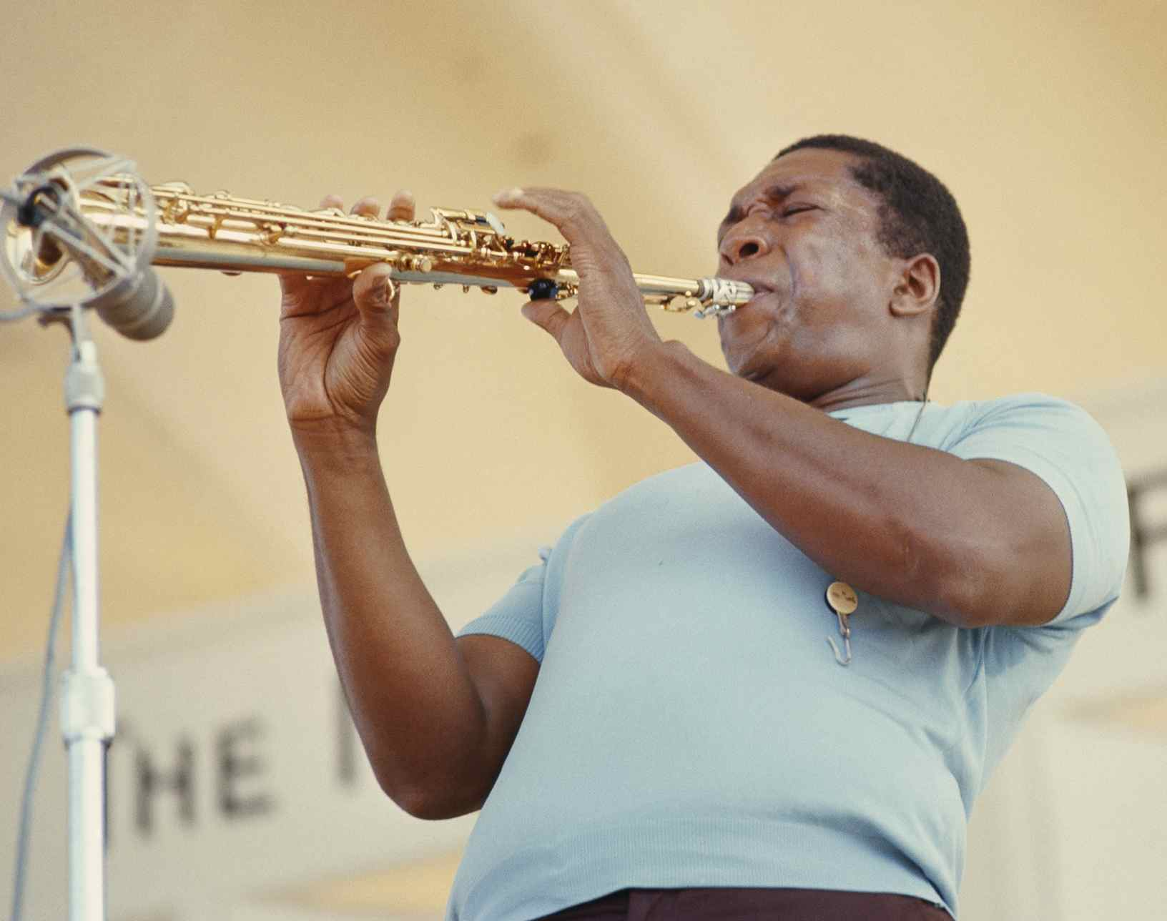
Coltrane at Newport, 1966.
Credit: Nakadaira
(San Francisco, CA) — Set against the social, political and cultural landscape of the times, Chasing Trane brings saxophone great John Coltrane to life, as a man and an artist. Written and directed by John Scheinfeld, Chasing Trane is the definitive look at the boundary-shattering musician whose influence continues to this day. The film kicks off the new season of Independent Lens Monday, November 6, 2017, 10:00-11:30 PM ET (check local listings) on PBS.

Chasing Trane features never-before-seen Coltrane family home movies, footage of Coltrane and his band in the studio (discovered in a California garage during production of this film), along with hundreds of never-before-seen photographs and rare television appearances from around the world. Coltrane’s exceptional story is told by the musicians who worked with him (Sonny Rollins, McCoy Tyner, Benny Golson, Jimmy Heath, Reggie Workman), musicians inspired by his fearless artistry and creative vision (Common, John Densmore, Wynton Marsalis, Carlos Santana, Wayne Shorter, Kamasi Washington), Coltrane’s children and biographers, and well-known admirers such as President Bill Clinton and Dr. Cornel West.

Chasing Trane reveals the critical events, passions, experiences and challenges that shaped Coltrane’s life and his revolutionary sounds. It is a story of demons and darkness, of persistence and redemption. Above all, it recounts the spiritual journey of a man who found himself and, in the process, created an extraordinary body of work that transcends all barriers of geography, race, religion and age.

“The fact that, 50 years after his death, there had never been a definitive film on John Coltrane was reason enough to support Chasing Trane,” said Lois Vossen, Independent Lens executive producer. “What I really appreciate is director John Scheinfeld’s full portrait of Coltrane as a man and a musician. What emerges is a noble person who, in his short life, transformed an art form and left an indelible mark on our culture. As one critic noted, ‘the fact that someone as wholly beautiful as John Coltrane once walked this earth is enough to make you maintain some kind of faith in humanity itself.’”

Visit the Chasing Trane page on Independent Lens, which features more information about the film. The film will be available for online viewing on the site beginning November 7, 2017.

About John Coltrane
Born September 23, 1926, in Hamlet, North Carolina, John Coltrane was introduced to music by his musician father. Growing up, Coltrane was obsessed with the records of Count Basie and Lester Young. At the age of 13, he picked up the saxophone and tried to imitate the sounds of his then-idols Charlie Parker and Johnny Hodges. Thus began the career of one of the 20th century’s most important and influential artists. Coltrane’s dramatic life story was cinematic in its scope, from his early musical life playing alongside giants Dizzy Gillespie, Eddie Vinson and Jimmy Heath, to breakout performances with the Miles Davis Quintet on their classic recordings ‘Round About Midnight and Kind of Blue, to the historic partnership with Thelonious Monk and then finally to his astonishing solo career that gave the world such musical diamonds as Giant Steps, My Favorite Things, Impressions, Live at Birdland and 1965’s seminal A Love Supreme. “Trane” died in 1967 at the age of 40; his massive influence on generations of artists has grown even stronger since his death.

About the Filmmaker

John Scheinfeld (Writer/Director) is an Emmy®, Grammy® and Writers Guild Award nominee and writer/director/producer of documentaries for theatrical and television distribution. His films have premiered at Telluride, Toronto, Venice and IDFA and include The U.S. vs. John Lennon, Who Is Harry Nilsson (And Why Is Everybody Talkin' About Him), We Believe and Dick Cavett's Watergate. In addition, Scheinfeld has written pilot scripts for drama series for ABC, CBS, NBC and Fox. He is a graduate of Oberlin College and received his MFA from Northwestern University.

CREDITS

Written and Directed by John Scheinfeld
Produced by Spencer Proffer
John Beug
Scott Pascucci
Dave Harding
Co-Produced and Edited by Peter S. Lynch, II
Executive Producers Mark Pinkus
Bruce Resnikoff
Sig Sigworth
Director of Photography Stan Taylor
Music by John Coltrane

About Independent Lens
Independent Lens is an Emmy® Award-winning weekly series airing on PBS Monday nights at 10:00 PM. The acclaimed series, with Lois Vossen as executive producer, features documentaries united by the creative freedom, artistic achievement, and unflinching visions of independent filmmakers. Presented by ITVS, the series is funded by the Corporation for Public Broadcasting, a private corporation funded by the American people, with additional funding from PBS, the John D. and Catherine T. MacArthur Foundation, Wyncote Foundation, and the National Endowment for the Arts. For more, visit pbs.org/independentlens. Join the conversation: facebook.com/independentlens and on Twitter @IndependentLens.

###

