Chasing Trane Opens New Season of
Independent Lens Monday, November 6, 2017 on PBS

TCA Panelists

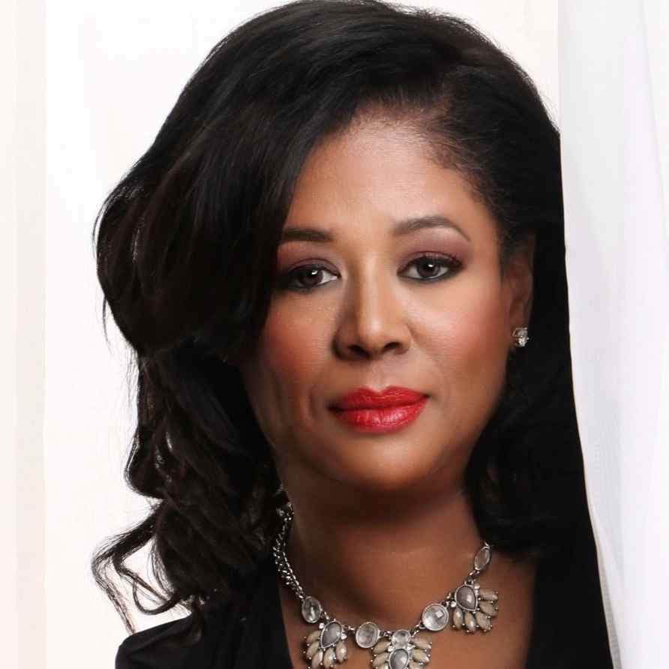
Michelle Coltrane (Participant) is an acclaimed performer, songwriter, music arranger, DJ and voice actor and is the only daughter of Alice and John Coltrane. As a soloist, she has performed across the U.S. and France with artists Kenny Kirkland, Jeff Watts, Ronnie Laws, Billy Childs, Jack DeJohnette, Marvin “Smitty” Smith, Ryan Cross, Tim Lefebvre, Reggie Workman, The Gap Band, The McCoy Tyner Trio, Cameron Graves and Kamasi Washington, among others. Her first album, I Think of You, with its fusion of classic and contemporary jazz, received critical praise and was a YES Award recipient. Coltrane has been featured at the 2013 Panama Jazz Festival, the Miami Jazz Festival, Yoshi’s Jazz Club in Oakland, California, Vibrato Grill Jazz in Bel Air, as well as the John Ford Amphitheater in Los Angeles. Coltrane and Maggie Le Pique’s radio program on KPFK 90.7 FM, “Straight No Chaser,” ran for several years in the late 1990s and featured interviews with the likes of Charlie Haden, Alice Coltrane, Elvin Jones and Stanley Clarke. Coltrane is president of the John & Alice Coltrane Foundation and the John Coltrane Scholarship program, for which she has emceed events at the Wiltern Theatre and the House of Blues Los Angeles. Her forthcoming album is due later this year on Blue Jazz and features original material and standards performed by Michelle Coltrane, Lonnie Plaxico, Alex Collins, Gerry Gibbs, Cameron Graves and others.

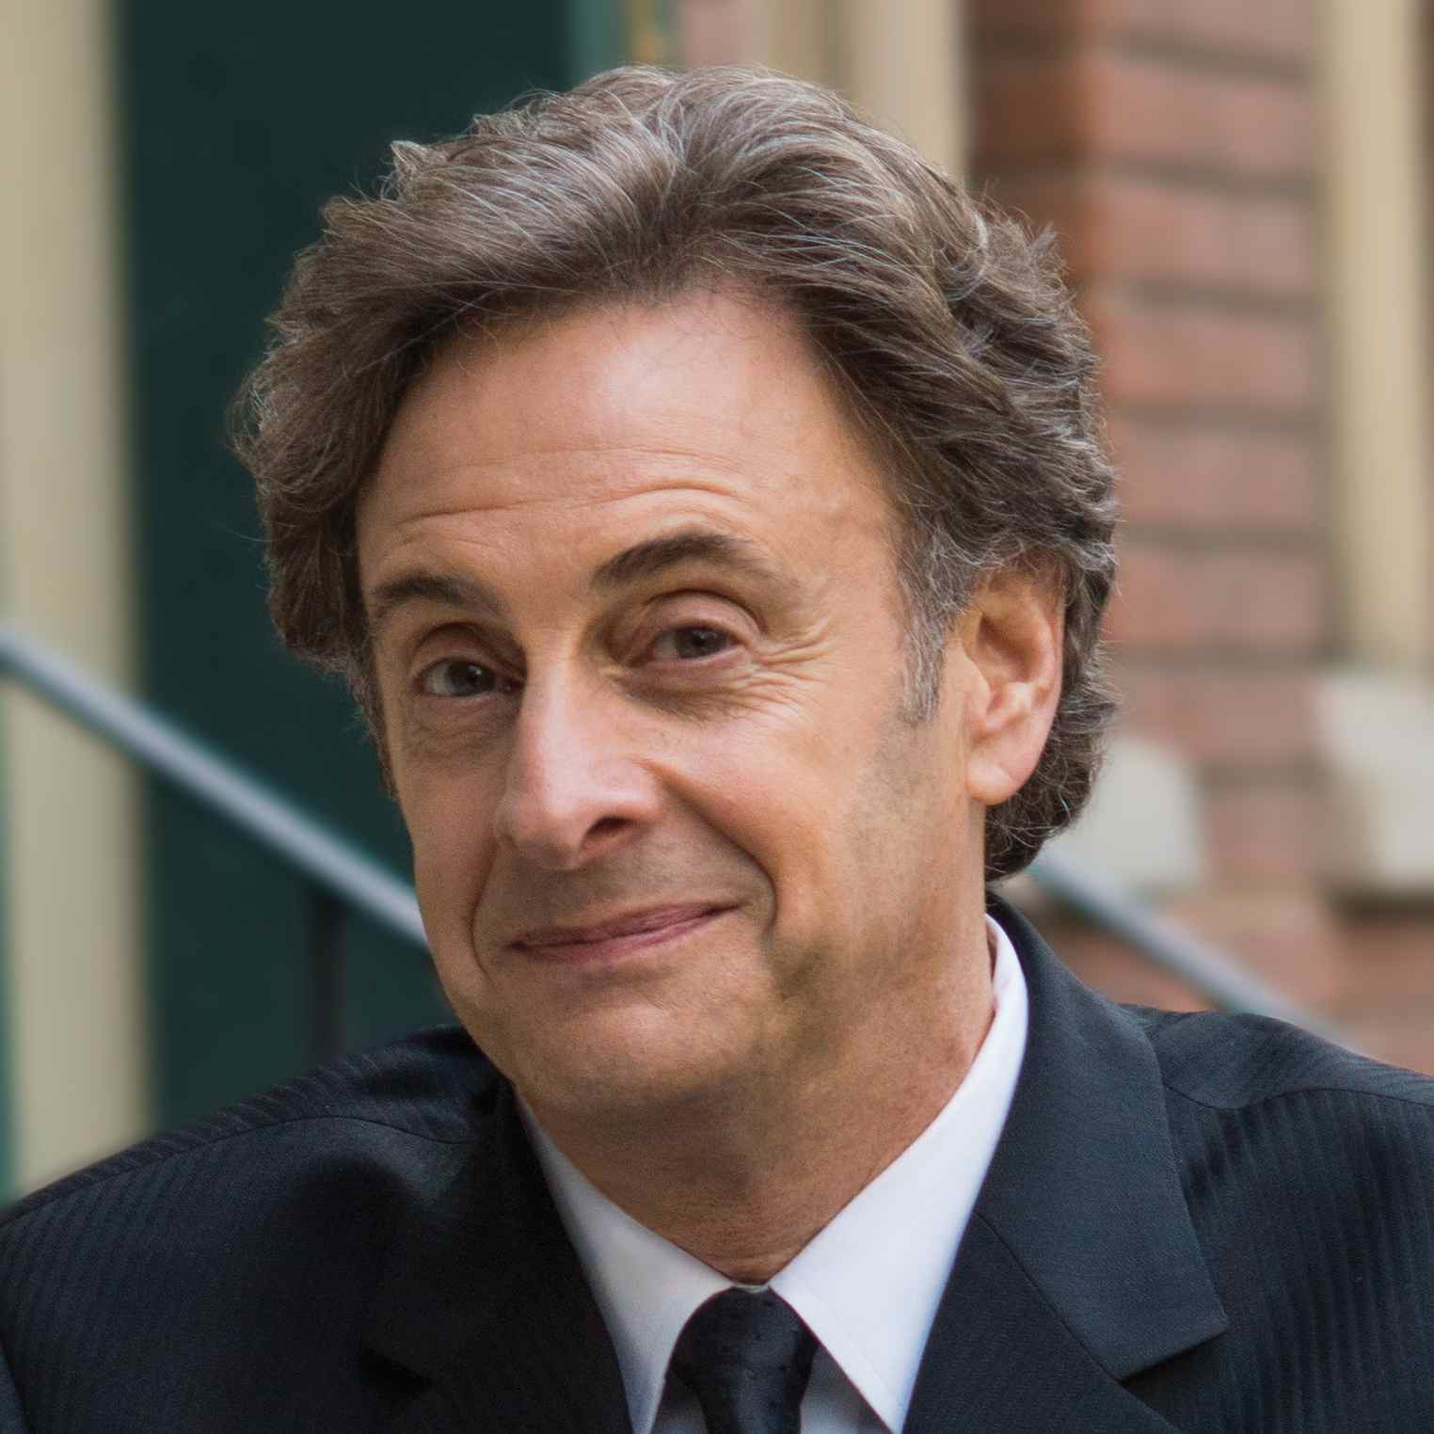
John Scheinfeld (Writer/Director) is an Emmy®, Grammy® and Writers Guild Award nominee and writer/director/producer of documentaries for theatrical and television distribution. His films have premiered at Telluride, Toronto, Venice and IDFA and include The U.S. vs. John Lennon, Who Is Harry Nilsson (And Why Is Everybody Talkin' About Him), We Believe and Dick Cavett's Watergate. In addition, Scheinfeld has written pilot scripts for drama series for ABC, CBS, NBC and Fox. He is a graduate of Oberlin College and received his MFA from Northwestern University.

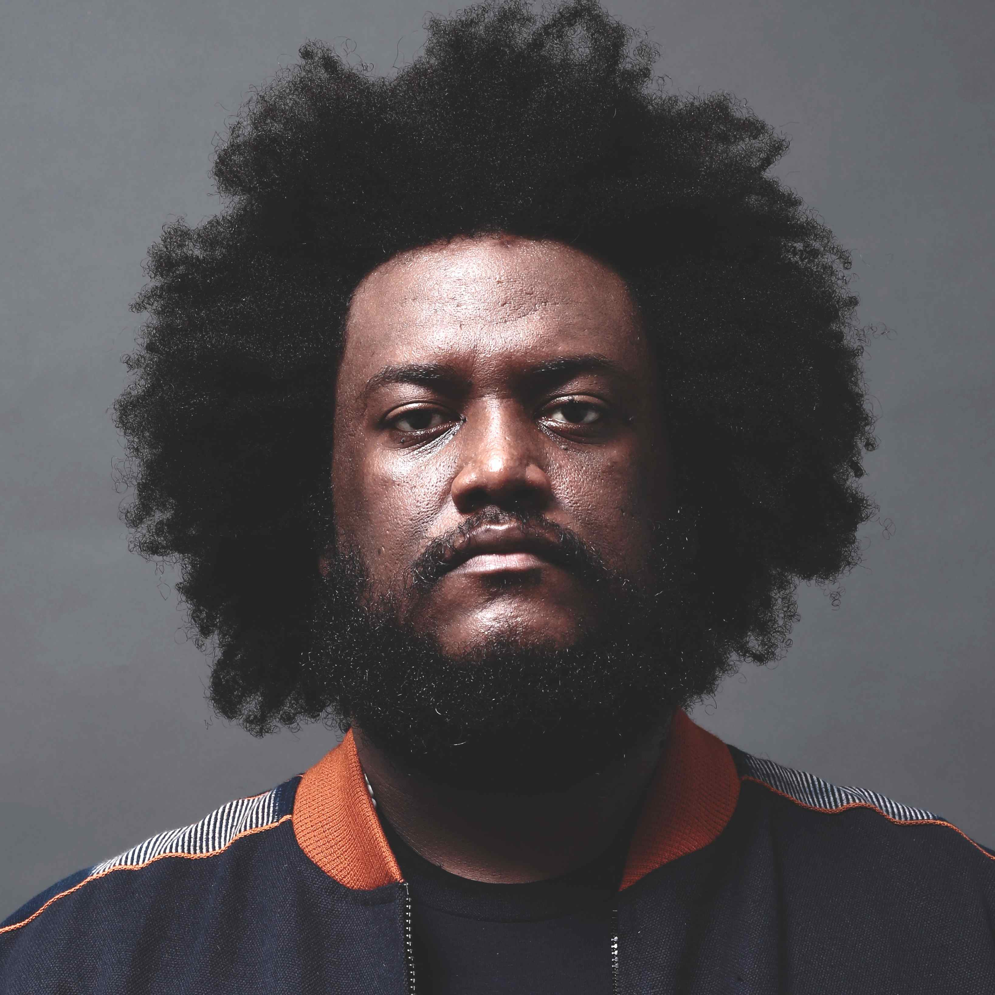
KamasI Washington (Participant). When Kamasi Washington released his tour de force LP, The Epic , in 2015, it instantly became a cornerstone of his burgeoning career. The 172-minute odyssey featuring his 10-piece band, The Next Step, covers nearly every aspect of Black music landscape, many of which were popular years before he was born.

Released to critical acclaim, the album won numerous “best of” awards, including the inaugural American Music Prize and the Gilles Peterson Worldwide album of the year. Washington followed that with continued collaboration with rapper Kendrick Lamar, work with John Legend and Run the Jewels, and “Harmony of Difference,” a multimedia installation during the Biennial at the Whitney Museum of American Art in New York City.

It’s the partial fulfillment of destiny for the saxophonist and bandleader, among the torchbearers—perhaps the torchbearer—for jazz music due to his monstrous ability and mass appeal. Tour stops at festivals such as Coachella, Glastonbury, Fuji Rock and Primavera Sound are routine, and, coupled with the vibrant, multi-ethnic crowds that witness his performances, make Washington the closest thing to a superstar that the vast genre has today.

It was, however, meant to be. His father, Rickey, was a horn player with 1970s funk outfit Raw Soul Express. At age 13, the younger Washington picked up his father’s horn and proceeded to play the Wayne Shorter composition “Sleeping Dancer Sleep On” despite never touching a saxophone or knowing how to play. A Los Angeles native, he was lead tenor saxophone chair in the top jazz ensemble at the Grammy Award-recognized Academy of Music and Performing Arts at Alexander Hamilton High School, and as a senior, started his first band—Young Jazz Giants—with pianist Cameron Graves and childhood friends Ronald and Stephen “Thundercat” Bruner.

Washington received a full scholarship to the University of California at Los Angeles, where he studied ethnomusicology. He recorded his first album with Young Jazz Giants during the summer following his freshman year. The quartet’s self-titled debut was dripping with maturity well beyond the players' collective age, and with Washington penning four of the album’s seven original songs, became a platform to spread the “now” sound of jazz all around the country. Following his sophomore year at UCLA, Washington went on his first national tour with West Coast hip-hop legend Snoop Dogg, performing alongside some of the most talented young jazz musicians in the country.

Later that year, the young saxophonist joined the orchestra of Gerald Wilson, one of his biggest heroes. After graduation, Washington toured with Grammy Award-winning producer, singer and songwriter Raphael Saadiq, and later that year, returned to Wilson’s band on the album In My Time.

Over the next few years, Washington performed and recorded with a number of icons from all genres of music: McCoy Tyner, Freddie Hubbard, Kenny Burrell, George Duke, Lauryn Hill, Jeffrey Osborne, Mos Def and Quincy Jones. It was in this time that he also assembled The Next Step, the band that would help him transmit his spirituality and sounds of Blackness to the world.

In past years Washington has been touring with The Next Step, as well as legendary musicians such as Stanley Clarke, Harvey Mason and Chaka Khan. Recent work with Thundercat and Brainfeeder visionary Flying Lotus, as well as Ibeyi and Kendrick Lamar on his Damn album, reveals that as he matures and blazes a trail for prodigies like himself, he remains a young jazz giant. His breakthrough The Epic album, which featured a full string orchestra and choir, wasn’t a peak, but merely the shape of things to come for an artist who was destined to reach all the heights he will eventually attain.


Lois Vossen (Executive Producer, Independent Lens) has been with the program since its inception as a primetime series on PBS. Vossen is responsible for commissioning new films, programming the series and working with filmmakers on editorial and broadcast issues. Independent Lens films have received 13 Emmy Awards, 16 George Foster Peabody Awards, five Alfred I. duPont-Columbia Journalism Awards and eight Academy Award nominations. The series was honored in 2013, 2014 and 2015 with the International Documentary Association (IDA) Award for Best
Series. Before joining ITVS, Vossen was the associate managing director of the Sundance Film Festival and Sundance Labs. Currently she represents the documentary branch on the Television Academy Board of Directors. She has served on the jury at Shanghai Festival, Toronto International Film Festival, SXSW, DOC New Zealand and Palm Springs International Film Festival, among others. Under her leadership, films funded or presented on Independent Lens include I Am Not Your Negro, TOWER, The Force, Newtown, Best of Enemies, The Black Panthers: Vanguard of the Revolution, (T)ERROR, The Waiting Room, The House I Live In, The Invisible War, The Trials of Muhammad Ali, God Loves Uganda, Hell and Back Again, Waste Land, Enron: The Smartest Guys in the Room and The Weather Underground, among many others.

