“Dolores” Premieres on Independent Lens,
Tuesday, March 27, 2018, on PBS

TCA Panelists
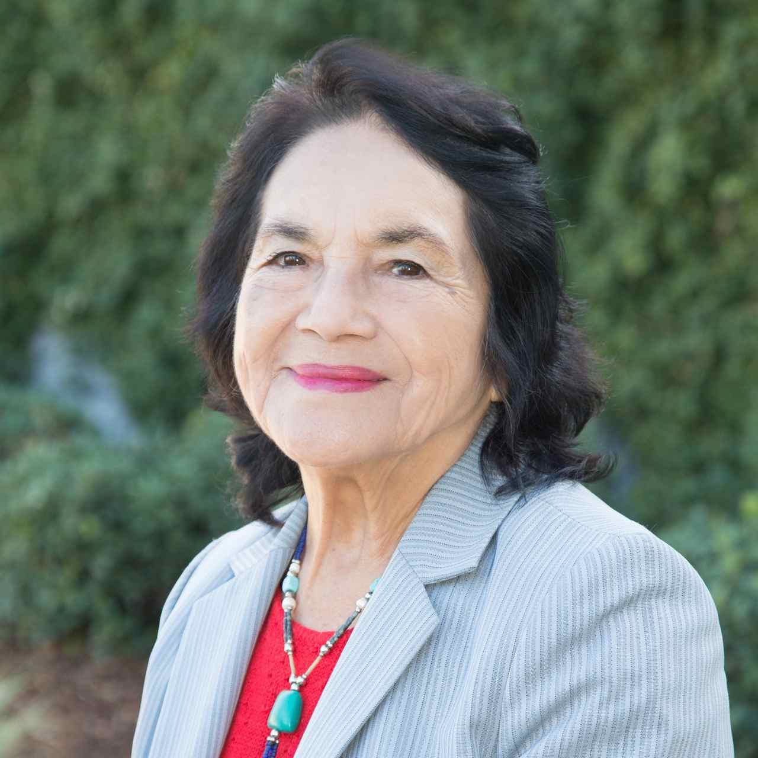
Dolores Huerta (Subject). Dolores Clara Fernández was born on April 10, 1930, in Dawson, a small mining town in New Mexico; she spent most of her childhood and early adult life in Stockton, California, where she and her two brothers moved with their mother following their parents’ divorce. Independent and entrepreneurial, her mother was an active participant in community affairs.

After graduating from high school, Dolores earned a teaching degree, married and had two daughters. Seeing her students come to school with empty stomachs and bare feet inspired her lifelong commitment to correcting economic injustice. She found her calling as an organizer while serving in the leadership of the Stockton Community Service Organization (CSO). During this time, she founded the Agricultural Workers Association, set up voter registration drives and pressed local governments for barrio improvements.

It was in 1955 that she met a likeminded colleague, CSO Executive Director César E. Chávez. The two soon discovered that they shared a common vision of organizing farm workers and in 1962 they launched the National Farm Workers Association, which would evolve into the United Farm Workers and bring national attention to the conditions faced by farm laborers.

Huerta’s lobbying and negotiating talents helped secure Aid for Dependent Families (AFDC) and disability insurance for farm workers; she was also instrumental in the enactment of the Agricultural Labor Relations Act of 1975, which granted California’s farm workers the right to collectively organize and bargain for better wages and working conditions. While the farm workers lacked financial capital, they were able to wield significant economic power through hugely successful national boycotts. As their principal legislative advocate, Dolores became one of the UFW’s most visible spokespersons.

While directing the first National Boycott of California Table Grapes out of New York, Huerta met Gloria Steinem and was introduced to the burgeoning feminist movement, which rallied behind the farm workers’ cause. Having found a supportive voice with other feminists, Huerta began to challenge gender discrimination within the farm workers’ movement.

At age 58, Huerta suffered a life-threatening assault while protesting against the policies of then presidential candidate George H.W. Bush in San Francisco. Following a lengthy recovery, she began to focus on women’s rights, traversing the country on behalf of the Feminist Majority’s “Feminization of Power: 50/50 by the Year 2000” campaign which encouraged Latinas to run for office.

Huerta continues to work tirelessly developing leaders and advocating for the working poor, women and children as founder and president of the Dolores Huerta Foundation. She was inducted into the California Hall of Fame in March of 2013 and has received numerous awards

including The Eleanor Roosevelt Human Rights Award from President Clinton in 1998, Ladies Home Journal’s “100 Most Important Women of the 20th Century,” and nine honorary doctorates from U.S. universities. In 2012, President Obama bestowed on Huerta her most prestigious award, The Presidential Medal of Freedom.

Benjamin Bratt (Consulting Producer). A veteran of more than 25 films, Bratt’s distinguished career includes the critically acclaimed films Piñero, Steven Soderbergh’s Traffic, which received five Academy Award nominations, and The Infiltrator opposite Bryan Cranston. Other notable film credits include The River Wild opposite Meryl Streep, and Donald Petrie’s beloved blockbuster comedy Miss Congeniality opposite Sandra Bullock.
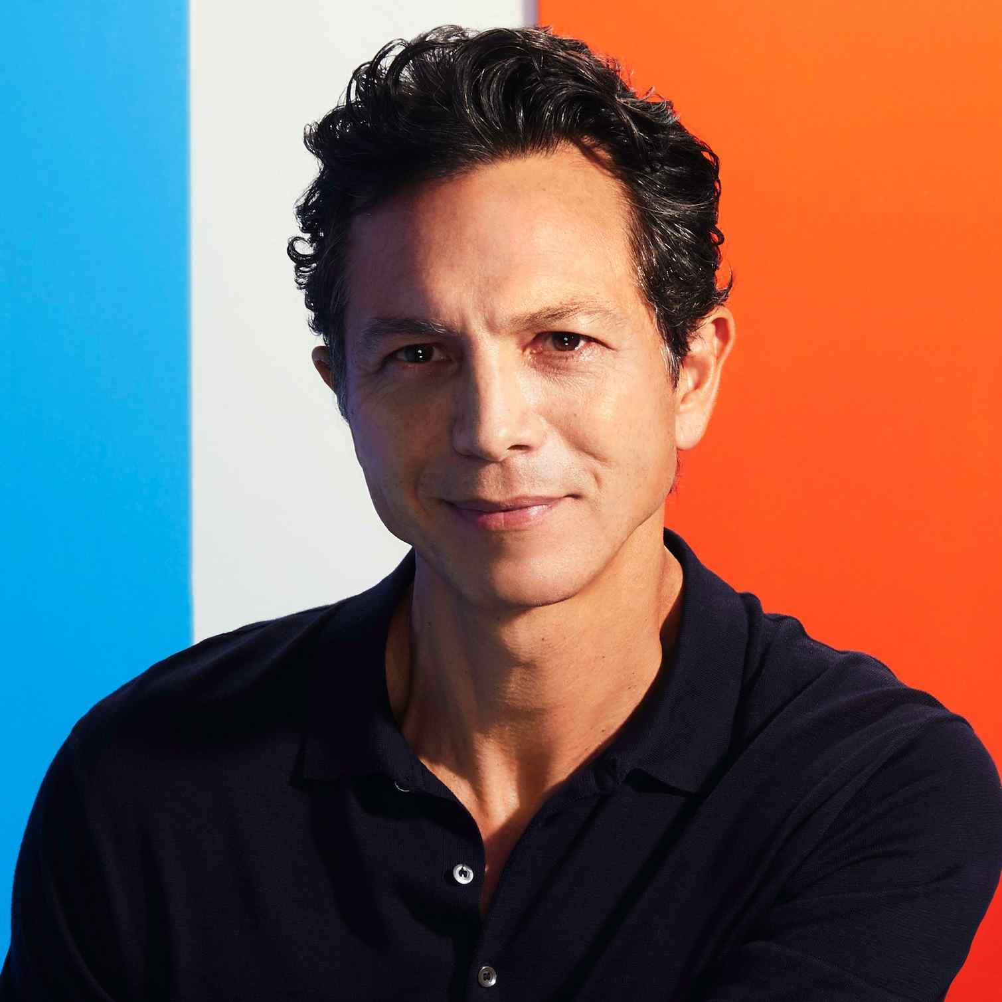

In 2010, Bratt won Cinequest’s Maverick Spirit Award for his work as producer and star of the acclaimed independent hit La Mission. Bratt served as Consulting Producer for “Dolores.” Numerous accolades for the film include the Audience Award for Best Documentary Feature at the San Francisco International Film Festival and the Audience Award for Best Feature Film at the Houston Latino Film Festival.

Currently, Bratt voices the famed musician Ernesto de la Cruz in Pixar’s critically lauded film Coco, which premiered in theatres November 22, 2017. Just weeks since its release, the animated picture has already received multiple accolades including awards for Best Animated Film by the National Board of Review and the New York Film Critics Circle.

On television, audiences perhaps best recognize Bratt from his Emmy-nominated role as Detective Rey Curtis on NBC’s long-running drama Law & Order. He also previously starred in the ABC drama Private Practice and in a recurring role as Sofia Vergara’s ne’er-do-well ex-husband Javier on Modern Family. Bratt can now be seen in Lee Daniels’s Star on Fox.

Peter Bratt (Producer/Writer/Filmmaker) is an award-winning screenwriter and independent filmmaker whose first feature Follow Me Home premiered in competition at the 1996 Sundance Film Festival and won the Best Feature Film Audience Award that same year at the San Francisco International Film Festival. In 2009, he and his brother Benjamin produced La Mission, a feature film shot on location in their hometown of San Francisco. The film, which Bratt wrote and directed, premiered at the 2009 Sundance Film Festival and was the opening night film at the 2009 San Francisco International Film Festival, the 2009 New York International Latino Film Festival and the 2009 Outfest Film Festival in Los Angeles. For his work on La Mission, Peter received the prestigious Norman Lear Writer’s Award and was one of 10 American independent filmmakers selected by Sundance and the President’s Committee on Arts and Humanities to launch Sundance Film Forward, a program that uses film and conversation to excite and introduce a new generation to the power of story. Bratt is a San Francisco Film Commissioner and a longtime consultant for the Friendship House Association of American Indians, a local non-profit serving the Bay Area’s Native population.


