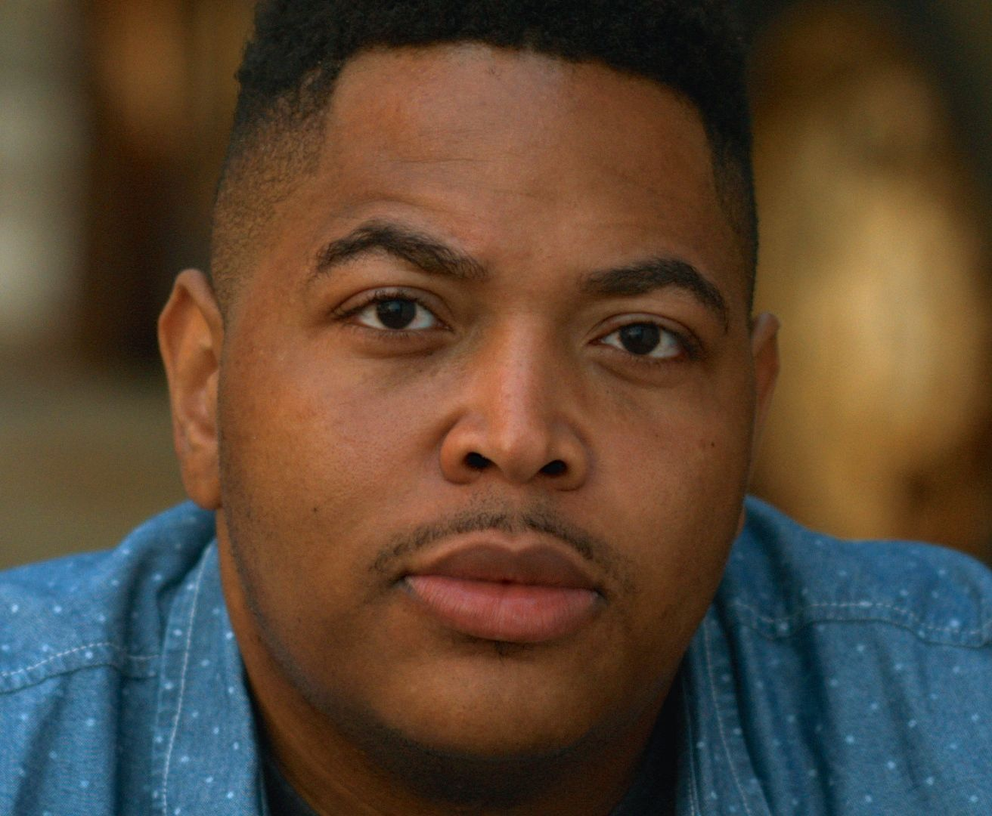

Independent Lens Presents Evolution of a Criminal
Monday, January 12, 2015 on PBS

About the Filmmaker

Darius Clark Monroe (Director, Producer, Subject) attended Willowridge High School in Houston, where he was an honors student taking advance placement courses. In his junior year, he and two classmates robbed a Bank of America branch near their high school. Convicted of the crime, Monroe was sentenced to five years in prison; while serving time he obtained his GED and took college courses, eventually deciding that he wanted to become a filmmaker. In 2004, Monroe graduated with honors from the University of Houston with a BA in Communications: Media Production, and subsequently received an MFA from NYU’s Tisch School of the Arts. An award-winning filmmaker, Monroe is a National Board of Review, HBO Short Film and Urbanworld Best Screenplay award recipient. Most recently, he was selected to participate in the prestigious Screenwriters Colony and chosen as a fellow at the Sundance Institute Screenwriters Intensive. Evolution of a Criminal is his first feature film and is the recipient of an Austin Film Society Grant, Spike Lee Production Fellowship, Warner Bros. Film Award, Cinereach Grant, King Finishing Award, Tribeca All Access Participant, and a selectee of the IFP Documentary Lab.

###

