FERGUSON RISES
TCA Bios

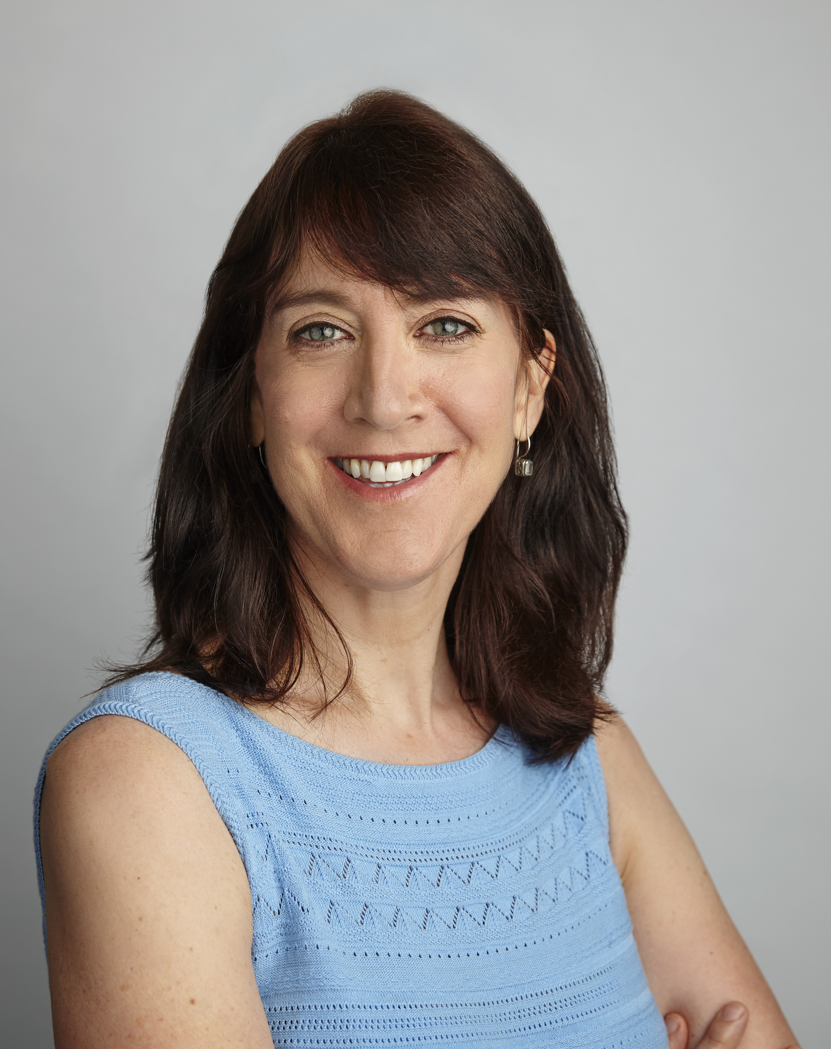
Lois Vossen (Moderator, Independent Lens EP)

Lois Vossen is the founding Executive Producer of PBS’s award winning series Independent Lens and serves on the Television Academy Board of Governors, representing the documentary branch and is a member of the Academy of Motion Picture Arts & Sciences (AMPAS). Under her leadership, the series has been named Best Documentary Series four times by the International Documentary Association (IDA), has earned more than 40 Emmy ® Awards and Peabody Awards.

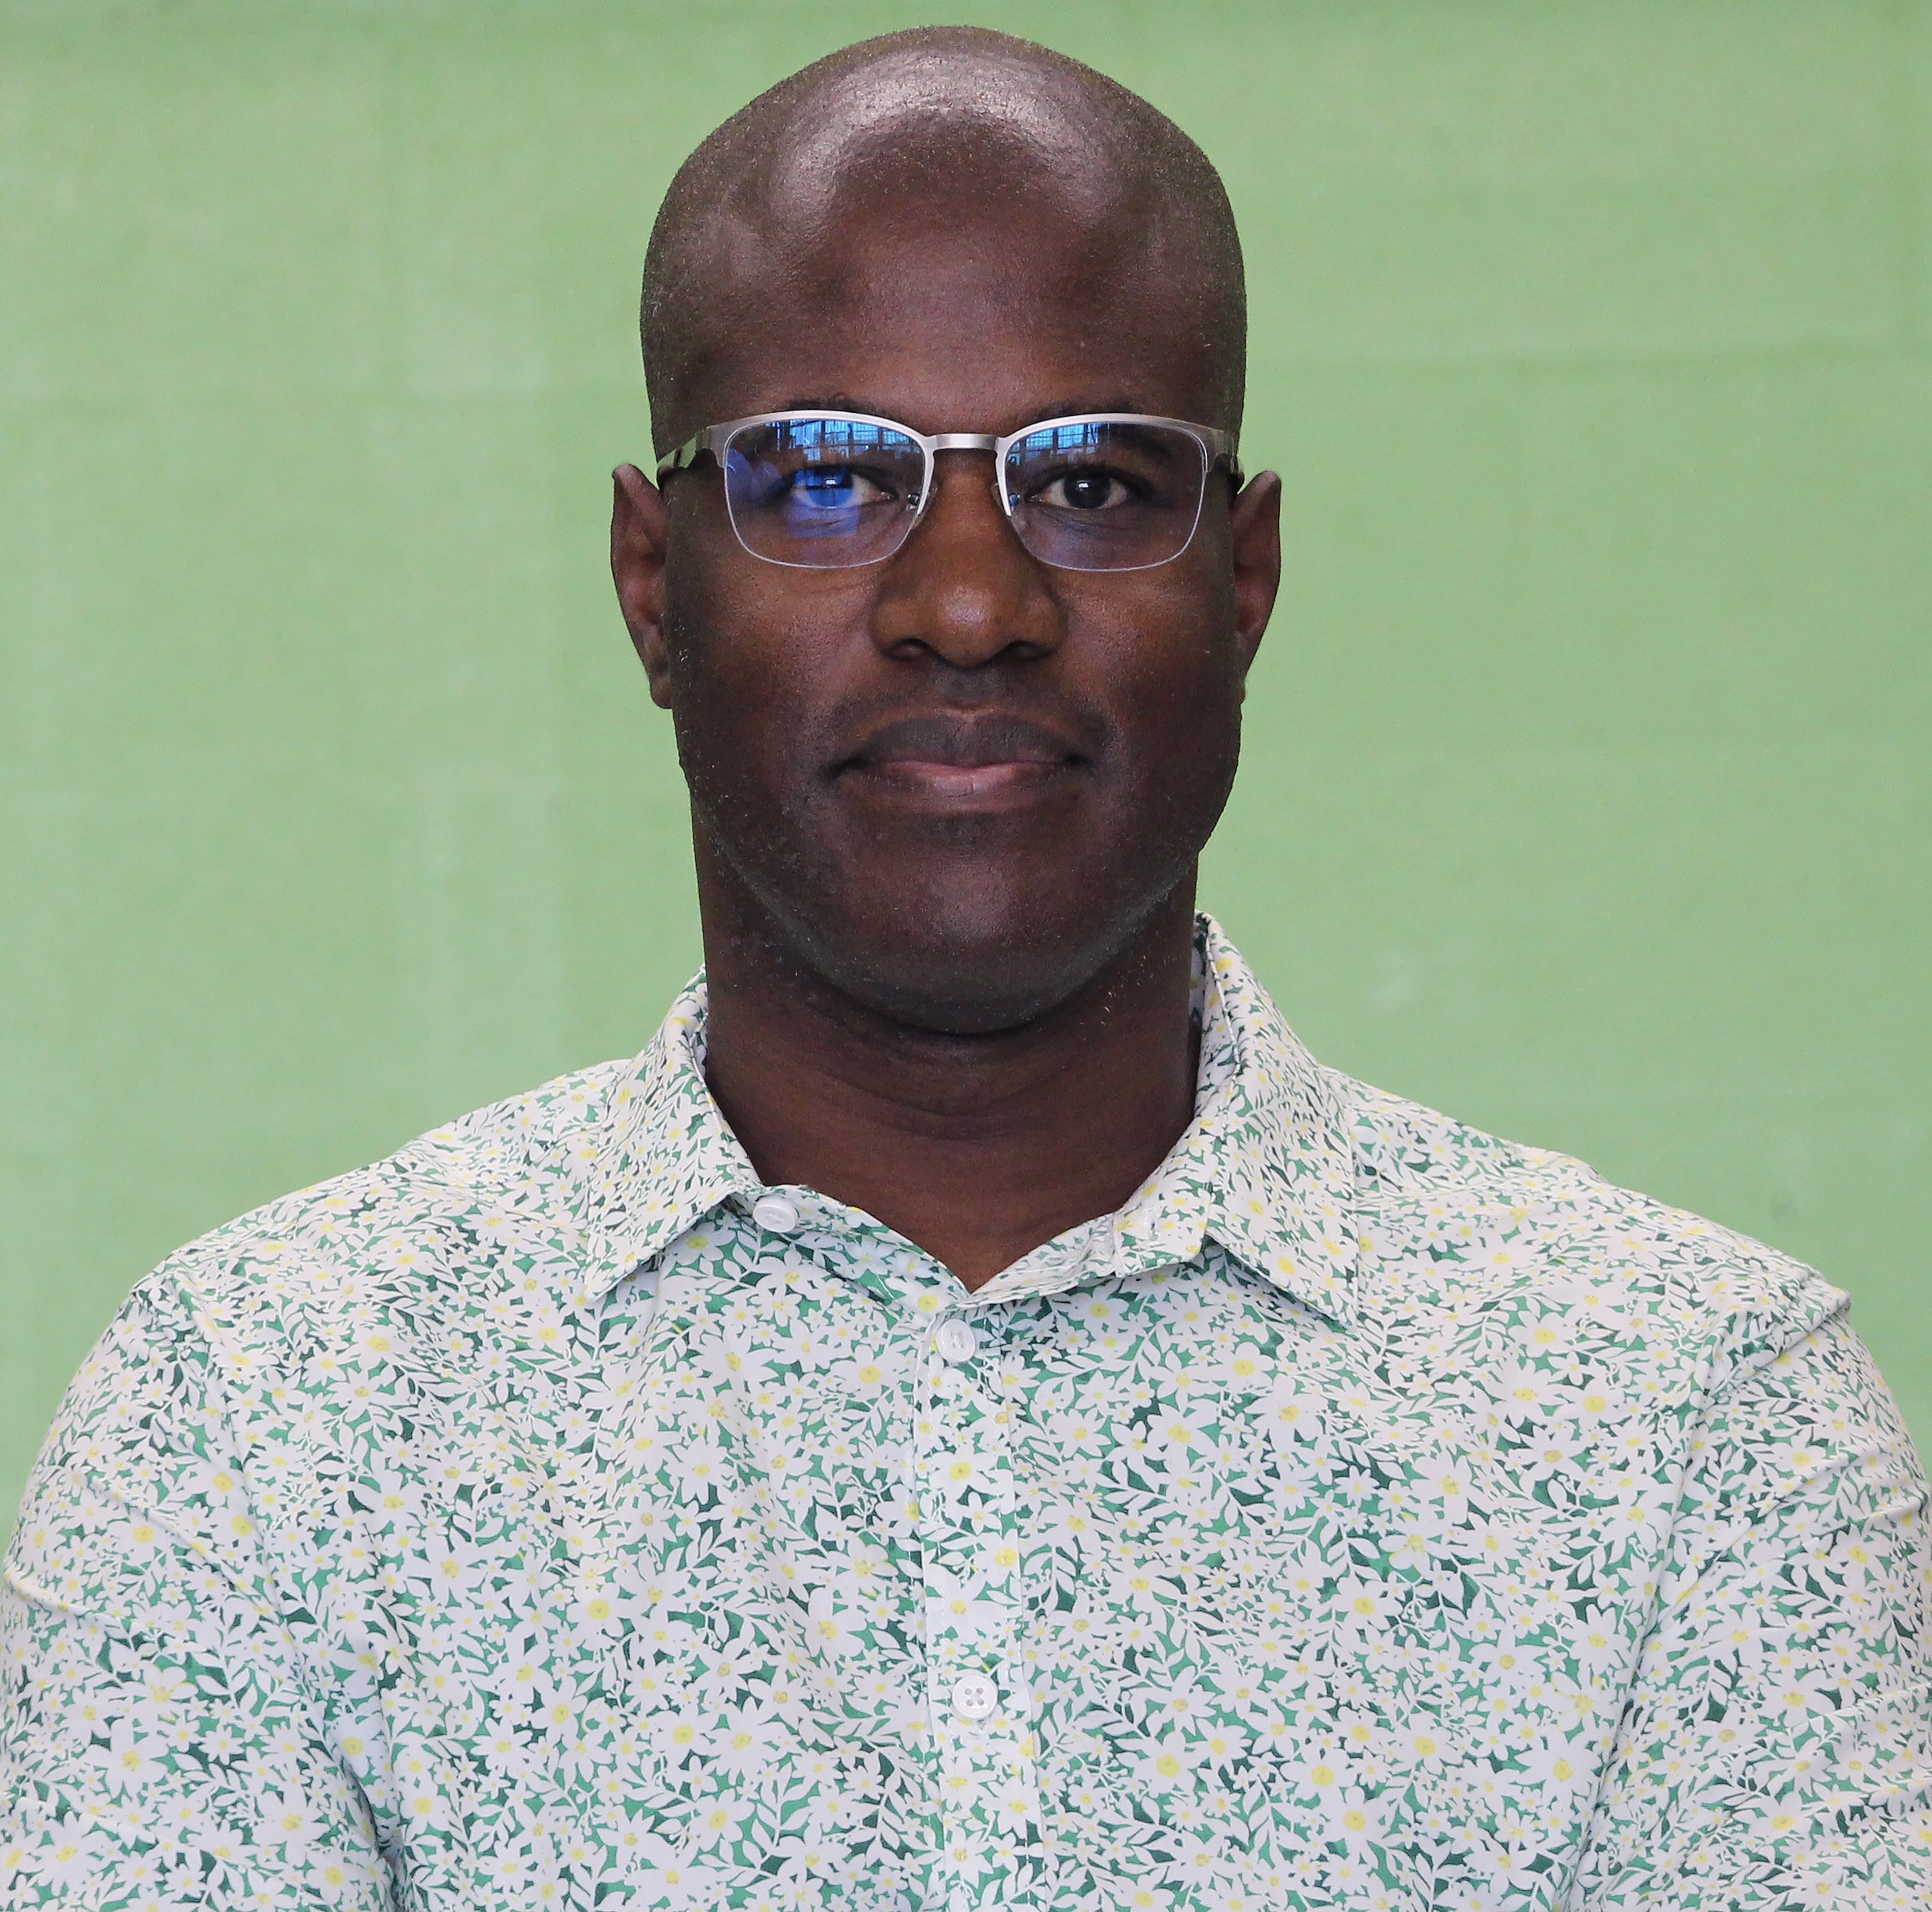
Mobolaji Olambiwonnu (Director)

Mobolaji Olambiwonnu is a graduate of UCLA and AFI. He is the recipient of the Directors Guild of America Student Filmmaker Award. Besides freelance film work, Mobolaji has also worked in the fields of education, conflict resolution, and community organizing. His community-based experience is the conscience behind his work. Ferguson Rises is Mobolaji’s first feature film.

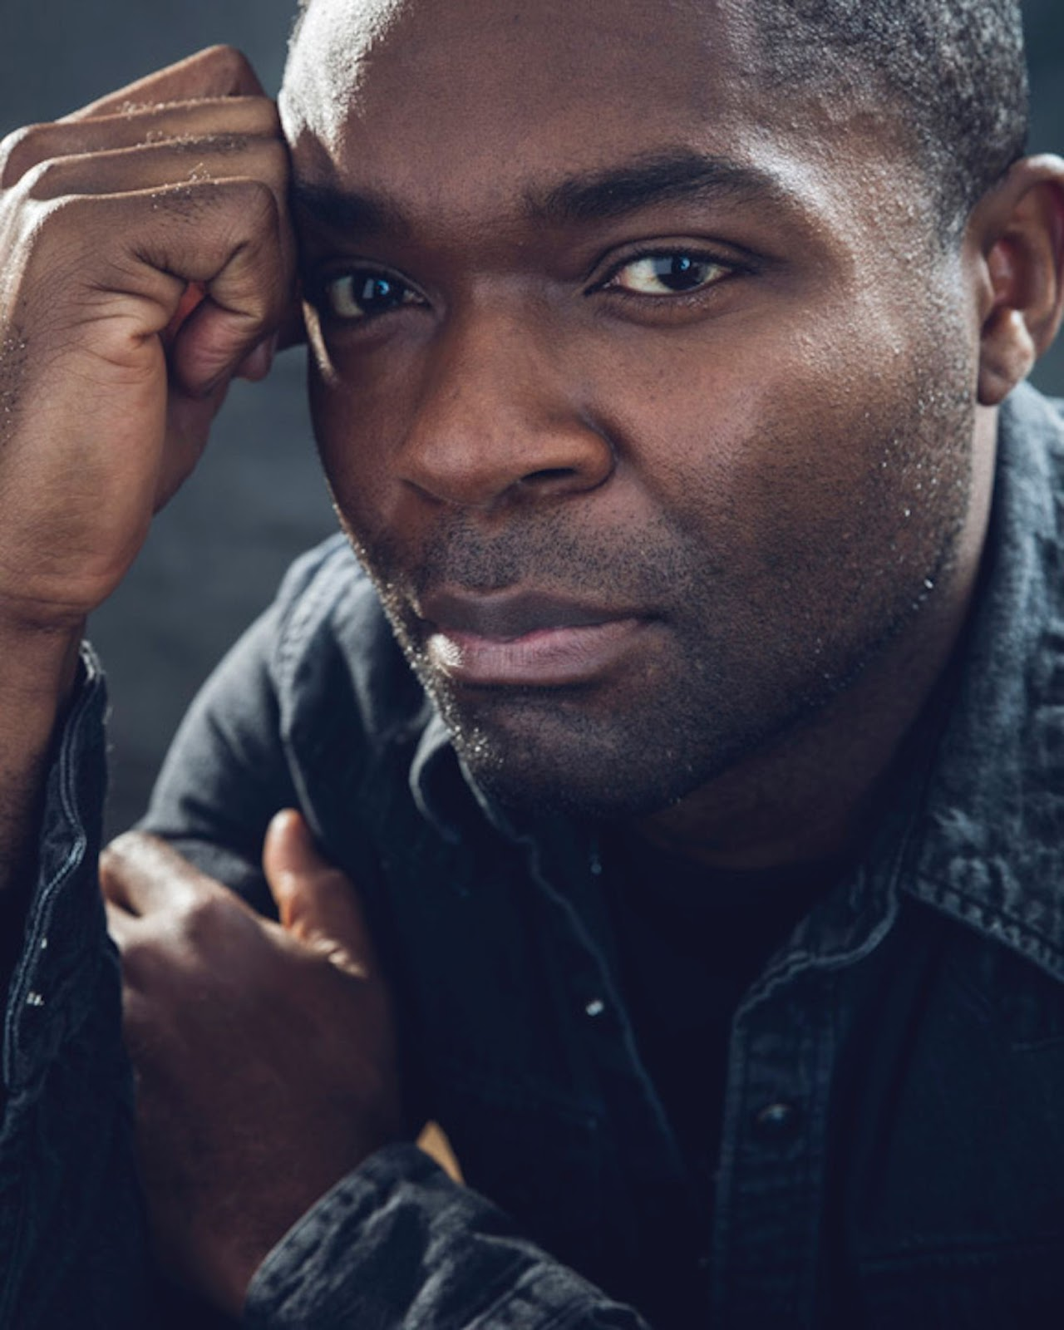
David Oyelowo (Producer)

David Oyelowo, is a multiple Golden Globe, BAFTA, and Emmy-nominated actor and producer. Oyelowo recently made his directorial debut with the critically acclaimed The Water Man, released domestically by RLJE Films and internationally by Netflix in Summer 2021. Oyelowo stars alongside Lonnie Chavis and Rosario Dawson, as well as, produces under his Yoruba Saxon banner that he founded with his wife, Jessica. Yoruba Saxon is focused on creating values-based content, across all platforms and for all quadrants, with an aim to shift the culture and color outside the lines. As artists and filmmakers, the Oyelowo’s are committed to expressing their love of storytelling and passion for people through entertainment for a global audience. Yoruba Saxon has a first-look deal with Walt Disney Pictures for feature length films. Previous film and television projects include: Nightingale (HBO), Captive (Paramount), A United Kingdom (Fox Searchlight), Come Away (Relativity Media), Five Nights in Maine (FilmRise), the upcoming Solitary (BRON Studios) and First Gen (Disney+).

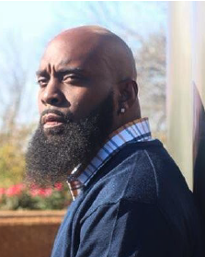
Michael Brown Sr. (film subject, father of Michael Brown Jr.)

Michael Brown, Sr. is a husband, father of four, step-up father to five and a Papa to one beautiful granddaughter. He is a Transformative Speaker, Forgiveness Coach, and he and his wife Cal Brown are Co-Founders of the Michael Brown Foundation DBA Chosen For Change. The foundation was formed in 2014 after the tragic murder of their son Mike Brown, Jr. in Ferguson, Missouri. Mr. and Mrs. Brown have chosen to turn their pain into purpose and build a legacy in memory of Mike, Jr.

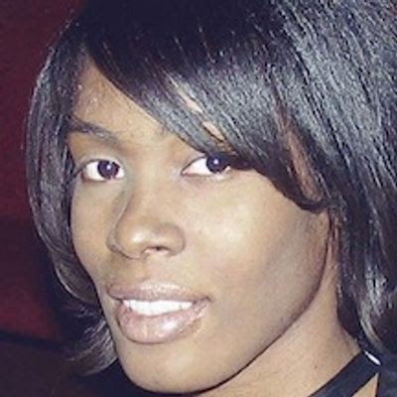
Heather Taylor (film subject, retired St. Louis Police Sgt.)

Heather Taylor is a retired Police Sgt. (Homicide Division), current Senior Advisor to the Public Safety Director of the City of St. Louis, and long-time advocate for police reform. As an officer and police association president for the Ethical Society of Police (ESOP), she co-authored a comprehensive evaluation of the SLMPD. Those reports exposed rampant police corruption, racism, cronyism, and other biases in law enforcement that hindered community cooperation. During her tenure as president, Heather introduced the ESOP Pre-Academy Recruitment Program, where prospective hires were taught courses on de-escalation, importance of ethics, community outreach, mental health awareness, and more.

