Look & See: Wendell Berry’s Kentucky
FOR IMMEDIATE RELEASE

CONTACT
Donna Hardwick, ITVS 415-356-8383 donna.hardwick@itvs.org
Mary Lugo 770-623-8190 lugo@negia.net
Cara White 843-881-1480 cara.white@mac.com
For downloadable images, visit pbs.org/pressroom/
Premieres on Independent Lens
Monday, April 23, 2018 on PBS

Online Streaming Begins April 24

A Lyrical Portrait of the Writer, Poet, Farmer and Environmental Activist

(San Francisco, CA) — Look & See: Wendell Berry’s Kentucky is a cinematic portrait of the changing landscapes and shifting values of rural America in an era of industrial agriculture, as seen through the mind’s eye of writer, farmer, and activist Wendell Berry. Through his poetic and prescient words and the testimonies of his family and neighbors — all deeply affected by the industrial and economic changes to their agrarian way of life — we see the changing landscapes of rural America and the redemptive beauty in taking the unworn path. Often called “a prophet for rural America,” Berry has long been a voice for communities frequently overlooked by the media. Directed by Laura Dunn and executive produced by Terrence Malick and Robert Redford, Look & See: Wendell Berry’s Kentucky premieres on Independent Lens Monday, April 23, 2018, 10:00-11:00 PM ET (check local listings) on PBS.
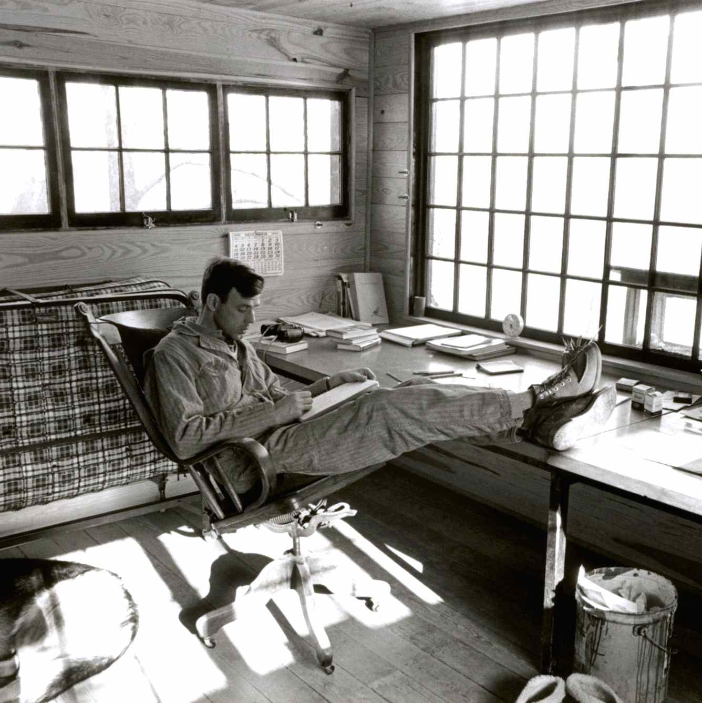
Credit: James Baker Hall

In 1965, after living in California, Europe and New York, Wendell Berry returned home to Henry County, bought a small farmhouse and began a life of farming, writing, and teaching. This lifelong relationship with the land and community would come to form the core of his prolific writings. A half century later, Henry County — like many rural communities across America — has become a place of quiet ideological struggle. In the span of a generation, the agrarian virtues of simplicity, land stewardship, sustainable farming, local economies, and rootedness to place have been replaced by a capital-intensive model of industrial agriculture characterized by machine labor, chemical fertilizers, soil erosion, and debt — all of which have frayed the fabric of rural communities. Writing from a long wooden desk beneath a forty-paned window overlooking the land, Berry has watched this struggle unfold, becoming one the most passionate and eloquent voices in defense of agrarian life.

Filmed across four seasons in the farming cycle, Look & See: Wendell Berry’s Kentucky combines observational scenes of farming life and interviews with farmers and community members with lyrical and evocative shots of the surrounding landscape. Thus, in the spirit of Berry’s agrarian philosophy, Henry County itself emerges as a character in the film, a place and a landscape that is deeply interdependent with the people that inhabit it.

Visit the Look & See page on Independent Lens, which features more information about the film, which will be available for online viewing on the site beginning April 24, 2018.

About Wendell Berry

Wendell Berry was born in Henry County, Kentucky, in 1934. He earned a bachelor’s degree from the University of Kentucky in 1956 and continued on to complete a master’s degree in 1957. In 1958, he received a Wallace Stegner Fellowship from Stanford University. Berry has taught at Stanford University, Georgetown College, New York University, the University of Cincinnati, and Bucknell University. He taught at his alma mater, the University of Kentucky, from 1964-77 and from 1987-93.

The author of more than 40 works of fiction, nonfiction, and poetry, Wendell Berry has been the recipient of numerous awards and honors, including a Guggenheim Foundation Fellowship (1962), the Vachel Lindsay Prize for Poetry (1962), a Rockefeller Foundation Fellowship (1965), a National Institute of Arts and Letters award for writing (1971), the Emily Clark Balch Prize from The Virginia Quarterly Review (1974), the American Academy of Arts and Letters Jean Stein Award (1987), a Lannan Foundation Award for Non-Fiction (1989), membership in the Fellowship of Southern Writers (1991), the Ingersoll Foundation's T. S. Eliot Award (1994), the John Hay Award (1997), the Lyndhurst Prize (1997), and the Aitken-Taylor Award for Poetry from The Sewanee Review (1998). His books include the novel Hannah Coulter (2004), the essay collections Citizenship Papers (2005) and The Way of Ignorance (2006), and Given: Poems (2005), all available from Counterpoint. Berry's latest works include The Mad Farmer Poems (2008) and Whitefoot (2009). In 2015 he became the first living writer named to the Kentucky Writers Hall of Fame.

Berry lives and works with his wife, Tanya Berry, on their farm in Port Royal, Kentucky.

About the Filmmakers

Laura Dunn (Director/Producer/Editor) started making documentaries in response to her undergraduate experience at Yale University. Through a chronicle of labor strikes on campus, The Subtext of a Yale Education examines the corporatization of higher education. She then returned to her birthplace to make Green, a sobering look at environmental racism along the Mississippi River petrochemical corridor, a.k.a. “Cancer Alley.” Other work includes experimental films Baby, a personal take on population issues, and Become the Sky, an ecological map of power in Texas. Her first feature documentary, The Unforeseen, executive produced by Robert Redford and Terrence Malick, premiered at the Sundance Film Festival, was released theatrically, and broadcast on the Sundance Channel. Look & See: Wendell Berry’s Kentucky premiered at Sundance and Berlinale, won a Visual Design Prize at SXSW and the Grand Jury Prize at the Nashville Film Festival. Other honors include a Rockefeller Media Arts Fellowship, Student Academy Award, Yale’s Trumbull Fine Arts Prize, International Documentary Association Pare Lorenz Grant and an Independent Spirit “Truer than Fiction” Award. She lives in Austin, Texas with her husband and six young boys.

Jef Sewell (Co-Director/Producer/Visual Designer) acted as producer on Laura Dunn’s first feature documentary The Unforeseen. In addition to fundraising and extensive on-location work, Jef designed The Unforeseen’s motion graphic sequences for which he was nominated for Outstanding Achievement in Graphics and Animation at the inaugural Cinema Eye awards.
Jef is also Founder/CEO of Austin-based Amplifier, a vertically-integrated merchandising logistics firm that serves well-known Internet brands such as MailChimp, Rooster Teeth, Reddit, Geek and Sundry, Slack, InVision and many others.

CREDITS

Directed by Laura Dunn
Co-Directed by Jef Sewell
Produced by Laura Dunn, Jef Sewell
Director of Photography Lee Daniel
Co-Produced by Owsley Brown III, Gill Holland,
Elaine Musselman and Nick Offerman
Edited by Laura Dunn
Executive Producers Terrence Malick and Robert Redford
Original Music by Kerry Muzzey
Visual Design by Jef Sewell
Sound by Justin Hennard
Associate Producer/Field Producer Lynsey Jones
Wood Engravings by Wesley Bates

About Independent Lens

Independent Lens is an Emmy® Award-winning weekly series airing on PBS Monday nights at 10:00 PM. The acclaimed series, with Lois Vossen as executive producer, features documentaries united by the creative freedom, artistic achievement, and unflinching visions of independent filmmakers. Presented by ITVS, the series is funded by the Corporation for Public Broadcasting, a private corporation funded by the American people, with additional funding from PBS, the John D. and Catherine T. MacArthur Foundation, Wyncote Foundation, and the National Endowment for the Arts. For more visit pbs.org/independentlens. Join the conversation: facebook.com/independentlens and on Twitter @IndependentLens.

###

