FOR IMMEDIATE RELEASE

CONTACT
Lisa Tawil, ITVS 415-356-8383 lisa_tawil@itvs.org
Mary Lugo 770-623-8190 lugo@negia.net
Cara White 843-881-1480 cara.white@mac.com
For downloadable images, visit pbs.org/pressroom/
Peace Officer Premieres on Independent Lens
Monday, May 9, 2016 on PBS

Former Sheriff’s Search for Truth Raises Questions
About the Dangers of Increased Militarization of American Police
“My name is William J. ‘Dub’ Lawrence. I was elected county sheriff of Davis County in 1974. On the 22nd of September, 2008, the very SWAT team that I founded in the 1970s killed my son-in-law, in my presence, as I defended them to his father, and his mother, and my children, promising them that these men were trained and professional and knew what they were doing.”
(San Francisco, CA) – Winner of both the Grand Jury and Audience Awards for Best Documentary at the 2015 SXSW Film Festival, Peace Officer is the story of William “Dub” Lawrence, a former sheriff who established and trained one of Utah’s first SWAT teams — only to watch in horror as that same unit killed his son-in-law in a controversial standoff years later. Driven by an obsessive sense of mission, Lawrence uses his investigative skills to uncover the truth about that incident and other officer-involved shootings in his community, while tackling larger questions about the changing face of peace officers nationwide. Directed by Scott Christopherson and Brad Barber, Peace Officer premieres on Independent Lens Monday, May 9, 2016, 9:00-10:30 PM ET (check local listings) on PBS.
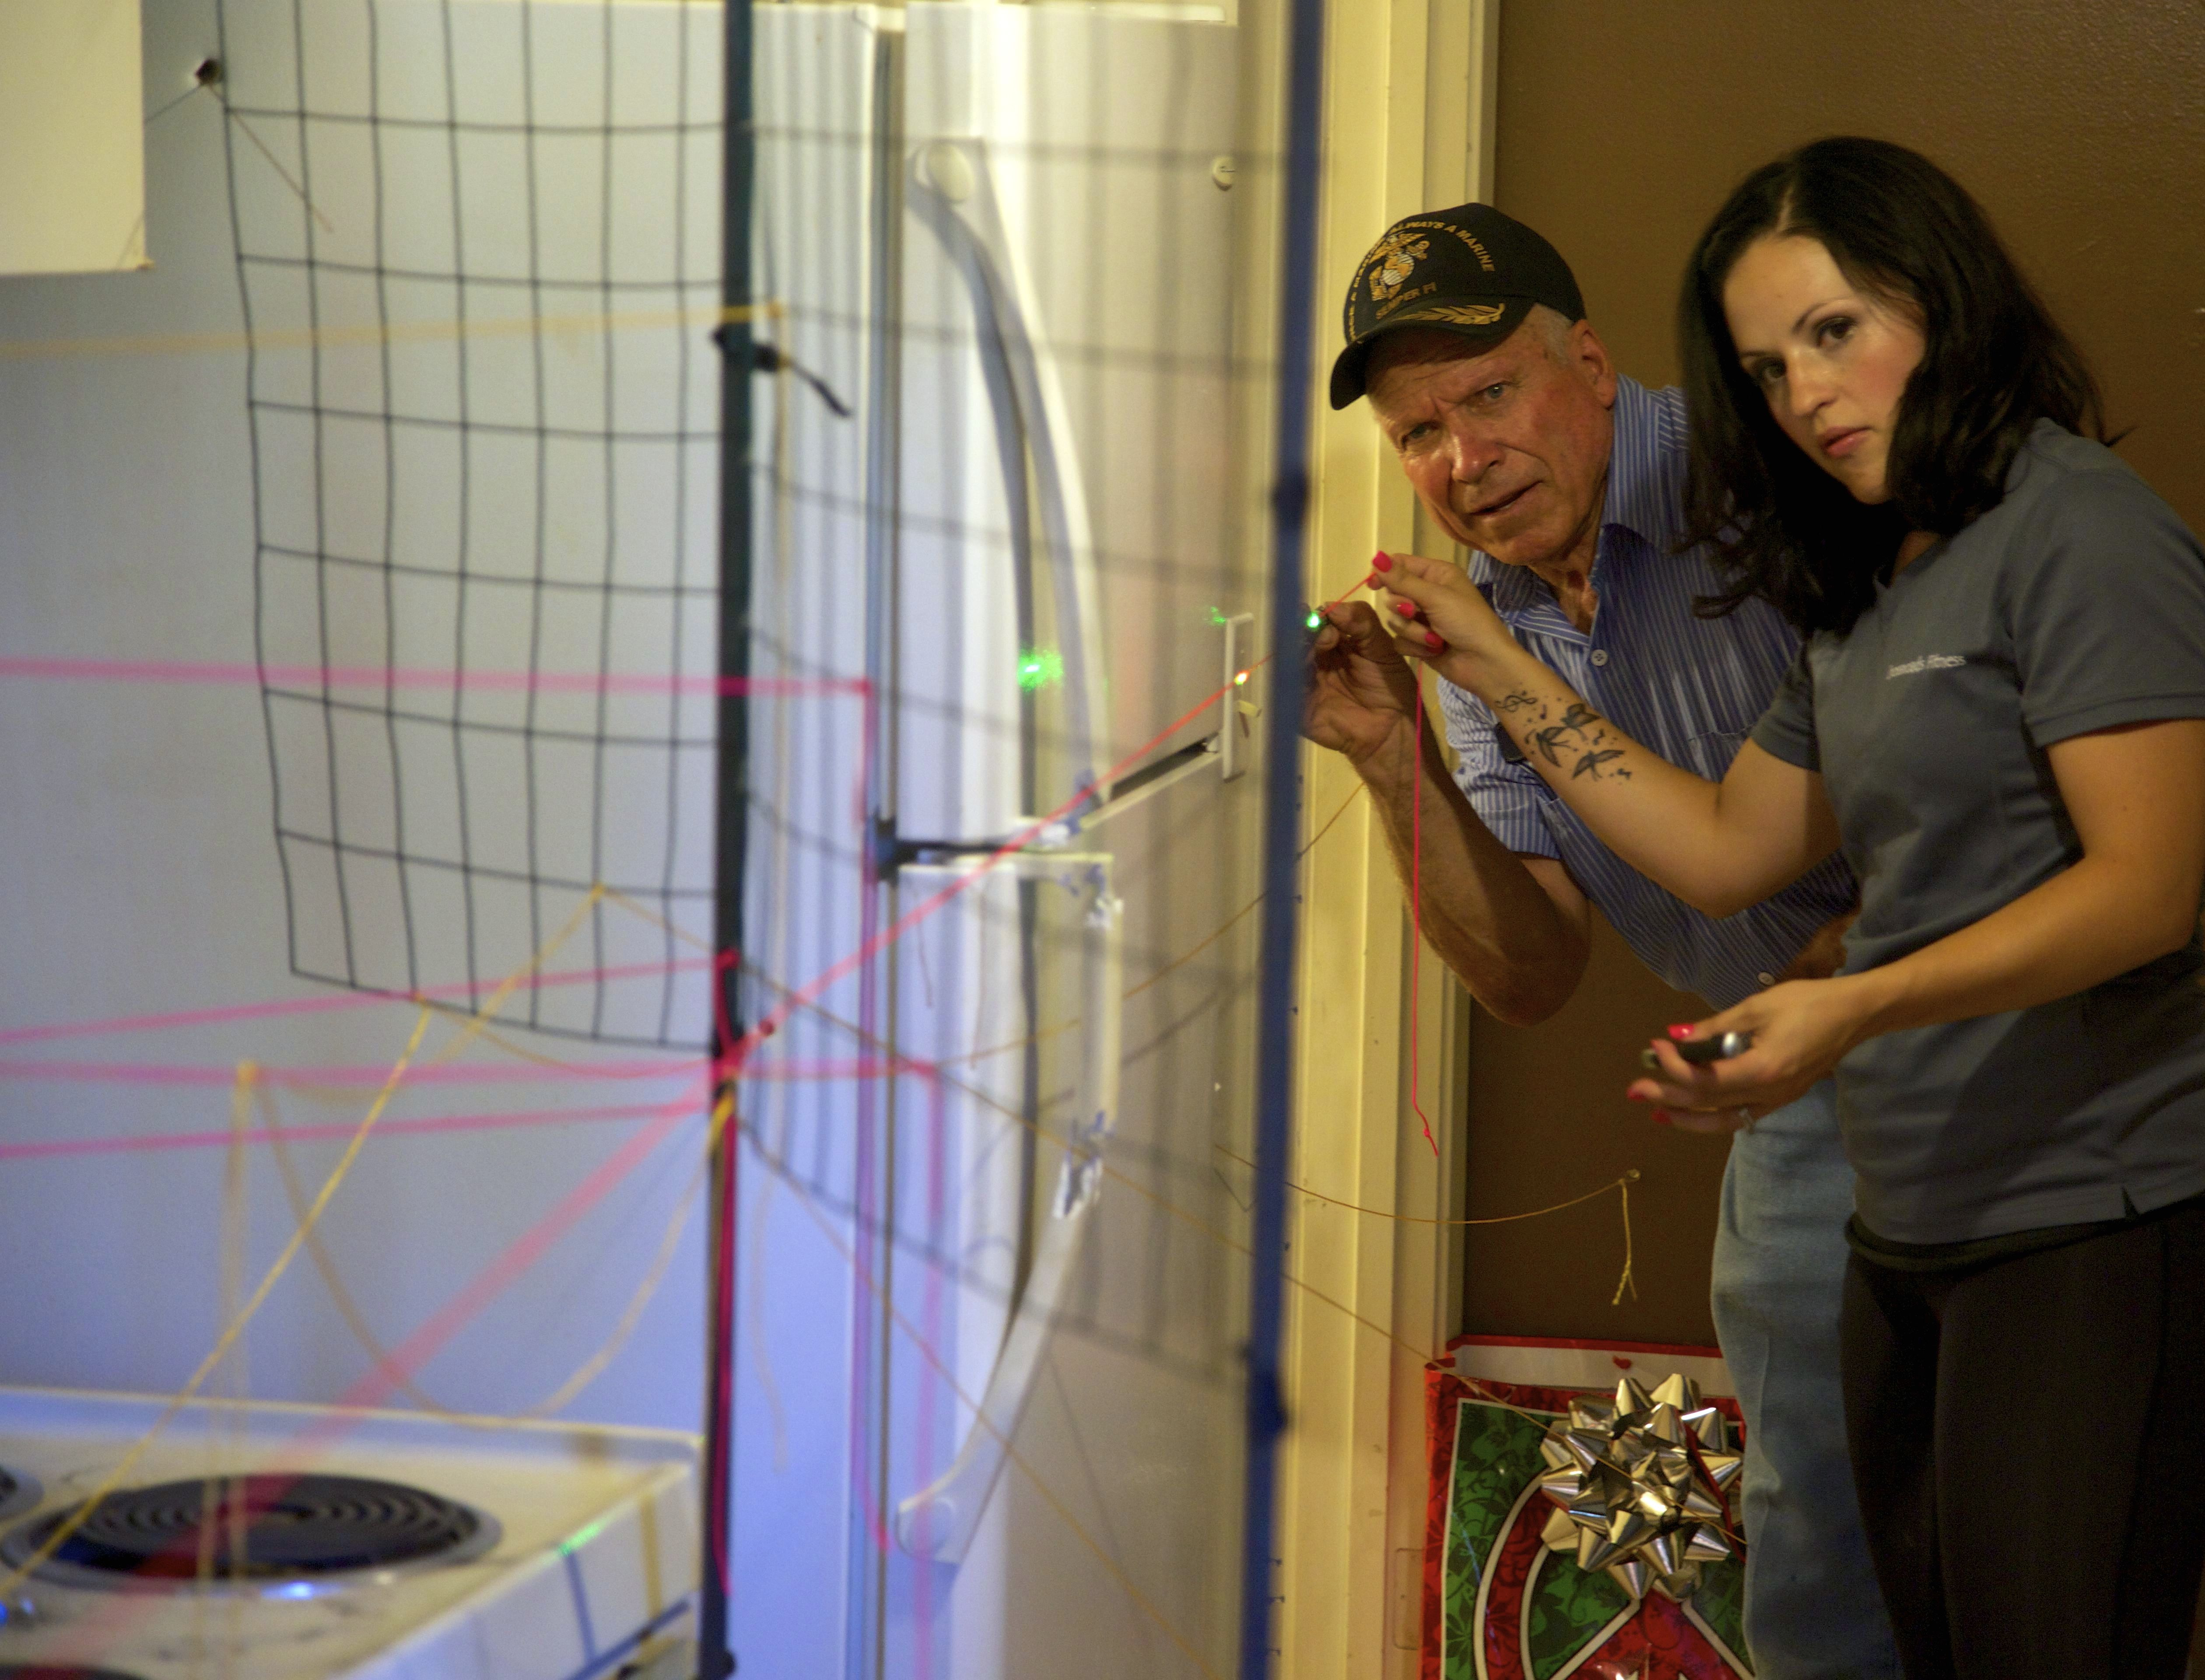
Dub Lawrence and Erna Stewart reconstruct the path of bullets.
Credit: Jared Jakins.

His commitment to turn around the systemic failings he saw as a young officer led to a successful bid to become Sheriff of Davis County, Utah, in 1974. As a newly elected Sheriff, Lawrence used his skills to help break the Ted Bundy case. Committed to the highest standards of peace officers serving the public good, he once wrote himself a parking ticket when a citizen called him out for his patrol car's violation.

After years in public service, Lawrence now works in semi-retirement as a private investigator on projects fueled mostly by income from his water and sewage pump repair service. When he's not wading through raw sewage, his remaining free time is spent investigating the shooting death of his son-in-law Brian Wood.

Using painstaking and exhaustive forensic techniques to find and examine evidence the police have overlooked, Lawrence reconstructs what happened to Wood on the day of his death.
His investigation reveals the tragic mistakes and problems created by the multiple SWAT teams involved in the arrest of one desperate man in his parked truck threatening no one but himself, and laments what the SWAT team he founded 30 years earlier has become.

Lawrence’s long-term obsession with bringing to light the truth behind Wood’s killing is entwined with his investigations of other recent officer-involved shootings and SWAT team raids in quiet neighborhoods just miles from where his son-in-law was killed. Several of these cases are related to aggressive no-knock search warrant laws typical across the country.

These events are contextualized within the growing problem of violent SWAT raids and governmental immunity laws established as part of the War on Drugs. Officers in cities and small towns are routinely armed with military surplus weapons and equipment, backed by federal incentives to use what they are given. These and other factors have led to a 15,000% increase in SWAT team raids in the United States since the late 1970s.

Peace Officer follows Dub as he doggedly picks apart these cases with the zeal of a rule-of-law detective combined with the grief of a victim.

Visit the Peace Officer page on Independent Lens, which features more information about the film.

About the Filmmakers

Scott Christopherson (Director, Producer, Cinematographer), a native of York, Pennsylvania, worked as an undergraduate for Harvard University’s Ross McElwee on the film In Paraguay (2008). McAlwee then helped guide Christopherson’s first film Only the Pizza Man Knows, which was broadcast internationally on the satellite cable network BYUtv. Christopherson subsequently worked as the Documentary Arts director/instructor for Spy Hop Productions and the Sundance Institute’s youth documentary workshops. Films made by his students went on to win multiple awards locally and internationally. While attending graduate school in San Francisco, Christopherson shot, directed, and edited over 20 short films for Project Runway’s season six website. He received his MFA in documentary cinema from San Francisco State University and also earned an MA degree in Anthropology from UW-Madison. He was an assistant professor of documentary film at St. Edward’s University in Austin, Texas, prior to relocating back to Provo, where he is teaches non-fiction film at Brigham Young University.

Brad Barber (Director, Producer, Cinematographer), who was named to Variety's “10 Documakers to Watch” list in 2015, is an Emmy-nominated filmmaker who works in multiple forms and genres. Peace Officer, his feature directing debut, won the Grand Jury Prize and the Audience Award at the 2015 South by Southwest Film Festival, the Human Rights Award at Full Frame Documentary Film Festival, and the David Carr Award for Truth in Non-Fiction Filmmaking at the Montclair Film Festival, among other festival honors. The film was recently announced as a recipient of the AFI Docs/NBC Universal Impact Grant for social outreach, and is a current Cinema Eye Honors nominee. In 2009 Barber was nominated for an Emmy for his work as an editor on the HBO documentary Resolved, for which he also served as an associate producer and cinematographer, and he has won multiple regional Emmys for his public television documentary series Beehive Stories. Immediately after completing his undergraduate work in non-fiction film and journalism in 2001, Barber got his start professionally through a stroke of luck when he was asked to shoot a documentary across five continents. After returning to the states he attended USC, where he received an MFA in Cinema-Television Production. He then worked in Los Angeles as an editor, cinematographer, and director/ producer of documentary film and television with credits on Showtime, ESPN, Discovery Channel, and many others. His shorts and feature film work have been shown at film festivals and art museums around the world. Barber, who lives in Provo, Utah, currently works as an independent filmmaker and professor and is married to artist Susan Krueger-Barber. Together they have two amazing sons. Barber was born in Walnut Creek, California, and raised in Knoxville, Tennessee.

CREDITS

Directed by Scott Christopherson
Brad Barber
Produced by Scott Christopherson
Brad Barber
Dave Lawrence
Executive Producers Sterling Van Wagenen
Roger Fields
Scott Christopherson
Dave Lawrence
Brad Barber
Marcy Garriott
Clark & Jesse Lyda
Director of Photography Brad Barber
Scott Christopherson
Editor Renny McCauley
Original Music by Micah Dahl Anderson

About Independent Lens

Independent Lens is an Emmy® Award-winning weekly series airing on PBS Monday nights at 10:00 PM. The acclaimed series features documentaries united by the creative freedom, artistic achievement, and unflinching visions of independent filmmakers. Presented by Independent Television Service, the series is funded by the Corporation for Public Broadcasting, a private corporation funded by the American people, with additional funding from PBS and the John D. and Catherine T. MacArthur Foundation. For more visit pbs.org/independentlens. Join the conversation: facebook.com/independentlens and on Twitter @IndependentLens.

###

