Stanley Nelson’s Tell Them We Are Rising: The Story of Black Colleges and Universities Premieres on Independent Lens
FOR IMMEDIATE RELEASE

CONTACT
Donna Hardwick, ITVS 415-356-8383 donna.hardwick@itvs.org
Mary Lugo 770-623-8190 lugo@negia.net
Cara White 843-881-1480 cara.white@mac.com
For downloadable images, visit pbs.org/pressroom/

Monday, February 19, 2018 on PBS

Online Streaming Begins February 20

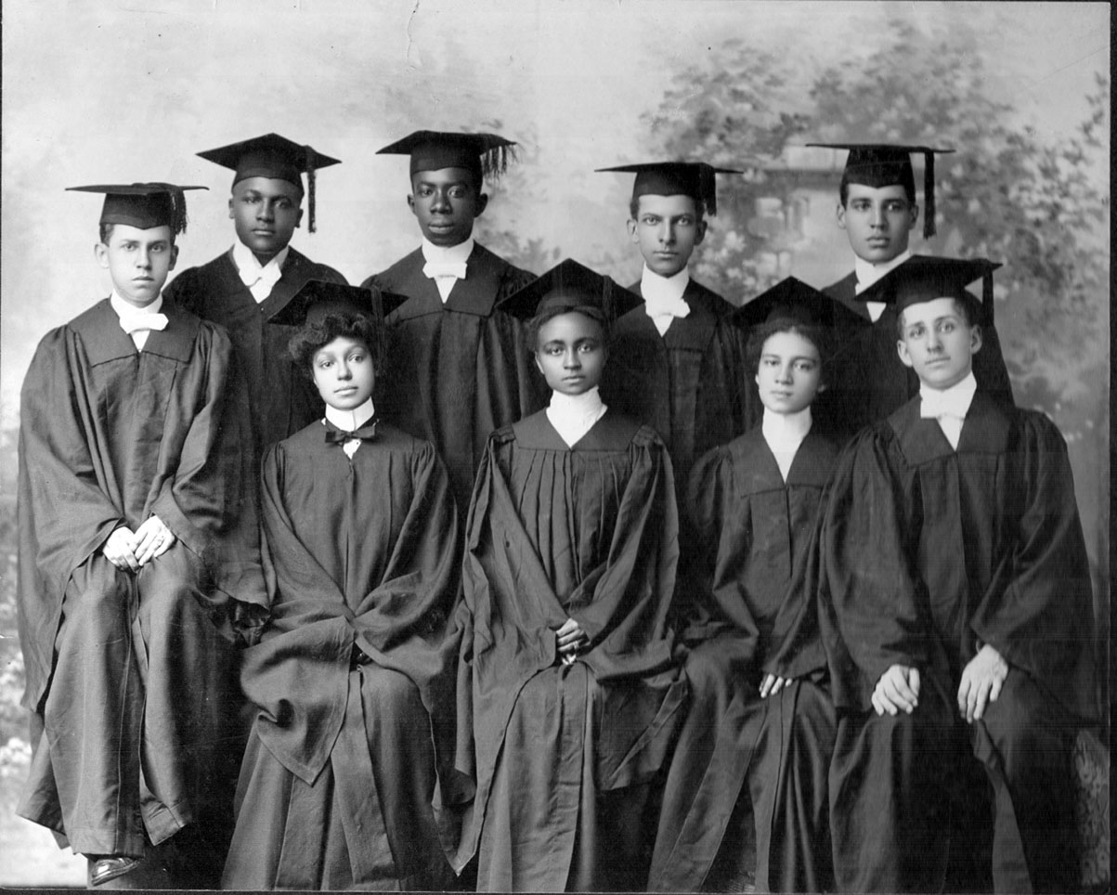
Graduates of Atlanta University, early 1900s.
Credit: Atlanta University Center
(San Francisco, CA) — The rich history of America’s Historically Black Colleges and Universities (HBCUs) began before the end of slavery, flourished in the 20th century, and profoundly influenced the course of the nation for more than 150 years — yet remains largely unknown. With Tell Them We Are Rising: The Story of Black Colleges and Universities, the latest documentary from Stanley Nelson (Black Panthers, Freedom Riders), America’s foremost film chronicler of the African-American experience, the powerful story of the rise, influence, and evolution of HBCUs comes to life.Tell Them We Are Rising, co-directed and co-produced by Marco Williams, premieres on Independent Lens, Monday, February 19, 2018, 9:00-10:30 PM ET (check local listings) on PBS.

A haven for Black intellectuals, artists, and revolutionaries — and a path of promise toward the American Dream — HBCUs have educated the architects of freedom movements and cultivated leaders in every field while remaining unapologetically Black for more than 150 years. These institutions have nurtured some of the most influential Americans of our time, from Booker T. Washington to Martin Luther King, Jr., W.E.B. Du Bois to Ralph Ellison, Toni Morrison to Oprah Winfrey, Alice Walker to Spike Lee to Common.

A key driver of Black social, political and economic progress, HBCUs were also a place of unprecedented freedom for African-American students and a refuge from the rampant racism that raged outside the campus walls. Created following the era when it was a crime in many states to teach African Americans to read, HBCUs sprang up following the end of the Civil War, particularly in the rural south. On these campuses were waged the intellectual battles that would determine the future of African-American society, starting with the ideological difference between Booker T. Washington’s emphasis on technical trades and W.E.B. Du Bois’ more progressive vision of HBCUs as not just institutions for turning out labor for white businesses but places of intellectual rigor and societal transformation.

That ideology took root following WWI, when African American soldiers returned from the front expecting a more equitable piece of the American Dream. Known as “The New Negro” movement, these new students wanted nothing less than the full rights of citizenship. More HBCUs were founded — and run by — African-American leaders unlike their predecessors. During the 1930s and 40s — what many consider the “Golden Age” of HBCUs — these institutions graduated doctors, lawyers and professionals who created the first Black middle class.

The influence of HBCUs would continue to grow as Howard University Law School Dean Charles Hamilton Houston and graduate Thurgood Marshall fought the case that sounded the death knell for segregation with Brown v. Board of Education in 1954; six years later, it was four North Carolina A&T students who began the Greensboro lunch counter sit-in that led to the dismantling of segregation in public spaces.

Says filmmaker Stanley Nelson: “My parents were the product of HBCUs. For generations, there was no other place our parents, grandparents, and great-grandparents could go to school. I set out to tell a story of Americans who refused to be denied a higher education and — in their resistance — created a set of institutions that would influence and shape the landscape of the country for centuries to come. If education is a cornerstone of society, then HBCUs are the groundwork for advancing justice in America.”

“I first began working with Stanley Nelson in 2003 when we presented his family memoir A Place of Our Own,” said Lois Vossen, Independent Lens executive producer. “One of our pre-eminent storytellers, when he proposed his ‘America Revisited’ trilogy — which includes Black Panthers, Tell Them We Are Rising and a third film about the slave trade currently in production — we didn’t fully realize how relevant these films would be. The history we make each day reminds us that an educated Black population cannot be an enslaved population, as education advances justice in America.”

In addition to the broadcast, Tell Them We Are Rising: The Story of Black Colleges and Universities is the centerpiece of a yearlong multi-platform effort called HBCU Rising. Featuring national partnerships (including The Black College Fund, Color of Change, Akila Worksongs, Association for the Study of African American Life and History [ASALH], Thurgood Marshall College Fund, Schomburg Center for Research in Black Culture, National Pan-Hellenic Council [NPHC], Alpha Kappa Alpha Sorority, Inc., United Negro College Fund, NAACP Legal Defense Fund, Blackout for Human Rights and The Campaign for Black Male Achievement), exclusive events, StoryCorps audio stories, video shorts, an HBCU campus tour and a crowdsourced HBCU Digital Yearbook, HBCU Rising will examine and celebrate the legacy of HBCUs. For more information, visit HBCURising.com.

Visit the Tell Them We Are Rising page on Independent Lens, which features more information about the film. A full list of on-screen participants is available at PBS pressroom. The film will be available for online viewing on the site beginning February 20, 2018.

About the Filmmakers

Stanley Nelson (Director/Writer/Producer) has been acknowledged as one of the preeminent documentary filmmakers of our time. He has directed and produced more than 12 documentary features including Black Panthers: Vanguard of the Revolution, Freedom Summer, Freedom Riders, Jonestown: The Life and Death of People’s Temple and The Murder of Emmett Till. Nelson has won every major award in broadcasting. In 2016, he was honored with a Lifetime Peabody Award, a Lifetime Emmy Award and a Lifetime Achievement Award from the International Documentary Association. He is a 2014 National Humanities Medalist, multiple Emmy Award winner, MacArthur “Genius” Fellow, and member of the Academy of Motion Picture Arts and Sciences. He holds a BFA from City College of New York and Honorary Doctorates from Duke University and Haverford College. He has taught documentary film production at Howard University, Brooklyn College and the University of California, Berkeley, and guest lectured at universities and film schools around the world.

Nelson is co-founder of Firelight Media, a nonprofit production company dedicated to using historical film to advance contemporary social justice causes, and to mentoring, inspiring and training a new generation of diverse young filmmakers committed to advancing underrepresented stories.

Marco Williams (Co-Director/Co-Producer) is a filmmaker and a film educator. He is an Arts Professor at New York University, Tisch School of the Arts, Undergraduate Department of Film and Television. His directing credits include The Black Fives; The Undocumented; Inside the New Black Panthers; Banished; Freedom Summer; I Sit Where I Want: The Legacy of Brown v. Board of Education; MLK Boulevard: The Concrete Dream; Two Towns of Jasper; Making Peace: Rebuilding our Communities; The Spiritual Deficit and The American Dream; In Search of Our Fathers; and From Harlem to Harvard. His awards include a Guggenheim Fellowship, a George Foster Peabody Award, the Alfred I. duPont Silver Baton, the Pan African Film Festival Outstanding Documentary Award, the Full Frame Documentary Festival Spectrum Award, and the National Association of Black Journalists First Place Salute to Excellence.

Marcia Smith (Writer) served as president of Firelight Media for most of its first decade. During her tenure, Firelight produced more than 18 hours of film for national broadcast on PBS and garnered every major award in television, including multiple Primetime Emmy, Peabody, Sundance, duPont-Columbia and International Documentary Association (IDA) awards. She has written numerous films for PBS including Wounded Knee, Jonestown: The Life and Death of Peoples Temple, Marcus Garvey: Look for Me in the Whirlwind and The Murder of Emmett Till for American Experience, and Beyond Brown and Running: The Campaign for City Council for WNET. She has also written a documentary about OJ Simpson for HBO Sports, and the acclaimed book Black America: A Journey in Photographs, published by Thunder Bay Press. She received the award for Best Nonfiction Writing from the Writers Guild of America and a Primetime Emmy nomination for Emmett Till.

CREDITS
Written, Produced and Directed by Stanley Nelson
Co-Produced and Co-Directed by Marco Williams
Produced by Cyndee Readdean, Stacey L. Holman
Executive Producers Lois Vossen, Sally Jo Fifer (ITVS)
Written by Marcia Smith
Edited by K.A. Miille
Music Composed by Tom Phillips
Archival Producer Carol Bash
Director of Film Research Prue Arndt
Film Researcher Mattie Akers
Advisors Walter Allen
James Anderson
Marybeth Gasman
Michael Lomax
Edna Greene Medford

About Firelight Media
Firelight was founded in 2000 by Emmy-winning, National Humanities medalist and MacArthur “Genius” Fellow documentarian Stanley Nelson and award-winning writer and philanthropy executive Marcia Smith as an independent production company dedicated to harnessing the power of story-driven media as a platform for education and action. Best known for producing high-quality powerful productions for PBS and creating dynamic community engagement campaigns to ensure their reach and impact, Firelight is committed to making films about pivotal events, movements and people in American history. Firelight has won numerous awards and enjoyed great critical acclaim, with nine films in the documentary competition at the Sundance Film Festival. Past titles include Freedom Riders, Jonestown: The Life and Death of Peoples Temple, The Murder of Emmett Till, A Place of Our Own and Freedom Summer.

Firelight’s Documentary Lab is the largest program in the United States aimed specifically at developing the documentary projects and professional skills of emerging diverse documentary filmmakers. In 2015, The John D. and Catherine T. MacArthur Foundation awarded Firelight with the MacArthur Award for Creative and Effective Institutions, for its demonstrated creativity and impact in supporting the talents and careers of a diverse new generation of filmmakers.

Tell Them We Are Rising: The Story of Black Colleges and Universities is the second in a three-part series called America Revisited, with major support from the Corporation for Public Broadcasting, which includes The Black Panthers: Vanguard of the Revolution and the forthcoming The Slave Trade: Creating a New World.

About Independent Lens
Independent Lens is an Emmy® Award-winning weekly series airing on PBS Monday nights at 10:00 PM. The acclaimed series, with Lois Vossen as executive producer, features documentaries united by the creative freedom, artistic achievement, and unflinching visions of independent filmmakers. Presented by ITVS, the series is funded by the Corporation for Public Broadcasting, a private corporation funded by the American people, with additional funding from PBS, the John D. and Catherine T. MacArthur Foundation, Wyncote Foundation, and the National Endowment for the Arts. For more visit pbs.org/independentlens. Join the conversation: facebook.com/independentlens and on Twitter @IndependentLens.

###

