What Lies Upstream Premieres on Independent Lens
FOR IMMEDIATE RELEASE

CONTACT
Donna Hardwick, ITVS 415-356-8383 donna.hardwick@itvs.org
Mary Lugo 770-623-8190 lugo@negia.net
Cara White 843-881-1480 cara.white@mac.com
For downloadable images, visit pbs.org/pressroom/

Monday, April 16, 2018 on PBS

Online Streaming Begins April 17

Documentary Thriller Investigates the Largest Chemical Drinking Water Contamination in a Generation

(San Francisco, CA) — In this unsetting exposé, investigative filmmaker Cullen Hoback travels to West Virginia to study the unprecedented loss of clean water for over 300,000 Americans. Upon examination, he uncovers a shocking failure of regulation from both state and federal agencies and a damaged political system where chemical companies often write the laws that govern them. While he’s deep into his research in West Virginia, a similar water crisis strikes Flint, Michigan, revealing that the entire system that Americans assume is protecting their drinking water is fundamentally broken. What Lies Upstream premieres on Independent Lens Monday, April 16, 2018, 10:00-11:30 PM ET (check local listings) on PBS.
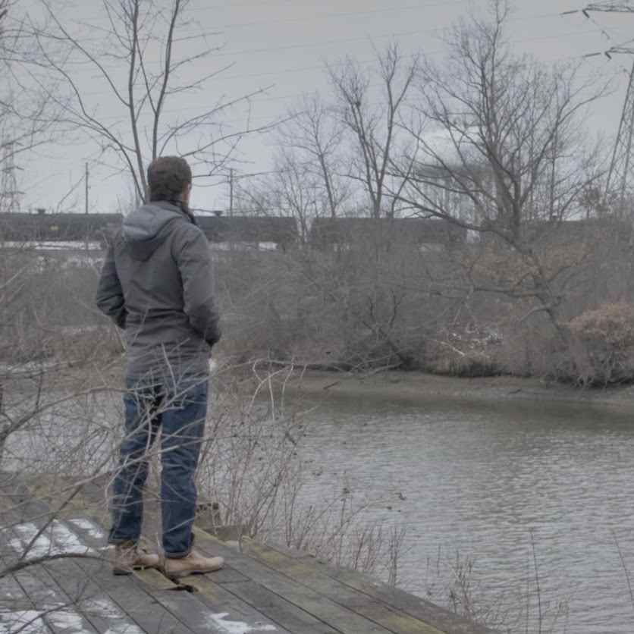
Credit: Hyrax Films

In January 2014, West Virginians noticed that their tap water had a peculiar smell. It was soon discovered that a mysterious chemical, MCHM, has leaked into the Elk River from a damaged tank at a nearby chemical plant, poisoning the drinking water supply for nearly half of the state’s citizens. Hoback — whose interest was piqued by family ties to the state and a desire to understand why the contamination happened — embarked on an investigation that would lead him down a rabbit hole of an unimaginable scale.

As Hoback continues his investigation, several leading players in the drama come forward including Randy Huffman, the head of the State’s Department of Environmental Protection (DEP),
Dr. Rahul Gupta, who runs the local health department, and several scientists, lobbyists, politicians, and industry insiders-turned-whistleblowers. Disillusioned, Hoback travels to Flint, Michigan to see if there is a connection between the recent lead contamination there and the water contamination in West Virginia. With the guidance of the key whistleblowers in Flint, Dr. Marc Edwards and Dr. Mona Hanna-Attisha, the connection becomes clear: the regulatory agencies charged with protecting citizens are too often beholden to political interests over scientific facts.

“You may want to watch this documentary before you drink that glass of tap water,” said Lois Vossen, Independent Lens Executive Producer. “In his quiet, earnest way, Cullen lifts a nonpartisan lid off state and federal regulatory agencies to show a persistent link between contaminated drinking water in West Virginia and government negligence and cover-ups and industry malpractice. We want to believe the people working inside our government agencies act in the best interest of ‘we the people.’ Regrettably, that’s not always the case.”

Visit the What Lies Upstream page on Independent Lens, which features more information about the film. The film will be available for online viewing on the site beginning April 17, 2018.

About the Filmmaker

Cullen Hoback (Writer/Director/Producer/Editor), originally from Los Angeles, spent many summers as a child with his family in West Virginia. His films, which have won multiple awards, include Monster Camp (2007) and Terms and Conditions May Apply (2013), which were shown in top festivals and theaters around the world. Terms and Conditions May Apply, a humorous but chilling documentary about digital privacy, had a significant theatrical release, was picked up by Participant’s PIVOT network, and has been viewed by millions. Hoback has appeared on MSNBC, CNN, NPR, Fox, and HuffPost Live and has written op-eds for The Guardian and other major media outlets. He is also a Film Independent Fellow.

CREDITS

Director Cullen Hoback
Producers John Ramos
Cullen Hoback
Nitin Khanna
Executive Producers Nitin Khanna
Karan Khanna
Jaswinder Grover
Jay Walia
Co-Producer Alina Solodnikova
Writer Cullen Hoback
Cinematographer Vincent Sweeney
Editor Cullen Hoback
Consulting Editors Geoffrey Richman
Greg Finton
Composer John Morgan Askew

About Independent Lens
Independent Lens is an Emmy® Award-winning weekly series airing on PBS Monday nights at 10:00 PM. The acclaimed series, with Lois Vossen as executive producer, features documentaries united by the creative freedom, artistic achievement, and unflinching visions of independent filmmakers. Presented by ITVS, the series is funded by the Corporation for Public Broadcasting, a private corporation funded by the American people, with additional funding from PBS, the John D. and Catherine T. MacArthur Foundation, Wyncote Foundation, and the National Endowment for the Arts. For more visit pbs.org/independentlens. Join the conversation: facebook.com/independentlens and on Twitter @IndependentLens.

###

