What Was Ours Premieres on Independent Lens
FOR IMMEDIATE RELEASE

CONTACT
Lisa Tawil, ITVS 415-356-8383 lisa_tawil@itvs.org
Mary Lugo 770-623-8190 lugo@negia.net
Cara White 843-881-1480 cara.white@mac.com
For downloadable images, visit pbs.org/pressroom/
Monday, January 16, 2017 on PBS

Online Streaming Begins January 17

Film Asks Who Owns the Past When Sacred Cultural Artifacts Have Been Removed from Those Who Created Them

(San Francisco, CA) — For the Eastern Shoshone and Northern Arapaho tribes living on the isolated Wind River Indian Reservation in Wyoming, new contact with lost artifacts risks opening old wounds but also offers the possibility for healing. A young Northern Arapaho journalist and a teenage powwow princess travel with an Eastern Shoshone elder to search for missing artifacts in the vast archives of a museum. There they discover a treasure trove of ancestral objects, setting them on a journey to recover what has been lost and build hope for the future. What Was Ours, directed by Mat Hames, premieres on Independent Lens Monday, January 16, 2017, 10:00-11:00 PM ET (check local listings) on PBS.
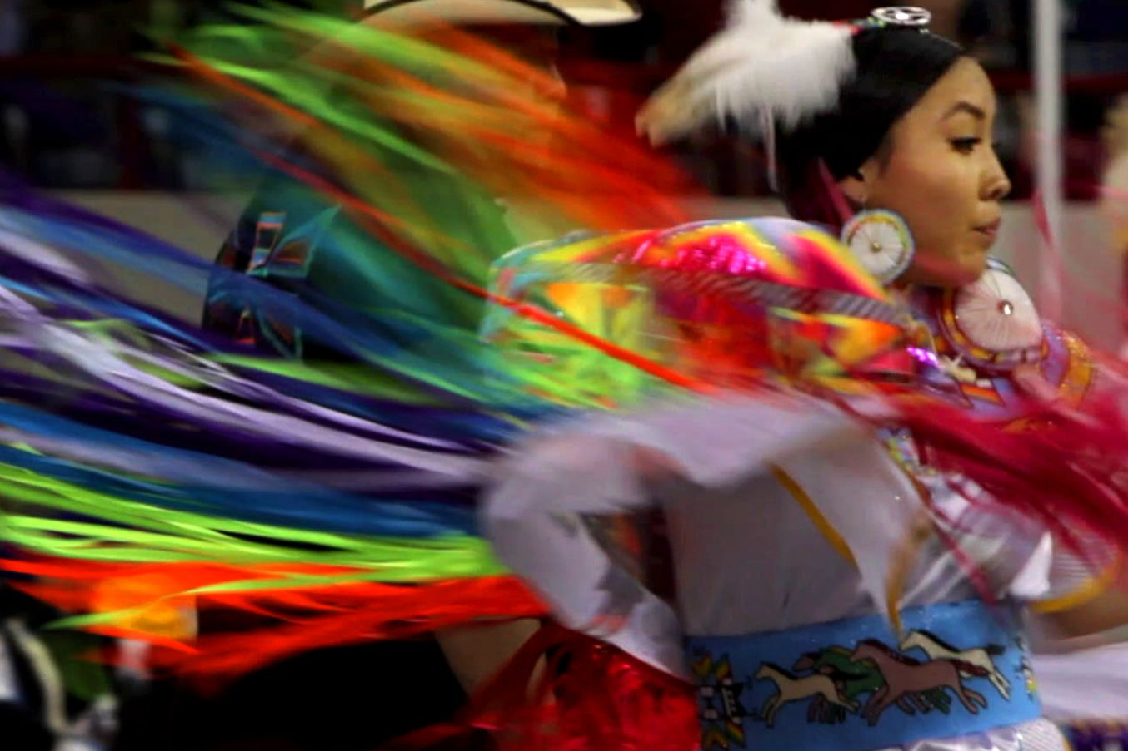
Mikala SunRhodes
Credit: Courtesy of Alpheus Media

When Jordan Dresser returned to Wind River after graduating from college, he began working at the casino on the reservation. He was excited when they expressed interest in establishing a museum on the premises to tell the stories of the Eastern Shoshone and Northern Arapaho, but was surprised to learn the tribes no longer had possession of many artifacts. Most were located in museum collections around the country. How, he wondered, could Wind River get them back?

The journey to recover sacred objects takes him from the Episcopal Church Diocese in Casper, which had taken charge of a collection of objects formerly housed on the reservation, all the way to Chicago’s Field Museum. Making the trip to Chicago with Jordan were Mikala SunRhodes, a Northern Arapaho student, and Philbert McLeod*, an Eastern Shoshone elder whose last trip off the reservation was when he left to fight in Vietnam, where he nearly died. Philbert believes an old beaded charm passed down by an elder helped him survive. Reluctant to make the trip at first, he decides to go because he and other elders want Wind River’s young people to know who they are and be inspired to bring the artifacts home.

Once at the Field Museum, Jordan, Mikala, and Philbert see rooms full of tribal artifacts and learn that a curator had purchased them in the early 20th century, when members of the tribe, removed from their traditional culture, sold them for money to survive. While grateful that the artifacts have been preserved, they are sad to see them closed up in drawers in the dark, away from the people who used them and could best interpret them. “We went there to go view pieces of ourselves, but we had to leave them there,” said Jordan.

The tribal members decide to focus their efforts on the Edith May Adams collection, the artifacts held by the Episcopal Church. During her lifetime, Adams, a deacon of the church, had lived on Wind River and purchased items from tribal members in need of cash. Upon her death she specified in her will that the artifacts be turned over to the church for safekeeping for the tribes.

After discussion with Northern Arapaho members of St. Michael’s Mission on Wind River, the Episcopal Church agreed to loan objects from the collection to be displayed at the Wind River Hotel & Casino Experience Room, where they continue to remain today. The museum has been an empowering experience for the community, allowing them to tell their story in their own way.

“Our ancestors have fought for us as Indian people to live this way,” said Mikala SunRhodes. “We’re strong people because we have gone through so much. I’m proud of where I live and where I come from. I have to keep fighting for what I’ve been given.”

Currently playing film festivals, What Was Ours was recently awarded both Best Feature and Best of Class X at SWAIA Indian Market in Santa Fe during the Smithsonian Native Cinema Showcase.

Visit the What Was Ours page on Independent Lens, which features more information about the film. What Was Ours will be available for online viewing on the site beginning January 17, 2017.

(*Note: Philbert McLeod passed away in January 2016 following the completion of the film.)

About the Filmmakers

Mat Hames (Director/Producer) is an Emmy Award-winning independent filmmaker based in Austin, Texas. His feature documentary, When I Rise, about African American mezzo-soprano and civil rights icon Barbara Conrad, premiered at SXSW and internationally at HotDocs, and was featured on Independent Lens. After playing in ten festivals in the US, the UK, and Canada, the film was nominated for an IDA Documentary Award. Prior to When I Rise (2011), Mat directed the 2008 documentary Fighting Goliath for Robert Redford’s Sundance Preserve. It was an official selection in 12 film festivals, awarded the Grand Jury Prize and Audience Award for Best Documentary Short at the Red Rock Film Festival, and the Golden Sun at the Barcelona Festival Internacional de Cinema del Medi Ambient. In 2006, Mat was knighted by the King of Belgium for drawing attention to the efforts of the Belgian Resistance during World War II in his first PBS film Last Best Hope. In 2014 Mat's short doc, Austin Revealed, played as part of the Faces of Austin SXSW Showcase. He’s the co-founder of Alpheus Media, a film company in Austin, and directs documentaries about Internet culture for comedy and gaming site Rooster Teeth, including Connected and The World's Greatest Head Massage.

Beth Hames (Executive Producer) is co-owner and executive producer at Alpheus Media in Austin, Texas. She has been producing documentaries, non-profit films, and commercial productions for the past two decades. Beth’s most recent film, A Fighting Chance, was broadcast on PBS in 2012 and follows five families living in poverty. Beth served as producer for the PBS films Last Best Hope and When I Rise, which premiered on Independent Lens, and the Sundance Channel’s Fighting Goliath. Another career highlight has been raising awareness about issues facing cancer survivors by capturing hundreds of their stories for the LIVESTRONG Foundation. Beth also produced the Emmy-winning 13-part series, State of Tomorrow, which aired on PBS stations across Texas in 2007. Beth’s next project is a six-part series called Power Trip: The Story of Energy.

Jordan Dresser (Co-Producer and Subject) is a journalist and member of the Northern Arapaho tribe. He was recently appointed Native American Fellow at one of the oldest museums in the U.S., the Peabody Essex Museum in Salem, Massachusetts. In 2015, Jordan received a master's degree in Museum Studies from the University of San Francisco. What Was Ours is Jordan’s first feature film. His knowledge of reservation culture and history provided an essential and invaluable contribution to the success of the film.

CREDITS

Directed and Produced by Mat Hames
Executive Producer Beth Hames
Co-Producer Jordan Dresser
Director of Photography Wilson Waggoner
David Layton
Edited by Greg Wright
Ginny Patrick
Sandra Guardado
Mat Hames
Post Production Supervisor Melinda Bonifay
Original Score by Nathan Halpern and Chris Ruggerio
Courtesy of Copticon Music
and Jasper vs Sanchez (ASCAP)

About Independent Lens

Independent Lens is an Emmy® Award-winning weekly series airing on PBS Monday nights at 10:00 PM. The acclaimed series, with Lois Vossen as executive producer, features documentaries united by the creative freedom, artistic achievement, and unflinching visions of independent filmmakers. Presented by ITVS, the series is funded by the Corporation for Public Broadcasting, a private corporation funded by the American people, with additional funding from PBS, the John D. and Catherine T. MacArthur Foundation, Wyncote Foundation, and the National Endowment for the Arts. For more visit pbs.org/independentlens. Join the conversation: facebook.com/independentlens and on Twitter @IndependentLens.

###

