When God Sleeps Premieres on Independent Lens
FOR IMMEDIATE RELEASE

CONTACT
Donna Hardwick, ITVS 415-356-8383 donna.hardwick@itvs.org
Mary Lugo 770-623-8190 lugo@negia.net
Cara White 843-881-1480 cara.white@mac.com
For downloadable images, visit pbs.org/pressroom/
Monday, April 2, 2018 on PBS

Online Streaming Begins April 3

A Love Story in the Age of Terror

(San Francisco, CA) — Directed by Till Schauder, When God Sleeps is a rap-punk-rock documentary about Iranian musician Shahin Najafi, who is forced into hiding after hardline clerics issue a fatwa for his death, incensed by a rap song that focuses on the oppression of women and human rights abuses. Shahin’s frantic escape leads to an impossible romance with Leili Bazargan, granddaughter of the first prime minister of the Islamic Republic of Iran, who was handpicked for the job by none other than the late Ayatollah Khomeini.
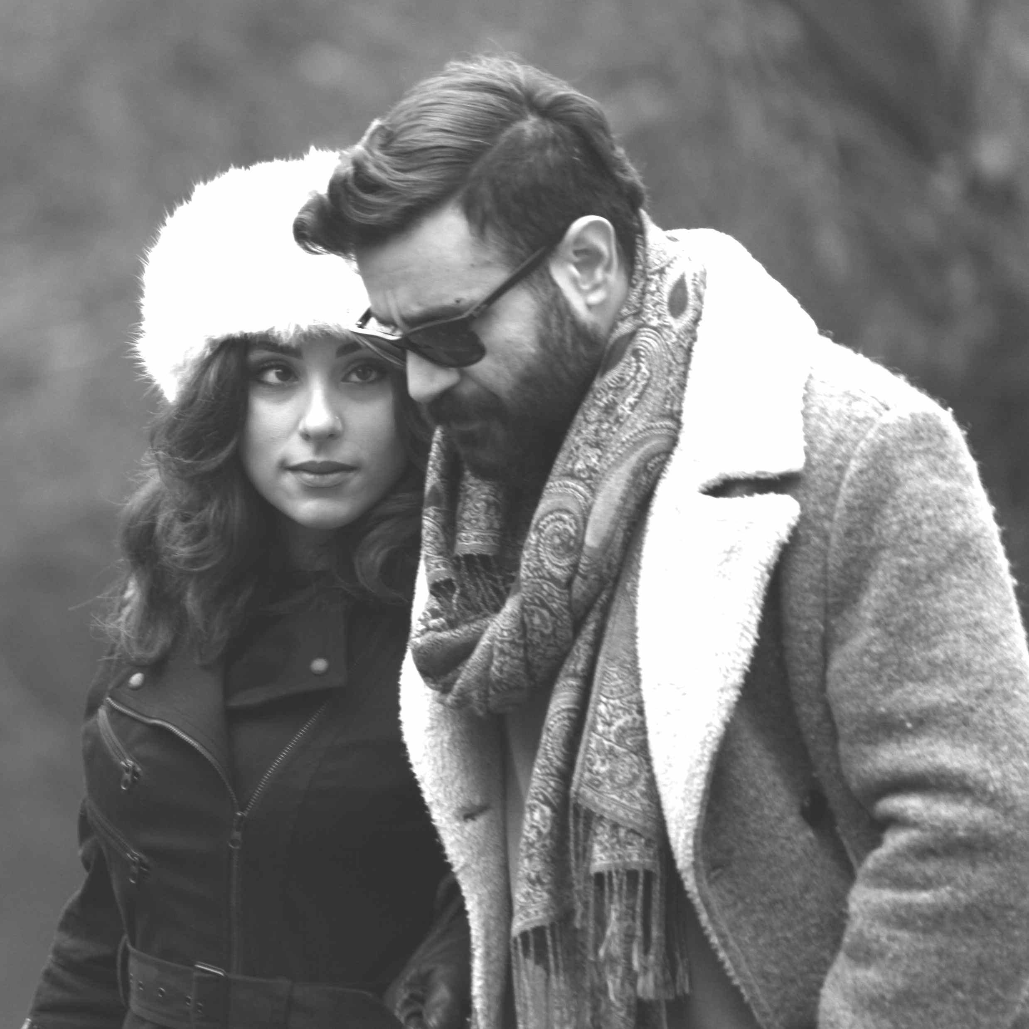
© Amin Khelghat

Risking his life every time he steps on a stage, Shahin refuses to stop performing as an act of resistance while living a modern day Romeo and Juliet romance. When God Sleeps premieres on Independent Lens on Monday, April 2, 2018, 10:00-11:30 PM ET (check local listings) on PBS.

In 2012, Najafi released a satirical rap song that triggered thousands to rally in a campaign for his assassination. Incensed by the song’s irreverent remarks about Ali al-Naghi, one of twelve imams revered by Shia Muslims, hardline clerics placed a $100,000 bounty on his head. “My songs didn’t make me famous,” said Shahin. “The fatwa did.”

German journalist Günter Wallraff, who gave refuge to Salman Rushdie after his death fatwa, offers shelter to Shahin too. Despite the threats against his life, Shahin insists on total freedom of expression. His stubborn refusal to back down in spite of death threats is reminiscent of a suicide mission, complicating long-term planning for his new romantic relationship. Ironically, his uncompromising stance is not unlike that of the religious hardliners who want him dead. Shahin sees it as his mission, indeed his life’s purpose, to stand up to oppressive religious leaders — even if he has to pay the ultimate price for it.

“Touching on hot topics like Islam, terrorism, protest, and the global refugee crisis, When God Sleeps checks off just about every newsworthy box as we immerse ourselves in the life of the ‘Salman Rushdie of Rap,’” said Lois Vossen, Independent Lens Executive Producer. “The human cost of resistance is at the core of this film, which explores nationalism and the growing hostility toward immigrants through the lens of a rebellious musician who occupies the complex role of both political activist and cultural bridge-builder.”

Visit the When God Sleeps page on Independent Lens, which features more information about the film, which will be available for online viewing on the site beginning April 3, 2018.

About the Filmmakers

Till Schauder (Writer/Director/Producer) got his start in Germany where he wrote and directed the award-winning narrative short City Bomber and his award-winning narrative feature debut Strong Shit (Max Ophüls Film Festival Reader’s Award). His U.S. debut, Santa Smokes, won several international awards, among them Best Director at the Tokyo International Film Festival and the Studio Hamburg Newcomer Award. In 2012, Schauder completed his first documentary,The Iran Job, which made several ‘best film of the year’ lists in the U.S. and was shortlisted for a German Academy Award. In 2014 he was awarded the Gerd-Ruge-Stipendium by Medienstiftung NRW, Germany’s largest federal film fund, for When God Sleeps, as well as grants from the Catapult Film Fund, The Sundance Institute, Fork Films and the Hartley Film Foundation. His script was recommended for a German Academy Award in the Films in Development category in 2015. Also in 2015 Schauder directed The Young Man and the Sea, a TV documentary for ZDF 3Sat, which was shortlisted for Germany’s Grimme Award for Best Documentary Series. When God Sleeps has won several international awards including “Most valuable Documentary of the Year” from Cinema for Peace during Berlinale, and the “Golden Heynal Award” at the 57th Krakow Film Festival. It is currently shortlisted for a German Academy Award, and nominated for “best documentary” at festivals in Gothenburg, Oslo and Prague. In 2017, Schauder also completed Warriors of Faith (Glaubenskrieger), for which he won the “ARD Top of the Docs” Award and a German Emmy for Best Documentary 2017. Warriors Of Faith was also nominated for the Prix Europa 2017. Schauder is currently completing Reggae Boyz for ARTE. He received his MFA at the University of Television and Film, Munich and teaches film at Vermont College of Fine Arts and NYU’s School of Professional Development.

Sara Nodjoumi (Producer) is an independent film producer, film festival programmer and consultant. Under their company banner, Partner Pictures, Nodjoumi and Till Schauder most recently produced WHEN GOD SLEEPS, co-produced by ITVS, executive produced by Motto Pictures, Catapult Film Fund, and Fork Films, and supported by numerous foundations including the Sundance Institute, Jerome Foundation, and NYSCA. The film premiered in competition at the 2017 Tribeca Film Festival. It later went on to win the Golden Heynal award for Best Music Documentary at the Krakow Film Festival and the Most Valuable Documentary of the Year award for Cinema for Peace in Berlin. From 2004-2009, Nodjoumi worked at the Tribeca Film Festival as an Associate Programmer. She is currently the Artistic Director of the New York Sephardic Film Festival. Nodjoumi also produced the feature documentary THE IRAN JOB, which was released theatrically and on Netflix worldwide. In Germany, the film was shortlisted for a German Academy Award. For THE IRAN JOB, Nodjoumi managed two of the most successful Kickstarter campaigns of all time. She regularly consults with filmmakers on crowd-funding and audience engagement campaigns. In 2016, Nodjoumi was invited to attend the Sundance Creative Producer’s Summit. In 2017 she was an IFP Cannes Producer’s Network Fellow. Nodjoumi and Schauder are currently working on the feature documentary REGGAE BOYZ, which is in post-production, and will air on ARTE in 2018.

CREDITS

Written and Directed by Till Schauder
Produced by Sara Nodjoumi and Till Schauder
Executive Producers Lisa Kleiner Chanoff and Bonni Cohen
Julie Goldman and Chris Clements
Abigail Disney and Gini Reticker
Sally Jo Fifer
Photographed by Till Schauder and Gerardo Milsztein
Editor Tina Grapenthin
Consulting Editor Mark Becker
Commissioning Editor for ITVS Noland Walker
Supervising Producer for ITVS Michael Ehrenzweig
Commissioning Editor WDR Jutta Krug
Original Score by Max Avery Lichtenstein
Songs by Shahin Najafi and Majid Kazemi

About Independent Lens

Independent Lens is an Emmy® Award-winning weekly series airing on PBS Monday nights at 10:00 PM. The acclaimed series, with Lois Vossen as executive producer, features documentaries united by the creative freedom, artistic achievement, and unflinching visions of independent filmmakers. Presented by ITVS, the series is funded by the Corporation for Public Broadcasting, a private corporation funded by the American people, with additional funding from PBS, the John D. and Catherine T. MacArthur Foundation, Wyncote Foundation, and the National Endowment for the Arts. For more visit pbs.org/independentlens. Join the conversation: facebook.com/independentlens and on Twitter @IndependentLens.

###

