

JAMES BAKER: THE MAN WHO MADE WASHINGTON WORK
Premieres Tuesday March 24, 2015 on PBS

– New Documentary Profiles the Influential Diplomat and Dealmaker –

Narrated by Tom Brokaw, James Baker: The Man Who Made Washington Work explores the life and long political career of James A. Baker III, a remarkably savvy power player, dealmaker and diplomat respected on both sides of the aisle for his ability to get things done. Now 84, Baker was instrumental in getting three presidents elected, served in top posts for two of them, and was a central player in some of the most momentous events of the late 20th century. Candid revelations from Baker and first hand accounts from former Presidents Clinton, Carter, and Bush Sr.; former Secretaries of State Condoleezza Rice and Henry Kissinger; and other journalists, authors and historians provide an eye-opening, behind-the-scenes story of power, persuasion and diplomacy at the highest levels. Written, directed and produced by Eric Stange with John Hesse as Executive Producer, James Baker: The Man Who Made Washington Work will premiere on Tuesday, March 24, 2015 from 8:30-10:00 p.m. ET (check local listings) on PBS.
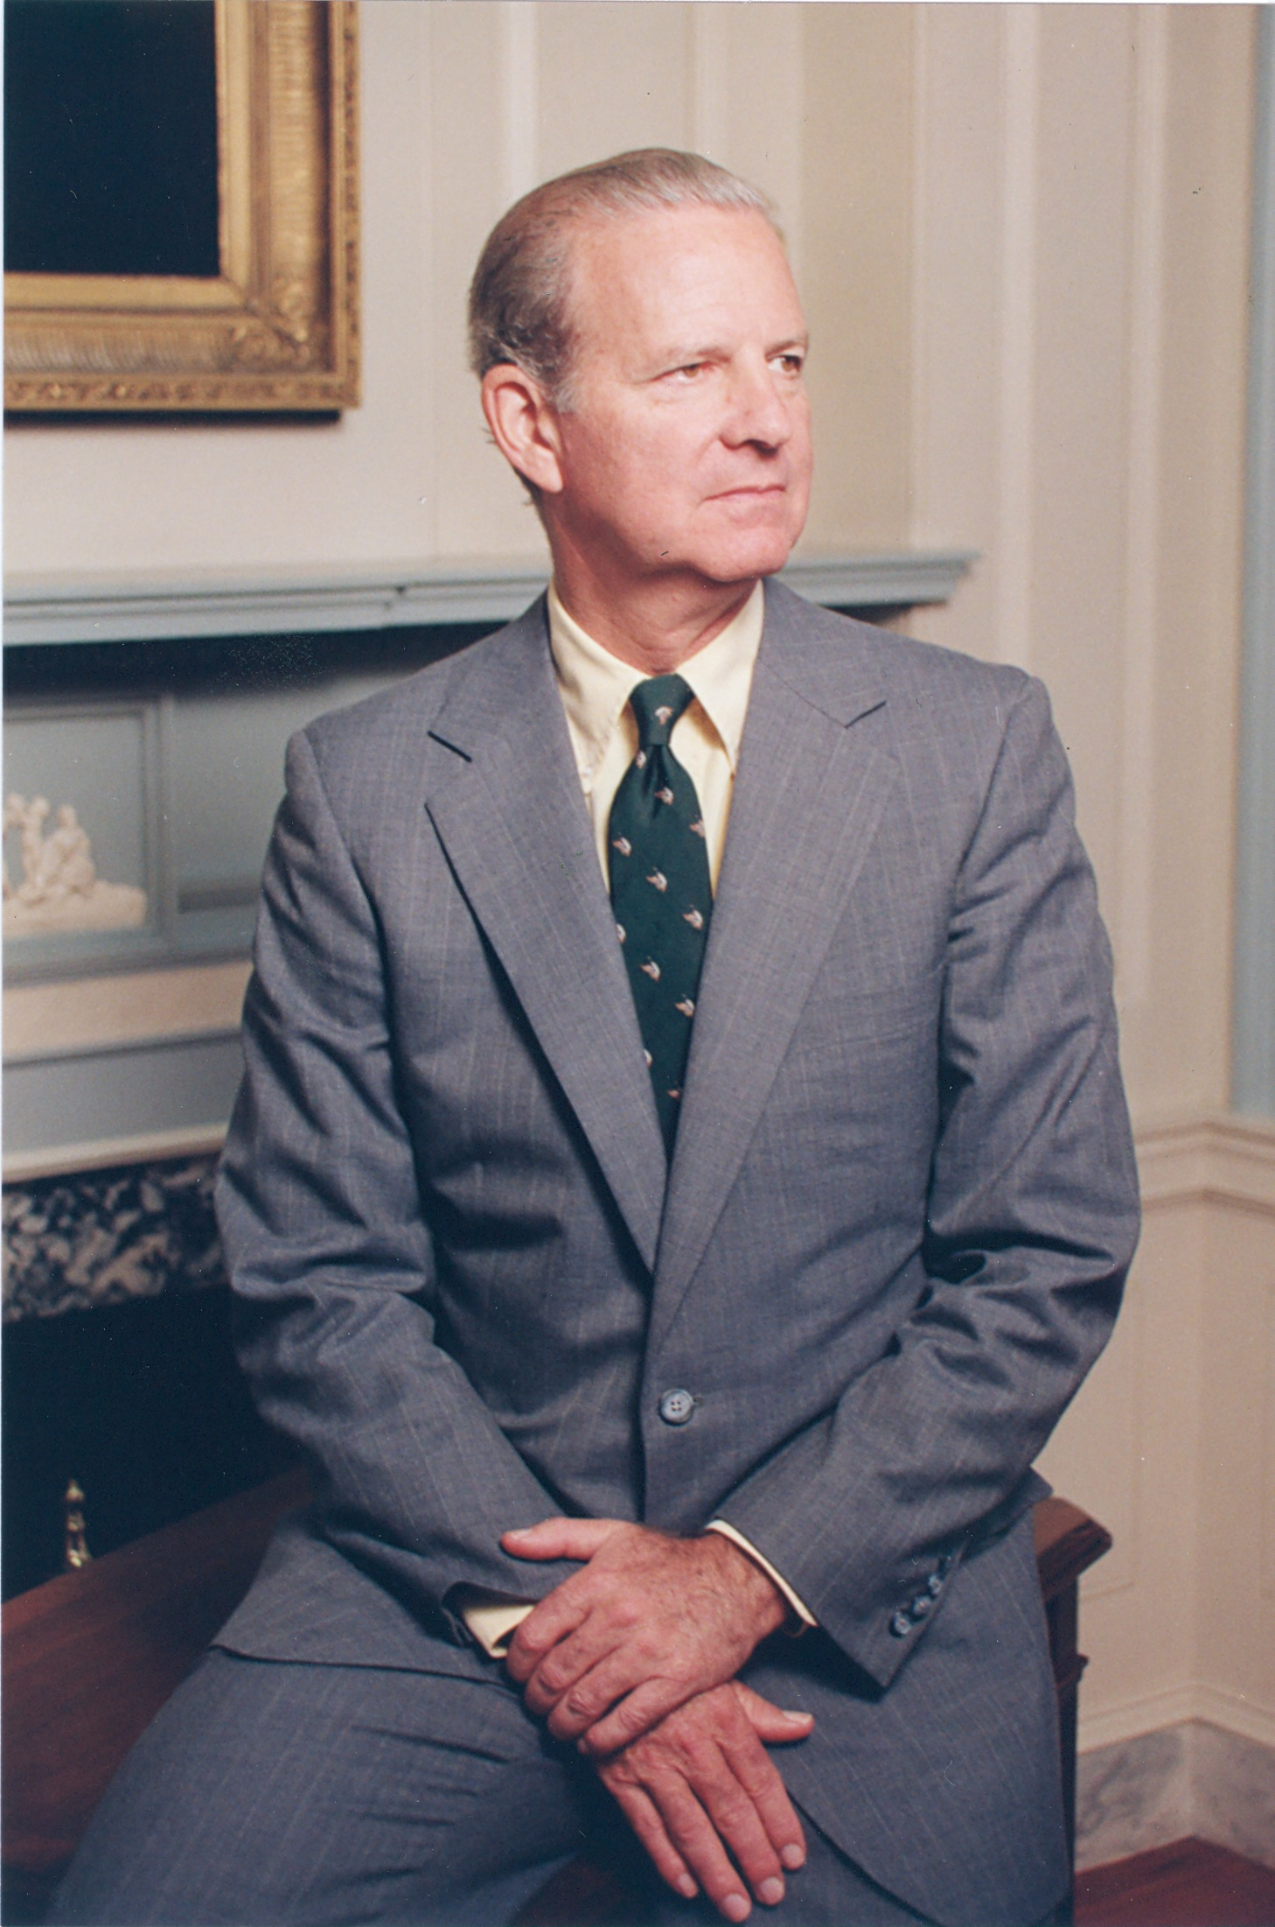
Courtesy: Rice University Baker Institute for Public Policy

As White House chief-of-staff, James Baker facilitated the Reagan Revolution by using his political skills to get much of Reagan’s hugely ambitious agenda through a hostile Congress. As Treasury Secretary, he negotiated the Tax Reform Act of 1986, a legislative feat no one believed possible in a divided government. And, as Secretary of State, Baker brought the Cold War in for a soft landing, working alongside Mikhail Gorbachev and Eduard Shevardnadze to maintain stability in Eastern Europe. Almost simultaneously, he put together the unprecedented coalition of nations that fought the first Gulf War. On the heels of that success, he organized the Madrid Peace Conference that brought Arab nations and Israel to the table for the first time in modern history.

The program also sheds light on some of the more controversial aspects of Baker’s tenure including his role as George W. Bush’s master strategist in the disputed 2000 election. He craftily steered the case to the U.S. Supreme Court, thereby winning the White House for the son of his close friend. As former President Bill Clinton admiringly recalls, “He had a strong hand going in but he played it very well. I hated it – he whipped us, but he was good at it.”

Nothing in Baker’s early life suggested such a successful political career. Born into a prominent Texas family, he became an oil and gas lawyer with no interest in politics. Then, when he was 40, his good friend and tennis partner, George H. W. Bush, recommended him to President Gerald Ford Within eighteen months, he had become the chair of Ford’s 1976 presidential campaign. It was a meteoric rise and the beginning of a career in public service that literally changed history.

For further information, visit www.pbs.org/jamesbaker. DVDs are available for purchase at www.jamesbakerfilm.com.

* * *

The Participants, in Order of Appearance

Jeffrey Toobin, journalist and author of Too Close to Call

James A. Baker III

John F. W. Rogers, former aide to James Baker

Margaret D. Tutwiler, former aide to James Baker

President Bill Clinton

Julian Zelizer, historian, Princeton University

Eliza Lovett Randall, James Baker’s cousin

James K. Sebenius, Harvard Negotiation Project

President George H. W. Bush

Barbara Bush, former First Lady

Jon Meacham, author/journalist

Wallace S. Wilson, childhood friend

Susan Baker, wife

Dick Cheney, former Vice President and Chief of Staff to President Gerald Ford

Timothy Naftali, author/historian

Stuart Spencer, Republican political consultant

Hedrick Smith, former New York Times Washington bureau chief

Lesley Stahl, CBS News

David Gergen, presidential advisor

Alan Murray, president, Pew Research Center

Jeffrey H. Birnbaum, author/journalist

Kathleen Day, Johns Hopkins University

Condoleeza Rice, Secretary of State, 2005-2009

Michael Beschloss, presidential historian

Dennis B. Ross, former aide to James Baker

Thomas L. Friedman, author/New York Times columnist

Mikhail Gorbachev, General Secretary, USSR, 1985-1991

Charles Powell, advisor to Margaret Thatcher

Elizabeth Pond, author/journalist

Robert Zoellick, former aide to James Baker

Brent Scowcroft, National Security Advisor, 1989-1993

Henry Kissinger, Secretary of State, 1973-1977

Gen. Colin Powell, Chairman, Joint Chiefs of Staff, 1989-1993

President Jimmy Carter

Zalman Shoval, Israeli Ambassador to the U.S., 1990-1993

Shimon Peres, President of Israel

Edward Djerejian, U.S. Ambassador to Syria, 1989-1991

Charles Lewis, investigative reporter

CREDITS

Written, produced and directed by Eric Stange

Narrated by Tom Brokaw

Edited by Peter Rhodes

Director of Photography Mark Rublee

Original Music John Kusiak and P. Andrew Willis

Executive Producer John Hesse

This program was produced by John Hesse Productions, which is solely responsible for its content. Copyright © 2014 John Hesse Productions LLC

About the Filmmakers

Eric Stange (Writer/Director/Producer) is a documentary filmmaker who specializes in historical subjects, and in new media forms of documentary storytelling. His films have appeared on PBS, The Discovery Channel, the National Geographic channel, and the BBC. Previous films include The Wall – A World Divided and After The Wall – A World United about the fall of the Berlin Wall and the re-unification of Germany; The War That Made America, about the French and Indian War; and Murder At Harvard, an analysis of historical inquiry through a real murder story. Upcoming film projects include Edgar Allan Poe: Buried Alive. His work in new media includes co-producing an award-winning iPhone app walking tour of historic Boston based on one of his films, among other projects for mobile media.

John Hesse (Executive Producer) is the former General Manager of

KUHT/HoustonPBS, serving in that capacity from June 2002 to November 2011. Most recently, Hesse served as the Executive Producer for the award-winning PBS documentaries The Wall – A World Divided and After The Wall – A World United, and re-established his former production company, John Hesse Productions, to develop and produce content for national and international distribution.
About PBS

PBS, with its over 350 member stations, offers all Americans the opportunity to explore new ideas and new worlds through television and online content. Each month, PBS reaches nearly 109 million people through television and over 28 million people online, inviting them to experience the worlds of science, history, nature and public affairs; to hear diverse viewpoints; and to take front row seats to world-class drama and performances. PBS’ broad array of programs has been consistently honored by the industry’s most coveted award competitions. Teachers of children from pre-K through 12th grade turn to PBS for digital content and services that help bring classroom lessons to life. PBS’ premier children’s TV programming and its website, pbskids.org, are parents’ and teachers’ most trusted partners in inspiring and nurturing curiosity and love of learning in children. More information about PBS is available at www.pbs.org, one of the leading dot-org websites on the Internet, or by following PBS on Twitter, Facebook or through our apps for mobile devices. Specific program information and updates for press are available at pbs.org/pressroom or by following PBS Pressroom on Twitter.

* * *
CONTACTS:

CaraMar Publicity
Mary Lugo 770-623-8190 lugo@negia.net
Cara White 843-881-1480 cara.white@mac.com
Abbe Harris 908-233-7990 abbe@caramar.net

For further information and photos visit http://www.pbs.org/pressroom

