LIFE OF ORIGINAL “ART STAR” JAMES MCNEILL WHISTLER
AND HIS TRANSFORMATIVE WORK EXPLORED ON PBS
- New Documentary Examines How the Infamous and Revered 19th-Century Artist
Changed the Course of Modern Art, Premieres September 12, Part of PBS Arts —

WASHINGTON, D.C. — An art star, dandy, instigator and radical artistic visionary, James McNeill Whistler (1834–1903) introduced ideas and forms that were avant-garde for their time. A new documentary by award-winning filmmaker Karen Thomas, James McNeill Whistler & The Case for Beauty, examines the life of the man and the course of his career. The one-hour documentary premieres Friday, September 12 at 9 p.m. ET on PBS stations nationwide, as part of PBS Arts. (Check local listings.) Two Academy Award-winners provide voices in the film; Kevin Kline is the voice of Whistler, and Anjelica Huston is the film’s narrator.
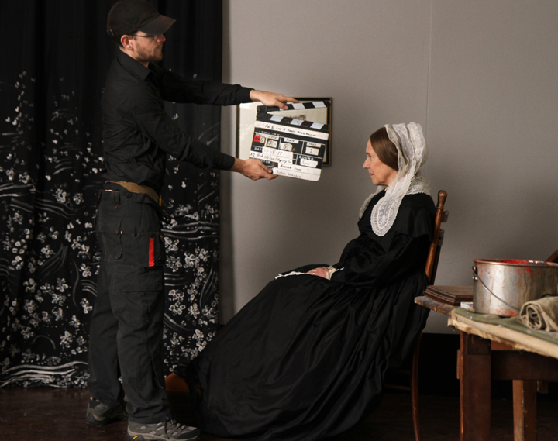

Film Odyssey, Inc. shoots a re-enactment scene from James McNeill Whistler & The Case for Beauty featuring the creation of “Arrangement in Grey and Black No.1” — popularly known as “Whistler’s Mother.” (Photo Credit: Courtesy of Film Odyssey, Inc.)

Whistler was known as a caustic wit and man-about-town in his adopted home of London, and the film takes a close look at that life, and at how the 19th-Century artist pioneered a new way of thinking about art that supported beauty in and of itself as a work’s most essential value, what we know today as “art for art’s sake.” This pioneering genius’ struggle to find his own voice resulted in a breakaway style that moved painting towards abstraction and revolutionized the art world in Whistler’s time — paving the way for what became known as modern art decades later in the 20th -Century.

Featuring nearly 200 etchings, paintings and historical photographs, James McNeill Whistler & The Case for Beauty provides a look at Whistler’s art and the adventuresome nature that earned him his often-controversial reputation and made him the original “art star.” The documentary employs unique animations and layered builds of the artist’s great works. Re-enactments show scenes from Whistler’s life and the behind-the-scenes work on the creation of several of his famous paintings, including “Arrangement in Grey and Black No.1” — popularly known as “Whistler’s Mother” — one of the most iconic works of art in history. Also featured are “The White Girl,” “The Balcony,” and the creation of the famed “The Peacock Room,” a masterpiece of decorative arts. Digital animations offer a 3-D journey through Whistler’s etchings of the French countryside and capture his process of revising etchings in Venice.

The film is part of a landmark year recognizing Whistler. The documentary coincides with the U.S. and Japanese tours of major Whistler exhibitions. An American in London: Whistler and the Thames has traveled to the Smithsonian’s Arthur M. Sackler Gallery, Washington, D.C. (May 3–August 17, 2014). After this, selected works will join a major Whistler retrospective, organized by NHK, to be shown at the National Museum of Modern Art in Kyoto (September 13–November 16, 2014) and the Yokohama Museum of Art (December 6, 2014–March 1, 2015). Both exhibitions draw heavily on the Hunterian Museum and Art Gallery’s Whistler Collection of oils, etchings, lithographs and watercolors. The Smithsonian’s Freer Gallery of Art is also hosting Off the Beaten Path: Early Works by James McNeill Whistler (September 28, 2013–September 28, 2014) and The Peacock Room Comes to America (April 9, 2011–December, 2015), in addition to their regular exhibit Freer & Whistler: Points of Contact (continues indefinitely). Additionally, the authoritative biography of Whistler, Whistler: A Life for Art’s Sake (Yale University Press, 2014) by Daniel E. Sutherland, was published in March and is the first biography of Whistler to make extensive use of the artist’s private correspondence.

In James McNeill Whistler & The Case for Beauty, leading art historians — including Lee Glazer, Associate Curator of American Art, Freer Gallery of Art and Arthur M. Sackler Gallery, Smithsonian; Stephen Calloway, design historian, author and former Curator, Victoria & Albert Museum; and Tim Barringer, Paul Mellon Professor of the History of Art, Yale University — guide viewers through the moments that defined Whistler as a visionary American artist and champion of beauty.

The documentary traces Whistler’s artistic life from his birth in America and his formative years in Russia, where he first began to draw, and on to Paris in his early youth, living the life of a bohemian artist. After Paris, Whistler finally landed in the Chelsea neighborhood of London in the 1850s. As an American in London, he could mingle with the lower and upper-classes. He was working in an art world that was benefitting from an increasingly wealthy middle class who saw art as an opportunity to purchase the appearance of aristocracy. Famous for his patent leather shoes, monocle and uptown swagger, Whistler’s theatrics attracted the curiosity of buyers and the attention of the critics. The program examines how Whistler’s unique Sunday breakfasts at his studio ensured that the boisterous artist, and his art, would remain the talk of the town. The documentary also looks at his volatile nature and the bold letters to the press that earned Whistler notoriety. By the time of his death, Whistler had become one of the most recognized artists in Europe. He is now placed in the first rank of modern painters, his work compared to that of Velázquez and Rembrandt.

An electronic press kit for James McNeill Whistler & The Case for Beauty, including downloadable photos for promotional use, is available at www.pressroom.pbs.org. On Twitter, follow #PBSArts. A website with more information on the film will be available at pbs.org/whistler.

James McNeill Whistler & The Case for Beauty is a production of Film Odyssey, Inc., in association with the Freer Gallery of Art and Arthur M. Sackler Gallery, Smithsonian; 1-A Productions Ltd., Glasgow; and WETA Washington, D.C. A film by Karen Thomas. Executive Producers: Dalton Delan and David S. Thompson for WETA. Producer/Director/Writer: Karen Thomas. Narrator: Anjelica Huston. James McNeill Whistler Readings: Kevin Kline. Editor: Adam Lingo. Associate Producer: Rebecca Taylor. Senior Researcher/Assistant Producer: Colin W. Bayly. Director of Photography: Brett Wiley. Composer: Peter Melnick.

Major funding for James McNeill Whistler & The Case for Beauty is provided by the National Endowment for the Humanities. Additional funding is provided by the Lunder Foundation; the Annenberg Foundation; the Lewis B. and Dorothy Cullman Foundation; the National Endowment for the Arts; the DC Commission on the Arts and Humanities; the Humanities Council of Washington, DC; and the Maryland Humanities Council. Funding is also provided by PBS and public television viewers.

Karen Thomas’ credits include three programs on the Emmy Award-winning PBS series American Masters. Her production company, Film Odyssey, has produced high-quality cultural and educational programming for the American television audience since its incorporation in 1986, exploring the visual arts and literature, American history and music, cinema and science, and featuring the nation’s most respected journalists and actors, including Rene Auberjonois, Ruby Dee, Barbara Feldon, John Heard, Dennis Hopper, Roger Mudd, George Page, Cliff Robertson, Wes Studi, Meryl Streep and Sigourney Weaver. For more information, visit www.odysseymedia.org.

WETA Washington, D.C., is one of the largest producing stations of new content for public television in the United States. WETA productions and co-productions include PBS NewsHour and Washington Week with Gwen Ifill; films by Ken Burns such as The Roosevelts: An Intimate History, premiering September 14–20, 2014; performance specials from the White House, the U.S. Capitol, and the John F. Kennedy Center for the Performing Arts; and documentaries such as Cézanne in Provence, Van Gogh’s Van Goghs, John Singer Sargent: Outside the Frame and Mary Cassatt: A Brush with Independence. WETA studios and administrative offices are located in Arlington, Virginia. Sharon Percy Rockefeller is president and CEO of WETA. For more information about WETA and its services, visit www.weta.org.

# # #

