PBS TO AIR KEHINDE WILEY: AN ECONOMY OF GRACE, A SXSW 2014 AWARD-WINNING FILM, ON FRIDAY, SEPTEMBER 5

−Award-winning Director Jeff Dupre Follows Renowned Artist Kehinde Wiley as He Creates a New Series of Paintings in Collaboration With Givenchy’s Riccardo Tisci −

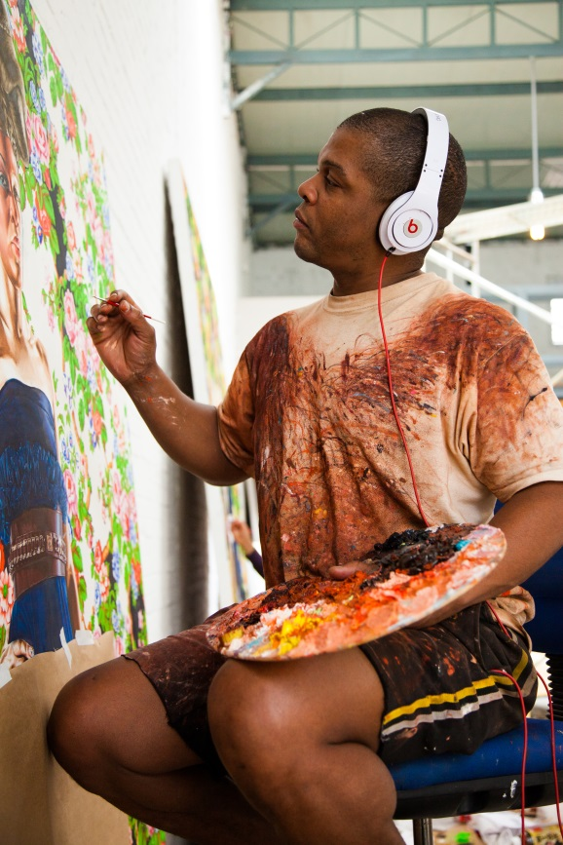
Kehinde Wiley painting in his Beijing studio.
© Show of Force; photo by William Peña

ARLINGTON, VA; May XX, 2014 – A Jury Award winner at the SXSW 2014 Film Conference, KEHINDE WILEY: AN ECONOMY OF GRACE debuts on PBS on Friday, September 5, 2014, 9:00-10:00 p.m. ET (check local listings). Known for his vibrant, larger-than-life reinterpretations of classical portraits featuring young African-American men, New York-based visual artist Kehinde Wiley has turned the practice of portraiture on its head and, in the process, taken the art world by storm. Wiley recently embarked on an exciting new project: his first series of classical portraits featuring women. KEHINDE WILEY: AN ECONOMY OF GRACE documents the project as it unfolds, tracking Wiley’s process from concept to canvas and as he gets to know the women whom he selects to paint.

As with Wiley’s previous works, his models were street-cast in New York City and posed to resemble 18th-and 19th-century portraits of society figures, which inspire Wiley’s vision. Instead of posing the women in their own clothing, however, as he has done with his male subjects, Wiley envisioned each of his female models swathed in an original couture gown. To realize this vision, he joined forces with Givenchy’s Riccardo Tisci, giving rise to a unique and high-profile collaboration between art and haute couture.

“We are thrilled to introduce PBS viewers to the vibrant and contemporary work of Kehinde Wiley,” said Donald Thoms, Vice President of Programming, PBS. “Airing as part of our Friday night PBS Arts programming, this documentary shows the detailed creative process of this great visual artist— from start to finish—in a way that viewers will truly appreciate.”

Wiley embraces serendipity when casting his models, selecting for this project a compelling cast from the streets of Harlem, Brooklyn and Queens: Chanel, a prison guard on Rikers Island; Shantavia, a bubbly teen mother working toward her G.E.D; Cali and Dacia, young lovers in the throes of a new romance; Treisha, a Barbadian immigrant with attitude to spare; and Ena, a nurse who hopes to open her own art gallery.

Cameras followed Wiley from start to finish, from the streets of New York where he cast his models, to meetings with Riccardo Tisci in Paris and New York, to the artist’s studio in Beijing, where he put paint to canvas, and in Manhattan at the Sean Kelly Gallery, where the stunning works were finally unveiled.

Award-winning director/producer Jeff Dupre’s work has been released theatrically and screened at film festivals throughout the world and broadcast on PBS, HBO, BBC, NHK and ARTE. Together with Maro Chermayeff, Dupre founded Show of Force, a film and television production company. Dupre was the producer/co-director of “Marina Abramovic: The Artist is Present,” which debuted at the 2012 Sundance Film Festival and garnered several awards, including a Peabody and Emmy, and an Independent Spirit Award nomination. He was an executive producer of HALF THE SKY: TURNING OPPRESSION INTO OPPORTUNITY FOR WOMEN WORLDWIDE, the groundbreaking documentary series and trans-media project based on the best-selling book by Pulitzer Prize-winning journalists Nicholas Kristof and Sheryl Wudunn. Other projects include CIRCUS and FRONTIER HOUSE for PBS; BROADWAY THE AMERICAN MUSICAL, an Emmy-winning six-part series for PBS, BBC, NHK and AMERICAN MASTERS; and JULLIARD for PBS.

KEHINDE WILEY: AN ECONOMY OF GRACE is part of the ongoing, multi-platform “PBS Arts” initiative, which highlights PBS’s commitment to the performing and visual arts, and gives millions of viewers a front-row seat and a backstage pass for the best music, theater, dance, art, and cultural history programs on-air and online. For more information, www.pbs.org/arts.

KEHINDE WILEY: AN ECONOMY OF GRACE is a Show of Force production in association with PBS, executive produced by Lamar Johnson and Maro Chermayeff, produced by Jessica Chermayeff, produced and edited by Ana Veselic and directed and produced by Jeff Dupre.

This program was made possible by generous support from Anne Ray Charitable Trust.

About PBS
PBS, with its over 350 member stations, offers all Americans the opportunity to explore new ideas and new worlds through television and online content. Each month, PBS reaches nearly 109 million people through television and over 28 million people online, inviting them to experience the worlds of science, history, nature and public affairs; to hear diverse viewpoints; and to take front row seats to world-class drama and performances. PBS’ broad array of programs has been consistently honored by the industry’s most coveted award competitions. Teachers of children from pre-K through 12th grade turn to PBS for digital content and services that help bring classroom lessons to life. PBS’ premier children’s TV programming and its website, pbskids.org, are parents’ and teachers’ most trusted partners in inspiring and nurturing curiosity and love of learning in children. More information about PBS is available at www.pbs.org, one of the leading dot-org websites on the Internet, or by following PBS on Twitter, Facebook or through our apps for mobile devices. Specific program information and updates for press are available at pbs.org/pressroom or by following PBS Pressroom on Twitter.

– PBS –

MEDIA CONTACTS:
Dish Communications
Amy Grey / Ashley Mariner
Office: 818-508-1000
amyg@dishcommunications.com / ashleym@dishcommunications.com

Michaé Godwin, PBS, mmgodwin@pbs.org, 703-739-8483
Nicole Wells Foster, PBS, njwells@pbs.org, 703-739-5351

For images and additional up-to-date information on this and other PBS programs, visit PBS PressRoom at pbs.org/pressroom.

