KRISTIN CHENOWETH: COMING HOME
Premieres As Part of PBS Arts Fall Festival on Friday, November 28

Emmy and Tony Award-winner Returns to Oklahoma for an Unforgettable Concert of
Favorite Songs From Her Career
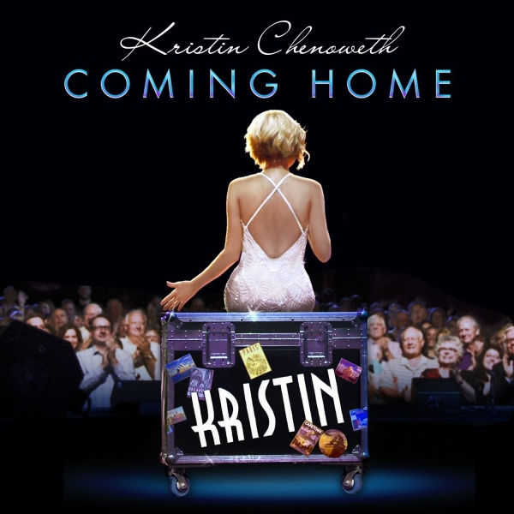

Credit: Courtesy of Concord Records

Emmy® and Tony® Award-winner and accomplished singer Kristin Chenoweth brings it home — to Broken Arrow, Oklahoma that is — to perform a career-spanning concert. With a classically trained voice set off by a gift for acting and comedy, Chenoweth appears at a state-of-the-art theater that now bears her name, performing Broadway, television and film songs like “Popular” and “For Good” from Wicked, songs from her acclaimed performances on “Glee,” and beloved music from Les Miserables, Phantom of the Opera and many more. Backed by a 13-piece orchestra led by Musical Director Mary-Mitchell Campbell, Chenoweth welcomes song and dance friends from Broadway in a program sure to be unforgettable. Produced and directed for television by Scott Lochmus, KRISTIN CHENOWETH: COMING HOME premieres as part of the PBS Arts Fall Festival on Friday, November 28, 2014 at 9:00 p.m. ET (check local listings) on PBS.

KRISTIN CHENOWETH: COMING HOME features these performances:

- “I Could Have Danced All Night”
- “Going To The Dance With You”
- “My Coloring Book”
- “Bring Him Home”
- “Upon This Rock”
- “Maybe This Time”
- “Fathers and Daughters”
- “Somewhere Over The Rainbow”
- “Popular”
- “For Good”
- “Wishing You Were Somehow Here Again”
- “All the Things You Are”
- “Enough Is Enough”
- “I Was Here”

Emmy and Tony Award-winner and Hollywood Bowl and Oklahoma Hall of Fame inductee, Kristin Chenoweth effortlessly transitions between stage, television, film and an accomplished singing career. Many remember her show-stealing, Tony-winning performance in You’re A Good Man, Charlie Brown and her triumphant star turn when she originated the role of Glinda the Good Witch in Wicked, which earned her a leading actress Tony Award nomination. While starring in the ABC series “Pushing Daisies,” she received an Emmy Award for Best Supporting Actress in a Comedy Series. Chenoweth has appeared on Fox’s comedy “Glee” in a role for which she was nominated for two Emmy Awards and for a People’s Choice Award in the category of Favorite TV Guest Star. In early 2015 she will return to Broadway to play the glamorous film star Lily Garland in the Roundabout Theatre Company’s 20-week limited engagement of On the Twentieth Century. Chenoweth has completed production on the Universal film The Boy Next Door, alongside Jennifer Lopez, Opposite Sex, an indie teen drama entitled Hard Sell and the Disney Channel’s live-action original movie Descendants, in which she will play the classic Sleeping Beauty villain Maleficent. On November 17, her new album, “Coming Home,” will be released on Concord Records.

KRISTIN CHENOWETH: COMING HOME is part of the 2014 PBS Arts Fall Festival, an 11-week series hosted by Chenoweth that features artists and performances in a variety of disciplines from around the country. Now in its fourth season, the festival underscores PBS’ strong, ongoing commitment to present viewers with America’s best performing arts. This year’s PBS Arts Fall Festival also features two programs from LIVE FROM LINCOLN CENTER’s 40th anniversary season: “‘Sweeney Todd: The Demon Barber of Fleet Street’ In Concert With the New York Philharmonic” starring Bryn Terfel and Emma Thompson, and “The Nance” starring Nathan Lane, and THE GERSHWINS’® PORGY AND BESSSM FROM SAN FRANCISCO OPERA, starring bass-baritone Eric Owens as Porgy and soprano Laquita Mitchell. The festival also includes AUSTIN CITY LIMITS CELEBRATES 40 YEARS; GREAT PERFORMANCES “Tony Bennett & Lady Gaga: Cheek To Cheek LIVE!” and an encore of the musical “Cats”; MICHAEL FEINSTEIN AT THE RAINBOW ROOM, celebrating the reopening of the historic restaurant and nightclub; and HITMAKERS, an up-close look at the music industry’s resilience in the digital age. The PBS Arts Festivals are television’s only consistent home for the performing and fine arts, giving millions of viewers a front-row seat and a backstage pass to the best music, theater, dance, art, and cultural history programs on air. For more information, please visit pbs.org/pressroom.

National funding for the PBS Arts Fall Festival is provided by a generous grant from Anne Ray Charitable Trust.

About PBS
PBS, with its over 350 member stations, offers all Americans the opportunity to explore new ideas and new worlds through television and online content. Each month, PBS reaches nearly 109 million people through television and over 28 million people online, inviting them to experience the worlds of science, history, nature and public affairs; to hear diverse viewpoints; and to take front row seats to world-class drama and performances. PBS’ broad array of programs has been consistently honored by the industry’s most coveted award competitions. Teachers of children from pre-K through 12th grade turn to PBS for digital content and services that help bring classroom lessons to life. PBS’ premier children’s TV programming and its website, pbskids.org, are parents’ and teachers’ most trusted partners in inspiring and nurturing curiosity and love of learning in children. More information about PBS is available at www.pbs.org/, one of the leading dot-org websites on the Internet, or by following PBS on Twitter, Facebook or through our apps for mobile devices. Specific program information and updates for press are available at pbs.org/pressroom or by following PBS Pressroom on Twitter.

– PBS –

CONTACT:

Michaé Godwin, PBS, 703-739-8483; mmgodwin@pbs.org

Cara White, CaraMar, Inc., 843-881-1480; cara.white@mac.com

For full episode descriptions, images, videos and additional up-to-date information on these and other PBS programs, visit PBS PressRoom at pbs.org/pressroom

