BBC WORLDWIDE AND PBS SIGN DEAL TO BRING
“LAST TANGO IN HALIFAX” TO U.S.

Derek Jacobi and Anne Reid Lead Stellar Cast in BAFTA Award-Winning Drama

Third Season of BBC Hit CALL THE MIDWIFE to Premiere in 2014 on PBS

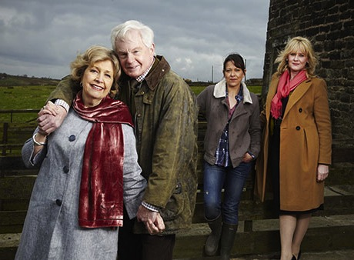
L-R: Anne Reid, Derek Jacobi, Nicola Walker, Sarah Lancashire (Credit: Helen Turton/BBC)
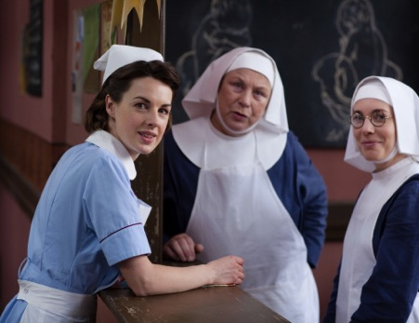
L-R: Jessica Raine, Pam Ferris, Laura Main
(Credit: Laurence Cendrowicz/Neal Street Productions)
ARLINGTON, VA; May 14, 2013 -- BBC Worldwide North America Sales & Distribution and PBS announced today the sale to PBS of the first season of the critically acclaimed British drama LAST TANGO IN HALIFAX and the third season of the award-winning BBC hit CALL THE MIDWIFE.

LAST TANGO IN HALIFAX will premiere Sunday, September 8, 2013, at 8:00 p.m. ET, leading into the finale of the MASTERPIECE MYSTERY! courtroom drama “Silk,” as part of PBS’ continuing Sunday nights of drama. CALL THE MIDWIFE (Season 3) will premiere in 2014.

Written by Sally Wainwright (“Scott and Bailey,” “Unforgiven,” “At Home With the Braithwaites”) and directed by Euros Lynn (“Black Mirror,” “Sherlock”) and Sam Donovan (“Skins,” “Secret Diary of a Call Girl”), LAST TANGO IN HALIFAX completed its first season in the UK in late 2012. The premiere ranked within BBC One’s top 10 highest-rated drama series in 2012, attracting 7.3 million viewers. A second series has been commissioned in the UK. A Red Production for the BBC, LAST TANGO IN HALIFAX is produced by Karen Lewis and Nicola Shindler, with Sally Wainwright and Matthew Read as the executive producers.

Matt Forde, EVP Sales and Co-productions, BBC Worldwide, said, “LAST TANGO IN HALIFAX is an uplifting series that will challenge and captivate the PBS audience. It’s a terrific complement to an all new series of CALL THE MIDWIFE.”

“I fell in love with ‘Last Tango’ and its stars from the moment I saw it,” said Beth Hoppe, Chief Programming Executive and General Manager, General Audience Programming, PBS. “And love and family and all the complications that come with it are at the heart of this warm comedy-drama. We’re pleased to add this new series and to continue our partnership on CALL THE MIDWIFE, solidifying Sunday nights as our highest-rated night of the week.” Season-to-date, PBS ratings for Sundays are up 26 percent.

LAST TANGO IN HALIFAX stars Derek Jacobi (The King’s Speech, “The Borgias,” My Week With Marilyn) as Alan, Anne Reid (“Upstairs, Downstairs,” “Marchlands”) as Celia, Sarah Lancashire (“Five Daughters,” “Wuthering Heights,” “Inspector George Gently”) as Caroline, Nicola Walker (“Inside Men,” “Spooks,” “Being Human”) as Gillian, Tony Gardner (“Fresh Meat,” “My Parents Are Aliens”) as John, Dean Andrews (“Life On Mars,” “Ashes To Ashes,” “Marchlands”) as Robbie, Nina Sosanya (“Silk,” “Five Days,” “Hustle”) as Kate, Ronni Ancona (“Skins,” “Big Impression”) as Judith and Josh Bolt (“Shameless,” Nowhere Boy) as Raff.

The six-part series is an uplifting comedy/drama about romance and second chances. Full of zesty humor, great characters and glorious dialogue, it’s about timeless love in a modern setting.

Childhood sweethearts Alan and Celia, both widowed and in their 70s, fall for each other all over again when they are reunited over the internet after nearly 60 years. As their lives collide for a second time, the couple laments what might have been as they take audiences on a life-affirming journey together. While their relationship is a celebratory tale of the power of love at any age, it is also a story about family and the complications the relationship causes, especially for their grown daughters.

CALL THE MIDWIFE (Season 3) brings viewers back to East London, now in 1959 and the eve of the Swinging Sixties. The winds of change are sweeping through the country and the residents of Nonnatus House face some momentous changes of their own.

CALL THE MIDWIFE stars Jessica Raine as Jenny Lee, along with Jenny Agutter (“The Railway Children,” “Spooks”) as Sister Julienne, Pam Ferris (“Little Dorrit,” “Darling Buds of May”) as Sister Evangelina, Miranda Hart (“Miranda”) as Chummy, Judy Parfitt (“Little Dorrit,” Girl With a Pearl Earring) as Sister Monica Joan, Helen George (“Hollyoaks,” “Doctors”) as Trixie Franklin, Bryony Hannah (Cemetery Junction) as Cynthia Miller, Laura Main (“Monarch of the Glen”) as Sister Bernadette and Cliff Parisi (“East Enders”) as Fred. Vanessa Redgrave provides the voice of the mature Jennifer. CALL THE MIDWIFE is a Neal Street production for BBC, executive produced by Pippa Harris (Revolutionary Road, “The Hollow Crown”) and Heidi Thomas. The series is produced by Hugh Warren (“Survivors”).

Full episodes of LAST TANGO IN HALIFAX and CALL THE MIDWIFE will be available for viewing on the PBS Video Portal for a limited time after each national broadcast.

About BBC Worldwide North America Sales & Distribution
BBC Worldwide Sales & Distribution is one of five core businesses under BBC Worldwide, the commercial arm and wholly-owned subsidiary of the UK public service broadcaster, BBC (British Broadcasting Corporation). BBC Worldwide exists to maximize the value of the BBC’s assets for the benefit of the BBC, and invests in programming in return for rights. The Sales & Distribution business negotiates, sells and distributes television programs to networks and secures co-production partners, across the U.S. and Canada.

About PBS
PBS, with its over 350 member stations, offers all Americans the opportunity to explore new ideas and new worlds through television and online content. Each month, PBS reaches nearly 120 million people through television and over 29 million people online, inviting them to experience the worlds of science, history, nature and public affairs; to hear diverse viewpoints; and to take front row seats to world-class drama and performances. PBS’ broad array of programs has been consistently honored by the industry’s most coveted award competitions. Teachers of children from pre-K through 12th grade turn to PBS for digital content and services that help bring classroom lessons to life. PBS’ premier children’s TV programming and its website, pbskids.org, are parents’ and teachers’ most trusted partners in inspiring and nurturing curiosity and love of learning in children. More information about PBS is available at www.pbs.org, one of the leading dot-org websites on the Internet, or by following PBS on Twitter, Facebook or through our apps for mobile devices. Specific program information and updates for press are available at pbs.org/pressroom or by following PBS PressRoom on Twitter.

About Red Production Company
Red Production Company is one of the UK’s leading independent drama producers. Since 1998 Red has worked with the UK’s leading writers including Russell T Davies, Paul Abbott and Sally Wainwright on productions such as “Queer as Folk” (C4), “Clocking Off” (BBC1), “Bob & Rose” (ITV), “Scott & Bailey” (ITV), “Hit & Miss” (Sky Living) and “Last Tango in Halifax” (BBC1). For more information visit www.redproductioncompany.com, follow us on Twitter, watch us on YouTube or ‘Like’ us on Facebook.

About Neal Street Productions
Neal Street Productions was formed in 2003 by Sam Mendes, Pippa Harris and Caro Newling. The company has been successful in film, theatre and television with hit movies including Revolutionary Road, Jarhead and Starter for Ten. Their upcoming contemporary British thriller, Blood, starring Paul Bettany and Mark Strong, will be released on May 31, 2013, in the UK. Their diverse television slate includes the award-winning “Stuart A Life Backwards,” with Tom Hardy and Benedict Cumberbatch, and the hugely successful, award-winning CALL THE MIDWIFE, which has been a ratings smash hit in the UK. Neal Street also produced the critically acclaimed “The Hollow Crown” — a series of Shakespeare films for the BBC/PBS — starring Ben Whishaw, Tom Hiddleston and Jeremy Irons, due to air in the U.S. in fall 2013. A new series, “The Flavia de Luce Mysteries,” based on the books by Alan Bradley, is being developed for the BBC. On the theatre side, they have produced The Bridge Project, Shrek the Musical, South Downs & The Browning Version, Enron, Three Days of Rain and are currently working on a new West End musical of Charlie and the Chocolate Factory, directed by Sam Mendes, which will make its world premiere in June 2013.

– PBS –

CONTACTS:
Carrie Johnson, PBS, 571-265-1738; cjohnson@pbs.org
Veronica Logue, BBC Worldwide, 212-339-1708, veronica.logue@bbc.com

For images and additional up-to-date information on PBS programs, visit PBS PressRoom at pbs.org/pressroom

PBS Sunday nights at 8:00 p.m., when CALL THE MIDWIFE’s first two seasons have aired, are up 24 percent over last season-to-date.

