THE LAVENDER SCARE
Premieres Tuesday, June 18, 2019
9:00-10:00 p.m. ET on PBS

Narrated by Glenn Close, Film Tells the Shocking Story of the
U.S. Government’s Decades-Long Effort to Rid the Federal Workforce
Of LGBTQ Employees

ARLINGTON, VA – Narrated by Glenn Close and featuring the voices of Cynthia Nixon, Zachary Quinto, T. R. Knight and David Hyde Pierce, THE LAVENDER SCARE tells the little-known story of an unrelenting campaign by the federal government to identify and fire employees suspected of being homosexual. Produced and directed by Josh Howard and based on the award-winning book by David K. Johnson, THE LAVENDER SCARE premieres Tuesday, June 18, 2019, 9:00-10:00 p.m. ET (check local listings) on PBS.
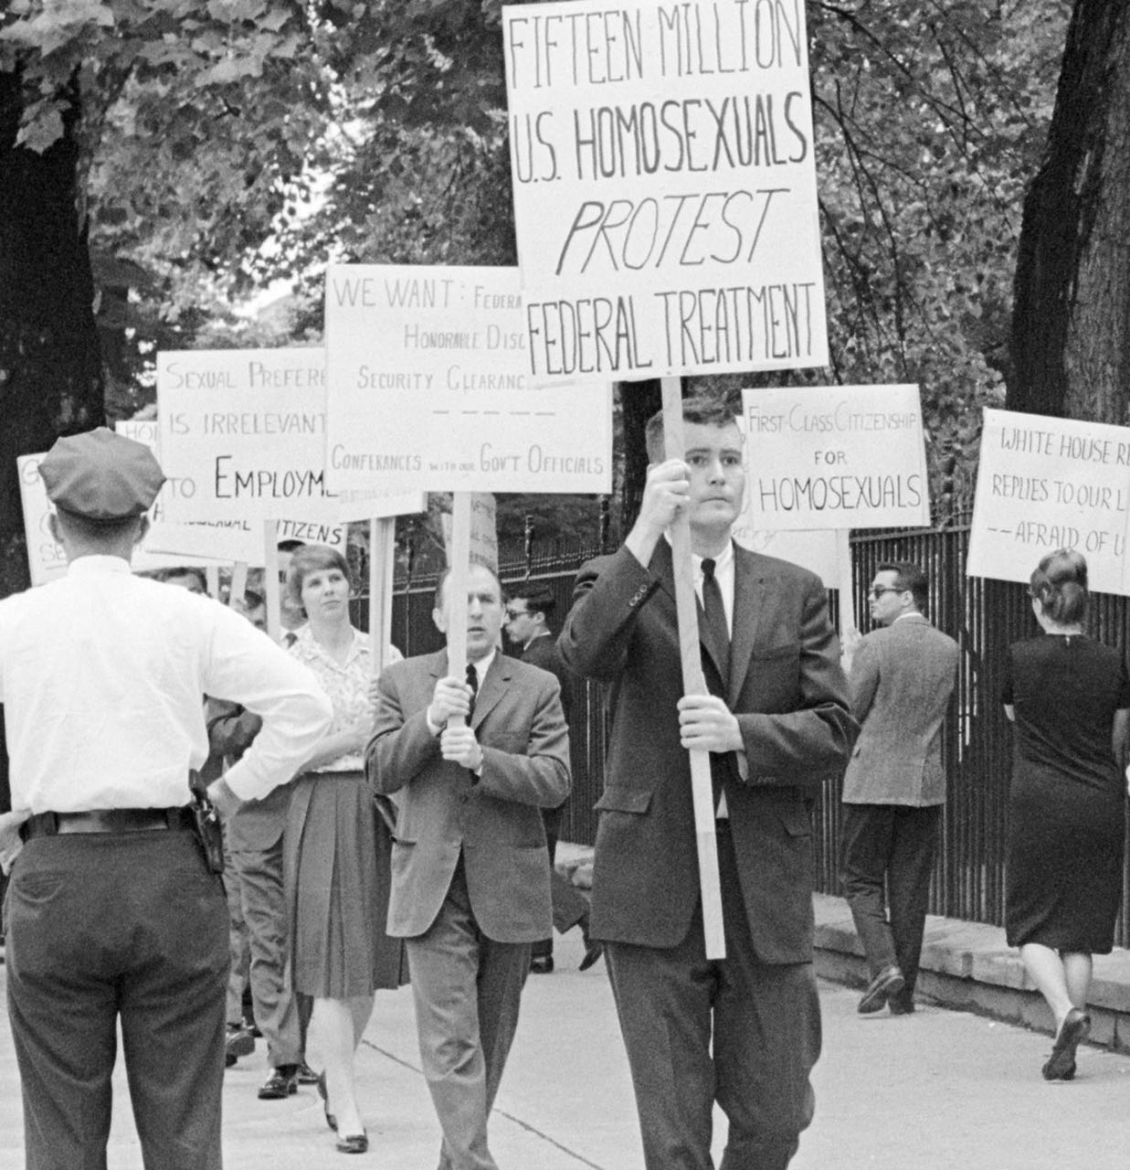
A 1965 protest march in front of the White House, the first of its kind.
Credit: Courtesy of the New York Public Library.

In 1953, at the height of the Cold War and Senator Joe McCarthy’s virulent campaign against suspected Communists and possible traitors, President Eisenhower declared gay men and lesbians to be a threat to the security of the country and therefore unfit for government service. In doing so, he incited decades of stigmatization against LGBTQ employees in the federal workforce.

Over the next four decades, tens of thousands of government workers were intimidated, harassed and investigated, confronted with information from anonymous informants and threatened with exposure. Many lost their jobs and prospects for the future — some even driven to suicide — for no reason other than their sexual orientation. But the actions of the government had an unintended effect, stirring outrage in the community and helping to ignite the gay rights movement.

In 1957, after being questioned about his homosexuality by two civil servants, a Harvard-trained astronomer working with the U.S. Army’s Map Service became the first person to fight his dismissal. Instead of arguing against the prevailing opinion that homosexuality was immoral, Frank Kameny reframed the issue as one of civil rights — discrimination against a particular group — and his attempts to regain his job evolved into a lifelong battle for the rights of LGBTQ people until his death in 2011.

It was not until 1995 that President Clinton signed an executive order ending the ban on security clearances for gay workers.

Featuring interviews with Kameny and others who were targeted, as well as authors and government officials responsible for investigating federal employees, THE LAVENDER SCARE is a compelling story of a fight for justice and a chilling reminder of how easy it can be, during a time of fear and uncertainty, to trample the rights of an entire class of people in the name of patriotism and national security.

About the Filmmaker
Josh Howard (Producer/Director) is a producer and broadcast executive with more than 25 years of experience in news and documentary production. He has been honored with 24 Emmy Awards, mostly for his work on the CBS News broadcast 60 Minutes. Josh began his career at 60 Minutes reporting stories with correspondent Mike Wallace. He was later named senior producer and then executive editor of the broadcast. Following that, he served as executive producer of the weeknight edition of 60 Minutes.

Josh then joined NBC Universal as Vice President of Long Form Programming for CNBC. In that position, he created a unit that produced a series of award-winning documentaries focusing on American business. The 90-minute film Big Brother, Big Business, which explored the ways in which corporate America works hand-in-hand with the government to collect information about the personal habits of private citizens, won the Emmy Award for Best Documentary on a Business Topic, one of three Emmy Awards he earned for CNBC.

About PBS

PBS, with more than 330 member stations, offers all Americans the opportunity to explore new ideas and new worlds through television and digital content. Each month, PBS reaches over 120 million people through television and 26 million people online, inviting them to experience the worlds of science, history, nature and public affairs; to hear diverse viewpoints; and to take front row seats to world-class drama and performances. PBS’ broad array of programs has been consistently honored by the industry’s most coveted award competitions. Teachers of children from pre-K through 12th grade turn to PBS for digital content and services that help bring classroom lessons to life. Decades of research confirms that PBS’ premier children’s media service, PBS KIDS, helps children build critical literacy, math and social-emotional skills, enabling them to find success in school and life. Delivered through member stations, PBS KIDS offers high-quality educational content on TV – including a 24/7 channel, online at pbskids.org, via an array of mobile apps and in communities across America. More information about PBS is available at www.pbs.org, one of the leading dot-org websites on the internet, or by following PBS on Twitter, Facebook or through our apps for mobile and connected devices. Specific program information and updates for press are available at pbs.org/pressroom or by following PBS Pressroom on Twitter.

- PBS -
CONTACTS:
Atiya Frederick, PBS
anfrederick@pbs.org

Meredith Wohl, PBS
mawohl@pbs.org

Cara White / Mary Lugo, CaraMar, Inc.
cara.white@mac.com; lugo@negia.net

For further information and photos visit http://www.pbs.org/pressroom.

