The Fascinating Seasons of Marine Life Are on Display in
LIFE ON THE REEF

− Three-Part Series Premieres July 22, 2015, 8:00-9:00 p.m. ET –

Green Sea Turtle. Courtesy of Nick Robinson / © Eye Spy Productions Trading as Northern Pictures

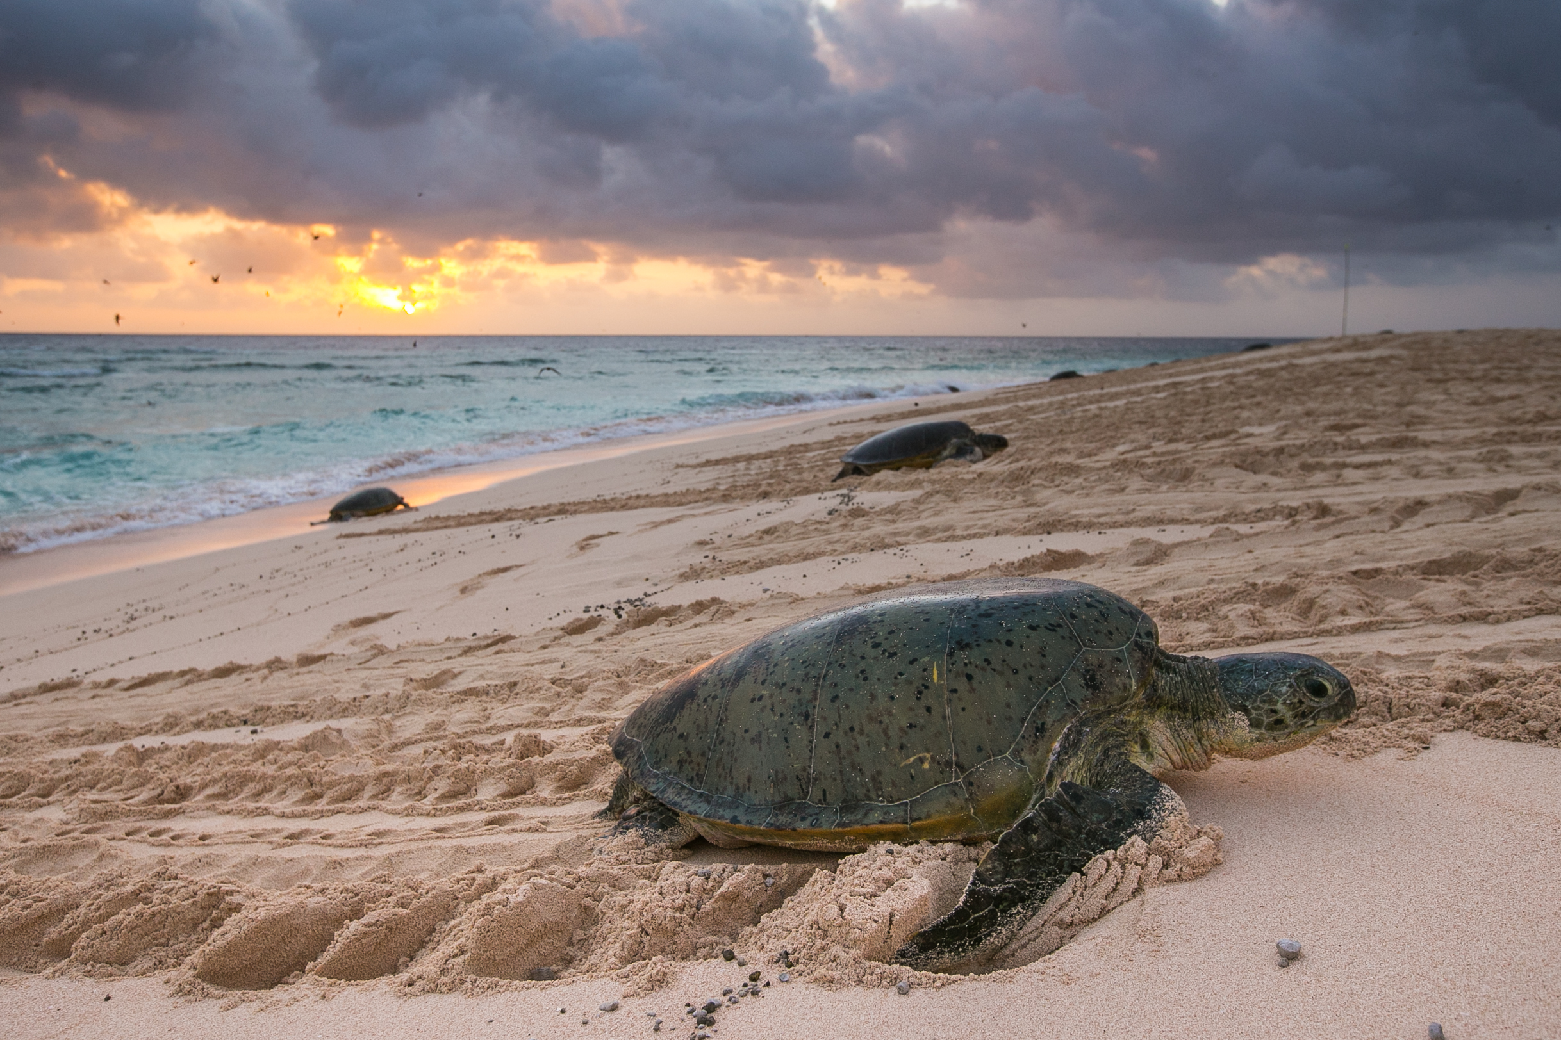
ARLINGTON, VA; May 21, 2015 -- LIFE ON THE REEF, a three-part series that explores the mysteries and hardships of the world’s greatest marine wilderness, premieres Wednesday, July 22, 2015, at 8:00 p.m. ET on PBS (check local listings). The documentary examines the array of life in and around one of the planet’s most extraordinary and endangered places, Australia’s Great Barrier Reef, and the efforts to protect it.

Amid the fringing reefs, coral cays and islands of the Torres Strait, the human residents living on the Great Barrier Reef seek to find the critical balance between their needs and those of a diminishing natural world. LIFE ON THE REEF combines observational documentary storytelling with cutting-edge cinematography to present a unique angle on Australia’s greatest natural icon.

“PBS’ summer of science continues with this look at one of the world’s greatest natural treasures,” said Bill Gardner, Vice President of Programming and Development. “The Great Barrier Reef is rich, it’s vibrant, and it’s also under threat. By presenting the beauty and scientific wonder of the reef to our PBS audience, we hope to generate awareness for its welfare.”

Set against a backdrop of extraordinary marine habitats, the series’ three episodes take the audience above and beneath the waters to see how nature adapts to the changing seasons throughout the year.

Episode One, July 22, 8:00-9:00 p.m.: The first episode explores the Great Barrier Reef during Australia’s tourist-heavy winter season. During this time, humpback whales make the long journey to calve in the warm tropical waters, while rescue crews respond to a human and environmental emergency in one of the most sensitive parts of the reef. On the most protected island in Australia, scientists work to save the biggest turtle rookery on Earth.

Episode Two, July 29, 8:00-9:00 p.m.: The second episode transitions into spring, capturing the Great Barrier Reef as it is about to explode with new life. Divers descend into dark water in the hope of seeing the annual coral spawn, and manta rays enter the reef to filter-feed on the nutrient rich waters. Thousands of sea birds congregate on the islands and coral cays to nest, while in the mangroves, saltwater crocodiles violently defend their eggs. In the far north, rangers and scientists fight to control a potentially catastrophic plague of coral-eating crown of thorn starfish.

Episode Three, August 5, 8:00-9:00 p.m.: The final episode follows the summer season on the Great Barrier Reef. Thousands of tiny turtles emerge from the sand and begin the struggle to survive. The human and animal residents prepare as a category five cyclone bears down on the North Queensland coast. Conservationists also fight against other threats to the marine wilderness, including shipping accidents and oil spills.
LIFE ON THE REEF is one of PBS’ robust summer science programs. Also airing this summer: OPERATION WILD, following veterinarians around the world as they save animals' lives; THE BOMB, revisiting the atomic bomb on its 70th anniversary; URANIUM: TWISTING THE DRAGON’S TAIL, the complex history of the most controversial rock on Earth; NOVA’s “Chasing Pluto,” capturing New Horizon’s historic flyby of the far-off planet, and “Nuclear Meltdown Disaster,” recounting Japan’s nuclear energy crisis and its ongoing aftermath; and BIG BLUE LIVE, a live-as-it-happens look at the amazing sea life returning to California’s Monterey Bay National Marine Sanctuary.

Produced by Northern Pictures for PBS, LIFE ON THE REEF was directed by Nick Robinson, who was also one of the cinematographers. He was joined by cinematographers Luke Peterson on land and Jon Shaw underwater. Executive producers for Northern Pictures are Karina Holden and Sue Clothier. Bill Gardner, Vice President of Programming and Development, has overseen the series for PBS.

About PBS
PBS, with over 350 member stations, offers all Americans the opportunity to explore new ideas and new worlds through television and online content. Each month, PBS reaches more than 103 million people through television and over 33 million people online, inviting them to experience the worlds of science, history, nature and public affairs; to hear diverse viewpoints; and to take front row seats to world-class drama and performances. PBS’ broad array of programs has been consistently honored by the industry’s most coveted award competitions. Teachers of children from pre-K through 12th grade turn to PBS for digital content and services that help bring classroom lessons to life. PBS’ premier children’s TV programming and its website, pbskids.org, are parents’ and teachers’ most trusted partners in inspiring and nurturing curiosity and love of learning in children. More information about PBS is available at www.pbs.org, one of the leading dot-org websites on the Internet, or by following PBS on Twitter, Facebook or through our apps for mobile devices. Specific program information and updates for press are available at pbs.org/pressroom or by following PBS Pressroom on Twitter.

– PBS –

MEDIA CONTACTS:
Ellen Stanley Booth, PBS, 703-739-5120; esbooth@pbs.org
Chelsey Saatkamp, Goodman Media for PBS, 212-576-2700; PBSProgramming@goodmanmedia.com

For images and additional up-to-date information on this and other PBS programs, visit PBS PressRoom at pbs.org/pressroom.

