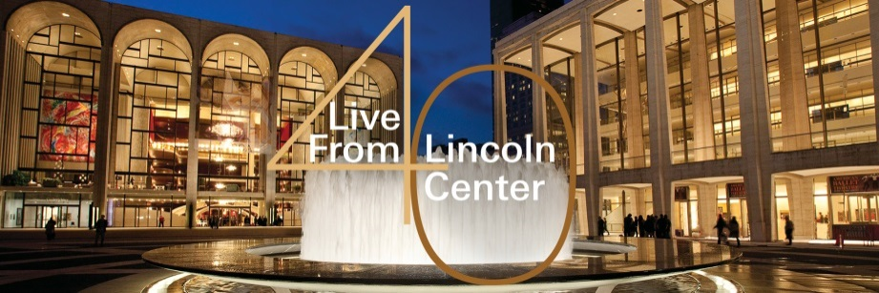

Date: November 3, 2014
Eric M. Gewirtz
212-875-5049
EGewirtz@LincolnCenter.org

LIVE FROM LINCOLN CENTER: 40TH ANNIVERSARY SEASON

“Curtain Up: The School of American Ballet Workshop Performances”
Rare glimpse of Rehearsals and Performances by
Future Dance Stars at School of American Ballet
with Host Audra McDonald

Friday, December 12, 2014 at 9:00 p.m. (ET) on PBS (check local listings)

FOR IMMEDIATE RELEASE — For the first time on Live From Lincoln Center, the curtain will be drawn back on one of the world’s premier ballet academies – the School of American Ballet – with the presentation of the School’s 50th Annual Workshop Performance. Taped during a live event in May 2014, this coming broadcast will feature performances and rare behind-the-scenes footage, demonstrating the legacy and continuing tradition of the excellence fostered at this prestigious academy and showcasing the talented dancers of the future. Live From Lincoln Center’s 40th anniversary season presentation of the “Curtain Up: The School of American Ballet Workshop Performances” will air on Friday, December 12, 2014 at 9:00 p.m. on PBS (*check local listings), hosted by Audra McDonald.

This past Spring, the 50th Annual Workshop featured a program specially chosen to recognize the School’s co-founder George Balanchine and former faculty member Alexandra Danilova, who together launched SAB’s first year-end student showcase in 1965. The all-Balanchine program, which was presented at Lincoln Center’s Peter Jay Sharp Theater, included the seminal Serenade as well as excerpts from such famous works as Coppélia, Swan Lake, and Western Symphony. These excerpts were taught by some of the world’s most-acclaimed instructors and foremost stagers of Balanchine’s work, including Peter Martins and Darci Kistler, who also appear in this broadcast, talking about the school and its history, the works, and the dancers to be featured. This broadcast represents the first-ever School of American Ballet presentation on Live From Lincoln Center.

>> Watch a preview here: http://youtu.be/9dpt4isQPhE

The School of American Ballet (SAB), the official training academy of the New York City Ballet, was founded by Lincoln Kirstein and legendary choreographer George Balanchine in 1934 as the first and most essential step in their mission to establish a uniquely American classical ballet company. Since its founding, SAB has elevated the quality of American dance and is today the premier ballet academy in the United
Live From Lincoln Center is made possible by a major grant from MetLife.
States, training more students who go on to become professional dancers than any other institution. At the end of each school year, advanced students are selected to perform in the School’s Spring Workshop, which is presented in this broadcast, providing audiences a unique opportunity to witness the pre-professional debuts of the nation’s most talented ballet students as they prepare to embark on professional ballet careers with notable companies in the U.S. and abroad.

This episode of Live From Lincoln Center is directed for television by Matthew Diamond, who also directed The Nance which aired earlier in this anniversary season as well as Dance in America, as well as documentary segments contributed by Elliot Caplan, the filmmaker in residence at the Cunningham Dance Company from 1983-1998). The executive producer of the Live From Lincoln Center series is Andrew C. Wilk.

About School of American Ballet
The School of American Ballet, founded by legendary choreographer George Balanchine and Lincoln Kirstein in 1934, is the premier ballet academy in the United States. Approximately 570 boys and girls ranging in age from six to nineteen attend classes during the Winter Term at SAB, which is both a resident organization of Lincoln Center for the Performing Arts and the official academy of New York City Ballet. While children enrolled at the School hail from the New York metro area, SAB’s intermediate and advanced classes are filled with talented students from around the U.S. and abroad, with more than 60 living in the School’s onsite residence hall. Each year, twenty advanced students on average sign professional contracts with dance companies around the United States and abroad. Not only do SAB alumni comprise 97 percent of New York City Ballet, but dancers trained at the School also currently appear on the rosters of over 70 U.S. and more than a dozen international companies. For more information: sab.org

About Live From Lincoln Center
Live From Lincoln Center is a cornerstone of performing arts broadcasting, presenting the world’s greatest artists and performances in music, dance and theater from Lincoln Center’s renowned stages. Now in its 40th season on PBS, the pioneering series—produced by Lincoln Center—has been seen by hundreds of millions of viewers since its debut and celebrated by 13 Emmy Awards and other honors for its broadcasting excellence. Additional Live From Lincoln Center content is accessible online at PBS.org and watch.lincolncenter.org. For more about upcoming broadcasts, visit livefromlincolncenter.org

About Lincoln Center for the Performing Arts
Lincoln Center for the Performing Arts (LCPA) serves three primary roles: presenter of artistic programming, national leader in arts and education and community relations, and manager of the Lincoln Center campus. A presenter of more than 3,000 free and ticketed events, performances, tours, and educational activities annually, LCPA offers 15 series, festivals, and programs including American Songbook, Avery Fisher Artist Program, Great Performers, Lincoln Center Books, Lincoln Center Festival, Lincoln Center Out of Doors, Midsummer Night Swing, Martin E. Segal Awards, Meet the Artist, Mostly Mozart Festival, Target Free Thursdays, and the White Light Festival, as well as the Emmy Award-winning Live From Lincoln Center, which airs nationally on PBS. As manager of the Lincoln Center campus, LCPA provides support and services for the Lincoln Center complex and 11 resident organizations: Chamber Music Society of Lincoln Center, The Film Society of Lincoln Center, Jazz at Lincoln Center, The Juilliard School, Lincoln Center Theater, The Metropolitan Opera, New York City Ballet, New York Philharmonic, The New York Public Library for the Performing Arts, the School of American Ballet and Lincoln Center for the Performing Arts. For more information: aboutlincolncenter.org

About PBS
PBS, with over 350 member stations, offers all Americans the opportunity to explore new ideas and new worlds through television and online content. Each month, PBS reaches nearly 109 million people through television and over 28 million people online, inviting them to experience the worlds of science, history, nature and public affairs; to hear diverse viewpoints; and to take front row seats to world-class drama and performances. PBS’s broad array of programs has been consistently honored by the industry’s most coveted award competitions. Teachers of children from pre-K through 12th grade turn to PBS for digital content and services that help bring classroom lessons to life. PBS’s premier children’s TV programming and its website, pbskids.org, are parents’ and teachers’ most trusted partners in inspiring and nurturing curiosity and love of learning in children. More information about PBS is available at www.pbs.org, one of the leading dot-org websites on the Internet, or by following PBS on Twitter, Facebook or through our apps for mobile devices. Specific program information and updates for press are available at pbs.org/pressroom or by following PBS PressRoom on Twitter.

Live From Lincoln Center is made possible by a major grant from MetLife.

In addition to underwriting from MetLife, the series is also made possible with generous support from the Robert Wood Johnson 1962 Charitable Trust, Thomas H. Lee and Ann Tenenbaum, The Robert and Renée Belfer Family Foundation and the National Endowment for the Arts.

MetLife
National Sponsor of Lincoln Center

Movado
Official Sponsor of Lincoln Center

United Airlines
Official Airline of Lincoln Center

WABC-TV
Official Broadcast Partner of Lincoln Center

William Hill Estate Winery
Official Wine of Lincoln Center

Further information about Live From Lincoln Center, along with photos and videos can be found at:
Lincoln Center Press Room: http://aboutlincolncenter.org/press-room/subject/18
PBS Press Room: http://pressroom.pbs.org/Programs/l/LIVE-FROM-LINCOLN-CENTER.aspx

Follow Live From Lincoln Center on social media:
Facebook: facebook.com/LiveFromLC
Twitter: twitter.com/LiveFromLC
Join the conversation during the broadcast: #LFLC
Tumblr: lincolncenter.tumblr.com
# # #

