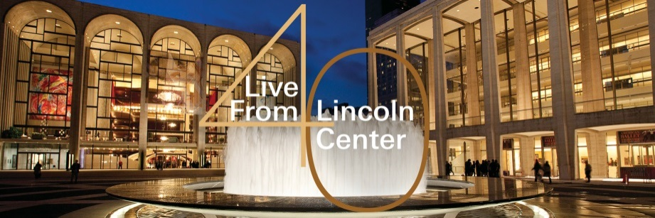

Billy Porter is a Tony® and Grammy® Award-winning singer, composer, actor, playwright and director from Pittsburgh, Pennsylvania. Porter’s solo albums include his first release, Untitled, on A&M records, and his sophomore album, At the Corner of Broadway + Soul - LIVE, on Sh-K-Boom Records.

Billy’s Back on Broadway, Porter’s debut on Concord Records, features 10 classics made famous on the Great White Way, focusing on inspiration, empowerment and hope. The album’s title is a nod to Sammy Davis, Jr.’s recording Sammy’s Back on Broadway.

Porter’s voice can also be heard on the albums A Very Rosie Christmas, Jim Brickman’s Destiny (top 10 AC hit), Grease (revival cast album), Adam Guettel’s Myths & Hymns, Gershwin and Sondheim Benefit Albums, Hercules (Disney) and Anastasia (Warner Bros.), Liz Callaway – The Story Goes On, Alvin Ailey/Revelations, Broadway Cares Home for the Holidays, Dreamgirls in Concert, HAIR (Actor’s Fund Benefit recording), Great Joy: A Gospel Christmas (with The Broadway Inspirational Voices) and The Human Rights Campaign’s Love Rocks.

Porter currently stars as “Lola” in the smash hit Broadway musical Kinky Boots, for which he won the 2013 Drama Desk and Tony Awards for Best Actor in a Musical. Other Broadway acting credits include Miss Saigon, Five Guys Named Moe, Grease (all original cast), Smokey Joe’s Café and Dreamgirls (20th Anniversary Broadway Concert and LA Ovation Award). Off Broadway and regional credits include Angels in America (Signature Theater), Romance in Hard Times, The Merchant of Venice, House of Lear and Radiant Baby (The New York Shakespeare Festival), Birdie Blue (Second Stage), Angels in America (Actors Theatre of Louisville), Going Native (The Long Wharf), Jelly’s Last Jam (Alliance), Topdog/Underdog (City Theatre), King Lear (Exit, Pursued By A Bear), Jason Robert Brown’s Songs for a New World (original cast), Jesus Christ Superstar, Antigone, A Chorus Line and Chicago. His one-man show, Ghetto Superstar: The Man That I Am, debuted at The Public Theater in NYC, in conjunction with City Theatre of Pittsburgh, and was nominated for a 2005 GLAAD Media Award. Porter was also named “Pittsburgh’s Performer of the Year 2003-2004” by the Pittsburgh Post-Gazette.

As a director, Porter oversaw a critically acclaimed re-creation of The Wiz and conceived a musical revue entitled Signed, Sealed, Delivered: The Music of Stevie Wonder, which starred Chaka Khan and ran at the Venetian Hotel in Las Vegas in the spring of 2002. Porter conceived and directed Being Alive, a musical celebration that aligns the canons of Stephen Sondheim and William Shakespeare and combines them with the soulful musical styles of the African-American experience. Being Alive made its world premiere in the summer of 2007 at The Westport Country Playhouse and immediately transferred to The Philadelphia Theatre Company, inaugurating the new Suzanne Roberts Theatre. He directed the new musical Twilight in Manchego for the NYMF in the fall of 2008, and is the NAACP Theatre Award winner for Best Direction of a Musical for his production of Once on This Island at Reprise Theatre Company – where he also conceived and directed a new musical revue called The Soul of Richard Rodgers. Other directing credits include Five Guys Named Moe for Casa Manana, Altar Boyz for Lyric Theatre of Oklahoma, RENT (Associate Director: Off-Broadway Revival), Wicked Summer Nights Concert Series at The Ford Amphitheater, starring Shoshana Bean, Eden Espinosa and Stephen Schwartz in conjunction with Upright Cabaret, where he was artistic director for the 2009 season. Porter made his London directorial debut in the fall of 2009 with Olivier Award nominee Patina Miller at Live in the Delfont Room. Porter is also a graduate of the Professional Program in Screenwriting at UCLA and is an adjunct professor at his alma mater, Carnegie Mellon University’s School of Drama, where he has directed productions of Company and Letters From ‘Nam. This fall, Primary Stages will present the world premiere of his play While I Yet Live.

Porter’s film and television credits include Sundance Film Festival features The Broken Hearts Club (Sony Pictures) and Intern, Noel (with Susan Sarandon and Robin Williams), “Shake Rattle & Roll” as Little Richard (CBS mini-series), “Another World” (recurring), “Twisted,” “Law & Order,” “The Oprah Winfrey Show,” “A Very Rosie Christmas,” “The Tonight Show” and multiple appearances on “The Rosie O’Donnell Show.” Most recently, Porter guest-starredon “Law & Order: SVU,” in a part written for him. He will appear as a guest judge in the upcoming season of the hit television show “So You Think You Can Dance” and will also appear in the film The Humbling, starring Al Pacino. His original song “Time” has been featured twice on “So You Think You Can Dance” and in the 2011 Miss America Pageant. Porter’s concert credits include opening for Rosie O’Donnell and Aretha Franklin, Carnegie Hall, John McDaniel and the St. Louis Symphony Orchestra, as well as the Buffalo Philharmonic, Peter Nero and the Philly Pops, soloist for President Bill Clinton and various benefits throughout the United States.

billyporter.com

Andrew C. Wilk is an Emmy Award-winning producer and director whose career has encompassed leading roles in many areas of television and media content. He arrived at Lincoln Center in 2011 and has served as executive producer of Live From Lincoln Center, combining his extensive television, music and theater backgrounds. Prior to his work at Lincoln Center, Wilk served as chief creative officer at Sony Music Entertainment, where he oversaw all visual content for Sony’s label groups and spearheaded Sony’s digital expansion. He also served as founding programmer and executive vice president of programming, production and news for the National Geographic Channel, where he launched the channel, developed its initial programming and scheduled and commissioned new programs, including specials with PBS and NBC. Wilk has won four Emmy Awards and received 13 nominations, in addition to other distinguished industry awards for programming excellence. Over the course of his career, he has produced or directed more than 1,000 television shows ranging from children’s programming to news to commercial entertainment. Additionally, Wilk has maintained a second career in music and theater, having conducted and directed hundreds of musicals, symphonic and concert performances.

