LUCY WORSLEY INVESTIGATES:
THE AMERICAN REVOLUTION

Historian Lucy Worsley Explores One of History’s Most Explosive Breakups and How the British Empire Lost the War for America’s Independence Against a Ragtag Band of Rebels

New Two-Part Series, Filmed on Both Sides of the Atlantic, Premieres Tuesdays, April 7-14, 2026, on PBS, PBS.org and the PBS App

ARLINGTON VA; February 18, 2026 – On the eve of America’s 250th anniversary, popular British historian Lucy Worsley investigates the sabotage, espionage, and unrest that led to the birth of a new nation. In 1776, 13 American colonies declared independence from one of the most powerful empires in the world, igniting a bloody eight-year war that claimed thousands of lives and ended in Britain’s humiliating defeat. But how did this historic rupture come to pass, and could it have been avoided? Over two episodes, Lucy delves deeper into the American Revolution by examining it from the British perspective, discovering the human drama, radical ideas, and political missteps behind this seismic split, and revealing how losing America changed Britain forever. Part of the PBS America @ 250 special programming lineup, LUCY WORSLEY INVESTIGATES: THE AMERICAN REVOLUTION premieres Tuesday, April 7 and 14, 2026, at 9:00 p.m. ET (check local listings) on PBS, PBS.org and the PBS app.
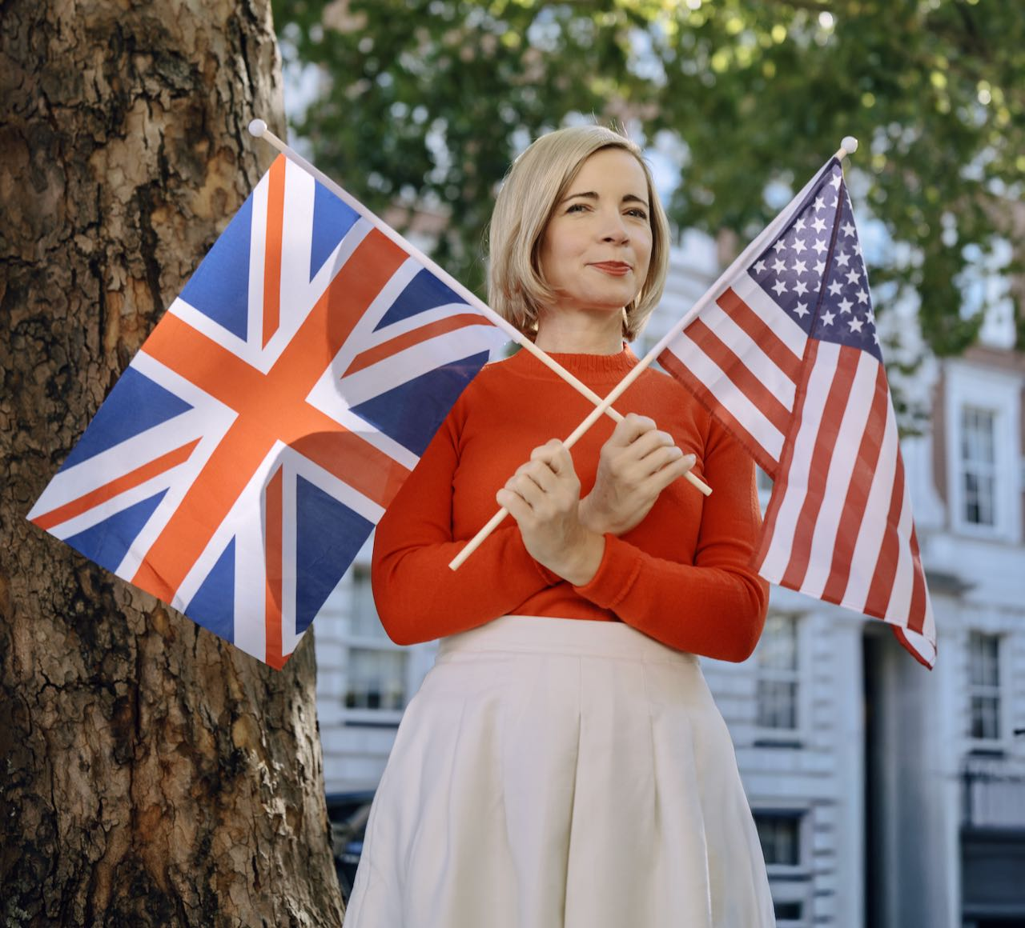
Lucy Worsley in Grosvenor Square.
Credit: Tom Hayward

“Digging into the past is a true joy for me. So often history gets written by the winners: lots of people know the US side of the American Revolution, but much fewer the British one,” said Worsley. “Interrogating amazing sources and meeting people who can shine a light on this hidden history, I can’t wait to share the forgotten and surprising story of how losing America affected Britain and beyond.”

“Lucy is a PBS treasure, beloved by our audiences for bringing her signature wit and contemporary perspective to history,” said Zara Frankel, Senior Director, Programming and Development at PBS. “As America approaches its Semiquincentennial, I can’t think of anyone better to guide us through this story from a British point of view. By stepping outside the familiar narrative, the series invites viewers to see how the Revolution not only forged a new nation, but also fundamentally altered Britain and sent shockwaves across the globe.”

Episode descriptions are provided below:

Episode One (April 7, 2026) takes Lucy to New York’s City Hall Park, where George Washington’s troops heard the Declaration of Independence read aloud — a rallying cry that inspired rebels to destroy a statue of King George III and melt it into musket balls. At the New York Historical, Lucy examines a relic of this defiance and asks whether the rupture was inevitable. She then travels home to England to uncover the British perspective, studying King George’s maps and visiting Benjamin Franklin’s London home. She traces British and American tensions rising from Britain’s punitive taxes and the Stamp Act of 1765. In Boston, Lucy explores how the Boston Massacre and Boston Tea Party were flashpoints that pushed Americans toward war. Finally, Lucy reveals the radical voices — John Wilkes and Thomas Paine — whose words crystallized America’s vision of liberty and independence.

Episode Two (April 14, 2026) uncovers how the war reverberated in Britain itself. At Portsmouth Royal Dockyard, Lucy investigates James Aitken’s shocking arson plot to cripple the Royal Navy. She traces Franklin’s secret mission to Paris to secure French support, while British spy Edward Bancroft fed intelligence back to London. Lucy explores Britain’s growing fears as France — and later Spain — joined the conflict, and how Irish Volunteers forced Britain to lift trade restrictions between Ireland and America. Back in London, riots erupted, and George III agonized over the possibility of losing the empire. By 1781, Britain’s campaign collapsed at Yorktown, and two years later, Britain formally recognized American independence. Concluding her investigation at Grosvenor Square, the site of America’s first embassy in London, Lucy reflects on a revolution that created an independent America and reshaped Britain forever.

LUCY WORSLEY INVESTIGATES: THE AMERICAN REVOLUTION will stream simultaneously with broadcast and be available on all station-branded PBS platforms, including PBS.org and the PBS app, which is available on iOS, Android, Roku, Apple TV, Amazon Fire TV, Android TV, Samsung Smart TV, Chromecast and VIZIO.

LUCY WORSLEY INVESTIGATES: THE AMERICAN REVOLUTION, a 2x60’ for BBC Two and iPlayer, is made by BBC Studios Specialist Factual Productions. It was commissioned by Simon Young, Head of History for the BBC and Zara Frankel is the Executive In Charge for PBS. The Executive Producer is Amanda Lyon and the Series Producer is Linda Sands. BBC Studios is handling Global Sales.

LUCY WORSLEY INVESTIGATES: THE AMERICAN REVOLUTION is part of a slate of new programming for PBS America @ 250, a multiyear celebration of U.S. history, culture, and children’s programming that pays homage to America’s Semiquincentennial in 2026. As part of the largest national and local engagement effort in its history, PBS member stations are activating events in more than 75 markets nationwide. In addition to tentpole programming like THE AMERICAN REVOLUTION from Florentine Films, PBS KIDS, PBS LearningMedia, PBS Digital Studios, and PBS member stations are exploring these topics at a national and local level. PBS America @ 250 programming will span across History, Music and Culture, plus programming from PBS KIDS. Visit the PBS America @ 250 Explore Page at www.pbs.org/explore/pbs-america-at-250 for more program information and PBS LearningMedia resources.

About Lucy Worsley
For over two decades, Lucy Worsley OBE served as the Chief Curator at Historic Royal Palaces in the U.K. She's the author of popular books about Jane Austen and Queen Victoria as well as the Sunday Times no. 1 bestselling biography of Agatha Christie. She is the host of dozens of PBS specials and series including LUCY WORSLEY INVESTIGATES, LUCY WORSLEY’S HOLMES VS. DOYLE, AGATHA CHRISTIE: LUCY WORSLEY ON THE MYSTERY QUEEN, LUCY WORSLEY’S ROYAL MYTHS AND SECRETS, A VERY BRITISH ROMANCE WITH LUCY WORSLEY, 12 DAYS OF TUDOR CHRISTMAS, VICTORIA & ALBERT: THE WEDDING, TALES FROM THE ROYAL BEDCHAMBER, and more. She also hosts the hit BBC Radio 4 podcasts LADY KILLERS and LADY SWINDLERS WITH LUCY WORSLEY, which investigate the crimes of Victorian women from a contemporary, feminist perspective.

About PBS
PBS, with more than 330 member stations, offers all Americans the opportunity to explore new ideas and new worlds through television and digital content. Each month, PBS reaches over 36 million adults on linear primetime television, 16 million users on PBS-owned streaming platforms, 56 million viewers on YouTube, and 10 million followers on social media, inviting them to experience the worlds of science, history, nature, and public affairs and to take front-row seats to world-class drama and performances. PBS’s broad array of programs has been consistently honored by the industry’s most coveted award competitions. As the number one educational media brand, PBS KIDS helps children 2-8 build critical skills, enabling them to find success in school and life. Delivered through member stations, PBS KIDS offers high-quality content on TV — including a PBS KIDS channel — and streaming free on pbskids.org and the PBS KIDS Video app, games on the PBS KIDS Games app, and in communities across America. Teachers of children from pre-K through 12th grade turn to PBS LearningMedia for digital content and services that help bring classroom lessons to life. More information about PBS is available at PBS.org, one of the leading dot-org websites on the internet, Facebook, Instagram, or through our apps for mobile and connected devices. Specific program information and updates for press are available at pbs.org/pressroom or by following PBS Communications on X.

– PBS –

CONTACTS:

Atiya Frederick, PBS, anfrederick@pbs.org

Cara White / Mary Lugo, CaraMar, Inc.
cara.white@mac.com; lugo@negia.net

For images and additional up-to-date information on this and other PBS programs, visit PBS PressRoom at pbs.org/pressroom.

