THE MAKING OF A LADY to Premiere on PBS
Sunday, February 9, 2014
10:00-11:30 p.m. ET

– British Drama Joins PBS’ Robust Sunday Lineup –

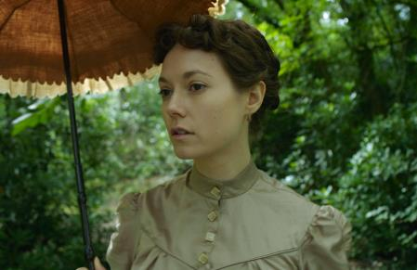
Lydia Wilson as Emily Fox Seaton
Courtesy of Runaway Fridge TV
ARLINGTON, VA – PBS announced the addition of British drama, THE MAKING OF A LADY, to its Sunday lineup, premiering February 9, 2014 at 10:00 p.m. ET. The 90-minute program will premiere following “Downton Abbey, Season 4” on MASTERPIECE to round out PBS’ star-studded night of British programming.

Based on the novel by celebrated writer Frances Hodgson Burnett (The Secret Garden, A Little Princess), THE MAKING OF A LADY is the story of the educated but penniless Emily Fox Seaton (“South Riding,” “Any Human Heart”). During her duties as a lady’s companion for Lady Maria (Joanna Lumley, “Absolutely Fabulous,” “Marple”), she meets her employer’s wealthy widower nephew, Lord James Walderhurst (Linus Roache, Titanic, Batman Begins). Accepting his practical, if unromantic, marriage proposal, Emily finds solace in the company of Walderhurst’s nephew Alec Osborn (James D’Arcy, Cloud Atlas, Hitchcock) and his glamorous wife, Hester (Hasina Haque), after Lord James leaves to rejoin his regiment. But all is not what it seems as an increasingly contented Emily has no inkling her life is actually in danger. While Walderhurst risks his life overseas, Emily, alone with the Osborns, seems powerless to avoid the threat that begins to encircle her and begins to fear for her life.

Adapted for the screen by Kate Brooke (“Mr. Selfridge,” “The Forsyte Saga”) and directed by Richard Curson Smith (“Will Self’s The Minor Character,” “Consenting Adults”) THE MAKING OF A LADY is executive produced by Stevie Lee for Runaway Fridge TV and produced by Jo Willett (“Coming Up,” “Bertie and Elizabeth”).

“We're lucky to have such a wonderful script from Kate Brooke,” said executive producer Stevie Lee. “It’s an engaging and clever story with tension and jeopardy every step of the way, but also it’s fresh, a period story that very few people know.”

THE MAKING OF A LADY was originally broadcasted on ITV, in the UK.

About PBS
PBS, with its over 350 member stations, offers all Americans the opportunity to explore new ideas and new worlds through television and online content. Each month, PBS reaches nearly 120 million people through television and over 29 million people online, inviting them to experience the worlds of science, history, nature and public affairs; to hear diverse viewpoints; and to take front row seats to world-class drama and performances. PBS’ broad array of programs has been consistently honored by the industry’s most coveted award competitions. Teachers of children from pre-K through 12th grade turn to PBS for digital content and services that help bring classroom lessons to life. PBS’ premier children’s TV programming and its website, pbskids.org, are parents’ and teachers’ most trusted partners in inspiring and nurturing curiosity and love of learning in children. More information about PBS is available at www.pbs.org, one of the leading dot-org websites on the Internet, or by following PBS on Twitter, Facebook or through our apps for mobile devices. Specific program information and updates for press are available at pbs.org/pressroom or by following PBS PressRoom on Twitter.

– PBS –

CONTACTS:
Press:
Alyssa Winters, Sara Levin, Missy Krowne, DKC Public Relations, 212-685-4300;
Alyssa_Winters@dkcnews.com; Sara_Levin@dkcnews.com; Missy_Krowne@dkcnews.com

PBS Stations:
Jessie Yuhaniak, PBS, 703-739-5364; jayuhaniak@pbs.org
Lara Davidson, PBS, 703-739-5115; lkdavidson@pbs.org

For images and additional up-to-date information on this and other PBS programs, visit PBS PressRoom at pbs.org/pressroom.

