MARGARET: THE REBEL PRINCESS
Premieres Sundays, February 10 and 17, 2019 on PBS

New Two-Part Documentary Series Offers an Insider’s Look at the Tumultuous Life and Loves of Princess Margaret,
The Rebellious Royal Who Defied Expectations and Paved the Way for the New Generation of Britain’s Royal Family

ARLINGTON, VA; DECEMBER 17, 2018 – MARGARET: THE REBEL PRINCESS, an insightful new two-part biography of Princess Margaret, Queen Elizabeth’s beautiful and rebellious younger sister, will premiere on Sundays, February 10 and 17, 2019, 10:00-11:00 p.m. ET (check local listings) on PBS.
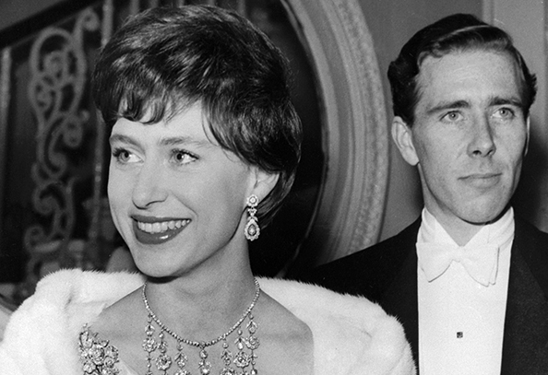Credit: ©Getty / Stringer

This new special, featuring rare footage and interviews with those who knew her best, offers unparalleled insight into Margaret’s turbulent life and times. Her unique position as the Queen’s younger sister in a changing Britain left her free to experiment and push boundaries, yet she was forever judged by a public and press beginning to question the very idea of a monarchy. While Margaret often followed the rigid rules under which she was raised, she also stepped outside those rules and into scandal. A complicated and contradictory princess, her story parallels her era, when the rules of social norms were being rewritten and a freer, more egalitarian society was emerging.

Margaret forged her own way by becoming a rule-breaking trendsetter and an eager participant in the excitement of a swinging 1960s London. Her loves were passionate if not always wise, from Peter Townsend, a married aide to her father, to her dashing yet philandering husband Lord Snowden, to the much-younger Roddy Llewellyn. But it was her relationship with her sister that was perhaps the most important, the woman against whom she defined herself all her life.

MARGARET: THE REBEL PRINCESS presents new interviews with several of her closest friends including Lady Anne Glenconner, Lady Jane Rayne and Jane Stevens; biographers Christopher Warwick, Craig Brown and Anne de Courcy; journalists Clive Irving of the Daily Express and Doris Bacon of AP and many others. They reveal Margaret as the first truly modern princess — a superstar who introduced a flash of Hollywood glamour into Buckingham Palace and paved the way for Diana, Kate and Meghan. A woman yearning for escape in a post-war world eager to shrug its own oppressive constraints, Margaret became a powerful and unpredictable force, reflecting and driving fundamental changes in our attitudes about the monarchy, celebrity, marriage and sex.

“People hold in their heads different ideas about what a princess should be,” said Clive Irving, former features editor of The Daily Express. “There’s the fairy-tale princess, the royal aloof, about whom you know very little. Then there’s the Princess Margaret type who suddenly becomes all too visible or all too human. The ground wasn’t prepared for Margaret in the way it’s been prepared for our current royal princesses. They are the beneficiaries of the suffering and pain that Margaret went through.”

MARGARET: THE REBEL PRINCESS is produced and directed by Hannah Berryman, edited by James Gold and executive produced by Chris Granlund.

Episode One
In 1930, Margaret Rose Windsor was born, a princess of the largest empire the world had ever seen. Seven years later, following the abdication of her uncle, Edward VIII, Margaret is suddenly second in line to the throne; her family’s life will never be the same. Britain too is changing, becoming more egalitarian after the Second World War.

While Elizabeth, the future queen, has a very clear — and starring — role in royal life, her sister Margaret’s role is less defined. She dutifully visits schools and opens flower shows, but privately prefers fashion, theater, parties and men. At 16, she is first thrust into scandal when she falls in love with Peter Townsend, a much older married man. Although he divorces, clergy and politicians are vehemently against the relationship while many of the more romantically-minded public support Margaret’s right to marry the man she loves.

Although she never marries Townsend, Margaret soon shocks the establishment again when, in 1960, she marries the handsome, bohemian photographer and “commoner,” Antony Armstrong-Jones (Lord Snowden), a charming but notorious womanizer. Margaret is happily drawn into his circle of artists, writers and celebrities, a freewheeling, uninhibited group that epitomizes the swinging sixties. The traditional era of Royal aloofness gives way to the age of celebrity and the press drop their deferential attitude to the royal family.

Episode Two
In the mid-1960s Princess Margaret and her husband are still riding the wave of a cultural and sexual revolution, while battling rumors of trouble in their marriage.

In 1965, the Princess and her husband set off on an official royal tour of the United States and the press is captivated. From California to small town Arizona, the royal couple promotes Britain by day and parties by night. They visit movie sets and experience a glamorous world where Hollywood royalty increasingly competes with the real thing. In Britain, the press begins to question whether the extravagant royal tour is worth the public’s money. In the years that follow, Antony Armstrong-Jones begins to withdraw from royal duties, the couple lead increasingly separate lives, and rumors fly.

By 1978, Margaret and Antony’s marriage is over, making Margaret the first member of the modern British Royal family to divorce. Soon Margaret is spending more and more time on the Caribbean island of Mustique, where a posh set of British aristocrats mingle with rock stars. In an era of celebrity gossip and the telephoto lens, her relationship with a younger man leads to ever more scandal and Margaret's lifestyle becomes the lightning rod for attacks on the monarchy.

MARGARET: THE REBEL PRINCESS is part of PBS’s regal lineup of royal programming featuring stories of the British monarchy. Kicking off on Sunday, January 13th at 9:00 p.m. ET, season 3 of “Victoria” on MASTERPIECE returns and finds the young Queen facing a crisis that threatens to end her reign. Following “Victoria” on January 13 is the premiere of a new two-part series, VICTORIA & ALBERT: THE WEDDING, featuring historian Lucy Worsley as she oversees an authentic reimagining of one of the most famous weddings of all time. And from royal weddings to royal bedchambers, on Sunday, January 27 at 10:00 p.m. ET, Worsley snuggles up with Britain’s past monarchs to uncover the fascinating secrets hiding within some of the most secluded spaces in an encore presentation of TALES FROM THE ROYAL BEDCHAMBER.

About PBS
PBS, with nearly 350 member stations, offers all Americans the opportunity to explore new ideas and new worlds through television and digital content. Each month, PBS reaches nearly 100 million people through television and nearly 28 million people online, inviting them to experience the worlds of science, history, nature and public affairs; to hear diverse viewpoints; and to take front row seats to world-class drama and performances. PBS’ broad array of programs has been consistently honored by the industry’s most coveted award competitions. Teachers of children from pre-K through 12th grade turn to PBS for digital content and services that help bring classroom lessons to life. Decades of research confirms that PBS’ premier children’s media service, PBS KIDS, helps children build critical literacy, math and social-emotional skills, enabling them to find success in school and life. Delivered through member stations, PBS KIDS offers high-quality educational content on TV – including a new 24/7 channel, online at pbskids.org, via an array of mobile apps and in communities across America. More information about PBS is available at www.pbs.org, one of the leading dot-org websites on the internet, or by following PBS on Twitter, Facebook or through our apps for mobile and connected devices. Specific program information and updates for press are available at pbs.org/pressroom or by following PBS Pressroom on Twitter.

CONTACTS:
Atiya Frederick, PBS
anfrederick@pbs.org

Sydney Cameron, PBS
sgcameron@pbs.org

Cara White / Mary Lugo, CaraMar, Inc.
cara.white@mac.com; lugo@negia.net
For further information and photos visit http://www.pbs.org/pressroom.

