Get Ready for the Holidays With
MARY BERRY’S ULTIMATE CHRISTMAS

Join The Beloved British Home Cook and Friends for Her Definitive Guide to a Festive Christmas Feast on PBS and BBC One

Premiering Monday, December 19 on PBS and
Streaming on PBS.org and the PBS Video App

ARLINGTON, VA/LONDON, UK –
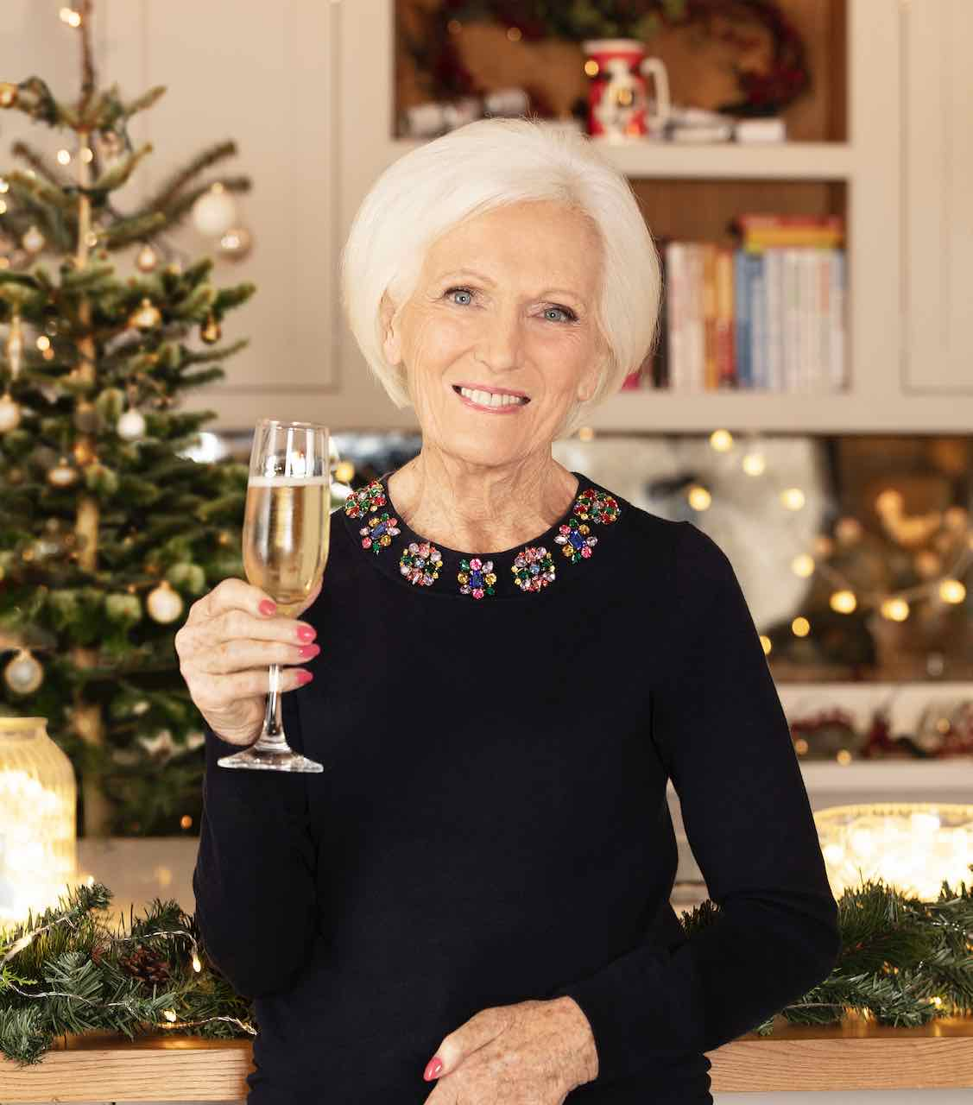
Credit: Cody Burridge for Plank PR
Learn how to prepare the perfect three-course Christmas dinner with Dame Mary Berry in this merry new special filled to the brim with her time-tested recipes. Mary provides the only guide you’ll ever need for a festive feast as she and some special friends show how to plan, shop and prep for a delicious, stress-free day. MARY BERRY’S ULTIMATE CHRISTMAS premieres Monday, December 19, 2022, 9:00-10:00 pm ET (check local listings) on PBS, PBS.org and the PBS Video app.

“It goes without saying that Christmas is a very special time of year, but over the last couple of years it has become for us all, whether it’s the emotional hardship of lost loved ones, the economic hardship of cooking for large families or a combination of both,” said Berry. “In this special, I am going to bring together everything you need with tips to make it a festive day to remember fondly.”

In this new special, Mary shares her ultimate Christmas feast using her definitive tried and tested recipes, perfected over 50 years. She begins with a deliciously simple Stilton and Sage Mini Scone Canapé, followed by her traditional Christmas dinner of Lemon and Herb Roast Turkey with all the trimmings, Crispy Roast Potatoes, Ruby Red Cabbage and Apricot and Chestnut Stuffing.

Checking in with friends who share recipes reflecting their own heritage, Mary visits the home of Chef Angela Hartnett, where she cooks up rich Pumpkin Ricotta Tortelli, a seasonal tradition for her Italian family. Monica Galetti welcomes Mary to her London restaurant, where she prepares a twist on Samoan Palusami with Smoked Haddock, Cavolo Nero and Sourdough, which she’ll be serving to her family on Christmas Day. And Mary and TV host Rylan visit a “pick your own” vegetable farm where they cook up a yummy dish of Brussels Sprouts with Peas and Cashews, hoping to convert some sprouts-hating kids.

Finally, to complete the feast, Mary shares two desserts. Her traditional British Christmas Pudding goes back to medieval times; the rich dessert made from dried fruit and nuts served alongside a boozy cream. Topping things off is a showstopping Festive Trifle with layers of custard, cream, sponge cakes and pear, topped with spun sugar.

“We are thrilled to welcome Mary Berry back to PBS platforms for a truly unforgettable holiday special,” said Zara Frankel, Senior Director of Programming and Development, General Audience Programming at PBS. “From the shopping to the prep, from the turkey to dessert, this holiday season Mary is serving up traditional dishes with her signature fuss-free style — exuding warmth, friendship and fun — and everyone’s invited.”

Catherine Catton Head of Commissioning, Factual Entertainment and Events at BBC, said: “With Dame Mary joined by Angela, Monica and Rylan, this Christmas is guaranteed to be one to remember. We’re delighted that Mary is back on BBC One to share her incredible recipes, tips and advice for what promises to be the ultimate Christmas feast. Whether it’s the secret to the perfect roast potatoes, tips for a stress-free starter, or an ingenious low-cost solution to table dressing, Mary’s got it well and truly covered this Christmas.”

Dame Mary Berry is the author of over 70 books, including the bestselling Mary Berry Cooks, Mary Berry's Absolute Favorites, Mary Berry At Home, and Mary Berry's Baking Bible. She was the much-loved judge on the BBC's The Great British Bake Off (which aired for five seasons on PBS as The Great British Baking Show) and has been teaching the world to cook for over four decades. Following her training at the Cordon Bleu in Paris, Mary began her career as a magazine cookery editor before publishing her first cookbook in 1966. In 2009, Mary was awarded the highly coveted Guild of Food Writers Lifetime Achievement Award and in 2012 she was made a CBE (Commander of the Order of the British Empire) in the Queen's Birthday Honours list.

MARY BERRY’S ULTIMATE CHRISTMAS will be available to stream on all station-branded PBS platforms, including PBS.org and the PBS Video app, available on iOS, Android, Roku, Apple TV, Amazon Fire TV, Android TV, Samsung Smart TV, Chromecast and VIZIO.

Mary Berry’s Ultimate Christmas will also premiere on BBC One and iPlayer in the U.K. during the festive season.

MARY BERRY’S ULTIMATE CHRISTMAS, a one-hour special for BBC One and iPlayer and PBS, is made by Rumpus Media. It was commissioned by Catherine Catton,
Head of Commissioning, Factual Entertainment and Events BBC. Emily Hudd and Kelly Sparks are Executive Producers for Rumpus Media and the Commissioning Editor is Ricky Cooper. The Director is Katy Fryer. Zara Frankel is the Executive in Charge for PBS.

About PBS
PBS, with more than 330 member stations, offers all Americans the opportunity to explore new ideas and new worlds through television and digital content. Each month, PBS reaches over 120 million people through television and 26 million people online, inviting them to experience the worlds of science, history, nature and public affairs; to hear diverse viewpoints; and to take front row seats to world-class drama and performances. PBS’ broad array of programs has been consistently honored by the industry’s most coveted award competitions. Teachers of children from pre-K through 12th grade turn to PBS for digital content and services that help bring classroom lessons to life. Decades of research confirms that PBS’ premier children’s media service, PBS KIDS, helps children build critical literacy, math and social-emotional skills, enabling them to find success in school and life. Delivered through member stations, PBS KIDS offers high-quality educational content on TV – including a 24/7 channel, online at pbskids.org, via an array of mobile apps and in communities across America. More information about PBS is available at www.pbs.org, one of the leading dot-org websites on the internet, or by following PBS on Twitter, Facebook or through our apps for mobile and connected devices. Specific program information and updates for press are available at pbs.org/pressroom or by following PBS Communications on Twitter.

– PBS –

CONTACTS:

Atiya Frederick, PBS, anfrederick@pbs.org

Cara White / Mary Lugo, CaraMar, Inc.
cara.white@mac.com; lugo@negia.net

For images and additional up-to-date information on this and other PBS programs, visit PBS PressRoom at pbs.org/pressroom.
For BBC One information please contact Plank PR – lou@plankpr.com or 020 8995 3936

