METALLICA AND THE SAN FRANCISCO SYMPHONY: S&M2
Premieres Thursday, October 29, 2020 on PBS

Two Venerable Music Institutions Reunited for Epic Concert

ARLINGTON, VA – In September 2019, Metallica reunited for two incredible nights with the nearly 80-member San Francisco Symphony. Celebrating the 20th anniversary of the first S&M concert, these two sold-out performances were the first ever at the new Chase Center in Metallica’s hometown San Francisco. Metallica’s Lars Ulrich, James Hetfield, Kirk Hammett and Robert Trujillo combined forces with the symphony, led by conductor Edwin Outwater, with a special appearance by legendary conductor and longtime San Francisco Symphony Musical Director Michael Tilson Thomas. The concerts marked the first time these two venerable music institutions have performed together on stage since 1999, documented in S&M, the Grammy-winning album and concert film. METALLICA AND THE SAN FRANCISCO SYMPHONY: S&M2 premieres Thursday, October 29, 2020, 9:00-10:30 pm ET (check local listings) on PBS.
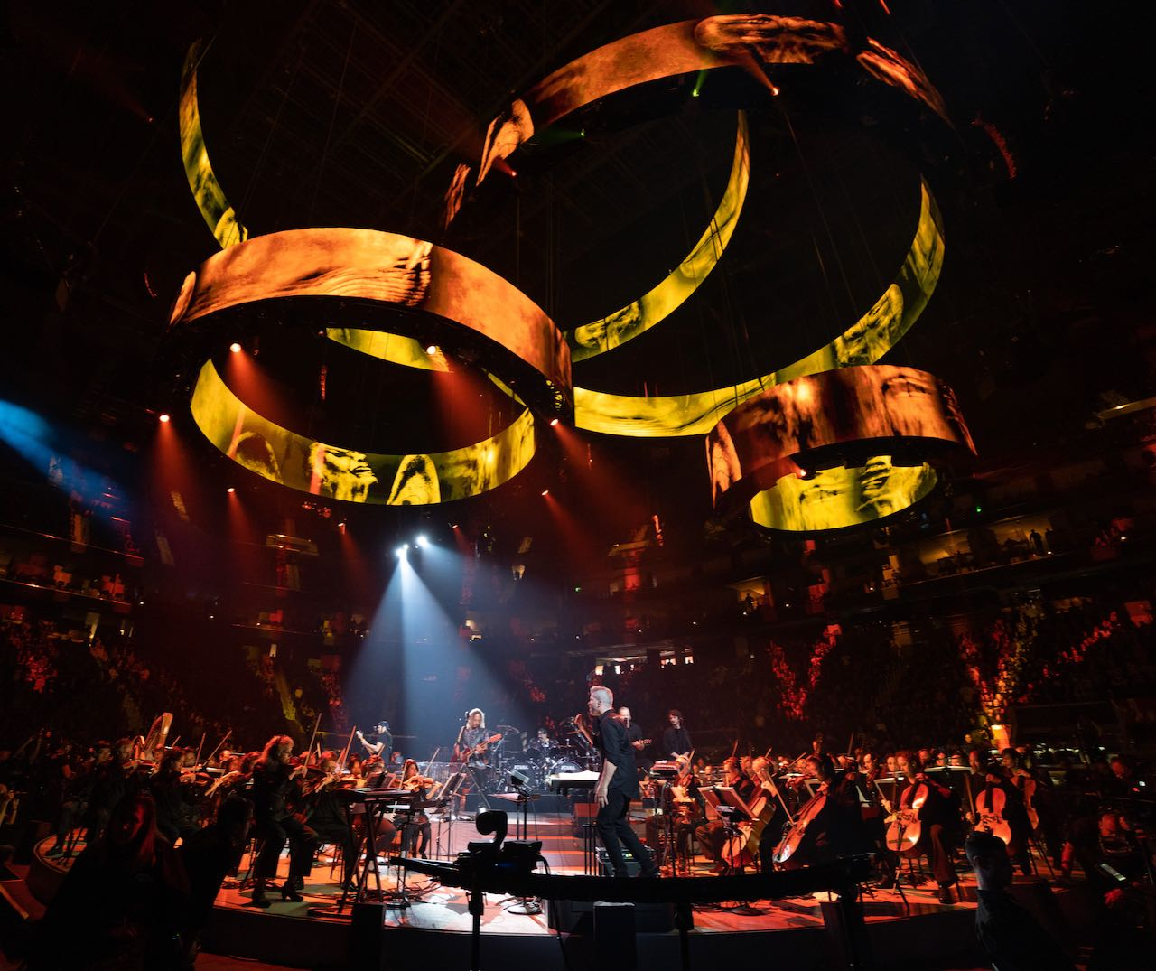
Credit: Courtesy of Eagle Rock Entertainment

Praised by critics, the concert captures Metallica fan favorites performed with elaborate symphonic arrangements. Songs include “For Whom the Bell Tolls,” “Enter Sandman,” “The Outlaw Torn,” “Nothing Else Matters,” “One,” “Master of Puppets” and more. “The group proved that anything was possible by teaming up with the Symphony,” said Rolling Stone, adding that “you could practically hear Beethoven roll over.” “One of the most epic shows of their lives,” said British weekly magazine Kerrang!, and Metal Hammer called the event “a must see.”

PBS special programming invites viewers to experience the worlds of science, history, nature and public affairs; hear diverse viewpoints; and take front-row seats to world-class drama and performances. Viewer contributions are an important source of funding, making PBS programs possible. PBS and public television stations offer all Americans from every walk of life the opportunity to explore new ideas and new worlds through television and online content.

– PBS –

CONTACTS:

Cara White, CaraMar, Inc., 843-881-1480; cara.white@mac.com

For images and additional up-to-date information on this and other PBS programs, visit PBS PressRoom at pbs.org/pressroom.

