MICHAEL FEINSTEIN NEW YEAR’S EVE AT THE RAINBOW ROOM Premieres on PBS Wednesday, December 31 at 10 PM ET

– Special Guests Include Christine Ebersole, Darren Criss, Julia Goodwin, Marilyn Maye, Leslie Odom Jr., Aaron Tveit and Kelli O’Hara –

– One of Three Special New Programs That Ring In 2015 with Music, including GREAT PERFORMANCES “From Vienna: The New Year’s Celebration 2015” hosted by stage and screen legend Julie Andrews –

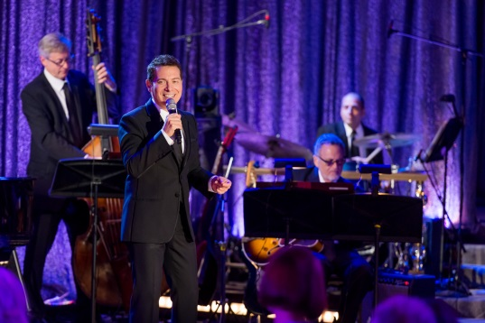
Michael Feinstein at the Rainbow Room. Credit: Marc Bryan-Brown Photography
ARLINGTON, VA; December 1, 2014 – Five-time Grammy® Award and two-time Emmy® Award nominee Michael Feinstein recaptures the heyday of one of New York’s most glamorous nightclubs as he hosts a New Year’s Eve celebration from high atop Rockefeller Center in the premiere of MICHAEL FEINSTEIN NEW YEAR’S EVE AT THE RAINBOW ROOM airing Wednesday, December, 31, 2014, 10:00-11:00 p.m. ET (check local listings). A consummate showman and American Songbook aficionado, Feinstein headlines an evening packed with musical entertainment as PBS rings in 2015 with family entertainment on New Year’s Eve and New Year’s Day as well.

Feinstein’s guests comprise a wide array of stage and screen stars including TV’s Darren Criss (“Glee”) and Leslie Odom, Jr. (“Smash”), award-winning Broadway actors Kelli O’Hara (“South Pacific”) and Aaron Tveit (“Next to Normal”), nightclub legend Marilyn Maye, Tony Award-winning actress Christine Ebersole (“Grey Gardens”) and 17-year-old “America’s Got Talent” finalist Julia Goodwin.

MICHAEL FEINSTEIN NEW YEAR’S EVE AT THE RAINBOW ROOM features songs from legendary composers Johnny Mercer, Cole Porter, George & Ira Gershwin and more. In tribute to Frank Sinatra’s upcoming 100th birthday celebration, Feinstein and Criss perform an energized duet medley. A rousing rendition of Jerry Lee Lewis’ “Great Balls of Fire,” with Feinstein re-creating Lewis’ signature piano-playing style, brings the star-studded evening to a spectacular close. The all-star broadcast is directed by Annette Jolles and produced by Jonathan Burkhart. The stage show was written, produced and directed by Marc Cherry, creator of the hit television shows “Desperate Housewives” and “Devious Maids.” Executive Producers are Lance Schultz and Jim Castle.

“Michael Feinstein shines a particularly glittering light on the Great American Songbook this coming New Years Eve,” said Donald Thoms, PBS Vice President of Programming. “Michael has secured a lineup of tremendous singers and performers, along with a swinging 17-piece band that viewers across America will find entertaining and memorable, whether they’re partying with a full house or enjoying a romantic evening for two.”

MICHAEL FEINSTEIN NEW YEAR’S EVE AT THE RAINBOW ROOM follows a brand new primetime program on December 31: LIVE FROM LINCOLN CENTER “New York Philharmonic New Year’s Eve: Gershwin Celebration with Dianne Reeves and Norm Lewis” premieres at 8 PM ET (check local listings). This live broadcast of the acclaimed orchestra’s New Year’s Eve celebration concert features Reeves, the award-winning jazz singer, and Lewis, the Tony Award-nominated actor and baritone, with Bramwell Tovey conducting. New Year’s programming continues on January 1 with GREAT PERFORMANCES “From Vienna: The New Year’s Celebration 2015” – a program from the opulent Musikverein concert hall with the Vienna Philharmonic under the baton of guest conductor Zubin Mehta -- hosted on New Year’s Day by stage and screen legend Julie Andrews, at 2:30 PM ET and at 8:00 PM ET (check local listings).

About PBS
PBS, with its over 350 member stations, offers all Americans the opportunity to explore new ideas and new worlds through television and online content. Each month, PBS reaches nearly 109 million people through television and over 28 million people online, inviting them to experience the worlds of science, history, nature and public affairs; to hear diverse viewpoints; and to take front row seats to world-class drama and performances. PBS’ broad array of programs has been consistently honored by the industry’s most coveted award competitions. Teachers of children from pre-K through 12th grade turn to PBS for digital content and services that help bring classroom lessons to life. PBS’ premier children’s TV programming and its website, pbskids.org, are parents’ and teachers’ most trusted partners in inspiring and nurturing curiosity and love of learning in children. More information about PBS is available at www.pbs.org, one of the leading dot-org websites on the Internet, or by following PBS on Twitter, Facebook or through our apps for mobile devices. Specific program information and updates for press are available at pbs.org/pressroom or by following PBS Pressroom on Twitter.
– PBS –
CONTACTS:
Michaé Godwin, PBS; mmgodwin@pbs.org; 703-739-8483
John Michael Kennedy/Roberta Lee, Goodman Media International; PBSArts@goodmanmedia.com; 212-576-2700

For images and additional up-to-date information on this and other PBS programs, visit PBS PressRoom at pbs.org/pressroom.

