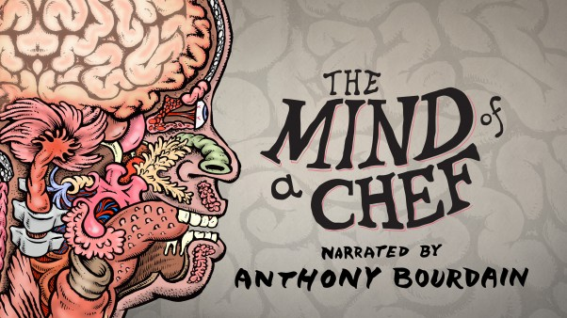

Award-Winning PBS Series The Mind of a Chef Takes
Viewers Inside the Creative World of Ludo Lefebvre in New Season
Season 5 Also Features Six All New Compilation Episodes Including EGGS, FRIED, and LEGENDS
BOSTON, September 20, 2016 – Narrated by Anthony Bourdain and combining cooking, travel, humor and science into a cinematic feast for the eyes, The Mind of a Chef, from Zero Point Zero Production and WGBH Boston, returns to public television this fall with world-renowned chef Ludo Lefebvre at the helm. Season five will also include six new compilation episodes featuring some of the best and brightest culinary minds.
"Ludo Lefebvre runs the best restaurant in Los Angeles, and is an extraordinary cook with a fascinating story," says Executive Producer and Narrator Anthony Bourdain. "He is one of the most inspiring and persistent mentors I've ever known. I've watched him turn mediocre cooks into good cooks in front of my eyes. There's no one like him."
The Mind of a Chef continues its award-winning legacy starting on October 1, 2016 (check local listings) with a 14-episode journey that focuses on what it truly means to cook, think, create, and live in a food-obsessed world. In the tradition of previous seasons that featured outstanding chefs Sean Brock, Gabrielle Hamilton, David Kinch, April Bloomfield, David Chang, Edward Lee and Magnus Nilsson, The Mind of a Chef continues to push the envelope and seek out the passions and creative drive behind some of the culinary community’s greatest minds as they search for ingredients, inspiration, and the perfect meal.
In eight episodes of the fifth season, audiences are introduced to Ludo Lefebvre, an influential chef who is stirring up the food scene in Los Angeles and pioneered the idea of the pop-up restaurant with his LudoBites concept. Not only will viewers get a peek into his life as the business owner of LudoTruck—a mobile truck that brought fried chicken to the streets of Los Angeles—LudoBird, Trois Mec, Petit Trois, and Trois Familia, but they’ll also find out the inspiration behind his use of unusual ingredients to create signature dishes.
"Season 5 of The Mind of a Chef takes us to the streets of Los Angeles and Paris with the outstanding Ludo Lefebvre in search of ingredients, inspiration, and what makes up the perfect dish," says Executive Producer Joe Caterini. "With his French culinary roots and cutting-edge LA style, Ludo is a perfect fit for the series, and we are excited he was able to invite us into his world for an all-access look at what makes him tick."
“The Mind of a Chef continues to push the envelope in the world of food on television,” says WGBH Executive Producer, Laurie Donnelly. “This season we’re delighted to have Ludo on board, leading the charge.”
Rounding out the all-new season will be six new episodes of the very best of previous seasons that feature themes like “Eggs,” “Fried” and “Legends.” These compilations bring together the best and brightest culinary minds under one theme.
The Mind of a Chef was awarded the Emmy for Outstanding Culinary Program in 2014, along with three Creative Arts Emmy awards in 2015 and five Creative Arts Emmy Awards in 2016. The series also won three consecutive James Beard Foundation Awards for Best Television Program on Location, a prestigious and unprecedented honor.
Major funding for The Mind of a Chef is provided by Breville with additional funding from Volpi Foods.
Like The Mind of a Chef on Facebook and follow us on Instagram and Twitter.
To view recipes featured in the show and more on us, visit PBS Food.
###
About Zero Point Zero Production: Zero Point Zero Production, Inc. is a television, film and digital media company founded in 2003 by Executive Producers Chris Collins and Lydia Tenaglia, with partner and Managing Director Joe Caterini joining in 2009. Since its inception, the company has produced hundreds of hours of television in over 100 countries around the world, including the critically acclaimed, Emmy & Peabody Award winning series, Anthony Bourdain: Parts Unknown (CNN); the Emmy Award winning The Mind of a Chef (PBS) and Emmy nominated The Hunt with John Walsh (CNN).
In 2009 Zero Point Zero began an expansion into other content platforms including interactive entertainment and publishing. In 2012 they released Pat LaFrieda’s Big App for Meat, an interactive encyclopedia chosen as Apple’s “App of the Week” and then named Apple’s “Best APPS of 2012”. In 2013 ZPZ acquired The Food Republic website, one of the launch properties in a new ZPZ-owned digital publishing venture. Other digital projects include content for such brands as Mastercard, Subaru, Microsoft/BING, TUMI, Lipton, Breville and Volpi Foods.
ZPZ is currently in production on Anthony Bourdain: Parts Unknown season 4 (CNN); The Hunt with John Walsh season 3 (CNN); Whistleblowers (Spike); The Mind of a Chef season 5 (PBS); the award winning series, MeatEater with Steven Rinella season 6 (Outdoor/Sportsman Channel); I’ll Have What Phil’s Having with Phil Rosenthal (PBS); a documentary feature film titled Stars in the Sky with Steven Rinella; and Executive Producers of Nightcap a scripted comedy series starring Ali Wentworth (POPtv).
Zero Point Zero’s hit shows, ANTHONY BOURDAIN: PARTS UNKNOWN (CNN) and THE HUNT WITH JOHN WALSH (CNN), ranked #1 overall across cable news in the time period among P2+ and P25-54. MEATEATER WITH STEVEN RINELLA is the #1 rated series on Sportsman Channel. ZPZ’s documentary feature film titled Jeremiah Tower: The Last Magnificent (CNN Originals, Distributed by The Orchard) premiered Tribeca Film Festival in 2016.
About WGBH Boston: WGBH Boston is America’s preeminent public broadcaster and the largest producer of PBS content for TV and the Web, including Frontline, Nova, American Experience, Masterpiece, Antiques Roadshow, Arthur, Curious George and more than a dozen other prime-time, lifestyle, and children’s series. WGBH also is a major supplier of programming for public radio, and oversees Public Radio International (PRI). As a leader in educational multimedia for the classroom, WGBH supplies content to PBS LearningMedia, a national broadband service for teachers and students. WGBH also is a pioneer in technologies and services that make media accessible to those with hearing or visual impairments. WGBH has been recognized with hundreds of honors. More info at www.wgbh.org.

PRESS CONTACTS:
Eileen Campion / Roslan & Campion PR
212-966-4600 / Eileen@rc-pr.com
Bara Levin / WGBH
617-300-5391 / bara_levin@wgbh.org

Alexis Feinberg / WGBH
617-300-5334 / alexis_feinberg@wgbh.org

