MUHAMMAD ALI
TCA Panelist Bios

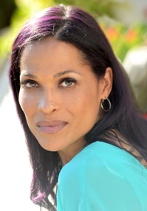
Rasheda Ali is an internationally known author, speaker, actress, spokesperson and Parkinson’s disease advocate. Her book, I’ll Hold Your Hand So You Won’t Fall-A Child’s Guide to Parkinson’s Disease, was inspired by her children and her father, Muhammad Ali, who suffered more than 30 years from the disease.

As an advocate of stem cell research, Rasheda travels the globe motivating others to make a difference in their communities, raising awareness and funds for neurocognitive disorders as well as promoting love and inclusion through the Muhammad Ali Center.

After her father’s death, Rasheda and her family were invited by President Barack Obama to attend the first Eid celebration at the White House.

Rasheda has participated in countless documentaries and projects such as the Double Helix Medal Awards, MUHAMMAD ALI directed by Ken Burns, “Dateline” with Katie Couric, BBC Studios, and has been interviewed by numerous media broadcasts and outlets as CNN, “The Today Show,” MSNBC, “Good Morning America,” PBS, “New York Nightly News with Chuck Scarborough” and many others.

As a member of the Screen Actors Guild and the American Federation of Television and Radio Artists, Rasheda served as writer, casting director and host for her own celebrity talk show in Las Vegas where she also formed a media company Raw Dreams LLC in 2007.

Most recently, Rasheda was cast in a film and starts shooting this year in Arizona.

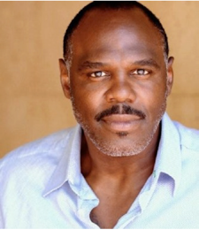
Michael Bentt has excelled in both athletics and the arts— as a boxer, actor, writer, producer and director. Born in London to Jamaican parents, he was raised in Springfield Gardens, Queens, New York, where he trained as an athlete from a young age.

As a boxer, Michael is the former WBO World Heavyweight Champion, winning the 1993 title after a 97-second, first-round knockout of the heavily favored Tommy “The Duke” Morrison on HBO. One of the most decorated amateur fighters in U.S. history, he placed a controversial second in the United States Olympic Trials to the eventual 1988 Olympic Gold Medalist, Ray Mercer. In the early 1990s, he was chief sparring partner for heavyweight champion Evander Holyfield. After his last pro fight in 1994, Michael was in a 96-hour coma that led to his retirement from boxing. After retiring, he studied journalism and acting at Northampton Community College in Pennsylvania and acting with the late Tina Sattin in Harlem.

As an actor, Michael has worked with several acclaimed directors: Michael Mann (six times), Bill L. Norton (five times), Ron Shelton (twice), Clint Eastwood and Sylvester Stallone. In 2001, Bentt was the first actor cast after Will Smith in Mann’s ALI, in which he portrayed Sonny Liston. He was also Smith's chief sparring partner and assistant trainer during the six months of boxing training before principal photography began on the film. For Public Enemies, Mann handpicked Bentt to play Herbert Youngblood opposite Johnny Depp (John Dillinger). His other film and TV credits include Million Dollar Baby, Girlfight, “Saturday Night Live,” “Sons of Anarchy,” “Firefly,” “JAG” and “Robbery-Homicide Division.” In 2003, he returned to Northampton Community College, where he became the first actor-in residence and played the title role in Othello, The Moor of Venice. Michael has written and commentated on boxing for: HBO.com; Bert Sugar's Fight Game; Bob Arum’s Top Rank Boxing on ESPN; Filmnet (Netherlands); and BBC Radio. A producer of nationally and internationally screened short films such as Broken, he is also currently co-producing a sports documentary. In November 2011, Michael made his directorial debut directing boxers-turned-actors in the sold-out play Kid Shamrock. In March 2019, his story was featured as the first episode in Netflix’s LOSERS documentary series on perseverance.

He has also mentored, served as a guest speaker and conducted seminars for juvenile facilities in New York City and Sylmar, California; L.A. Summer of Success Anti-Gang programs; the L.A. County Sherriff's Department Force Instructor School and Special Enforcement Bureau (formerly, SWAT); New York’s New Alternatives for Children “Siblings” program; Brooklyn’s Believe Northside High School; and co-instructed acting workshops with Anna Deavere Smith, who also portrayed Bentt in her stage piece Skipping Rope.

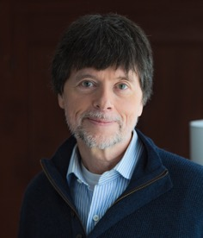
Ken Burns has been making documentary films for over 40 years. Since the Academy Award nominated Brooklyn Bridge in 1981, Ken has gone on to direct and produce some of the most acclaimed historical documentaries ever made, including The Civil War; Baseball; Jazz; The War; The National Parks: America’s Best Idea; The Roosevelts: An Intimate History; Jackie Robinson; The Vietnam War; and Country Music.

A December 2002 poll conducted by Real Screen Magazine listed The Civil War as second only to Robert Flaherty’s Nanook of the North as the “most influential documentary of all time,” and named Ken Burns and Robert Flaherty as the “most influential documentary makers” of all time. In March 2009, David Zurawik of The Baltimore Sun said, “… Burns is not only the greatest documentarian of the day, but also the most influential filmmaker period. That includes feature filmmakers like George Lucas and Steven Spielberg. I say that because Burns not only turned millions of persons onto history with his films, he showed us a new way of looking at our collective past and ourselves.” The late historian Stephen Ambrose said of his films, "More Americans get their history from Ken Burns than any other source." And Wynton Marsalis has called Ken “a master of timing, and of knowing the sweet spot of a story, of how to ask questions to get to the basic human feeling and to draw out the true spirit of a given subject.”

Future film projects include Muhammad Ali, Benjamin Franklin, The Holocaust and the United States, The American Buffalo, Leonardo da Vinci, The American Revolution, Emancipation to Exodus, and LBJ & the Great Society, among others.

Ken’s films have been honored with dozens of major awards, including 16 Emmy Awards, two Grammy Awards and two Oscar nominations; and in September of 2008, at the News & Documentary Emmy Awards, Ken was honored by the Academy of Television Arts & Sciences with a Lifetime Achievement Award.

